PHOTOS FROM MT HEBRON CEREMONY AUGUST 24, 2013
Photos from cameras of Mike Lyman and Stuart Butler
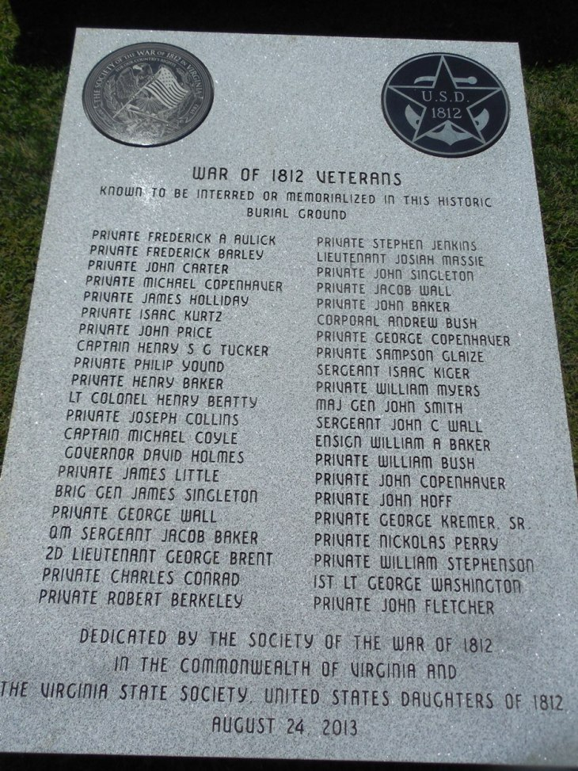
The above shows the inscriptions and logos of the two 1812 societies that financed the preparation. It lists the forty two 1812 veterans and their ranks during the war period. After the ceremony the monument will be placed on a base in the area of the General Daniel Morgan portion of the cemetery nearby.
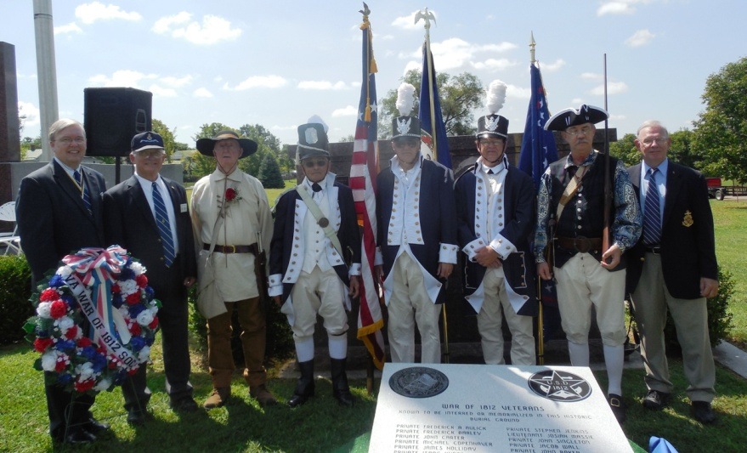
Above eight member of the War of 1812 in the Commonwealth of Virginia gather around the inscribed monument after the ceremony L/R: Rick Hendrick; John Epperly; Thad Hartman; Mike Lyman, Dennis Fritts, Charles Belfield; Victor Diehl and Stuart Butler
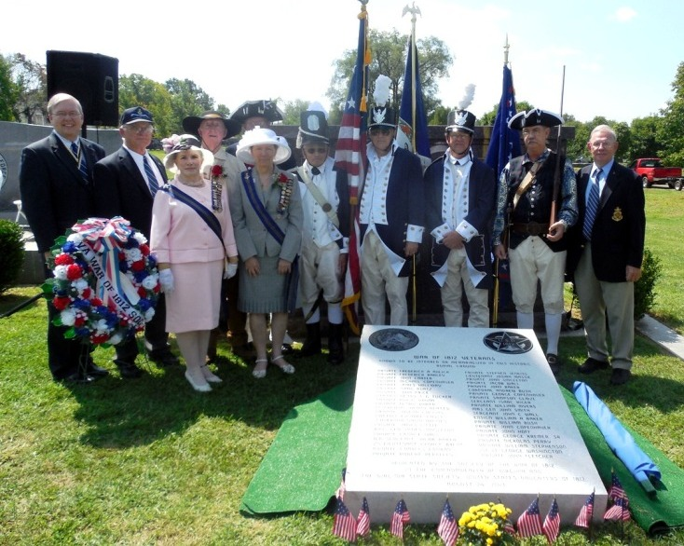
Jodi Killeen, 1st VP National & Jacque-Lynne Schulman, VA State President of the U.S. Daughters of 1812 join the group
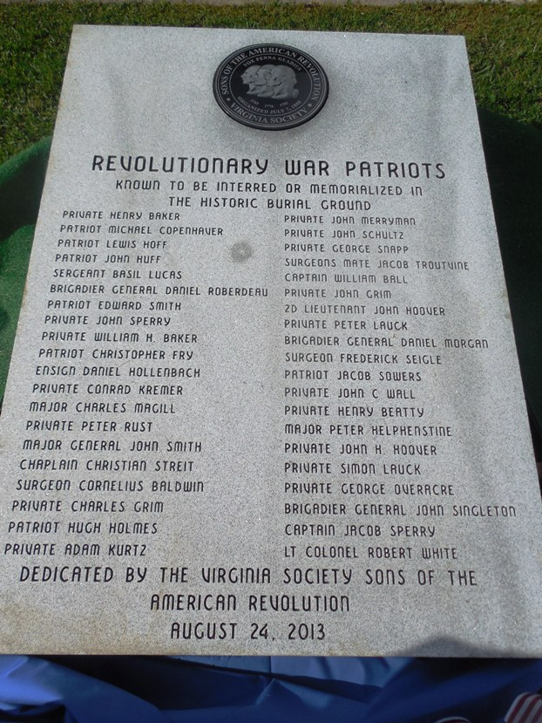
In the joint ceremony with the Virginia Society Sons of the American Revolution, forty Revolutionary War patriots were also honored by placing their names and ranks on the monument. Some of these men also served in the War of 1812. This monument, as well, will be mounted on a base following the ceremony.
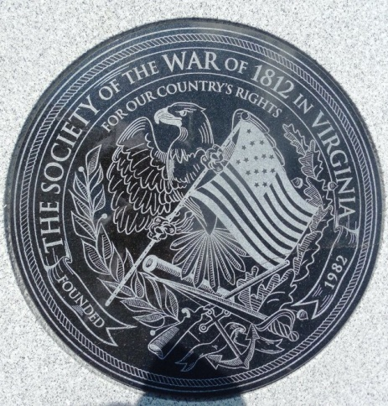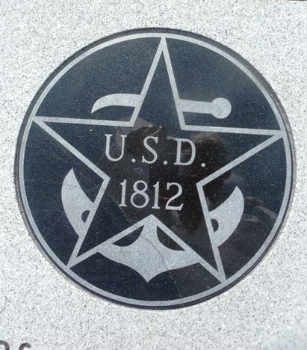
Close-ups of the two 1812 society logos on the monument and some of the attendees below
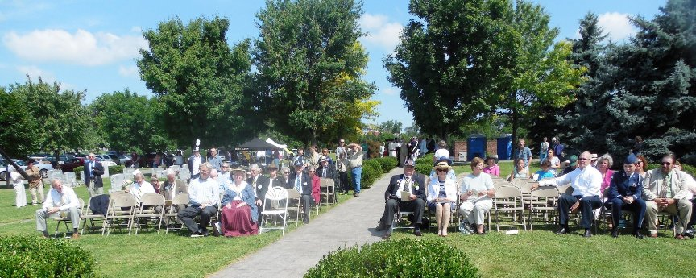
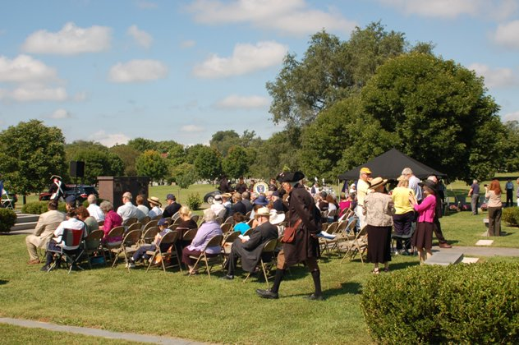
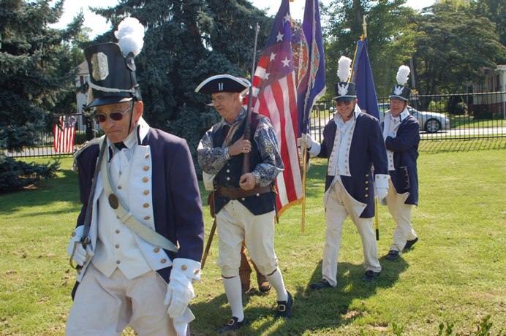
Above the War of 1812 Society Color Guard carry the colors to be posted L/R: Mike Lyman and Victor Diehl lead the guard, followed by Thad Hartman (hid behind Victor) carrying the Star Spangled Banner Flag, followed by Dennis Fritts with the Virginia flag and Charles Belfield with the Society flag
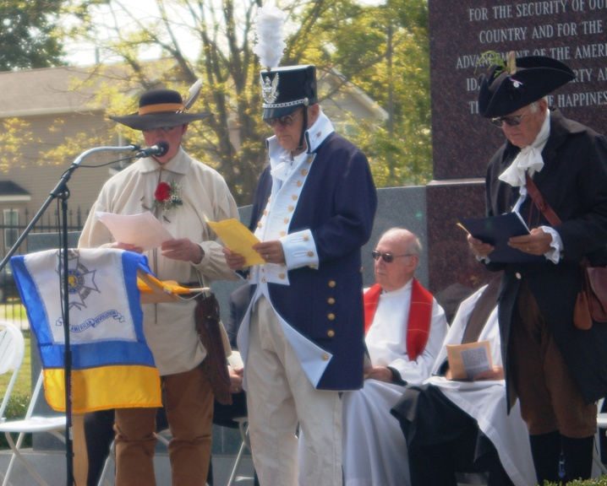
Above the ritual for unveiling monuments is recited by Thadeus Hartman and Dennis Fritts. Standing on the left is President Larry Johnson of the James Wood II SAR Chapter whose chapter conducted the ceremony.
Below the War of 1812 monument is unveiled by Virginia State President U.S. Daughters of 1812, Jacque-Lynne Amann Schulman and past President Myron (Mike) E. Lyman, Sr. of the War of 1812 Society in Virginia. The three posted flags of the 1812 Color Guard are posted behind the monument.
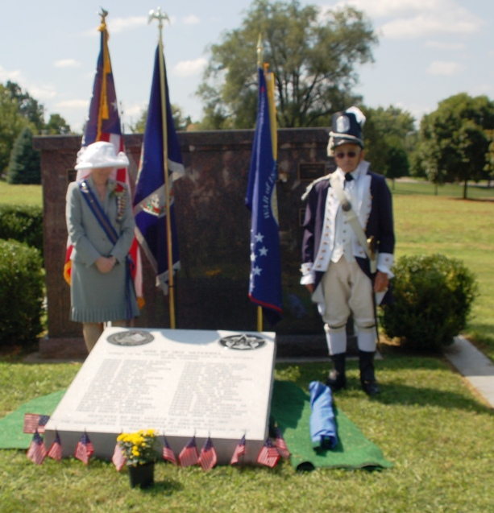
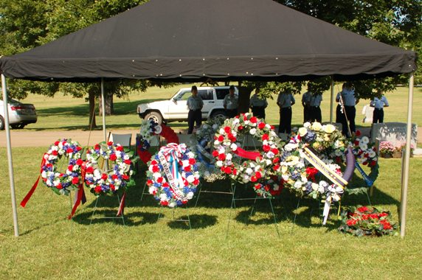
Some of the wreaths presented during the ceremony

