CEREMONY FOR REVOLUTIONARY WAR & WAR OF 1812 VETERANS WAS CONDUCTED
SEPTEMBER 29, 2013 IN FLOYD COUNTY IN THE PINE CREEK CEMETERY NEAR THE TOWN OF FLOYD
The events were sponsored by the Floyd Courthouse DAR. In addition to their members, Judge Gino Williams of the Montgomery General District Court was the primary speaker at both sites. He is pictured in the first photo below. Also pictured is the American legion Color Guard. Other groups represented were:
- DAR District VII
- The Fincastle Resolutions Chapter of the Sons of the American Revolution: John Cahoon, John Brown, Doug Hankins, and Chuck Poland
- The Society of the War of 1812 in Virginia: Chuck Poland, who placed a wreath at the Pine Creek Cemetery
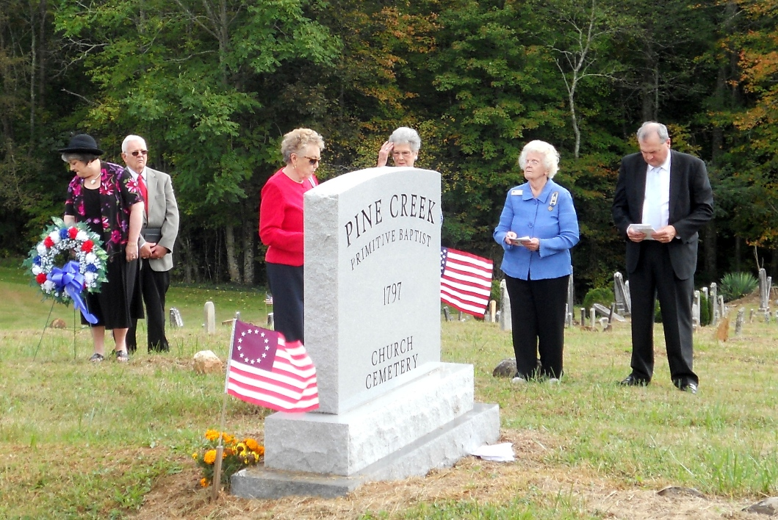

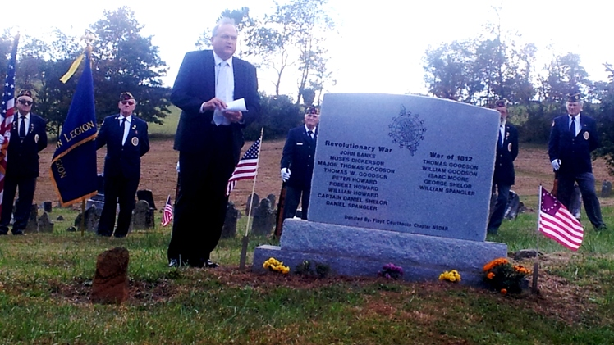

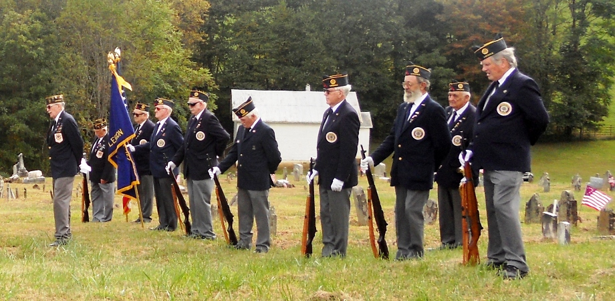
Also interred in the cemetery is the son of Patrick Henry who was also honored as shown below
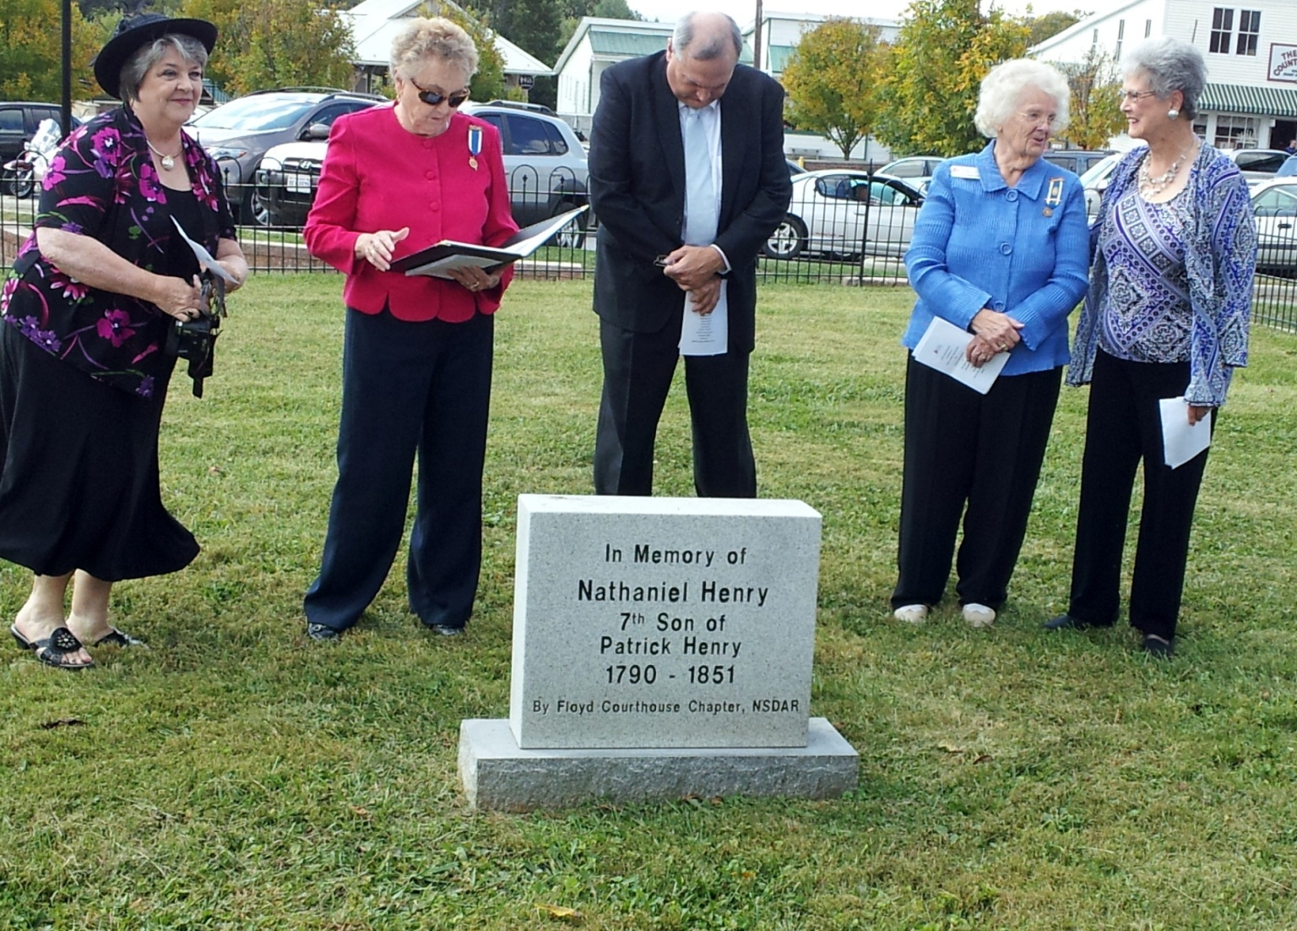
Below is the monument showing the names of the Revolutionary War and War of 1812 veterans buried in the cemetery
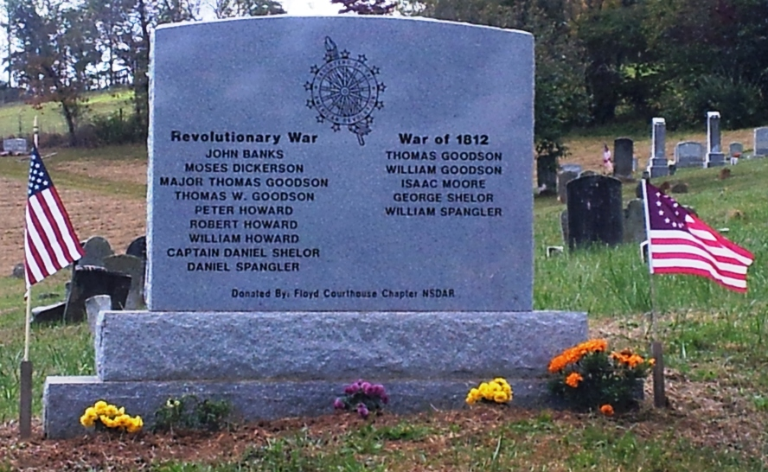
From the War of 1812 Society Burials of War of 1812 Veterans in the Commonwealth of Virginia book, the following text about the veterans honored in the ceremony follow:
GOODSON, Thomas; b 1789; d 15 Mar 1815 RU: Private, 8th VMR (Magnein) CEM: Pine Creek Primitive Baptist; Floyd; Spangler Mill Rd, Floyd GS: Y SP: No spouse information VI: No further data P: None BLW: No PH: N SS: A rec 972 BS: 91 pg 116.
GOODSON, William; b 11 Apr 1793; d 24 Oct 1852 RU: Private, 60th VMR, Capt George Graham, Troop of Cavalry, Fairfax Co, attached to 1st Corps d'Elite (Randolph) CEM: Pine Creek Primitive Baptist; Floyd; Spangler Mill Rd, Floyd GS: Y SP: mar in Patrick Co on 08 Jan 1837 America Sandefur, d c1891, LNR PO Turtle Rock, Floyd Co, 1878 VI: No further data P: Spouse BLW: Yes PH: Y SS: M pg 174; BD pg 838; B pg 71 BS: 25.
MOORE, Isaac; b 10 Aug 1789; d 01 May 1875 RU: Private, 4th VMR (Greenhill) CEM: Pine Creek Primitive Baptist; Floyd; Spangler Mill Rd, Floyd GS: Y SP: mar Nancy (-----), d 26 Dec 1862 age 70 yrs, 7 mos, 21 days VI: No further data P: None BLW: No PH: N SS: A rec 4268 BS: 91 pg 122.
SHELOR, George; b 25 Dec 1778, MD; d 10 Sep 1856 RU: Private, 75th VMR CEM: Pine Creek Primitive Baptist; Floyd; Spangler Mill Rd, Floyd GS: Y SP: mar in Montgomery Co, 27 Jan 1804 to Ruth Banks, b 23 Aug 1783, d 24 Apr 1875 VI: No further data P: None BLW: No PH: N SS: A rec 22129 BS: 91 pg 121.
SPANGLER, William; b 18 Sep 1792; d 14 Jun 1862 RU: Private, Cocke's Detachment VA Militia CEM: Pine Creek Primitive Baptist; Floyd; Spangler Mill Rd, Floyd GS: Y SP: mar Mary Irvin, b 1808, d 1880 VI: No further data P: None BLW: No PH: N SS: A rec 15423 BS: 91 pg 119; 49.

RU=Rank/Unit CEM=Cemetery GS=Gravestone SP=Spousal Information VI=Other Veteran Info P=Pension
BLW=Bounty/Land Warrant PH=Photo SS=Service Source BS=Burial Source VMR= VA Military Regt
LNR= Last Known Residence

It should be noted that this burial book containing information about over 4440 veterans interred in Virginia is available to be purchased from the Society. The book, of course, contains all the sources of burial and military service used in the book and a by-name listing of all parents and spouses identified. Individuals desiring to purchase the book should contact the editor at melyman@va.metrocast.net

