The Society Participates in a Grave Marking Ceremony at the Glade Springs Presbyterian Church in Washington County on April 26, 2014

First Vice President, Dennis Fritts was involved in the arrangements and conduct of the ceremony. He reports that between fifty to sixty people attended. A War of 1812 grave marker was unveiled on the grave of Benjamin Snodgrass
Program for War of 1812 soldier, Benjamin Snodgrass

1. Opening remarks Society of the War of 1812 in Virginia, Vice President, Dennis Fritts
2. Presenting of the Colors Gen William Campbell Chapter, SAR
3. Pledge of Allegiance Dennis Fritts leads all
4. Invocation Rev, Bill Graybeal
5. Welcome and introductions Wayne Snodgrass
6. Benjamin Snodgrass Reading Great-Great Grand Son, Wayne Snodgrass
7. Ceremonial protocol and prayer Dennis Fritts
8. Unveiling the marker Dennis Fritts
9. Presenting the wreaths
United Daughters of 1812 Joella Barbour
Society of the War of 1812 Dennis Fritts
10. Firing of the muskets Gen William Campbell Chapter
11, Invitation to Reception at the Joella Barbour
Overmountain Men Muster Grounds
12. Closing remarks Wayne Snodgrass
13. Retrieval of the Colors Gen. William Campbell Chapter, SAR
14. Benediction Rev. Bill Graybeal

This program has been planned by

Wayne Snodgrass – gggrandson of Benjamin
Joella Barbour – Daughters War of 1812
Dennis Fritts – 1st VP Virginia Society of the War of 1812

Information about Benjamin Snodgrass:
Benjamin was born on 06 Nov 1781 and died on 22 Jan 1857. He was the last of 12 children of David (1731-1814) and Margaret Glenn (1740-1816) Snodgrass. Benjamin was born (as the Revolutionary War ended) to a family committed to the values and freedoms of our new country. Benjamin’s older brothers served with the “Overmountain Men” at Kings Mountain and his family provided beef and other supplies to the military during the Revolutionary War. David and Margaret were among the early settlers moving into the area in 1771 and completing the Snodgrass Fort on the middle fork of the Holston River in 1774. The family also encountered Indian skirmishes and served in the Cherokee Campaigns.
During the War of 1812, Benjamin served in the 70th Regiment Virginia Militia in Washington County and is listed in the Militia Men Index. Since specific militia county records were destroyed, the family tradition believes that Benjamin served in the defense of Norfolk under Colonel Francis Preston (Commander of the USA Fifth Military District and the Militia Brigade during 1813-1814 appointed by VA Governor Barbour). Colonel Preston had been the Commander of the 70th Regiment Militia in Washington County. It is also a traditional belief that many of the Washington County militia men died from disease and inadequate living conditions while defending Norfolk.
Benjamin and his wife Elizabeth Fleming (1807-1877) had two sons, David Glenn Snodgrass (1838-1866) and William J. Snodgrass (1840-1865). David served in the 37th Virginia Infantry Regiment and William served in the 63rd Virginia Infantry Regiment during the War Between the States. David is buried here next to his father. William is buried in a mass grave along with other POW’s in Camp Douglas near Chicago.
The Snodgrass family and the Cousins of Washington County express our sincere gratitude to The Society of the War of 1812 in Virginia for the honor and remembrance of our ancestor Benjamin Snodgrass. Thank you.
While it is important to remember our ancestors, it is even more important to study and understand their motives, their beliefs, their values, and their willingness to fight and die for the rights to life, liberty, and the pursuit of happiness. Our ancestors pledged to each other their lives, their fortunes, and their sacred honor to achieve these rights
May we be willing to do the same for our future generations?
BENJAMIN SNODGRASS FAMILY RELATIONSHIPS
PARENTS: David Snodgrass (1731-1814), Margaret Glenn (1740-1816)
SIBLINGS: Martha (1759-1814), William (1760-1849), James (1762-1828), Margaret (1765-1858), David (1770-1828), Catherine (1771-1865), Jean (1772-1840), John (1773-1806), Mary (1774-)1850), Robert (1776-1835), Joseph (1780-1850)
WIFE: Elizabeth C. Fleming (1807-1877)
CHILDREN: David Glenn (28 Aug 1838 - 12 Dec 1866), William J. (1840 - 28 April 1865)
GRAND CHILD: David Glenn Snodgrass (5 March 1867- 25 August 1927)
GREAT GRAND CHILDREN: Sallie Elizabeth Pearl S. (1886-1958), Gordon Edmondson S. (1888-1888), Samuel Volney S. (1889-1938), Annie Gertrude S. (1893-1949), Leola Kathleen S. (1895-1987), John Henry S. (1898-1984), David Grant S. (1900-1914), Audrey Matilda S. (1903-1983), Spurgeon Oliver S. (1908-1968), Lydia Belle S. (1910-1979)
GREAT-GREAT GRAND CHILDREN: Clyde Edmondson Snodgrass (1913-1969), Catherine Elizabeth Snodgrass (1915-2001), William David Snodgrass (1920-1957), Polly Anne Snodgrass Owen (1923-1997), Clarence Waldo Taylor, Jr. (1926- ), Virginia Kathleen Harrison Kelly (1924-1989), Theodore Courtland Harrison, Jr. (1929-2012), Frances Belle Harrison Medell (1932- ), David Wayne Snodgrass (1939- ), Sarah Elizabeth Snodgrass (1942-2000)
GREAT-GREAT-GREAT GRAND CHILDREN: Twenty Great-Great-Great Grand Children
GREAT-GREAT-GREAT-GREAT GRAND CHILDREN: Thirty Eight Great-Great-Great-Great Grand Children
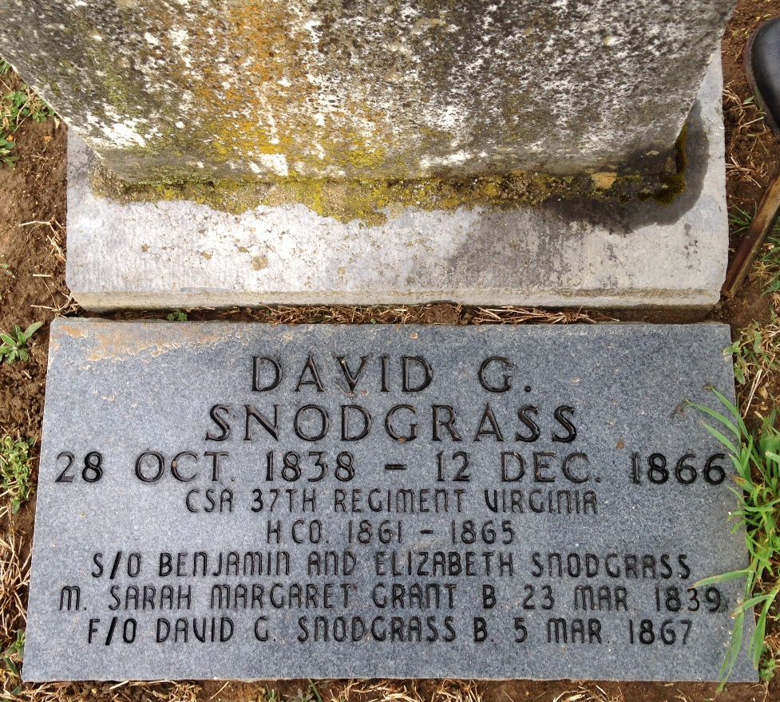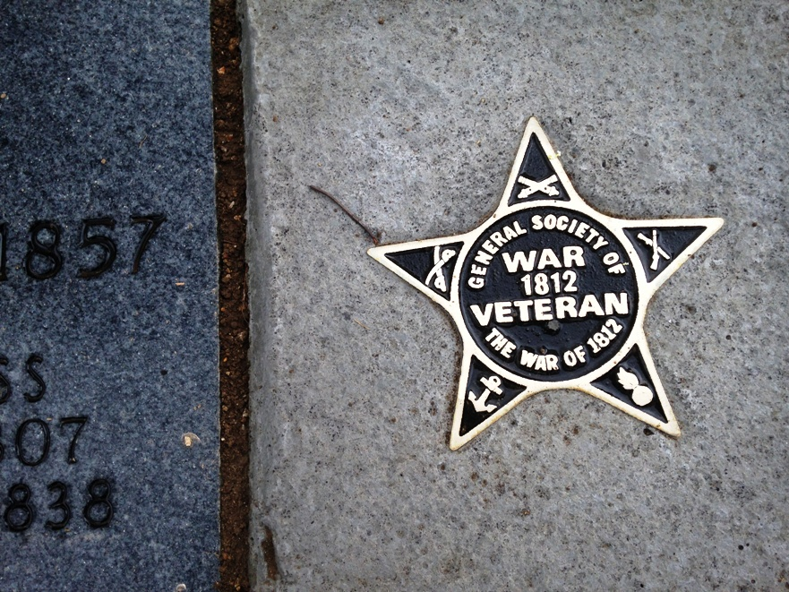

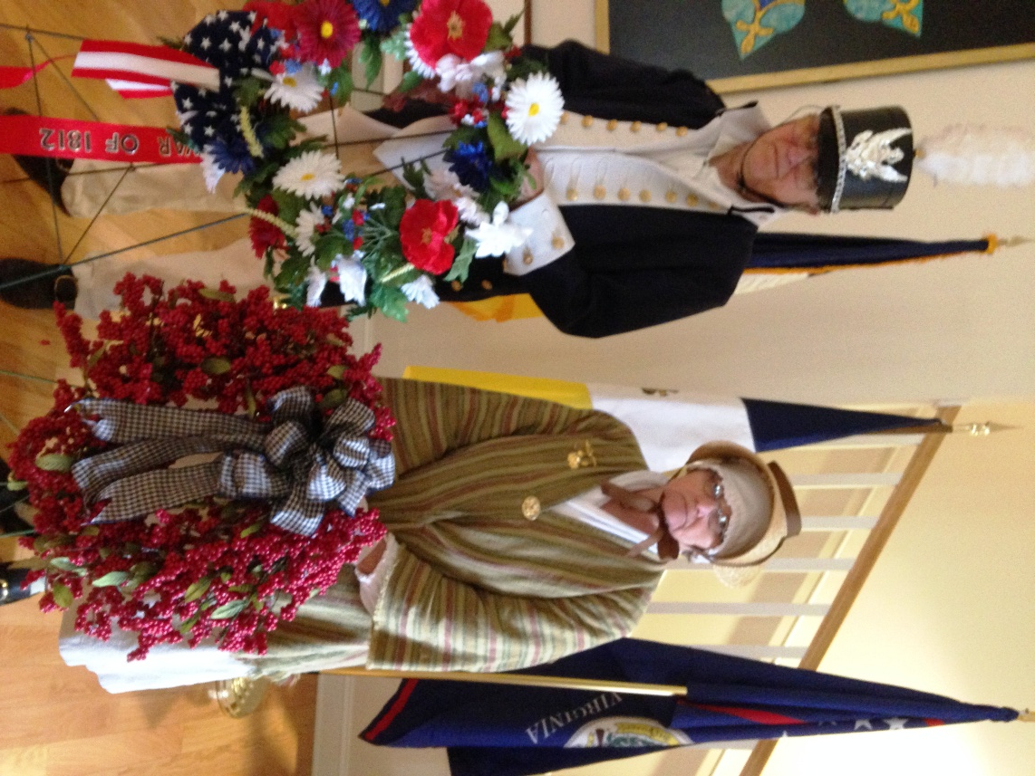
Because of the inclement weather a portion of the ceremony was conducted inside the church. Shown is Dennis Fritts and a member of the DAR that presented wreaths

