Members of The War of 1812 Society in Virginia participate in a Plaque unveiling at the Old Donation Episcopal Church in Virginia Beach
The program:
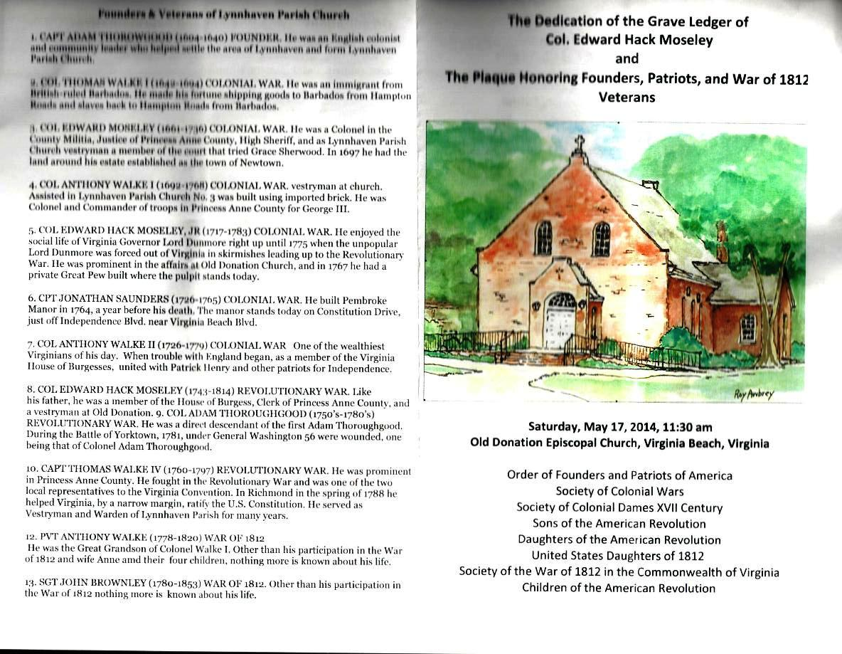
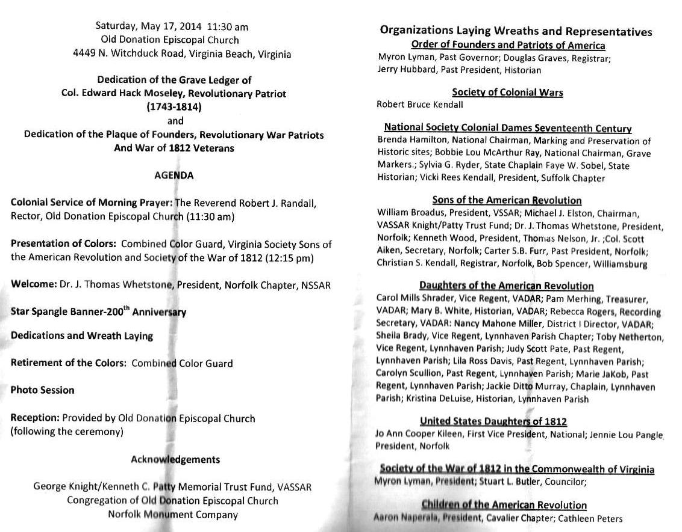
Below the Master of Ceremonies, Dr Thomas Whetstone presides
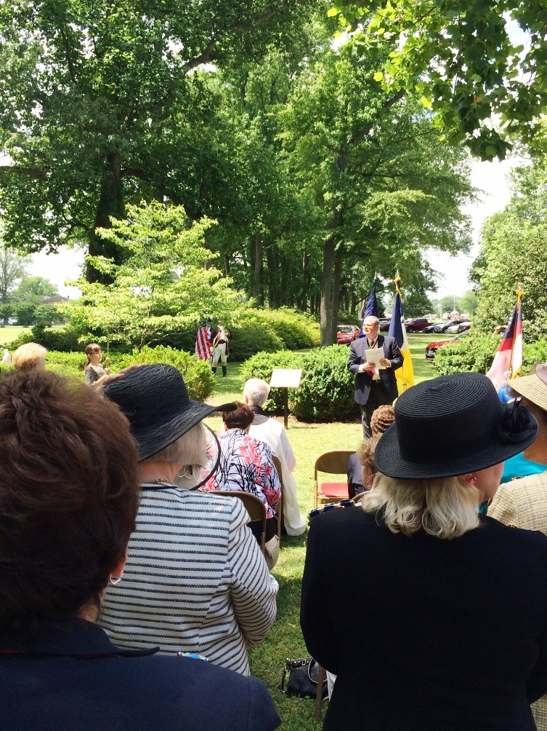
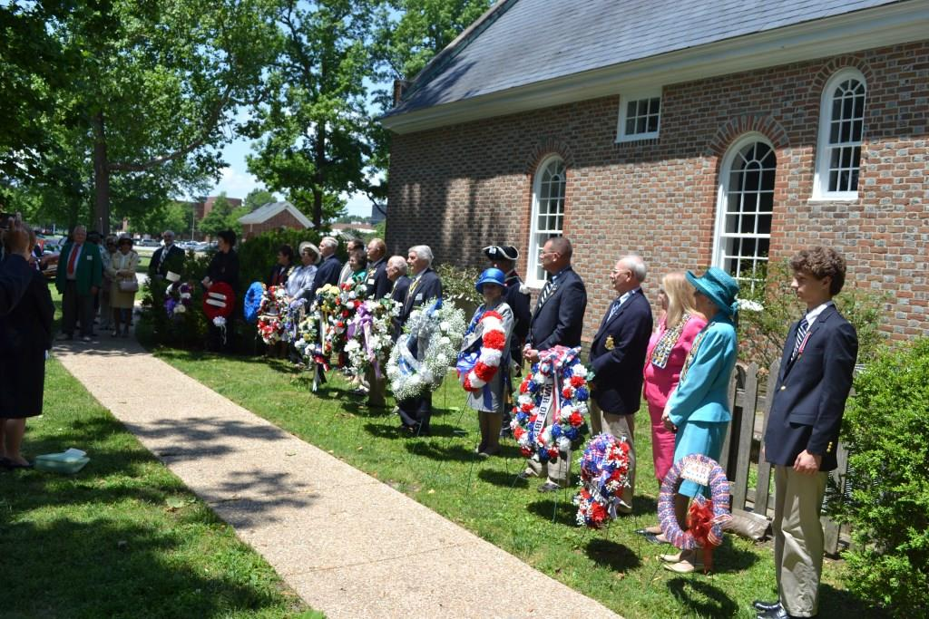
Above is a photo of the wreath presenters Below is James M Green and Stuart L Butler who represented our Society
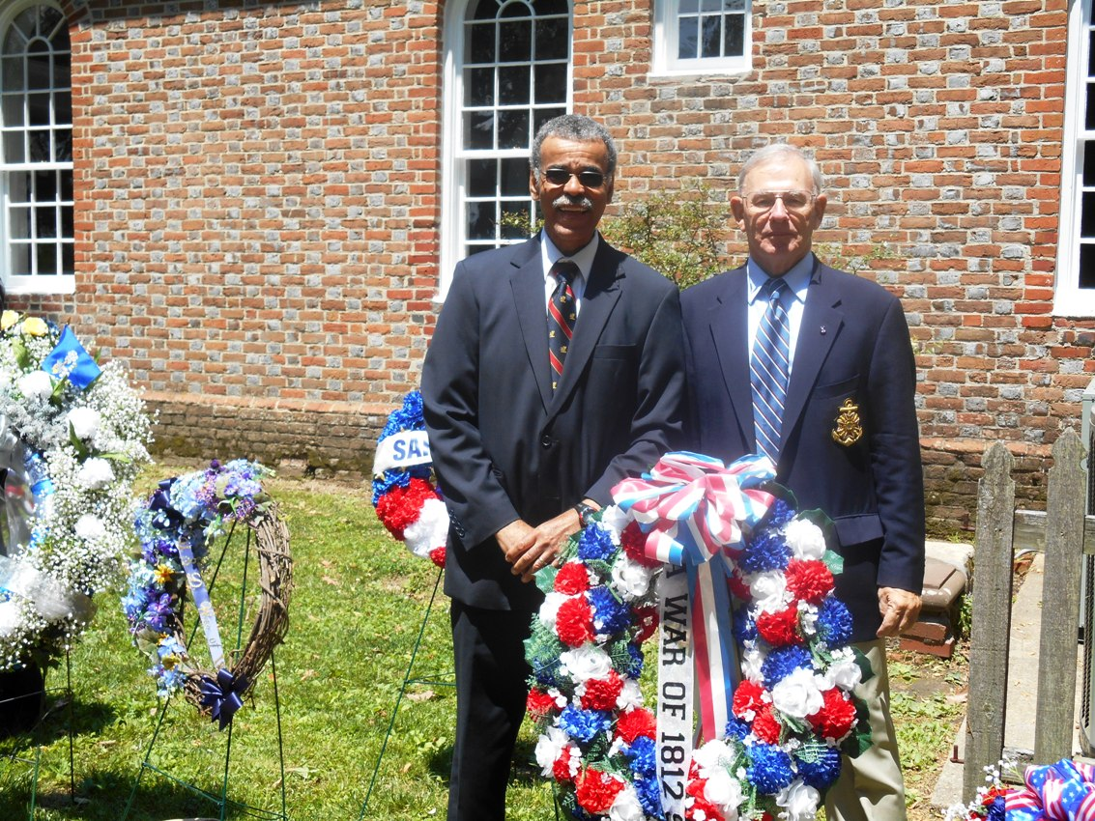
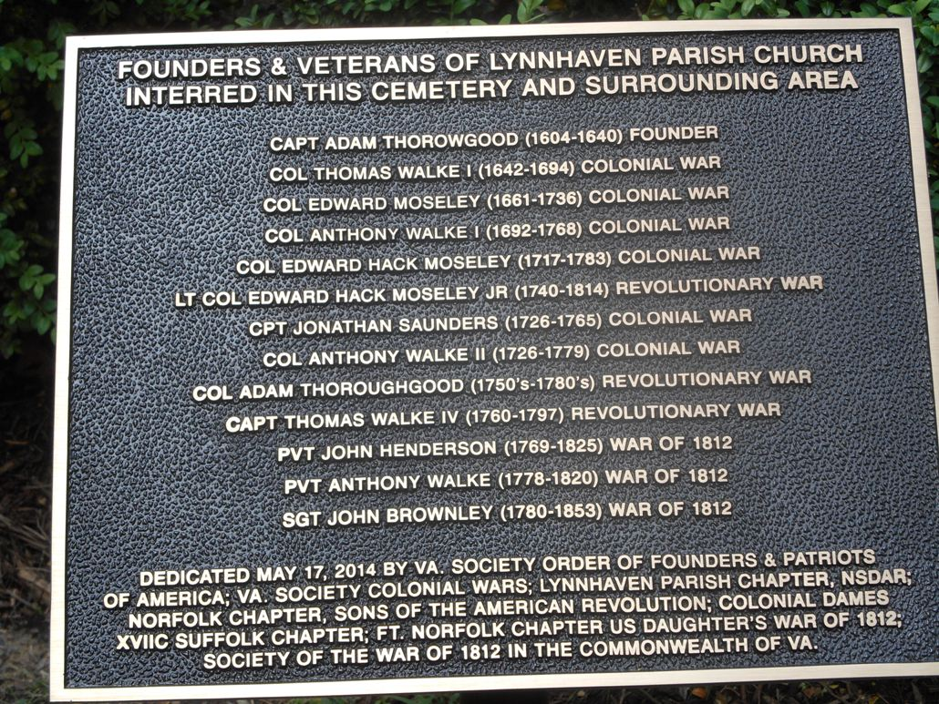
Above is a photo of the plaque that was unveiled at the ceremony
From the website of the church is found information about the church and the important people buried there, many of which were honored in the ceremony
This is the history of Lynnhaven Parish Anglican/Episcopal Church and its people, today known as Old Donation Church. From its earliest seventeenth century beginning in a wilderness area populated by mostly Native Americans to the eighteenth century “Golden Age” with its prosperous Virginia gentry to an abandoned burned out church in the woods with no services for over fifty years, Old Donation has managed to rise like a phoenix from the ashes.
The Church was originally established as Lynnhaven Parish Church. The word “Donation” was informally added after 1776 when the last colonial rector, the Reverend Robert Dickson donated land to the church to continue the funding of his boys’ orphanage. “Old” first appeared in the Vestry Record in 1822, when the vestry ordered that the “church called ‘old Donation Church’ be put in repair.” Old Donation is included on the National Register of Historic Places and is one of the stops on the Bayside History Trail. Today Old Donation Church stands as the oldest Episcopal Church in Virginia Beach.
The congregation built three churches: the first completed in 1639 at Church Point (Lynnhaven Parish Church No. 1), the second in 1692 on the West Branch of the Lynnhaven River (Lynnhaven Parish Church No. 2), and the third was completed in 1736 near the second building (present day Old Donation Church). Services ended in the early 1840’s as congregants switched to the more populous Kempsville Emmanuel Episcopal Church. The abandoned church caught fire in 1882 destroying the roof and part of the walls. Thurmer Hoggard IV (1819-1902), who attended services at Old Donation as a boy organized annual pilgrimages to the Old Donation's burned-out remains in the 1890’s. Then in the early 1900’s Reverend Richard J. Alfriend (1860-1923) began holding more frequent outdoor services in good weather and in the nearby Bayside School during inclement weather. By 1913 Reverend Alfriend was able to build a small membership (after a lapse of 57 years) at the newly completed parish house built prior to the 1916 re-construction of the burned-out church. From then through the Second World War the church struggled. Ann Parks in an Oct 4, 1987 Virginian Pilot’s “Beacon” article remembered Old Donation Church in the 1920’s when Sunday services were lucky to attract twenty-five. She said the church was very poor and the women of the church made preserves to raise money. In 1953 Reverend Tucker counted just 78 actual members. When he left in 1984, the congregation had more than doubled, and by the end of 2011 the membership had grown to over 800 with as many as 400 present on Sundays, and a 100+ member day school with children ages 2 to 6. Much of the latest surge in membership can be attributed to the current Rector, Reverend Robert J. Randall. Since his leadership began in 2004, the church has seen a dozen new programs started (see “Modern Activities History – Chronology” in this article).
Today Old Donation Church is full of life, providing abundant activities, and supporting and participating in over 20 different outside ministries. As an Episcopal Church, Old Donation Church belongs to the American branch of the Anglican Communion which has its roots in England after the time of the Reformation and break from the Roman Catholic Church. Old Donation Church retains the Catholic sense of sacraments and worship with a reformed Protestant sense about the importance and role of the Holy Scripture.
The Reverend John H. Emmert, Rector of Old Donation Church from 1985 – 1996 wrote the following; “The Judeo-Christian tradition has as its cornerstone the belief that God works in history. God has evidently seen fit to draw this congregation along in His providential care – blessing, guiding, prodding, chastising, leading. How could the congregation be here without Adam Thoroughgood, Robert Dickson, the Hoggard family, Richard Alfriend and a host of others, known and unknown? Would God have raised up others if it had not been for these?” (References 25, 127, and 197).
__________Milestone Dates of the Church__________
May 17, 1637. Captain Thoroughgood summoned Reverend William Wilkinson to hold the first services in his first home, a crude wooden structure on the shore of the Chesopean River (renamed Lynnhaven by Adam), a location on the edge of what is now Lake Joyce in Baylake Pines (Reference 1 – page 37).
1639-1640. Upon completion of church No. 1 at Church Point in 1639, Adam commissioned Reverend John Wilson to hold services, but he died less than a year later followed closely by Adam’s own death at the early age of 36 in Feb 1640.
Aug 3, 1640. The first Vestry is appointed. Thomas Todd and John Stratton are elected church wardens.
Sep 6, 1667. The dreadful hurricane of 1667 struck, which would eventually cause the waters of the Lynnhaven River to erode Church Point and undermine the foundation of Church No. 1.
Jun 1692. Church 2 was completed (to be known as the Brick Church or Mother Church). The new location was on two acres of land sold by Ebenezer Taylor, paid for in 1694 with 1,000 pounds of tobacco.
Jul 10, 1706. A jury from the church Vestry ordered Grace Sherwood (known as the Witch of Pungo) to a trial by ducking.
Mar 2, 1736 Anthony Walke put a motion before the Vestry “that the old church [church 2] would be a convenient place to make a public school for instructing children in learning and for no other use or purpose whatsoever.” The school was operated by the church as late as 1819.
Jun 25, 1736. Church No. 3 (present church) was received by the vestry from Peter Malbone, the builder.
Feb 14, 1777. Shortly after Reverend Dickson’s death his will was admitted on record donating his home, slaves, and more property to the church to be used to support and continue his free school for orphan boys in Church No. 2. The gifted property was called “Donation Farm,” but the term “Old Donation Church” did not appear until a Vestry Record entry in 1822 used that term to order that the “church called ‘old Donation Church’ be put in repair”
Oct 11, 1916. Christening ceremonies of the rebuilt church were held, a cornerstone was laid, and in it a time capsule was placed.
Dec 19, 1926. The First Christmas Pageant was held and has been held ever since on the Sunday evening before Christmas.
Nov 24, 1934. The First Oyster Roast was held and has been held ever since on the Saturday before Thanksgiving.
____________________Today - Three Separate Single Story Buildings
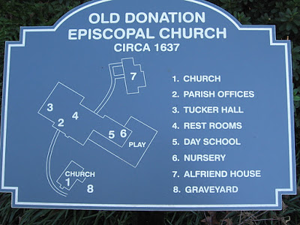___________A plaque in front of the Parish Offices shows locations of the three buildings.
The Historic Church is listed as number 1 (above) and is referred to as Church No. 3 in this document since three churches were built; i.e., No. 1 at Church Point built in 1639, No 2 built in 1692 at a location between the Parish Building (noted as numbers 2-6 above) and Alfriend House, and No. 3 - the present church built in 1736.
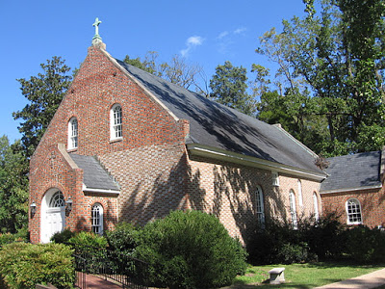1. The Historic Church. Old Donation Church, constructed in 1736, is a good example of colonial ecclesiastical architecture which combined elements of the first crude shelters in Jamestown with Early Georgian style. The rectangular 34 by 68 foot brick building was laid in Flemish bond, created by alternately laying headers and stretchers in a single course. The influence of Georgian architecture is evident with use of horizontal lines and rounded window headers and a slate-covered hipped gable roof. An altar and reredos are centered in the chancel with a communal rail separating the nave where the congregation is seated. Major renovations and structural reinforcement were completed in 1960 when five interior tie rods at the ceiling line were installed to stop outward wall thrust and again in 1966 after much deterioration had occurred due to termites, crumbling concrete floors, and pews that sorely needed replacement. The old floor was found to be sloped six inches between side walls causing the north wall windows to become six inches higher from the floor than the south wall windows after the floor was leveled. The 1966 renovations also included the return of the church to its original Colonial “Prayer Book” design (the 1916 rebuilding reflected the then popular Gothic chancel design) by moving the choir and organ up to the balcony, adding kneelers, and relocating the lectern and prayer desk adjacent to the pulpit. The primary focal point at the head of the church is a 9 by 15 foot high solid wood reredos, a 1916 gift from Norfolk St. Paul's Church. On it are the Ten Commandments and at its top is the Hebrew word “Yahweh” or “God.”
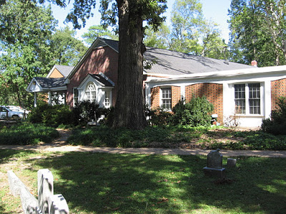2. Parish Building. Built between 1954 and 1991, this is a single story 15,853 square foot facility with class rooms for preschool children, a library, church offices, and a multipurpose room (Tucker Hall) for meals, services, and gatherings.
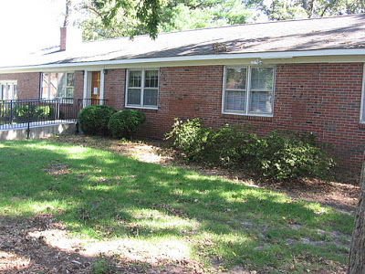3. Alfriends House. Built in 1957, this single story 2,422 square foot facility used to be the Rectory Residence but is currently used for Sunday School and meetings (References 5, 31, 64, and 179).
___________________________The Land____________
In 1634 King Charles II of England directed the formation of eight shires (counties) in the colony of Virginia. In the fall of that same year Adam Thoroughgood, the father of Lynnhaven Parish Church, moved from Kecoughtan (today’s Hampton) to his 5,350 acre estate, on the other side of the James River, to a location beside the Chesopean River which he renamed the “Lynnhaven” after the town in England where he grew up (Grimston-King's Lynn, Norfolk County, England). He is also given credit for naming New Norfolk county, and the James River after King James I of England. In 1691 Lynnhaven Parish became part of Princess Anne County, and in 1952 Virginia Beach was carved out of Princess Anne County as an independent city. In 1963 the lands left as Princess Anne County were incorporated into Virginia Beach (References 32, 33, and 114-pg 246).
__________________________Chapter 2 - The Chronology
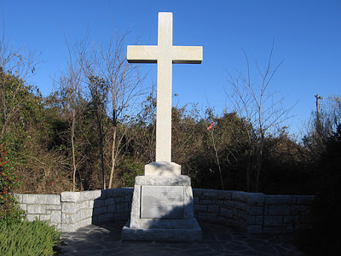This cross is located inside Fort Story at the mouth of the Chesapeake Bay. It reads, “Here at Cape Henry first landed in America, upon 26 April 1607, those English colonists who, upon 13 May 1607, established at Jamestown, Virginia, the first permanent English settlement in America. Erected by National Society Daughters of the American Colonists April 26, 1935.”
1607 - Anglicans and Oysters. Reverend Robert Hunt held the first Anglican service at Cape Henry in present-day Virginia Beach on 29 April, 1607. A granite cross was erected in 1935 to commemorate this historic occasion. After this first Anglican Christian service in Virginia, one of the first Anglican Christian Churches in Virginia (Lynnhaven Parish) would be built. Also of significance, these 104 men who sailed from England on the Susan Constant, Godspeed, and Discovery found natives roasting oysters and found them to be delicious. That April day would not only plant the seeds for a church, but also most likely the seeds for the Old Donation Church’s annual Oyster Roast, with both the oysters (Lynnhaven) and the church (Lynnhaven Parish) becoming celebrated. Old Donation’s yearly Oyster Roast held the Saturday before Thanksgiving, had its formal beginning in 1934, but from all indications, an informal roast goes back possibly as far as the church itself. Rufus Parks, member and later Church Lay Reader in the early 1920’s, invited Old Donation congregants to his home for oyster roasts just a mile north of the church, overlooking Witchduck Bay. He most likely inherited this tradition from his next door neighbor Senior Warden B. Dey White who had held an annual oyster roast at his estate down by Witchduck Bay, a tradition he certainly most likely acquired from C. M. Barnett (a member of the Vestry) who held oyster roasts for Lynnhaven Parish in the early 1900’s at his home (now Ferry Plantation House) near the church. And so it goes, a tradition most likely handed down from one generation to the next going back as far as that early landing party in 1607 that saw the natives roasting those famous Lynnhaven Oysters (References 16, 28, 47, 52, and 122).
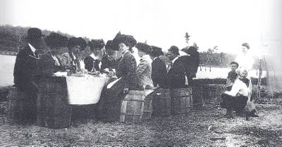 1909 - One of many Oyster Roasts held by Charles and Stella Barnett at their Ferry Farm Plantation Home facing the Lynnhaven River.
1634 - the Lynnhaven River. The Native Americans called the river the Chesopean. In the fall of 1634 Captain Adam Thoroughgood moved to the shores of the Chesopean and built his first crude wooden home on the river at a location that is now Lake Joyce in Baylake Pines. Mr. Floyd Painter in April 1955, while searching for Indian sites and artifacts, discovered Adam’s first wood house on Battery Road in Baylake Pines. His first house was situated a distance of about two miles from Church Point, the location of Lynnhaven Parish Church No. 1. Being from the town of Grimston-King's Lynn, Norfolk County, England, Adam renamed the river after his hometown. In 1634 the entrance from the Chesapeake Bay was not at today’s Lynnhaven Inlet, where the Lesner Bridge stands, as that location was occupied by a huge sandbar forcing the river to take a westward course. The river either emptied into the Chesapeake Bay at the edge of what is now Lake Joyce in Baylake Pines or further west at Little Creek. According to Benjamin Dey White, in his 1924 book “Gleanings in the History of Princess Anne County,” Lake Joyce formed the mouth of the Lynnhaven River. However, a map by Gen. Benedict Arnold’s engineers made in 1781 denotes the early flow of the Lynnhaven River to be two miles further west to Little Creek. Whatever the mouth of the Lynnhaven, in 1634 travel on Lynnhaven was arduous, as the first several miles of the river were quite shallow, and at Church Point, now a half-mile wide, the river was narrow.
The story of Lynnhaven Parish Church has its roots in the Lynnhaven River. Notable people, important to Lynnhaven Parish and to local government, lived along the shores of the river, and, along with other congregants, came to church mostly in boats. When the first church foundation was eroded by the river in the late 17th century, the congregation moved their church one and a half miles up the western branch of the Lynnhaven. Folks who come to hear about the history of the church usually ask about the Church’s most infamous member, Grace Sherwood, the Witch of Pungo, who was ducked in the Lynnhaven River for witchery. The river has seen much - Native Americans, pirates, and slaves, but there could be nothing more grounded in the heart and soul of the river than the people of Lynnhaven Parish Church (References 103-f, 155, and 156).
1637-1645. (Church No. 1). Adam Thoroughgood (1604-1640)shaped the area by leading the Lynnhaven residents in politics and in religious matters. Gathering citizens of the little Lynnhaven community, Adam Thoroughgood summoned Reverend William Wilkinson (1612-1663) to hold services in his crude wooden home on Sunday May 17, 1637. Assembling at this first service were local residences Thomas Keeling, William Kempe, Thomas Willoughby, Henry Seawell, and Henry Woodhouse. Reverend Wilkinson gave up his duties as priest less than a year later.
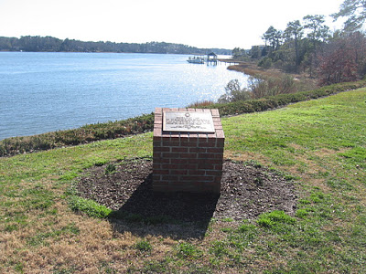This monument at Church Point on Spring House Trail (looking west up the West Branch of the Lynnhaven River) reads, “Church Point – 1639. Near this site Lynnhaven Parish was built in 1639. The church and its graveyard were the victims of erosion by the waters of the Lynnhaven River. Among gravestones found were those of Adam Thoroughgood and his wife Sarah, and her last two husbands, John Gookin and Francis Yardley. Presented by Suffolk Chapter Virginia Society, National Society Colonial Dames XVII Century 1995.”
Envisioning a town at Church Point, Adam in 1638 spearheaded the construction of Lynnhaven Parish Church No.1, a glebe (rectory), and court house; and in the next year a more substantial house for his wife and four children. Because Virginia Governor Wyatt had ordered all plantation homes sitting on 500 acres or more to be constructed of brick, all four structures were most likely built with brick. A newspaper article dated July 16, 1950 states, “the first Lynnhaven church, a brick building, was erected on Adam Thoroughgood’s land at what is now known as Church Point.” Furthermore, George Carrington Mason, a church historian, noted that remains of the Lynnhaven Parish Church were still visible as a mound of brick in 1850. Upon completion of the church in 1639, Adam commissioned Reverend John Wilson to hold services, but he died less than a year later followed closely by Adam’s own death at the early age of 36 in Feb 1640.
Seven months later on August 3, 1640, the first vestry was appointed. Those named in court minutes were Edward Windham, Henry Woodhouse, Bartholomew Hosskine, Thomas Todd, Christopher Burroughs, Thomas Bullock, Thomas Caussonne, Ensign Thomas Keeling, Robert Hayes, and John Lanckfield, along with Thomas Todd and John Stratton as churchwardens. Adam’s house(which remains standing today at 1636 Parrish Road Virginia Beach, Virginia) was completed after Adam’s death by his widowed wife Sarah in 1645. At present, a plaque commemorating the first Lynnhaven Parish Church is situated near the waterfront park at Church Point (see picture above). The Mayor and City Council of Virginia Beach have appointed May 20th of every year as Church Point Day.
Captain Adam Thoroughgood, the Father of Lynnhaven Parish Church, and Sarah Thoroughgood-Gookin-Yeardley, the Mother of Lynnhaven Parish Church, along with their small band of English settlers, would leave an indelible imprint on the history of early Virginia Beach (References 1- pages 31, 37, and 42; 2; 19; 20; 27; 34; 52; 103c; 108; 110-page 37; 114 – pages 251 and 264; 180; and 196).
1635-1692. Parish Survival Leads to Close Relationships. In 1635 the lands of Lynnhaven Parish were still wilderness with large tracts of land owned by each settler, most of them coming from England as indentured servants. They worked hard forging a society modeled as closely as possible to the one they had left in England, setting up the same class distinctions and Anglican traditions. Tobacco culture dominated, but most landowners produced only a small quantity as its cultivation required numerous manual operations and labor beyond that of one’s own family if more than a few acres were planted. The most successful Lynnhaven Parish planters invested their tobacco profits in additional lands and laborers rather than in pretentious life styles. Gradual prosperity would be manifested in rooms added to existing homes that began as simple two-room structures. High rates of death during childbirth and other misfortunes caused the colonists to rear large families. No widow was a widow for long as they were paraded in front of eligible bachelors and, if not by mutual attraction, they were coerced by the Lynnhaven Parish Senior Church Warden and other church members to quickly choose a new husband. History shows that every woman, except two, obliged. One was way ahead of her time in having power that few women during that period welded (Sarah Thoroughgood), and the other befell a terrible fate in the Lynnhaven River (Grace Sherwood). Therefore, by 1692 just about everyone in Lynnhaven Parish was related.
The colonists had many hazards to overcome including wolves, nor'easters, droughts, hurricanes, floods, and intermittent pirate skirmishes.
* Wolves were in abundance, killing many farm animals. The court ordered a bounty of 50 lbs of tobacco for each wolf killed that was soon raised to 100 lbs as the wolf population grew.
* Native Americans. In 1639 the Native American population outnumbered the colonists by 4 to 1 with intermittent attacks by the Pumunkey and Menticoke tribes. When several plantations in isolated areas were attacked and settlers massacred, Captain Thoroughgood led 15 men against the Menticoke Indians in a harsh retaliation on July 17, 1639.
* Pirates. The settlers in Lynnhaven Parish suffered what might have befallen the original Jamestown settlers if they had not been ordered by King James I to locate up the James River, safe from possible attacks by pirates, French, Spanish and Dutch ships. The pirate Capt. Kidd had his rendezvous on Pleasure House Creek, then part of the Lynnhaven River. The English pirate Edward Teach (1680 –1718), better known as Blackbeard, buried some of his treasure in the sands of a hill near Cape Henry. In 1669, the ship Maryland Merchant, while anchored near the Lynnhaven River was seized and plundered by an unknown vessel carrying thirty guns and a large crew. Lookouts were established along the shore for all suspicious vessels, and later all ships coming to Virginia were provided with cannon and men trained to shoot them. In 1684 the English Government furnished a ketch for the protection of the Virginia coast, but in spite of the Governor’s instruction to the naval officers to capture Capt. Kidd, he openly walked the streets of Norfolk.
* The Weather. In 1649 a severe storm destroyed a large quantity of tobacco, but this was small in comparison to the storm of 1667. Ironically, a month before the storm, Adam Keeling, whose plantation was situated east of Captain Thoroughgood’s property just east of today’s Lesner Bridge, organized a group of people to dig a small pilot channel from the Lynnhaven River through a huge sandbar about a half-mile long to the Chesapeake Bay so boats would not have to make the long journey west to the mouth of the river. A month thereafter, on September 6, 1667, the dreadful hurricane of 1667 struck, a storm considered one of the most severe hurricanes to ever strike Virginia. The hurricane devastated the Lynnhaven area as no other storm has ever done. The 1667 hurricane lasted about 24 hours and was accompanied by very violent winds and tides. Approximately 10,000 houses were blown over. Area crops (including corn and tobacco) were beat into the ground. Many livestock drowned in area rivers due to the twelve foot storm surge. The foundation of the fort at Point Comfort was swept into the river, and a graveyard of the First Lynnhaven Parish Church tumbled into the waters. Twelve days of rain followed this storm across Virginia. This system was blamed for enlarging the small pilot channel dug the month before to the size of an inlet and re-routing the river permanently. The new channel flow eventually eroded Church Point and undermined the church foundation. Five years later during the winter of 1672-73 another catastrophe hit the small Lynnhaven Parish when an unusually severe cold spell with hail and wind killed half the small herds of cattle left from the storm of 1667 (References 1- page 32; 8; 24; 103d -page 3; 104; 105; 114 - page 259; and 145).
1655. Witchcraft. Lynnhaven was caught up in one of darkest periods of seventeenth-century history, the persecution of witches. Women suspected of being witches were subjected to trial by water. The earliest known accusation of witchcraft in Lynnhaven Parish showed up in a court order of May 23, 1655. Ann Godby was ordered to pay 300 pounds of tobacco for slander for accusing Nicholas Robin’s wife of witchcraft (Reference 1- page 59).
1689-1755. Chapel-Of-Ease Churches. These crude church buildings were built within the bounds of Lynnhaven Parish for the attendance of those who could not reach the Lynnhaven Parish church conveniently. The first Eastern Shore Chapel-of-ease was built near present day First Colonial Road on a bank of the East Lynnhaven River. This chapel-of-ease and others to follow were served by "duly licensed" clerks. Eight chapel-of-ease churches were built: Seawell’s Point (1642), Elizabeth River (1666), 1st (1689), 2nd (1726), and 3rd (1755) Eastern Shore, and 1st (1692), 2nd (1739), and 3rd (1774) Pungo. Of the eleven churches built (eight chapel-of-ease and three Lynnhaven Parish churches) only one original building is standing today, i.e., Old Donation Church. When the 3rd Eastern Shore Chapel was condemned and disassembled in 1952, the congregation built a new Eastern Shore Chapel on Laskin Road, conforming as much as possible to the blueprints of the old structure (References 21, 44, and 114 pages 243-252).
1692-1695. Church No. 2 is Built. By 1692 tides and severe storms pouring in through the open channel near the church had caused the lands around the church to erode. First the cemetery collapsed into the river, followed by the undermining of the church foundation. Instead of rebuilding near the same location, the congregation decided to move from the mouth of the Lynnhaven River and the Chesapeake Bay further up the Lynnhaven River for a number of reasons: (1) movement of the population center further up the Lynnhaven River, (2) lack of protection from the British Navy against pirates, (3) Native Americans raids, and (4) severe storms. The vestry approved the building of a new church (Lynnhaven Parish Church No. 2) which was completed in June 1692 (to be known as the Brick Church or Mother Church) but not before the Lynnhaven River overcame Church No. 1. Services had to be held elsewhere for a little less than a year. The new location was on two acres of land sold by Ebenezer Taylor, paid for in 1694 with 1,000 pounds of tobacco. No. 2 was situated on the West Branch of the Lynnhaven River at the end of Cattail Creek (Cattayle Branch on old maps) in a location adjacent to Ferry Plantation known as Church Quarter. Church No. 2, built by Jacob Johnson, was specified to be 45 feet in length and 22 feet in breath between walls with a 13 foot ceiling and wainscot pews. A large rock with a brass plaque stands at the doorway of the Day School (Parish Building) telling about the history of Church No. 2. (References 2, 52, and 1- pages 36 and 39).
1735 - On January 3rd, just as five hundred colonists anchored in Lynnhaven Bay, a storm arose and the ship was driven ashore. Two-thirds either drowned or froze to death.
1695 - 1750. The Courthouses. The association between the colonial church and courthouse was always very close, and they were frequently built on adjoining sites. Adam Thoroughgood started the town of Lynnhaven with a church (church no. 1), a Glebe [rector’s house], and a courthouse. In 1660 a second courthouse was erected on Thomas Harding’s plantation at Broad Creek off the Eastern Branch Elizabeth River, and in 1689 the justices authorized the construction of two more courthouses, one in the town of Norfolk. For the other, Adam Thoroughgood’s grandson, Argall, obtained a court order for it to be built on Edward Cooper’s land near the first Eastern Shore Chapel. Then after Lynnhaven Parish Church No. 2 was completed in June 1692, in accordance with custom, the Eastern Shore Chapel Court House was torn down and moved by boat adjacent to Church No. 2. This courthouse, in which the famous Grace Sherwood was adjudged a witch, was torn down in 1735 to make way for construction of Lynnhaven Parish Church No. 3, and was rebuilt a mile away at Ferry Farm Plantation (References 1- page 36, 44- page xiii, 52, 74-page 109, and 155).
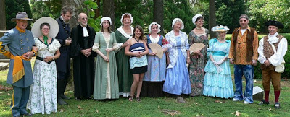June 2011 - At Feast Day, the 275th anniversary celebrating the completion of Church 3 (the current church), members of the Historic Traditions Committee dress in period costumes representing each of the four centuries the church has been in service.
1733-1736. Church No. 3 is Built. On November 13, 1733 the vestry ordered the Brick Church (No. 2) be abandoned and Church No. 3 built. This entry in the vestry records probably does not imply that services could no longer be held in the Brick Church (as they did until March 2, 1736) but simply that the Brick Church had reached a “dilapidated state” for a congregation that had progressed in wealth and social status. The new church, 628 sq ft larger than Church No. 2, was received by the vestry from Peter Malbone, the builder, on Friday, June 25, 1736. The three years it took to build Church 3 was in part due to the fact that the bricks were sent from England and the timber was hand hewn from trees felled near the spot. There is a brick to the right of the front doorway with the date inscribed (References 73 & 6-pgs 274-276).
1736-1776. The Church Prospers. The eighteenth century was referred to as the “Golden Age,” a time of prosperity and economic growth. Lynnhaven Parish Church served as the “Mother Church” of a rich and aristocratic parish exclusively from English ancestry making up almost half the population, with a quarter of the population being slaves and a quarter Native Americans. Tobacco was king, and horseback riding and fox hunting were the predominant sports. The church prospered under the Reverend Henry Barlow (serving for 18 years) and then Reverend Robert Dickson (serving more than for 27 years). During this colonial period Lynnhaven Parish Church was more of a social institution than a religious one, and Sundays provided the occasion to socialize and transact business. Services were long and held only every other week as some had quite a distance to travel, the fastest way being by water. Being part of the Church of England, Lynnhaven Parish Church was supported by taxation, and the church vestry set tax rates and collected the money, usually in the form of tobacco. Beginning in the 1730’s Presbyterians and Baptists began to protest the tax and steal away poorer church members into their primitive churches while railing against the easy life of the Lynnhaven Parish Church gentry. By the 1760’s a number of Lynnhaven Parish Church members found themselves in debt due to their luxurious and extravagant way of living (References 65 and 41- page 248).
1776–1856 – Demise of the Church. After the Revolutionary War (1783) the Protestant Episcopal Church of the U.S. took the place of the Church of England. With the British government no longer welding its Anglican authority over Americans, the church lost its tithing tax and the practice of younger sons entering the ministry or purchasing a commission in the army or navy. Without the protection of English church laws, new denominations drew people away from the Episcopal Church, and since there were no longer any bishops in the colonies to fight for the church, Princess Anne County confiscated some of the county's oldest historical Episcopal church properties after the church membership had faded away.
After Reverend Dickson (1776) stepped down, Lynnhaven Parish Church had no regular ministers for 45 years and subsequently church membership began a slow decline and the building deteriorated. On November 28, 1821, at a meeting chaired by Thurmer Hoggard (the first entry in the vestry records since 1813), the Reverend Robert Prout was elected rector and long overdue repairs commenced. Lynnhaven Parish Church with a membership of about 80 was still the center of Protestant Episcopal worship in Princess Anne County, but for the next 35 years, Princess Anne’s population center gradually shifted to Kempsville on the banks of the Elizabeth River, a far superior channel over the silting up Lynnhaven. On March 11, 1843 Reverend John G. Hull was forced to resign because of his failing health, but so entirely devoted was he, congregants refused to accept his complete resignation and insisted that he continue by going from house to house. Despite poor health, not only did he travel the distances between large farms, but he also managed to help build Emmanuel Church in 1843, a little brick church in Kempsville, and by 1856 Emmanuel Church had drawn away the remainder of the Old Donation’s Church congregants. Old Donation Church (name changed in 1822) Vestry Minutes closed with a notice of a meeting held in March, 1856 when William P. Morgan, John S. Woodhouse, Solomon S. Keeling, AG Tebault, and William C. Scott, qualified as vestrymen, signed the minutes for the last time.
In 1855 Author Bishop William Meade (1789-1862) wrote about the former and vibrant Lynnhaven Parish, “Our Prospects in this parish are now and have been for a long time discouraging. Formerly this was one of the most flourishing parishes in Virginia. Many circumstances have occurred to promote its declension. In my early youth I remember to have heard my parents speak of it as having what is called the best society in Virginia. The families were interesting, hospitable, given to visiting and social pleasures. The social class, the rich feast, the card-table, the dance, and the horse-race, were all freely indulged in through the county. And what has been the result? I passed through the length and breath of this parish more than twenty years ago, in company with my friend, David Meade Walke (1800 – 1854), son of the old minister of the parish (Reverend Anthony Walke), who was well acquainted with its past history and present condition, and able to inform me whose were once the estates through which we passed, and into whose hands they had gone; who could point me to the ruins of family seats which had been consumed by fire; could tell me what were the causes of the bankruptcy and ruin and untimely death of those who once formed the gay society of this county. Cards, the bottle, the horse-race, the continual; feasts, - these were the destroyers. In no part of Virginia has the destruction of all that was old been greater. But let us hope for better things, and strive for them by the substitution of honest industry for spendthrift idleness, of temperance for dissipation, of true piety for the mere form of it. Some excellent people, doubtless, they always were. Their number has increased of late years. Some have I known most worthy of esteem. May God strengthen the things that remain, though they seem ready to perish!” (References 6-page 284, 9, 41-pages 249- 252, 46, 115-page 69).
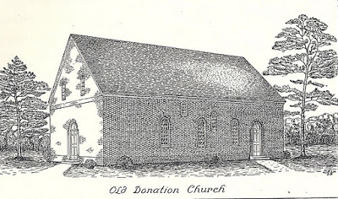Church 3 is depicted here prior to the 1882 fire and sometime after 1767 when the side door was moved about eight feet from the end of the long south wall to its present location. The entrance narthex and side sacristy were added during reconstruction in 1916.
1882 - The Fire. Abandoned for services in 1856 the church fell into a state of disrepair. Finally the sides buckled and the roof caved in. Then a woods fire burned most of the church in 1882. The roof and part of the walls were destroyed (Reference 195).
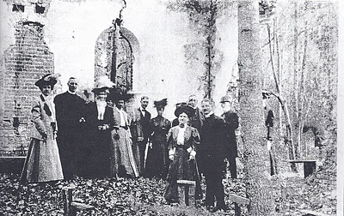1901 – Congregants pose for a picture after a memorial service in the ruins of Old Donation Church. Standing in the foreground are Licia Williamson and Dr. F.C. Steinmetz (Rector of Christ Church). From left to right in the background are Lulie Sharpe, Reverend J. Alfriend, (unknown), Mary Wilson Hoggard, Benjamin Dey White, Fanny Hoggard, Dr. David W. Howard, and (unknown).
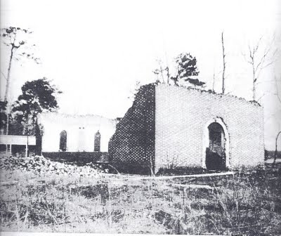This picture was taken sometime before the church was rebuilt and is a view of the north front corner. Stables used by past parishioners remained and can be seen in the rear of the church.
1882-1912 - Rescue of the Church. The Commonwealth of Virginia passed a law that churches and chapels formerly owned by the Church of England and not used within a calendar year reverted to the ownership of the Commonwealth. After the vestry held their last meeting in March, 1856, there was so much love for the abandoned old church that different folks from Emmanuel Episcopal Church made annual pilgrimages to the church to hold services. This might have included Reverends John G. Hull, Lewis Walke and N. A. Okerson, and possibly others. In 1882, after the fire had all but destroyed the church, Reverend Thurmer Hoggard IV (1819-1902) took over this responsibility. As a loyal Episcopalian and young man he had worshiped at Old Donation in the early 19th century and kept alive a dream of restoring Old Donation. After Hoggard’s death in 1902 his son and two daughters Mary and Fannie Hoggard continued annual services. Shortly afterwards Reverend Richard J. Alfriend (Oct. 1 1860 - Jan. 6 1923), a lay reader from Kempsville Episcopal Church, built on the Hoggard family’s success by continuing these annual services until 1912 when he was ordained as Rector (References 1–page 95, 44, 75 and 255).
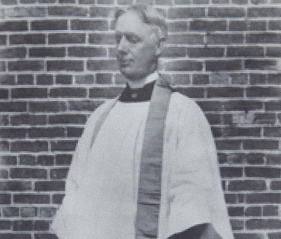________________________________ Reverend Richard Alfriend
1912-1916 - The Church is Rebuilt. Reverend Richard Alfriend began to build a new congregation as plans for restoration of the burned out church got underway. Mrs. Jeb Stuart, widow of the famous Confederate general, started the building fund with a donation of one dollar. Even before re-construction commenced, Reverend Alfriend led the small congregation in services on the church grounds in good weather and in nearby W.E. Biddle School during inclement weather (located near the intersection of Independence Blvd and Haygood Rd). Sometime in 1913 a saw mill was erected near the ruins of Old Donation, and huge trees that had grown up within the walls of the church were cut up and the lumber used to build a parish house and horse sheds (where Tucker Hall now stands). The below picture dated 1913 shows the parish house with two cars and two buggies (one hitched to a horse) in front.
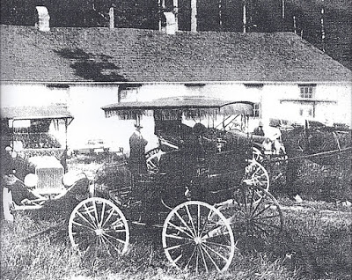After the erection of the parish house in 1913 services were held regularly indoors. By 1914 membership had grown to 50. Through the enthusiastic and tireless efforts of Reverend Richard Alfriend and Judge Benjamin Dey White, Senior Warden, plans went forward for reconstruction. Slade, C. M. Barnett, a member of the Vestry, and Judge White secured the necessary $7,000 when they traveled to New York in 1915 to borrow money from bankers. Mr. Barnett had connections there as his business was the shipping of the famous Lynnhaven Oysters to New York’s Waldorf Astoria Hotel and Grand Central Station. By May 15, 1916, at a re-consecrated or dedication ceremony, repairs were well under way and completed October 11, 1916 when the Church’s cornerstone on the northeast corner was laid. On May 15, 1918, the church held a consecration ceremony after the notes to the bankers in New York were paid off. Included in the rebuilding of the church was the addition of the narthex (10 by 12 foot vestibule entrance) and sacristy (16 by 14 foot services and storage area for altar vestments, linens, and other essentials for communion). One can tell the 1736 bricks from the new bricks by the color on the outside of the church. The restoration included a large chancel area around the altar for the choir, the only Gothic characteristic. The choir would be relocated 50 years later to the balcony. Four stone plaques on the walls of the church honor those members who worked to restore the church, i.e., May Etta Belle Fentress, George H.H. Woodhouse, Josiah Woodhouse, William Etheridge Biddle, B.D. White, M. Absalom, W.S. Fentress, S.F. Slade, C. M. Barnett. Included are the architect, J.W. Lee and builder, C. O. Sherwood (References 1-pg 96, 2, 3, 35, 52, 60, 61, & 64).
1916 - The Cornerstone and Time Capsule. At christening ceremonies of the rebuilt church on October 11, 1916 the cornerstone and a time capsule were laid. The gleaming white cornerstone of Old Donation Church hidden in the azaleas at the northeast corner of the old church has this inscription:
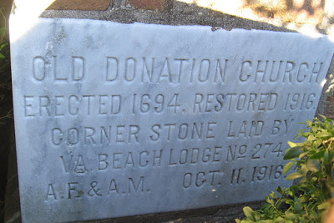[Note] The 1694 date is incorrect and should read 1692. Confusion arose from the fact that the deed (Deed Book 1, page 68, Virginia Beach Circuit Court) transferring the property clear of debt to the Lynnhaven Parish Church Senior Warden Eban Ezer Taylor was dated September 5, 1694, two years after construction was completed.
The Ancient Free & Accepted Masons were invited to conduct the service. At the appointed time, the freemasons (possibly Judge White) began the ritual. Complete with elements of wine (the Wine of Refreshment), oil (the oil of Joy and Gladness) and corn (the corn of Nourishment), the participants followed the elaborate and formal readings. At the setting of the stone, the following passage appears: “Most Worshipful Master: It has ever been the custom of the craft on occasions like the present to deposit within the cavity within the foundation stone certain memorials of the period at which it was erected. Has such a deposit been prepared? It has been prepared and placed within a sealed box. You will read a list of the contents of the box. You will superintend and see that the box is deposited in the place prepared for its reception.”
We know about one of the items in the time capsule from an entry in a notebook (one of a number of valuable documents, a copy of which is maintained in the Old Donation Library) by Richard J. Alfriend, Rector, and dated October 11th, 1916. “The cornerstone of Donation Church was laid by the Masons of Princess Anne Wednesday, October 11th 1916. In preparing the various records of interest – to be placed in the Stone the writer thought it only just to put in same a short sketch of one who was a faithful member of the parish of Lynnhaven, Lay Reader, and representative in the Diocesan Council for 60 years – Mr. Thurmer Hoggard late Senior Warden, Born 1819 – died 1902. This contribution to his relics placed in the box of this Sepns is offered in gratitude for the love friendship shown the writer by this godly churchman. Mr. Hoggard from his earliest youth, besides his interest in State & County affairs (he was at one time County Treasurer) showed a deep and pious interest in the affairs of his church of Old Donation. At the early age of 23 he was appointed Lay Reader (owing to the failing health of the Rector, the Reverend Mr. Hull) by the late Bishop Meade. At this time he was elected by the Vestry as a delegate to the Diocesan Council of Virginia, and represented his Church in the Councils faithfully for 60 successive years.”
The time capsule remains buried inside the walls of Old Donation Church for future folk to discover. The old term “sepns” relates to items separated from the time of placement until uncovered in some distant and far off time (Reference 3).
1916-1929 - the Church Struggles. Rufus and Diana Parks joined the church just after the 1916 reconstruction. Their daughter Ann (May 11, 1917 - Jun 21, 2002) recounted in an Oct 4, 1987 Virginian Pilot’s Beacon article “Old Donation Church Still a Quiet Island of Beauty” her memory of growing up in the church in the 1920’s. “There wasn’t any electricity or running water. But they had a Christmas pageant that drew people from far and wide the week before Christmas.” Ann recalled that the church was heated by coal stoves, two in the church and one in the Sunday school. “Sexton John Wilson would go over there and spend Saturday night and fire up the stoves so they would be warm in the morning.” She remembered the community and church life. “There were only country roads and all down Independence Boulevard. There were only farms – six, I believe. We were lucky if we had 25 in the congregation. And if we didn’t go every Sunday we’d get a call to see if we were sick. The church was very poor and women would meet every month and pickle and preserve to raise money.”
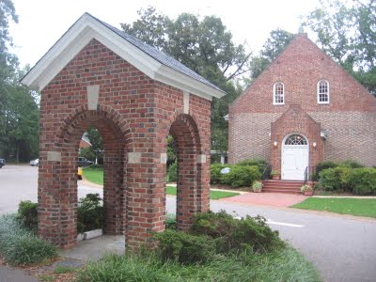1923 - Bell Tower. The church’s bell tower was erected in 1923. There was a bell tower or lychgate at the entrance to the cemetery (no longer standing). Bodies were placed here before being taken into the church for funeral services. (Reference 134).
1957 - The Rectory. A Rectory was built (Alfriends House) and the Reverend Beverley D. Tucker, Jr. was the first to reside there. Today the building is used for meetings, offices, and storage.
1954-1991 - The Parish House. Construction of the Parish House took place in four phases.
* 1954 - Phase One. A Christian Education building was constructed and completed in 1954. The original building had a large meeting area with fewer walls which were put up later for church offices. This is a 98 by 33 foot (3,100 sq ft interior space) single story brick building with a gable roof. After completion, the old frame parish house located where Tucker Hall now stands was torn down and donated to another small church, which hauled its lumber away in a truck (Reference 3).
* 1961 - Phase Two. A Day School was attached to the south side of Phase One, an 86 by 69 ft (4,735 sq ft) single story brick building, flat roof with double door opening to a 36 by 29 ft (1,044 sq ft) court yard surrounded on three sides by rooms and open to the east.
* 1969 - Phase Three. Rooms were added to the south side of the Day School which exits onto playground, a 70 by 46 ft (3,000 sq ft interior space) single story brick building with flat roof.
* 1991 - Phase Four. A multipurpose room with a room divider and three large storage areas was named Tucker Hall, for the Reverend Beverley Tucker (40 by 70 ft or 2,691 sq ft interior space). Also included in this last phase were the kitchen and two bathrooms (53 by 34 ft or 1,715 sq ft), library and hallway extension (29 by 23 ft or 615 sq ft interior space) connecting Tucker Hall and the Day School to then completely close off the east side of the courtyard, and bricking in the porch to the front of the Day School for five additional Day School rooms (69 by 10 ft or 612 sq ft interior space).
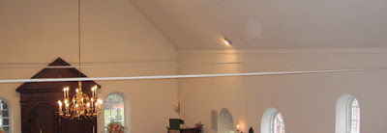_____________Five steel tension rods inserted to keep the walls from buckling outward
1960 - Major Structural Repairs. During an Easter service conducted by Reverend Beverley Tucker, when Ruth Ann Campbell was playing as church organist, the walls and roof began to separate, creating a gap between the stairs to the organ loft and the wall. The church was “condemned” by the county building inspectors. Major structural repairs were made to the roof structure and brick walls to include five steel spanner bars (visible today inside) to anchor the brick walls and prevent outward thrust from the gabled roof. During this 1966 restoration, Reverend Beverley Tucker stated that the original brick work on the south wall was uncovered, and the holes and shadows of the hanging box pews of early wealthy parishioners were exposed. Today no sign exists of these repairs and restorations except for the five steel rods overhead. A prominent Norfolk banker and descendant of the Reverend Alfriend, John Alfriend, arranged for his bank, the National Bank of Commerce (a predecessor of the old Virginia National Bank), to lend the repair money without a mortgage (deed of trust) on Old Donation. Reverend Beverly Tucker stated that the banker did not want a mortgage secured by a church in which his ancestor, the Reverend Alfriend, was buried (References 2 and 3).
1966 - More Repairs. Although major repairs to the roof and walls were made in 1960, the rest of the church was in a serious state of disrepair. The concrete floor was cracking and sinking in the nave area (central part of a church, extending from the narthex to the chancel), and the wood floor in the chancel area (space around the altar) was termite-eaten; the plaster on the side was falling; and the pews (a second-hand addition in 1916) needed replacing. These deficiencies were corrected with re-furred, re-plastered and re-painted walls, termite treatment, and a new slate floor. New lighting, heating, and air-conditioning systems were added. To bring the church back in line with its original Colonial “Prayer Book” architecture (the 1916 rebuilding reflected the then popular Gothic chancel design) and add more space, the choir and organ were relocated from the chancel up to the balcony, kneelers added, and the lectern and prayer desk relocated adjacent to the pulpit. The Architect, Milton Grigg, estimated the cost at $45,000 (Reference 48).
1986 – The Driveway and Parking Area. Up until this time this area was dirt and gravel with muddy potholes after a rain. Asphalting this whole area was a significant improvement. Sometime later a large oak tree standing in the middle of the driveway in front of Tucker Hall had to be felled. A large circle in the asphalt is visible where the tree once stood.
Chapter 3 - Significant Historic Topics______
Land Acquisitions
* 1694. Two acres of land was purchased from Ebenezer Taylor for Church No. 2 (the Brick Church) and paid for in 1694 with 1,000 pounds of tobacco. This description of two acres was an approximation since the Virginia Beach Court of Records shows a plat dated June 20, 1913 of “Donation P.E. Church Lot on Bay Shore” with 2.776 acres of land. The plat shows the church bordered by two roads, “Public Road to Witchduck” (present day North Witchduck Road) and “C. M. Barnett’s Private Road” (present day south boundary of the church property and road to Ferry Plantation House).
* 1774 - 1777. Large areas of land were added to the church property through Reverend Robert Dickson’s donations and bequeaths to support and continue the free school for orphan boys. Called “Donation Farm” the land included today’s area to the south of the church encompassing Pembroke Meadows, Old Donation Estates, Old Donation Farm, and Hudgins Shores. When the church was abandoned in 1856, Church No. 2 and the land given to the church by Reverend Dickson was appropriate by Princess Anne County and sold.
* 1950’s (early). A smaller plot was purchased for a below market price from Virginia Hutchison where Alfriends House is now located.
* 1972. On August 18, 1972, the Virginia Beach Court of Records has on record the deed to property purchased for one dollar from the Terry Corporation of Virginia with the condition that for period of ten years the property be used solely for park, recreation, playground, and/or landscaped areas with no building construction allowed. On January 28, 2012 the church dedicated the Donazione Labyrinth pathway, the only thing done with these 1.958 acres of land on the north side of North Witchduck Road (across the street from the church) For details of the labyrinth see “Modern Activities History” below.
* 1983. Mr. Hudgins promised land to Old Donation Church - the current field south of the Crape Myrtle tree line. His daughter, Mrs. Ethel Howren, completed the gifting after Mr. Hudgins’ death in 1983. This brought the total land area owned by Old Donation to today’s 8.545 acres (6.587 acres south of Witchduck Rd and 1.958 acres north of Witchduck) (Reference 35).
______________________________Seating Arrangements
1736 - 1767. Church No. 3 (today’s historic church) began June 25, 1736 with the traditional colonial seating arrangement, just as Bruton Parish Church in Williamsburg was arranged. In the back half of the church the sexes were segregated during “Divine Worship” with men seated on the north and the women on the south if this could be arranged. Occupying the front half of the church were boxed off areas know as Great Pews with seats facing each other. A vestry order dated July 10, 1736, tells of six Great Pews and a seventh on the north side of the communion table. The Great Pews were reserved for congregants of wealth and importance.
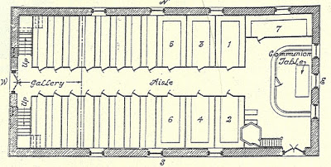The above picture shows locations of Great Pews for the Magistrates (1), their wives (2), the Thoroughgood family (3), the elder women of good repute and Magistrates’ daughters (4), vestrymen and their wives (5), such women as the Wardens chose (6), and Walkes family (7). Also in 1736 a private hanging pews was purchased and hung next to the north wall (left side when facing the altar) by Captain William Robinson (11) providing a better view and warmth in the winter. His hanging pew was accessible along a catwalk from the upper balcony and looked like a theater box seat suspended by iron tie-rods, decoratively twisted and tied into the roof beams.
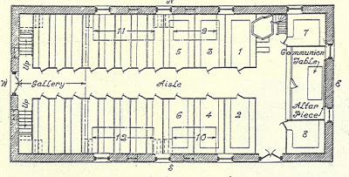The above picture shows the seating arrangement thirty-one years later in 1767. Captain James Kempe had another hanging pew installed on the same north wall (9), necessitating that his family walk through Captain William Robinson’s hanging pew to get to his. Walter Lyon (10) and Thurmer Hoggard (12) also had two more hanging pews installed on the south wall about that time. Small windows were cut into the wall (still in place today) to light the four hanging pews. Also in 1767 a private Great Pew was added by Colonel Edward Hack Moseley, Jr. (8) where the pulpit stands today. The pulpit had to be moved to the north side of the communion table and the side door moved about eight feet from the end of the long south wall to its present location. Also about this time the central altar window was bricked-up to make room for a reredos, a solid wood piece on the back wall of the altar (not the one currently in place).
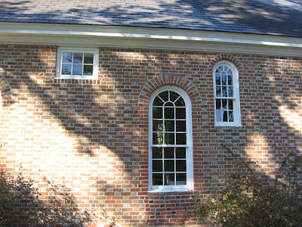Small windows cut to light the four hanging pews (two on each side of the church)
An October 16, 1736 entry in the Vestry Book revealed the strictness of these seating assignments. It was written, “The Vestry do hereby publish and declare, that who or whatsoever person shall assume to themselves a power: to take the liberty to place themselves or others in any other seats or pews in said church: shall be esteem’d a Disorderly person and may Expect to be dealt with according to law.” This law prescribed a visit to the stock and pillory just outside.
1822. The backs of the pews were cut down so the congregation could see each other. At this time the box pews and the hanging side pews were dismantled and the pulpit was moved back to the north side as it now stands (References 2, 5, 38, 52, 44-page xvii, and 179–page 28 with initials for “arrangements” GCM 1949).
______________________________Slavery
1619 - Sir George Yeardley (1587–1627) was the father of Sarah Thoroughgood-Gookin-Yeardley’s third husband, Francis Yeardley (1620-1655). Yeardley was not only the founding father of representative government in America but also the founding father of a cruel system of human bondage that would eventually strip Africa of fifty million natives, the largest genocide of a people, ever. In 1619 the Virginia Company sent 32 year-old Yeardley to the Virginia Colony to be the new governor and to establish a government along the same lines as the British Parliament. Only three weeks after he established the Virginia General Assembly, Yeardley bought his first slaves. On August 20, 1619, Sir John Rolfe (1585 – 1622), who cultivated tobacco as the first successful export crop, recorded the following in his diary; “There came in a Dutch man—of—warre that sold us 20 negars. He did not state the price, but added that fifteen of the blacks were bought by Yardley himself, for work on his 1,000—acre tobacco plantation.” These black men were strictly speaking, “indentured servants,” and a couple sold to William Tucker had the first black child born in America. Yeardley was so successful in using these blacks to work his tobacco plantations that soon he bought more blacks, this time as chattel slaves.
1624 – Indentured servants made up 60% of all immigrants. They had to work 3 to 5 years for their passage and were trained in a trade (mostly woodworking and raising tobacco). Along with these voluntary indentured servants, British convicts were sent as involuntary indentured servants, some causing trouble and some running away to join with Indians. Involuntary indentured servants included orphan children picked up off the streets of London.
1637 - Adam Thoroughgood imported “three negroes,” according to land grants.
1650 – Black involuntary indentured servants evolved into slavery, as blacks did not know the language or their rights in court. But the total number of slaves was estimated to be no more than 300 in Lynnhaven Parish. Coming from Barbados, Lynnhaven Parish Church members Francis Land and Thomas Walke brought slaves with them to work the lucrative tobacco fields. There were also free blacks at Lynnhaven Parish Church but their numbers were small and their freedom tenuous. There were also Indian slaves bought on the pretext of Christianizing them.
1667 – Black freedom slowly deteriorated during the 17th century. A Law of Virginia decreed that the conferring of baptism did not alter the condition of the person as to his bondage or freedom (Reference 146).
1687 – Lynnhaven Parish Church fought mightily during the 17th century to discourage miscegenation and maintain the purity of the English white race. At first the white men were soundly whipped in church for dishonoring God and shaming Christians for defiling their bodies by lying with black women. One such case was the reverse of a white man and black woman. By order of the court in 1687, William, a black slave, was given 30 lashes on his bare back in the presence of Lynnhaven Parish Church congregants for fornicating with white church member Mary Basnett Square. No punishment was given to Mary.
1690 on – The penalty for a white man fornicating with a black slave women was eased to the point that a white man caught fornicating with a black woman paid a fine and the black slave woman received the whipping despite the fact that she was raped.
1731 - By 1731 the decline of indentured servants saw the steady increase in the slave population to about a quarter of Virginia's population. With this increase the white population became increasingly worried about the possibility of a slave uprising. Until 1731 slave owners were allowed to bring their slaves to Lynnhaven Parish Church, where they sat in the balcony and took communion outside. As worries mounted, the vestry made the unwise decision to no longer allow slaves in the church at all. Not content to stand outside during the long services, they began to meet. In the winter of 1731 slaves in Lynnhaven Parrish assembled on a Sunday during church services and chose leaders for an insurrection, but the meeting was discovered. A trial ensued, and four black ringleaders were hanged and the rest harshly punished. But insurrection talk among the slaves continued to spread, and militia patrols were employed to break up slave gatherings. Further, every man had to carry his guns to church on Sunday less they be stolen by slaves. Virginia Governor Gooch told the Bishop of London that some of the blame for slave unrest fell on cruel masters who "use their Negroes no better than their Cattle."
1736 on - Tobacco was king in Lynnhaven Parish but would see a gradual shift to grain, requiring fewer slaves. Toward the close of the eighteenth century Lynnhaven Parish had one of the smallest percentages of slaves in Virginia, but Virginia as a whole had the largest slave population of all the states with almost forty-five percent of its households owning slaves.
1814 - Reverend Anthony Walke (1755 - 1814) wanted to see the end of slavery and along with Thomas Jefferson was one of the early thinkers on how this could happen. Nevertheless, he was the largest slaveholding Episcopal minister in Tidewater Virginia. When he died he had over sixty-five slaves without a mention of their freedom in his will. But he must have left his thoughts with his grandson David (1800-1854) who stipulated upon his wife’s death that his slaves were to be freed (References 51, 74, 101-page 69, 116, 174-176, and 214).
_________________________Reverend Dickson’s Free School.
For some unrecorded time Lynnhaven Parish Church conducted a free public school for orphan boys in the adjacent court house. In 1733 the Vestry decided to tear down the court house and jail to make way for Church No. 3. In order to continue the school, on March 2, 1736 Anthony Walke put a motion before the Vestry “that the old church [Church 2] would be a convenient place to make a public school for instructing children in learning and for no other use or purpose whatsoever.” When Reverend Robert Dickson became Rector in 1748 he took over running the school and for 28 years invested his energies in seeing that the orphan children became prosperous respected citizens. In this day most facilities for poor children were not schools at all but work houses that provided little education and sometimes worked the children to death at an early age. When Reverend Dickson stepped down as Rector in 1776, the school continued under the management of churchwardens as indicated in numerous Vestry Book entries. In 1803 the Reverend George Holston was put in charge of the free school, and in later years Reverends James Simpson and Anthony Walke alternated as head masters. The public school was operated as late as 1819, but a separate private school house was never built using Reverend Dickson’s endowment as he had instructed. With the church losing funding and attendance to the Kempsville Emanuel Church, the Vestry was no longer able to continue with the school. When the church was abandoned in 1856, Church No. 2 and the land given to the church by Reverend Dickson was appropriated by Princess Anne County and sold.
As early as 1627 the British shipped orphans to Virginia as a way of alleviating a financial burden. Unmarried mothers and the children of impoverished families made up the balance of these unfortunate youth. There were two prospects for these children: workhouses or free schools. Bruton Parish, being less than fifty miles to the north of Lynnhaven Parish took the economical route and built a workhouse in 1755, a complex of buildings near Capitol Landing on a hilltop overlooking Queens Creek. Under Reverend Thomas Dawson the vestry record states that the facility would be a place “where the Poor might be more cheaply maintained and usefully employed," because "providing for the Poor of the said Parish hath always been burdensome” and the church should "compel the Poor of their Parish to dwell and work in the said House under whatever restrictions the House might impose.” There is no direct record of the fate of the children on the other side of the James River from Lynnhaven Parish, but in general the plight of children who lived in workhouses in Virginia was far from happy, and mortality rates were high.
Lynnhaven Parish Church was one of the first institutions (if not the first) in Virginia to take advantage of a 1727 Virginia General Assembly update to the colony's poor laws providing funds for church wardens to train poor children to become self-supporting craftsmen with the added benefit of book learning. When Reverend Dickson took over as Rector in 1748 he lead the way in Princess Anne County convincing other churches that training orphans in a productive trade was more economical than working untrained youth for limited profit.
Given eighteenth-century presuppositions about education (it was not thought necessary or proper to educate girls, even the daughters of the gentry), it was not surprising that Lynnhaven Parish Church focused on the placement of disadvantaged boys and not girls. Nevertheless, Lynnhaven Parish provided the wards of girls in such circumstances with material aid. Vestry Record expenses for 1773 included subsidies to Susannah Nicholas for “support of two children” (480 lbs.), to Frances Jobson for “keeping her two children” (600 lbs.), to Elizabeth Petree for “supporting a Child” (300 lbs.), and to Hannah Fallen for “support of her three Children” (900 British Pounds).
From all over Lynnhaven Parish poor and neglected children were indentured or bound out to the Lynnhaven Parish Free School for orphan they were 21 years of age when they were free to live in Lynnhaven Parish practicing the trades they were taught. Prior to, during, and after Reverend Dickson’s death Lynnhaven Parish Church wardens displayed an impressive capacity for independent, innovative, and extraordinary acts on behalf of boys. Vestry Records indicate that the parish was educating a high percentage of boys in carpentry, shoemaking, coopering, weaving, and tailoring. A few were even bound out to more elite or genteel craft trades such as silversmith, wigmaker, pewterer, sailmaker, and clockmaker. Captains Kempe and Keeling bound out ten children, all boys, nine of them identified as “orphans” and one simply as “poor.” Lynnhaven Parish also provided health care to the boys. Vestry Records show that 1,948 British Pounds was paid to Dr. Christopher Wright in 1754, and in 1757 the Church hired a Dr. Price “to serve the Parish the ensuing year,” a commitment that continued through 1762.
In 1774, three years prior to Reverend Dickson death, he gave property to the Vestry of Lynnhaven Parish, the income to be used in employing, "an able and discreet teacher in the Latin and Greek languages and the mixed mathematics, to teach and instruct therein such number of the poor male orphan children being natives of the parish, as rents and income would justify.” Upon his death in 1777, Dickson’s will stated that one half of his personal estate should go to his wife Amy, with the rest to be sold and the money to go to the Vestry of Lynnhaven Parish, and after the death of his wife the balance of the estate was to be sold to support the free school. His estate included his home, slaves, and property. In 1801 there was a claim to the land Dickson donated to the church that challenged Old Donation Vestry control, and in 1813 the church was involved in a claim for the Dickson land from Dickson’s relatives living in Scotland. These claims apparently came to nothing.
After the American Revolution ended Virginia's state-church relationship, Reverend Dickson’s free school continued and became a model for the Virginia General Assembly. In about 1784 the Assembly appointed a county overseer of the poor whose job was to encourage churches to train poor orphans in lieu of working them to death. After Reverend Dickson’s death (1777), using proceeds from his land, the Vestry continued funding the free school, but, as stipulated in Reverend Dickson’s endowment, never built a private building to replace what was considered public to insure the school’s continuation. Reverend Dickson’s free school ended sometime around 1820 after a century of operation to become celebrated as the first public school in Princess Anne County. (References 6-page 284; 35; 44-page xv; 73-page 10; 41-page 248; 86-pages 74-79; 75; 87-91; and 155).
__________________________Old Donation Gets Its Name
Upon his death in 1777 Reverend Dickson donated his home, slaves, and more property to the church to be used to support and continue his free school for orphan boys in Church No. 2. The gifted property was called “Donation Farm” but the term “Old Donation Church” did not appear until a Vestry Record entry in 1822 used that term to order that the “church called ‘old Donation Church’ be put in repair.” (Reference 25).
___________________________Locating Church No. 2
The exact location of Church No. 2 has two possibilities. References (1-page 92 and 38) describe the location as being roughly 70 feet southwest of present-day Old Donation Church. Reference 44, page xv, states that sometime in the 1940’s, a “sounding rod reveals the outline of its foundation, parallel to the existing church and about 70 feet south and a little west of it, as marked by brick rubble in the soil. These remains lie due west of the present graveyard, which, although stripped of tombstones, is an ancient burial ground, and this would have been the most probable location for an earlier church.” Based on this information, Floyd Painter conducted a dig in this location in June 1986. He was only able to find an old dried up well used for garbage disposal and a few old bricks. The bricks he found may have been from other buildings on the property such as the jailhouse, stables, and/or stock and pillory, but the bricks could not have been remnants of the old courthouse which was moved to the Ferry Farm House when Church No. 3 was built, as the courthouse was wood with a limestone foundation. Also, some of the rubble may also have come from Church No.3 when it was in a state of ruin from 1882 to 1916.
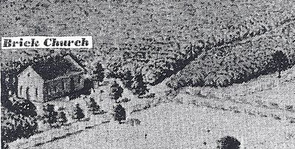The Brick Church (Church No. 2) shown on the north side of Cattail Creek in
General Thomas Hoones Williamson’s 1812 watercolor painting.
A watercolor painting dated 1812 drawn by General Thomas Hoones Williamson, professor of engineering and architecture at Virginia Military Institute (1813 – 1888) depicted his recollection of Ferry Farm and its original buildings. He has the Brick Church (Church No. 2) located at the end of Cattail Creek on the north side of Cattail Creek (whereas Church 3 is situated on the south side). That would put Church No. 2 over the present-day Parish Hall library and the land outside the library window where the annual roast oysters are prepared. With two acres of land, the “70 feet south of Church No. 3” location places Church No. 3 too close to Church No. 2 since Church No. 2 continued in operation as a public school for orphan boys until sometime after 1800. (References 44 - page xv, 52, and 54).
_________Chapter 4 - The Story of the People of the Church_____
Introduction.
The history of Old Donation could not be complete without giving an account of the church members who shaped local history in and outside the church. More than any institution, they are responsible for a large chunk of Virginia Beach’s past. Various roads, communities, and buildings were named after church members and their deeds, i.e., roads - Adam Keeling, Thoroughgood, Hoggard, Wishhart, Woodhouse, Burroughs, Windham, and Sewell’s Point; streets – Walke, Todd, and Warner; lanes - Kemp and Francis Land; mews – Hosskine, Lanckfield and Caussome (spelled differently); White Acres Court; Alfriends Trail; Yardley Landing; Hayes Avenue; Bullock Trail; Willoughby Spit; and Donation Drive and Old Donation Parkway (in honor of Reverend Robert Dickson’s 1776 land donation to the church).
From its first seventeenth century service in undeveloped lands with only a handful of English settlers in Adam Thoroughgood’s primate wooden house, to the eighteenth century “Golden Age” of the church with its prosperous Virginia gentry, to a burned out church in the woods with no services for over fifty years, to a small membership struggling throughout the first half of the twentieth century, growth and prosperity started to unfold in the early fifties when several parishioners made significant contributions for construction of a day school and parish hall. Then in 1999 Henry Keeling, a direct descendant of Thomas Keeling (1608-1664), originated the Old Donation Endowment Fund Trust with a one million dollar plus post mortem bequest from his estate. Shortly after Henry’s death, Margaret Milliken bequeathed over $800,000 upon her death.
The long history of the church would not be as dramatic without one legendary historic event, the ducking of Grace Sherwood, the “Witch of Pungo.” The street out in front of the church carries the name of this historic episode, i.e., “Witchduck,” and a statue honoring Grace is strategically placed not far from church grounds with Grace facing the church and casting a vigilant gaze on Old Donation. People who stop by to hear the history of Old Donation generally ask first about the “witch.”
From the earliest settler who started the church up to folks still living, this accounting is far from complete, but it represents what is known from their houses still standing, court records, what has been written in books, and interviews with folks still living.
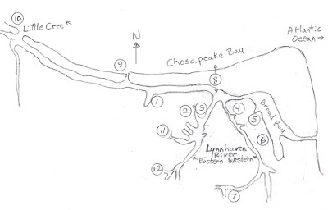
Above is a sketch of the Lynnhaven River as Adam Thoroughgood knew it. Numbers 1–12 show the location of estates and significant events.
(1) 1634 - Adam Thoroughgood built a crude type of wooden house (destroyed by fire in 1660).
(2) 1639 - Adam Thoroughgood started construction of a brick house which was finished by his wife in 1645 (today’s Adam Thoroughgood House).
(3) 1639 - Adam Thoroughgood built Lynnhaven Parish Church No. 1 at Church Point (consumed by the Lynnhaven River in 1692).
(4) 1636- Adam Keeling built the Adam Keeling House (today a private residence).
(5) 1637 - Thomas Allen built his house (today’s John B. Dey House, a private residence).
(6) 1640 - Henry Woodhouse was a member of the first vestry (1640) and the road around his estate carries his name, but the house has long since perished.
(7) 1638 - The Francis Land Estate. Francis Land II arrived in the area about 1638.
(8) 1667 - Adam Keeling dug a small pilot channel here as a quicker way to the Chesapeake Bay (today’s Lesner Bridge site). A month later on September 6, 1667 the worst hurricane ever to hit the area widened the pilot channel to create the new flow of the river.
(9) According to Benjamin Dey White, in his 1924 book “Gleanings in the History of Princess Anne County,” Lake Joyce formed the mouth of the Lynnhaven River.
(10) However, a map by Gen. Benedict Arnold’s engineers made in 1781 denotes the early flow of the Lynnhaven River to be two miles further west at Little Creek.
(11) 1692 / 1736 - Lynnhaven Parish / Old Donation Church No 2 (1692) and No. 3 (1736) on Cattail Creek (Cattayle Branch on old maps).
(12) 1764 - Pembroke Manor was built by Captain John Saunders I (1726 – 1765).
At least five estates (Thoroughgood, Keeling, Allen, Woodhouse, and Land) were connected to each other and were among the first in Lynnhaven Parish. Other first members of the church probably also had houses built on their lands but their locations remain unknown (Thomas Bullock, Christopher Burroughs, Thomas Caussonne, Robert Hayes, Bartholomew Hosskine, William Kempe, John Lanckfield, Henry Seawell, John Stratton, Thomas Todd, Augustine Warner, Thomas Willoughby, Edward Windham, and George Yeardley). Between 1634 and 1651 Thomas Keeling (1608 - 1664), Thomas Allen (1607-1660), Henry Woodhouse (1608 - 1655), and Francis Land (1604 - 1657) acquired lands, all of which were relatively small in comparison to the 5,350 acre estate Adam Thoroughgood (1604-1640) acquired for sponsoring 105 immigrants to Virginia in exchange for land. The story of the people of the church begins with these people and their houses (Reference 205).
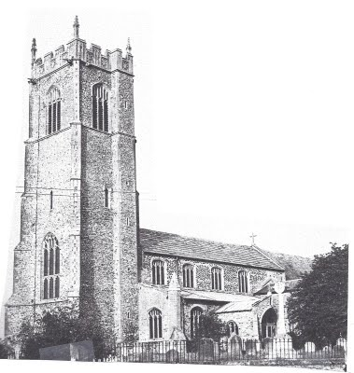The Reverend William Thoroughgood baptized his son Adam at St Botolphs, in Grimston Parish, England (as seen today in the above picture). Here young Adam worshiped prior to departing for Virginia.
Captain Adam Thoroughgood (1604-1640) (also spelled Thorowgood, Thorogood, Througood, and Thorugood) was an English colonist and community leader who helped settle the area of Lynnhaven and form Lynnhaven Parish Church. He was the youngest son of seven of an influential family headed by the Reverend William Thoroughgood (1579 – 1625), a Puritan minister at Grimston-King's Lynn, England. The topography of Lynnhaven reminded young Adam so much of his homeland town that he gave the Chesopean River and her shore the name Lynnhaven (named after the town of Grimston-King's Lynn, Norfolk County, England, 115 miles north of London). He is also credited with naming New Norfolk County.
Adam Thoroughgood arrived in Kecoughtan (today’s Hampton), Virginia in 1621 aboard the ship Charles, an 18 year old indentured servant of Captain Edward Waters (in return for his passage). Waters was a wealthy plantation owner and astute businessman. In Kecoughtan Adam attended Elizabeth Parish Church as noted in a 1623 census. By that time Adam had worked off his indenture and in 1624 returned to London where he began carrying out an ambitious plan of sponsoring immigrants to Virginia in exchange for land under the same terms that he had accepted when he first came to Kecoughtan – up to five years of servitude in exchange for passage to the colony and fifty acres of land plus fifty acres to the sponsor. While in London on July 18, 1627 he married Sarah Offley, daughter of a financially successful mercantile family, and in 1628, 24-year-old Adam brought 19-year-old Sarah to Kecoughtan.
In 1634 for Adam Thoroughgood’s work in local affairs and for convincing 105 English citizens to leave for Virginia as indentured servants, the Privy Council directed a letter to the Governor of Virginia recommending that Adam be given a patent for 5,350 acres of undeveloped lands (today’s northern Virginia Beach) on the other side of the James River from Kecoughtan. The names of all 105 can be found at reference 209. Moving to his relatively isolated 5,350 acre estate in the fall of 1634, Adam brought with him his 105 indentured servants including Augustus Warner whose granddaughter became the grandmother of George Washington. Adam’s 10 square mile estate in Lynnhaven extended from Little Creek to the present day Lynnhaven Inlet (Lesner Bridge) and south for about two miles incorporating the land on which Old Donations sits today. Adam had a “crude type of wooden house” built the fall of 1634 on the shore of the Chesopean River (renamed Lynnhaven by Adam).
An address delivered by Jacob Heffelfinger at the 3rd centennial of the founding of Elizabeth Parish on July 19th, 1910 (reference 131), reveals that Adam not only acquired a large estate in Lynnhaven Parish, but also had lands Kecoughtan.
“Listed as a servant in Mr. Edward Waters muster, he whose escape (Mr. Edwards) from the Nansemond Indians we have noted, is Adam Thorogood, aged eighteen years. He rose to a position of influence in the colony. He was a Burgess from Elizabeth City (in 1620 Kecoughtan was given a new name, Elizabeth City, in honor of the daughter of King James I) in the General Assemblies of 1629 – 1630 and 1632. In the session of September, 1632, he was made a member of the monthly court for Elizabeth City and in 1637 (after relocating to Lynnhaven Parish) was on the council of Governor Harvey. His land adjoined the lands of William Capp and William Clairbome. He also held large tracts of land in Lower Norfolk (Lynnhaven Parish), formerly lower part of Elizabeth City.”
Adam had many firsts in Lynnhaven Parish. One of those was the inauguration of the first public ferry service in 1636 transporting human passengers and, later, horses and wagons, across the Elizabeth River between what is now downtown Norfolk and Portsmouth. This was a simple skiff rowed by Adam’s indentured servants who brought everything from goods to people and animals across the river.
In 1636 Adam convinced the Virginia General Assembly to accept his Lynnhaven Parish as part of Lower Norfolk County (part of today’s Virginia Beach), and a year later he was appointed presiding justice of the county. An entry in the county records (Friday, May 15, 1637) ordered a service be carried out at Captain Thoroughgood’s residence. Therefore, it is logical to assume that the first service of the Lynnhaven Parish Church was held Sunday May 17, 1637. Also at that first session, there is record stating that Anne Fowler had insulted Adam Thoroughgood. She was sentenced to 20 lashes and required to attend the first services held in Adams house to publicly confess her sin and apologize to Adam. Gathering citizens of the little Lynnhaven community, Adam asked 25-year-old Reverend William Wilkinson from Yorkshire, England to hold that first service. County court sessions continued to be held monthly at Adam’s home and at other colonists’ homes. Church was held at Adam’s house every other Sunday until a church at Church Point could be built. Adam Thoroughgood was now, not only the Father of Lynnhaven Parish (Virginia Beach), but Father of the first church in Lynnhaven Parish.
In 1638 Adam had a church (Lynnhaven Parish No. 1) started at today’s Church Point and a year later a more substantial house to replace his crude wooden house. Adam’s second house was built just upriver from the church. The first Lynnhaven Parish Church was completed in 1639, but Adam’s house lacked one brick wall, and before it could be completed Adam died.
In February 1640 Adam and his servants set out to attend a Jamestown Burgess meeting. They all became ill during the trip and returned home. Adam, a few of the servants, and the attending doctor George Calvert died as a result of an unknown illness. At the age of 36 Adam was buried in the churchyard at Church Point and would be accompanied later by his children and Sarah. In 1819 Commodore Stephen Decatur described wading in the river and standing on the tombstone of Adam Thoroughgood.
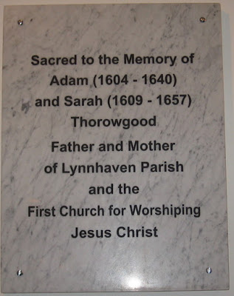The above plaque commemorating Adam and Sarah was placed on the back wall of Old Donation Church in October 2010 and consecrated at the All Saints’ Day service November 7, 2010 (References 1- pages 32; 18; 42; 43; 52; 56; 57; 59; 62; 103d-pages 6 and 10; 109-page 101; 103a&d; 107; 111-page 191; 112 pages 3 – 5; 113; 114 page 265; 117; 119; 129-133; 135; 143; 155; 157; 234; and 235).
Sarah Thoroughgood-Gookin-Yeardley (1609 – 1657). Of particular interest is Adam Thoroughgood’s wife Sarah, the founding Mother of Lynnhaven Parish. Her father, Robert Offley Jr., was a merchant, and her mother Anne Osborne, came from a politically powerful family. She would use her rearing to rise above the custom of the day for women to be subservient to men. She went on to exercise her wealth and her position in the budding colony in Virginia in a very strong and forceful manner over both men and women. While in Kecoughtan she gave birth to three girls Ann (1630-1703), Sarah (1631-1658), and Elizabeth (1633-1670), and later in Lynnhaven, Adam II (1638 - 1685); and finally at the age of 33 one daughter, Mary (1642 - ?), by her second husband Captain John Gookin.
When Adam Thoroughgood died in 1640 Sarah was named executrix in his will and inherited, among other things, the brick house for life which was then to go to their son Adam II. This shows that Adam had a lot of confidence in his wife, as wives in 1640 were considered the property of their husbands and participated very little in business affairs.
There is a record of Lower Norfolk Court proceedings on August 3, 1640, arising out of an argument over a cancelled note between Sarah and the wife of a Lynnhaven Parish Church vestryman who made insinuations against Sarah’s recently deceased husband Captain Adam Thoroughgood to which the widow Sarah exclaimed, "Why, Goody Layton, could you never get yours?" Goody Layton replied, "Pish!" To which Sarah replied, "You must not think to put off with a pish, for if you have wronged him you must answer for it, for though he is dead I am here in his behalf to right him." For this one word, “Pish,” Goody Layton was ordered by the court to ask Mistress Sarah's forgiveness on her knees, both in court and the following Sunday in the Lynnhaven Parish Church. Four years later on October 8, 1644, when again she was a widow, two excessively exuberant young men were tried in Quarter Court at James City for making insulting remarks against Sarah’s daughter, also named Sarah. One of them was sentenced to receive fifty lashes on his bare back and to ask forgiveness of the widow Sarah in the Lynnhaven Parish Church, as well as pay her court costs. These court rulings were indicative of her powerful social status in Lynnhaven Parish.
Sarah Thoroughgood remarried less than a year after Adam’s death at the age of 32 in the tradition of that time. The widow's new husband, 28 year old Captain John Gookin (1613 - Nov. 2, 1643), was the son of Daniel Gookin and Mary Byrd of the plantation at Marie's Mount, near Newport News (in most references Capt. John Gooking is spelled “Gookin.”). Upon marrying the influential widow, Captain Gookin assumed position in the community and soon became commander and presiding justice of Lower Norfolk County. Sarah was married to John Gookin little more than two years when he died in 1643.
Bucking the tradition to quickly remarry, Sarah would remain a widow for four years. During this time Sarah remained quite enterprising for a seventeenth century woman. She had Mr. Smyth complete the brick house Adam had started in 1639. In about 1645 she moved her family into it and used her old wood house for an ordinary (tavern) from 1645 to about 1647. It was a place where men could stop along the Lynnhaven River and discuss the politics of the day. Women were not allowed inside, except Sarah, adding to her reputation as being on an equal or even superior footing with the elite male gentry. The ordinary is possibly the source in naming Pleasure House Creek and Pleasure House Road many years later. The wood house burned down in 1660.
In 1647 Sarah married for the third time at the age of 38 to Colonel Francis Yeardley (1620-1655), a man 11 years her junior, son of the former Governor of Virginia. Although Colonel Yeardley had extensive land holdings on the Eastern Shore, he came to reside at Sarah’s new brick house.
In 1653 Sarah and her third husband, Francis Yeardley, sponsored a boat expedition into the unsettled Currituck and Albemarle sounds of North Carolina, then known as, “the south part of Virginia.” Frances and Sarah did not go but instead sent eighteen-year-old Adam Thoroughgood II, Sarah’s son. The expedition met with the leader of several area tribes including Chief Kiscatanewh of the Pasquotank River Yeopim Indians (related to the Weapemeoc Indians), representing himself as “the great commander in these parts.” The party was escorted to Roanoke Island and shown the ruins of Sir Walter Raleigh's fort (the Lost Colony of 1587). Yeardley’s party invited the Indians to “come in and make their peace with the English.” Indian representatives and Chief Kiscatanewh accompanied the expedition back to the Thoroughgood plantation where Chief Kiscatanewh saw Sarah’s children reading together and requested Yeardley raise and educate his only son as a Christian “to speak out of a book and to make a writing.” Mr. Yeardley agreed and also committed to build an English house for the chief in the Albemarle lands in exchange for the right to purchase some Albemarle lands. Sarah likely advised her younger husband throughout these negotiations, as she had intimate knowledge of the work of her two former brothers-in-law that supported Indian conversion. Yeardley was on the Patuxent River in Maryland when Chief Kiscatanewh returned the next time. Being a Sunday, Sarah escorted the chief to Sunday worship services at the Lynnhaven Parish Church -“in her hand by her side.” Sarah certainly was the only woman in those times that could have escorted into church a man who was viewed by the congregation to be dangerous and unwanted. Before and after the service Sarah had to fend off fellow parishioners who tried to intimidate the chief into not returning. Francis Yeardley returned from Maryland in March 1654 and promptly dispatched six men to Albemarle Sound to build the Chief’s English house along with a note requesting the purchase of land. Chief Kiscatanewh returned in May 1654 with his wife, son, and other Indians. The congregation and the visiting 45 Indians crowded into Church No.1 to witness the baptism of the Chief’s son at the baptismal font, the same font recovered from the Lynnhaven River in the early 20th century that had been used for many years as an anchor, and the same font now residing at the entrance to Old Donation Church.
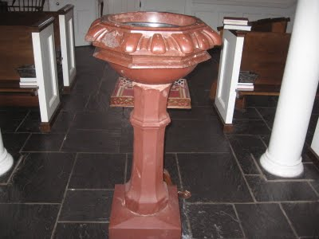
After the service the Chief’s child stayed with Francis Yeardley to be brought up a Christian. However, no record remains of the Chief’s son as Frances Yeardley lived for only a short time longer, dying of illness in 1655, and followed by Sarah two years later. Sarah’s heroic actions were praised in England and later commemorated in the ballad “Lady Yeardley’s Guest” written by Margaret Junkin Preston (1820–1897). The ballad title suggests the Chief’s son was the “guest” and that her husband was again away in Maryland on the Patuxent River.
Lady Yeardley’s Guest
T was a Saturday night, mid-winter,
And the snow with its sheeted pall
Had covered the stubbled clearings
That girdled the rude-built "Hall"
But high in the deep-mouthed chimney,
‘Mid laughter and shout and den,
The children were piling yule-logs
To welcome the Christmas in.
"Ah So! We’ll be glad to-morrow,"
The mother half-musing said,
As she looked at the eager workers,
And laid on a sunny head
A touch as of benediction,
"For Heaven is just as near
The father at far Patuxent
As if he were here with us."
In August, 1657 the thrice-widowed Sarah died at the age of 48. She was buried at Church Point next to her three husbands. She left orders that she be buried beside John Gookin, her favorite. Her tombstone was still visible at Church Point as late as 1819 when its inscription was published in a Richmond newspaper. “Here lieth ye body of Capt. John Gooking & also ye body of Mrs. Sarah Yardley [nee Sarah Offley] who was wife to Captain Adam Thoroughgood first. Captain John Gooking & Colonel Francis Yardley, who deceased August 1657." Remains of the church were still visible as late as 1850. In 1997 underwater archaeologists identified areas in buried silt where the Lynnhaven Parish Church and the cemetery, including the gravestones of Adam and Sarah Thoroughgood, were located (References 1-pages 32; 8; 17; 43; 45; 48; 52; 62; 98; 99; 100; 101-pages 36-42; 102; 103 page 3 and 4; 106 pages 3 & 6; 114 page 253; 123; and 124).
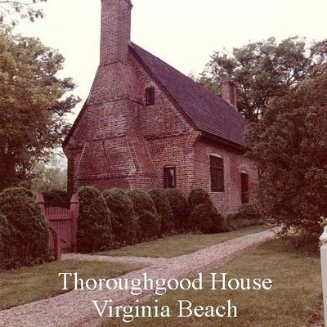The Construction Date of the Adam Thoroughgood House.
The Adam Thoroughgood House at 1636 Parish Road was once thought to be the oldest English brick house in the U.S.; however the interpreted date was changed from 1636 or 1645 to circa 1680 by the Chrysler Museum of Art in the late 1980's. The City of Virginia Beach acquired the property in 2003, and after pursuing several scientifically based research projects, agreed with the conclusions of professionals in the field that a circa 1720 date is supportable. While this should put to rest any controversy, there remain those who still claim the house was built between 1639 and 1645.
Virginia Beach used two reports as the primary source for re-dating the house, i.e., the “Archaeological Assessment of the Adam Thoroughgood House Site” by the James River Institute for Archaeology, Inc. and the “Oxford Dendrochronology Report for the Adam Thoroughgood House.” While very persuasive, there are some disconcerting statements that call into question an 18th century date.
* Floyd Painter found shreds of historic ceramics near the Adam Thoroughgood House of which “less than a handful were the type that was made during the 17th century.” If there was no house here in the 17th century, no 17th century pottery remains should have been found. Perhaps Adam Thoroughgood and his wife Sarah did build a house here only to be razed by later generations of Thoroughgood's.
* There is agreement that after acquiring his estate and moving from Kecoughtan (Hampton) to Lynnhaven Parish in the fall of 1634, Adam first hastily constructed a crude wooden house at today’s Battery Road in Baylake Pines, a location where the Lynnhaven River flowed in 1634. This house was substantiated in the report, but his second house was not. This was an English brick style house, which Adam Thoroughgood started to build in 1639 to replace his crude wooden house, and is the house some folks claim is the one standing today; else it has long since been destroyed with no remains left. The report concludes that Adam Thoroughgood and his wife and her second and third husbands, his son Adam II (1638 - 1685), and his grandson Argall I (about 1659 – 1700), never lived in the house standing today; but that his great-grandson Argall II (1885 – 1719) most likely built and lived in it.
* In stating that the architectural features could not have been that of a 17th century house, the report fails to acknowledge other contradictory historic architectural analysis such as one from the Virginia Department of Historic Resources which states, “One of the oldest houses in the English speaking colonies[Adam Thoroughgood House], it is believed to have been built about 1636-40. It is a fine example of the central-hall plan house of the 17th century, Virginia… most authorities believe that it is the identical house listed in his will in 1640 [Adam Thoroughgood’s will of February 17, 1639 as probated in Lower Norfolk Co., VA, April 27, 1640] ….it is of authentic 17th century design and workmanship.”
There are other sources that call into question the Historic Houses Office’s findings. Chief among these is Paul Treanor, a 10th generation Thoroughgood, who has painstakingly researched the Adam Thoroughgood House for more than twenty years. He was featured in the Virginia Pilot, “For One Man, House’s Age Is Much More Than Just a Number,” July 5, 2007 and published a book on the subject, “The Thoroughgood House, Virginia Beach, Virginia,” 2011. Treanor is adamant that the house standing today was begun in 1639 by Adam Thoroughgood and completed after his death in 1645 by his wife Sarah. By using land grants and court records Treanor claims the following residents lived in the Adam Thoroughgood House completed in 1645 and standing today at 1636 Parish Road.
1645-1655 – Sarah Thoroughgood-Gookin-Yeardley (1609 – 1657); Husband Francis Yeardley (married 1647 to 1655); Ann, Sarah, Elizabeth, and Adam II from Sarah’s first marriage to Adam I from 1624 to 1640; Mary from her second marriage to Captain John Gookin from 1641 to 1643.
1655 – 1685 - Adam Thoroughgood’s son Lt. Col Adam Thoroughgood II (1638 – 1685), his wife Frances Yeardley Thoroughgood (1643 - 1687), and their children – Argall I (1660 – 1700), John (1661 - 1702), Adam III (1662 - 1709), Francis (1665-1716), Robert (1669-1703), and Rose (1672- 1709).
1685-1687 - Frances Yeardley Thoroughgood (1643 - 1687), wife of Lt. Col Adam Thoroughgood II (1638 – 1685) and six children.
1687-1709 – Treanor has no documentation for this period and assigns it to “unknown.” Court records show that Argall I (1660 – 1700) married Pembroke Fowler in 1680. Moving out of the Adam Thoroughgood House he built a house for his family on Little Creek.
1709 – 1719 – Argall I’s son Argall II (1687 – 1719), his wife Susannah Sanford (1693 – 1749), and their son John (1713- 1763).
Besides Paul Treanor, other information has been printed that makes the case for a 17th century construction date.
There is record of a builder, Mr. James Smyth, completing a house for Sarah Thoroughgood in 1645 using a different brick style, Flemish bond (alternating long and short in the same row) from the three walls completed earlier, i.e., the same features of the house standing today. Also Alice Granbery Walter (1909 – 2003) honored later in this book under “Women Trailblazers,” a noted historian, found in a Lower Norfolk Court Record (Deed Book “B” page 61) an entry stating that Mr. James Smyth’s estate was owed payment for completing the fourth wall of the house, i.e., “the estate of James Smyth..for covering part of her[Sarah Thoroughgood-Gookin-Yeardley’s] howse…petitioner desires order for the payment of same.”
The letters “Adt 39” were cut quaintly on one of the tiles of the chimney wall, and a brick read “1640” until the surface disintegrated about 1912.
The best authority on the history of Princess Anne County, Benjamin Dey White, who made a comprehensive record search, wrote in his 1924 “Gleanings in the History of Princess Anne County” the following; “In 1640, possibly in 1636, he [Adam Thoroughgood] built the first brick house of importance in the County; so well and substantially built, that it is yet standing in a splendid state of preservation, and is claimed to be the oldest brick residence in the State. The river, now a half-mile wide at this point, was then quite narrow, and Little Neck, in which was located the Glebe [church rectory] and Court House, were then connected with the Thorogood land by a log.”
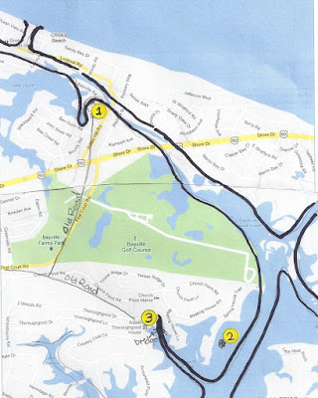
The above map is outlined in black showing the Lynnhaven River’s 1634 width and course to Little Creek with an outlet near Lake Joyce. (1) Adam’s first crude wooden home built in the fall of 1634. (2) Lynnhaven Parish Church No 1 built in 1639. (3) Adam’s second house started in 1639 and completed by his wife in 1645.
Mark Reed, Historical Resources Coordinator for the Department of Museums and Cultural Arts, City of Virginia Beach, sums up this discussion by saying, “Unfortunately, no one in the 21st century can say with certainty when the building construction was initiated or completed.”
In addition to the questioning of the date of the Adam Thoroughgood House, the construction dates of at least two other houses are discussed and are part of the two following family stories. The Adam Keeling House construction date has been posted as circa 1735 by the same Oxford dendrochronology company that dated the Adam Thoroughgood House. But the John B. Dey House has been left unaddressed by the city. A possible explanation is that one or more of the 17th century houses were razed with subsequent family members building more modern homes on or near the same site. The history of the men who settled the area in the early 17th century and were awarded plantations certainly built homes, and, if their heirs built over these homes, they must have copied the architectural features of their ancestors’ homes, i.e., Flemish bond brick style with a central colonial style hallway and a seventeenth century rectangular small size (References 102, 103, 110 page 210, 129, 136, 150, 155, 171, 172, 173, 183, 184, 196, 206, 208, 209, 210, 236, and 237).
The Keelings (References 162, 163, 237, and 243).
* Lieutenant Thomas Keeling (1608 - 1664) was one of 105 persons that Adam Thoroughgood persuaded to come from England to settle in the colony of Virginia. Thomas, at the age of 20, arrived in the ship Hopewell in 1628. Around 1635 Thomas was granted one thousand acres of land on the eastern shore of the Lynnhaven River for the transportation of various persons to Virginia. He served as vestryman in Lynnhaven Parish in 1640. He married Ann (1618 - 1682) in 1634 who may have been a niece to Adam Thoroughgood.
* Adam Keeling ( 1638 - 1683) was the son of Thomas Keeling and Ann Thoroughgood. He organized a group of people to dig a small pilot channel from the Lynnhaven River through a huge sandbar about a half-mile long to the Chesapeake Bay so boats would not have to make the long journey west to the mouth of the river.
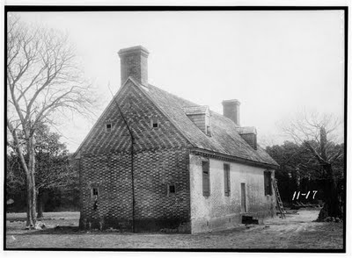* The Adam Keeling House stands today as a private residence at 3157 Adam Keeling Road, Virginia Beach in Great Neck Point near the mouth of the Lynnhaven. Adam referred to his house as "Ye Dudlies," a reference to the former Dudley property. The house was owned by the Keelings until 1884. It is a fine example of Flemish bond brickwork (alternate long and short bricks) with refined interior woodwork, decorative glazed headers, and a center hall design which was common in Tidewater Virginia colonial architecture. The owners have restored the house to its former beauty.
Like the Adam Thoroughgood House, the Adam Keeling House has been re-dated by the City of Virginia Beach. After study of the Adam Thoroughgood House, the City of Virginia Beach sponsored dendrochronology projects with the Adam Keeling House and the Lynnhaven House. This work solidified their conclusions for an eighteen century construction date for both the Adam Thoroughgood and Adam Keeling houses. The city re-dated the construction of the Adam Keeling House 15 years after Adam Thoroughgood House, or circa 1735. This date is a one century revision of information that has been on record for some time. Chief among this information is a December 1683 Lower Norfolk County Court record (book 4, page 155) titled Adam Keeling’s will of 25 April, 1683 states, “To my wife Ann Keeling, that plantation I now live and inhabit upon..for..life and after.” The oldest published description of the house that could be found is an article in the Virginian Pilot and the Norfolk Landmark titled, “Famous Old Monticello Farm Sold to Newly Organized Windsor Surf and Gulf Club,” dated October 24, 1926. The article states, “The farm [Monticello Farm formerly known as the Keeling Tract] contains the famous old Keeling house, a brick structure that was built in 1636, and which is still in an admirable state of preservation.”
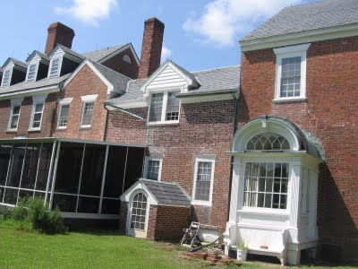The John B. Dey House at 1710 Dey Cove Dr, Virginia Beach, has had various additions built on to the original house shown above in the center.
The House that History Forgot. Around 1634 Thomas Allen (about 1607-1660) laid claim to his 550 acre estate on Broad Bay and built his house in 1637 (today’s John B. Dey House on Dey Cove Drive). It is the oldest house in Virginia Beach continuously occupied from the time it was built. Thomas Allen was a lawyer and one of the first members of Lynnhaven Parish. The only record available for Thomas is a will he executed for Henry Woodhouse, another early church member.
John B. Dey, for whom the Thomas Allen House and street were renamed, bought the Thomas Allen 550 acre estate in 1914. John’s holdings extended from Broad Bay, across present-day North Great Neck Road, to the western branch of the Lynnhaven River in sight of his first cousin’s estate, that of Benjamin Dey White (Senior Warden of Donation Church during its reconstruction in 1916). Benjamin purchased his ancestral home, White Acre, about the same time. John’s land holdings were extensive and included Chesapeake Beach fronting the Chesapeake Bay, just west of today’s Lesner Bridge. In 1918 he allowed 25 girls from the Y.W.C.A. camp at Broad Bay Farm to use the beach for camping, crabbing, fishing, and boating. Later in 1922, the Girl’s Work Committee purchased the beach and established Y.W.C.A. Camp Owasia (a Native American name meaning “camp of happiness”) (References 110, 167, 168, 169, 170, and 194).
The Woodhouses. Henry Woodhouse III (1607 - 1655) came to Virginia in 1630 and built his home on Linkhorn Bay shortly after a 1637 grant of 500 acres by the King of England. His estate was between those of Thomas Allen (1607-1660) and Francis Land II (1604 - 1657). Henry was a direct descendant of David I, King of Scotland, and his father, Capt Henry Woodhouse, was governor of Bermuda from 1623 to 1626. Henry's wife, Anne Bacon was a direct descendant of Edward I, King of England, and her father was Sir Nicholas Bacon the keeper of the Great Seal under Queen Elizabeth. Henry was a Lynnhaven Parish Vestryman and Justice from l642 to 1643 and member of the House of Burgess between 1647 and 1652.
Henry’s estate was willed from father to son for 269 years until 1906 with several houses being built on the plantation. The one standing today, “Old Comfort” at 1437 N Woodhouse Road, listed on Virginia Beach’s Historic Register, is just south of the original 1637 house (no longer standing). It was built using slave labor in 1832 by Henry Robert Woodhouse, the 8th generation from Henry Woodhouse III. It is called a Half House, common in this area in the early 19th Century, and thus named because Henry had planned to build the other half later, when he was prosperous enough to afford it. Because of a childhood illness Henry became stone deaf at 11 years of age. This physical handicap kept him from serving in the Confederate Army, but he was loyal to the cause of the south and was for years a friend of General Robert E. Lee who visited him at his home on Linkhorn Bay. When the war was over, and slaves freed, the Woodhouse slaves all stole off in the middle of the night leaving behind tiny baby Jim who was found the next morning in the kitchen and raised by the Woodhouse family. Henry Woodhouse died in 1890, and his wife Mary in 1907.
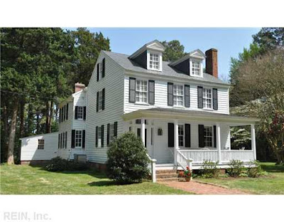
The Henry Robert Woodhouse 177 year old “Old Comfort” on N Woodhouse Road
Generation after generation of Woodhouse’s helped shape Lynnhaven Parish Church. There were certainly more than the folks recorded on these pages. On July 10, 1706 Captain Woodhouse was on the jury that heard the case against Grace Sherwood, accused of being a witch. John S. Woodhouse was one of the vestrymen who in March 1856 signed the minutes for the last time until the church was restored in 1916. Vestryman George H.H. Woodhouse (1840 - 1915) was a soldier in the Confederate Army and his memorial plaque is on the wall of the church. Josiah Woodhouse (1863 - 1929) worked to restore the church from 1910 to 1916. Josiah, along with his wife and infant daughter, are the only Woodhouses buried in Old Donation historical cemetery (References 205, 207, 238, 239, 240, 241, and 242).
The Moseleys (the six generations in Princes Anne County)
William Moseley I (1601-1655) in 1649 came to Virginia from Rotterdam, Holland with his wife Suzanna, two sons, William II and Arthur, and a large quantity of family jewels. As a Cavalier opposed to Oliver Cromwell, the jewels were all he was able to get out of England when he fled to Holland. Trading jewels, primarily to Adam Thoroughgood’s widow Sarah Thoroughgood-Gookin-Yeardley(1609 – 1657), in exchange for livestock, William I slowly gained prominence. As Commissioner of Lower Norfolk County from 1649 to his death in 1655 he built a sprawling Dutch- roofed house, Greenwich Plantation, later called Rolleston Plantation by his descendants. It was located on the edge of what would eventually be called Newtown, situated on the northeast corner of the I-64 and I-264 interchange just east of Woodlawn Memorial Gardens.
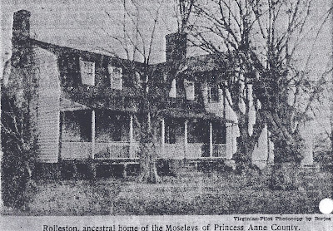
William Moseley II (1635-1700), son of William Moseley I (1601-1655) married Mary Gookin (1642 - ?), the daughter of Sarah Thoroughgood-Gookin-Yeardley (1609 – 1657), her last child by her second husband Captain John Gookin. William became Commissioner for Lower Norfolk County and was one of the investors that created Newtown in 1697. When William II died, Mary married Colonel Thomas Walke I (1642-1694), an immigrant from British-ruled Barbados and the first Walke in Princes Anne County (see the Walkes in this paper below). Two sons of William II and their descendants became leaders at Lynnhaven Parish Church and in local politics.
Descents of William II and Mary Gookin’s sons John (1670-1739) and Edward (1661-1736)
John (1670-1739)
Anthony (1689-?)
Francis (? - ?)
William (? - ?) and wife Betty Thorougood* (1747-1808)
Edward (1661-1736)
Hillary (1706-1736)
Edward Hack (1717-1782)
Col. Edward Hack (1740-1814)*
*Buried at Old Donation Cemetery, two of the oldest graves.
Edward Moseley (1661-1736), son of William II (1635-1700), married a widow, Mrs. Bartholomew Taylor. He was a Colonel in the County Militia, Justice of Princess Anne County, High Sheriff, and as Lynnhaven Parish Church vestryman a member of the court that tried Grace Sherwood. In 1697 he had the land around his estate established as the town of Newtown.
Edward Hack Moseley (1717-1783), grandson of Edward (1661-1736), married Mary Bassett (1737-1775) who died at the age of 35. Edward then married Frances Wylle who survived him. His daughter, Mary, married Antony Walke II (1726 - 1779) of neighboring Fairfield. Being loyal to King George III, the third British monarch of the House of Hanover, Edward enjoyed the social life of Virginia Governor Lord Dunmore right up until 1775 when the unpopular Lord Dunmore was forced out of Virginia in skirmishes leading up to the Revolutionary War. He remained loyal to the King throughout the Revolutionary War but was too old to take an active part in the conflict. So prominent was he at Old Donation that in 1767 he had a private Great Pew built where the pulpit stands today causing the side door to be moved about eight feet from the end of the long north wall to its present location.
Col. Edward Hack Moseley (1740- 1814), son of Edward Hack (1717 – 1782), first married Ann Lovett (1745 - ?) and then Martha Westwood (1747 – 1824). Following his father, Edward was a member of the House of Burgess, Clerk of Princess Anne County, and a vestryman at Old Donation. He was a loyal patriot during the Revolutionary War. Father and son stood on opposite sides, but this obviously did not affect their relationship. A plaque was placed by his broken grave stone in the Old Donation Cemetery by the Princess Anne County Chapter of the NSDAR Bicentennial Project 1977. Edward and Martha’s third child, Burwell Bassett, (1788 – 1868), married Elizabeth Amy Boush (1792 – 1815), the daughter of William Boush (1759 – 1834), a direct descendant of Maximilian Boush II (1660 – 1728) who was the prosecuting attorney against Grace Sherwood (the infamous Witch of Pungo).
Today Rolleston and Newtown are no more. Rolleston stood more than 200 years until it burned down sometime in the late 19th century. At the Kempsville Pleasant Hall there is a pair of old wrought irons that once held the logs that burned in Rolleston. And the family jewels that once belonged to William Moseley I are scattered among Sarah Thoroughgood-Gookin-Yeardley’s heirs. (References 246 – 254).
The Lands are one of the several notable families important to Lynnhaven Parish and to local government. Francis Land II (1604 - February 15, 1657) arrived in the area about 1638, and along with Thomas Walke, brought slaves to work the lucrative tobacco fields. By 1657 Francis had acquired 1,020 acres of land adjacent to Henry Woodhouse’s estate. He used flat bottom canoes to transport goods from Pine Tree Branch to the Chesapeake Bay. In 1640 he married Frances (1619 - 1646) whose surname is unknown. On 26 May 1647 Francis was nominated by the Court to serve as Churchwarden for Lynnhaven Parish Church. Francis’ oldest child, Renatus married next door neighbor Frances Keeling in 1665, the daughter of Thomas Keeling. Francis and Frances’ other two children were Francis III and Susan. Francis III had four more male descendants named Francis Land up through Francis Moseley Land VI. By the mid-18th century the plantation had around 20 slaves, typical for the tobacco plantations in the area.
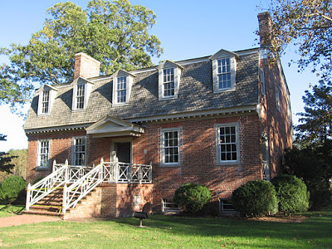The Francis Land House stands today at 3131 Virginia Beach Boulevard with the City of Virginia Beach placing its construction around 1805, which means Francis Moseley Land VI built it, but his descendants before him lived on the same estate and had houses in the same relative location. As is the case with the Adam Keeling and Adam Thoroughgood houses, the house standing today could date back much earlier. For example, a brick in the cellar has the date 1732 inscribed on its surface. Francis Moseley Land VI and his family lived there until 1819 when he died. He and his wife had two daughters who held onto the land until about 1850 when it was first sold outside their family. The City of Virginia Beach purchased the house and land in 1975 and in 1986 started operating it as a historic house museum. The Georgian Flemish-bond brick style house has heart of pine floors and Federal style antiques. Other examples of a Georgian Flemish-bond brick style house are Captain Thurmer Hoggard’s (1728 - 1779) Poplar Hall built in 1764 and historic Old Donation Church constructed in 1736. Today the manicured grounds include herb, vegetable, flax, formal, and "pleasure" gardens, as well as a history park which includes a constructed one-tenth mile nature trail in a wooded wetland with interpretive sign exhibits (References 190-193 and 233).
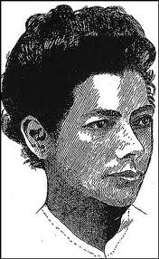Grace Sherwood - the Witch of Pungo (1660 – 1740). Grace’s father was John White, a carpenter and planter. She married James Sherwood at Lynnhaven Parish Church (Church No. 1) in 1680 and had three sons. Grace’s problems started in March 1697 when Richard Capps accused Grace of casting a spell on his bull, causing it to die. There were no findings, but the Sherwoods then brought suit against Capps for defamation, which by agreement of the parties was dismissed. Then in 1698 Grace was accused by John Gisburne of bewitching his hogs and cotton. James Sherwood brought an action for slander, but lost, and again was unsuccessful in an accusation of slander against Anthony Barnes, who charged Grace with riding his wife and then escaping through the keyhole in the shape of a black cat.
Grace’s husband James died in 1701 and left Grace to fend for herself in working the family's farm and raising her three sons. Bucking tradition by not re-marrying promptly, she unwittingly became exposed to hostilities she had created with her neighbors. Working the farm was hard work, and Grace often wore men's clothing (a rarity for women) while tending to the day-to-day activities on the farm. She was a skilled herbalist, and all of the rosemary growing in Virginia Beach is supposed to have come from a single piece Grace brought from England. As a skilled herbalist, she used her knowledge to cure church members and advise them on which herbs to use for their ailments (to her detractors – the work of a witch). She also served as a mid-wife for countless women. She was strikingly attractive, strong-willed, and a non-conformist by nature. All of these maverick traits plus the bad blood over the petty lawsuits filed by her former husband were more than enough to rekindle rumors about her witch-like behavior. She was accused of blighting gardens, causing livestock to die, and influencing the weather.
Sometime in 1704 Grace got into a fight with Luke Hill’s wife Elizabeth. With Grace getting the worst of it, she sued the Hills for assault and battery. Grace was awarded fifty pounds sterling. After that verdict Luke Hill and his wife resolved that Grace should pay dearly. So in February of 1706 Luke Hill and his wife Elizabeth formally accused Grace of witchcraft, and she was duly hauled before the county court on the charge of having bewitched the wife of Luke Hill. A jury of women was ordered to search her body for suspicious or unusual markings, thought to be brands of the devil, and naturally the jury found, "marks not like theirs or like those of any other woman." However, neither the local court nor the Attorney General in Williamsburg would pass judgment declaring her a witch. The case went back and forth between Williamsburg and Princess Anne County for the next five months. Each time Grace was required to appear in court next to Lynnhaven Parish Church (Church No. 2), she had to make a sixteen mile trek from her farm in Pungo to the court.
Grace finally agreed to have her day in court, and on July 10, 1706 Maximilian Boush, an early warden of Lynnhaven Parish Church (who gave the silver paten which bears his coat of arms to Lynnhaven Parish Church in 1711) prosecuted the case against Grace in front of a jury from the Lynnhaven Parish Vestry (Colonel Edward Moseley, Captain John Moseley, Lieutenant-Colonel Adam Thoroughgood, Captain Woodhouse, Sir John Cornick, Captain Chapman, William Smyth, and Mr. Richardson). Grace was first taken inside Lynnhaven Parish Church (Church No. 2), placed on a stool and commanded to ask for forgiveness for her witchery. She said, “I be not a witch, I be a healer.” Not only was this a travesty of justice but the Lynnhaven Parish congregation knew at the time that Luke and his wife were seeking retribution for Grace’s successful suit two years earlier. Instead of testifying on her behalf, they turned their backs on a widowed woman of five years who did not fit in with the norms of that day. The verdict from the jury was for Grace to undergo the ordeal of ducking to ascertain her witchery. If Grace would float in consecrated water she would be deemed guilty of witchcraft; if she drowned, she’d be innocent. Grace was then promptly led out of the church and marched down the dirt road (now Witchduck Road) around 10 a.m. This portion of the land and river where she was cast out of a row boat has since been named Witchduck Point and Witchduck Bay in memory of the occasion. This being a big event, hoards of people from all over the colony flocked to the scene as news of the ducking spread throughout the Commonwealth.
Five women of Lynnhaven Parish Church (Sarah Norris, Margaret Watkins, Sarah Goodaerd, Mary Burgess, and Ursula Henley) examined her naked body on the shoreline for any devices she might have to free herself. Six of the eight member jury (all Lynnhaven Parish vestrymen) rowed out in one boat. In another were the sheriff (Colonel Edward Mosely), the magistrate, and Grace. Just before she was pushed off the boat, the defiant and resolute Grace Sherwood spat out, “Before this day be through you will all get a worse ducking than I.” Grace, bound cross body (thumb to toe), was cast into the river where she quickly floated to the surface. The sheriff then tied a thirteen pound Bible around her neck. Sinking to the river depths once again she was able to untie herself and swim to the surface, proof that she was a witch. For this she spent seven years and nine months in the jail next to Lynnhaven Parish Church.
On July 10, 1706, the day Grace was tried and convicted, the vestrymen of Lynnhaven Parish Church met and voted funds for a proper ducking chair since the procedure used that day (being tossed overboard) was not the proper tradition used in Salem, Massachusetts and would provide no possibility of escape as witnessed in Grace Sherwood’s case. Because twelve years had passed since the infamous Salem Witch trials, interest in perusing other witches trailed off and the ducking chair was never purchased. Nevertheless, Lynnhaven Parish Church would continue to use their stock and pillory for those that perpetrated transgressions. Publicly shaming wrongdoers was customary in early Virginia and enlivened otherwise dull sermons.
Also on this day, July 10th, at the same hour, 10 a.m., 293 years later (1999), the ribbon was cut at Virginia Beach Recreation Center on First Court Road opening the Bayside History Trail that winds its way past Grace’s ducking place and Old Donation Church, two locations revealed to tour groups as places tied to each other in history.
After being released from jail, Grace Sherwood gathered her three sons, John, James and Richard, from a relative who had been looking after them, sued Princess Anne County to get her property back, paid back taxes, and lived out her life quietly on her 145 acres of land in Pungo near present day Muddy Creek Road, 16 miles southeast of present-day Old Donation Church. Grace died at the age of 80 in 1740. Her remains lie unmarked under a clump of trees in a field near the intersection of Pungo Ferry Road and Princess Anne Road.
Today a bronze statue of Grace Sherwood stands watch over Old Donation Church as the most infamous Lynnhaven Parish Church member of old and possibly the most wronged. Sometime about 2003, interim Rector Howard Hanchey talked about Grace from the pulpit admitting that the church had wronged her and that she was in fact a wonderful woman who most likely saved lives through her knowledge of herbs and as a mid-wife. In 2006 the Governor of Virginia officially admitting Grace had been falsely accused and was not a witch but instead an incredible woman, a woman the state of Virginia and Lynnhaven Parish Church wronged (References 10, 11, 12, 13, 28, 35, 40, 42-page, 53, 331, 137, 165, and 166).
Belinda Nash (1946 – present). (1946 – present). Canadian citizen and former Church Historian, Belinda joined Old Donation Church in 1985 and immediately became fascinated with the story of the church’s involvement with one of its congregants, Grace Sherwood, accused by a fellow congregant, Elizabeth Hill, of witchery. She spent long hours digging up historical documents about Grace Sherwood and Old Donation Church. In 2004 she asked interim Reverend Howard Hanchey if a $93,000 bronze statue of Grace Sherwood, sculpted by California artist Robert Cunningham, could be placed on the grounds of Old Donation Church. She argued that this would act as vindication for the wrong that forebears of the church had committed. Reverend Hanchey tentatively agreed, but when the Vestry got wind of this they tabled the issue, reasoning that such honor should be reserved for Christ and the Saints. Belinda sought another location near Old Donation. In the interim she was successful in persuading the Governor of Virginia, Timothy Kaine, to officially exonerate Grace Sherwood on the 300th anniversary (July 10th, 2006) of her conviction. Then in April 2007, though Belinda's tireless efforts, the statue of Grace found its way to a location next to Old Donation property on Sentara Bayside Hospital grounds at the corner of Independence Boulevard and North Witchduck Road, a mile from Sherwood's ducking point. Dubbed “Gracie's Girls," Girl Scouts gather each year to return Grace Sherwood's luster. Belinda’s closeness to the Grace Sherwood story has some observers saying that she is Grace Sherwood incarnate. Currently Belinda is director of the Ferry Plantation House just a walk down the road from Old Donation Church (References 10-13, 26, 35, 53, 55, and 165).
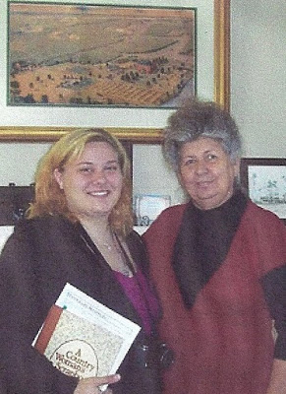Belinda Nash standing to the right and below General Thomas Hoones Williamson’s 1812 watercolor.
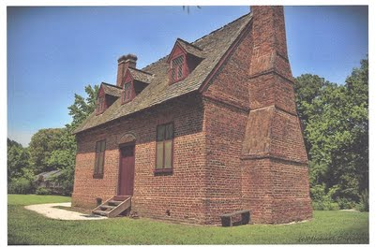__________________The Lynnhaven House at 4405 Wishart Road, Virginia Beach
Francis Thelaball. In 1725 Lynnhaven Parish Church was basking in the “Golden Age” of prosperity with a rich and aristocratic membership. Most of its members participated in the governance and political interests of the area and owned large tracts of land. This left little room for newcomers and would eventually by the early 19th century spell the doom for Lynnhaven Parish Church. One member, Francis Thelaball, a ship’s carpenter and master craftsman, being at the low end of the Lynnhaven social scale, established his status among his fellow church members by building a showplace 18th century Tidewater Virginia vernacular house with rich quality features. In 1725 Francis purchased 250 acres of land, a “middling farm,” and built his house (today’s’ Lynnhaven House). Using English bond pattern brick, Francis finished the house with brick jack arches, a closed-string staircase with teardrop pendant (a decorative finishing touch), and a ship's lap floor. Francis Thelaball died in 1727, two years after completing his house. Today the City of Virginia Beach owns the property. Guided tours discuss the roles of the household members--Francis, his wife Abigail, their five sons, an apprentice, and several enslaved people--as well as the Tidewater world of the early 18th century (Reference 178).
The Walkes. This is the story of Thomas Walke I, his two sons, their descendants and the historic houses they built.
Colonel Thomas Walke I (about 1642-1694) was an immigrant from British-ruled Barbados. He was born before 1643. While his exact birth year is unknown, he witnessed a will in Lancaster County, Virginia in 1664 requiring an age of 21. He married Mary Lawson in 1690, also an emigrate from Barbados. Thomas died in 1694, only four years after his marriage, leaving three children, Thomas II or Jr. (1691-1723), Anthony I (1692- 1768), and Mary. Thomas held colonial distinction and was commissioned a colonel by the Governor of Virginia. He made his fortune shipping goods to Barbados from Hampton Roads and slaves back to Hampton Roads from Barbados.
Thomas Walke II or Jr. (first son of Thomas Walke I) and His Descendants
Thomas Walke III - (around 1720– 1761) was the son of Thomas Walke II. He acquired land in Princess Anne County near London Bridge in the early 1700's. He had five daughters to his 1st wife Margaret Thorowgood and one son Thomas Walke IV (1760 – 1797) to his second wife Mary Ann Thorowgood. In 1759 Thomas III built a brick house, (preserved today at 2040 Potters Road, Virginia Beach) on Upper Wolfsnare Creek, an important waterway then. In 1761 Thomas III died, leaving Upper Wolfsnare to his infant son Thomas IV including seven thousand acres and fifty-five slaves.
Thomas Walke IV (1760 – 1797) was the son of Thomas Walke III. He grew up to be prominent in Princess Anne County. He fought in the Revolutionary War and was one of the two local representatives to the Virginia Convention. In Richmond in the spring of 1788 he helped Virginia, by a narrow margin, ratify the U.S. Constitution. He served as Vestryman and Warden of Lynnhaven Parish for many years. He had much to do with the designing and building of the third Eastern Shore Chapel which stood less than a mile from his home. Thomas IV had Communion Silver bearing the date 1759 shipped from England to Eastern Shore Chapel. The silver is now on exhibit at the Norfolk Museum. Thomas married Elizabeth (1797-1815), but had no children. In his will he left his estate to his wife Elizabeth and two of his sisters. Upper Wolfe Snare Plantation was purchased by the Commonwealth of Virginia to obtain right of way for the Norfolk-Virginia Beach Expressway in 1964, but members of the Princess Anne Historical Society, were able to save the house as a historic landmark.
Colonel Anthony Walke I (second son of Thomas Walke I) and His Descendants
Colonel Anthony Walke I (1692- Nov 8, 1768) was a man of high standing and character in the Lynnhaven Parish Church serving as a vestryman for many years and contributing to its support. Through his efforts and contributions, Lynnhaven Parish Church No. 3 was built using imported brick. He was Colonel and Commander of troops in Princess Anne County under his majesty King George III. He married three times. His first wife was Mary Sanford. They married March 3 1711 and had a daughter, Margaret Walke. His second wife was Elizabeth Newton. They married after 1713 but she died in 1724. They had no surviving children. Anthony's third wife was Anna Lee Armistead. They married on April 4, 1725 and had four children: Colonel Anthony Walke II, William Walke, John Walke, Mary Walke and Margaret Walke.
Colonel Anthony Walke II (1726 - 1779) was the son of Colonel Anthony Walke I. Colonel Walke II was one of the wealthiest Virginians of his day, a great advocate of social dinking, extravagant social gatherings, gambling, and horse racing. When trouble with England began, as a member of the Virginia House of Burgesses, he espoused the cause of the colonies, and united with Patrick Henry, Mason, Madison, Marshall, Jefferson, and other patriots in resisting British oppression and in establishing American independence. He married Jane Bolling Randolph (1729-1756) who was a direct descendant of Powhatan, the most powerful chieftain in Tidewater Virginia at the time of the arrival of the Jamestown settlers in 1607. This strain in her blood could account for her children’s horseback riding abilities. Reverend Anthony Walke was the only surviving child of these parents. After she died, Col. Walke II married Mary Mosely and had several children: William Walke (1762 - 1795) (who is buried on the property at Ferry Plantation), Edward Hack Walke, John Basset Walke, Mary Walke, Frances Walke and Anna Walke.
Reverend Anthony Walke (1755 - 1814) was the son of Colonel Anthony Walke II. He married Anne McColley McClenahan on January 15, 1776 and had six children: Anne M., Edwin, Jane Eliza, David Meade, Susan, and Anthony IV (1778 - 1820). On July 13, 1805, five months after Anne died, he married Anne Newton Fisher (1774 - 1840). They had three children: John Newton, Thomas, and Lemuel. They are all buried in the old burial ground in what is now Fairfield's subdivision, in unmarked graves.
Reverend Walke was 20 years old in the early winter of 1775 when he most likely witnessed troop movements and battles between Continental Army troops and Virginia Governor Lord Dunmore’s Loyalist troops (people who supported King George III) in battles at Kemp's Landing, 2.5 miles north and then at Great Bridge, 9 miles south of his Fairfield Manor House. The Revolutionary War (1775–1783) caught Reverend Walke at a time when he was coming of age into a Virginia gentry threatened by the loss of political power, wealth, and social prestige made possible by English control over the Virginia Colony. In his writings he blamed the north and their foolish Boston Tea Party actions.
Reverend Walke was a representative to the Virginia Constitutional Convention, and after the Revolutionary War, in early 1788 he was ordained a priest of the Episcopal Church in Philadelphia, and then served the following year as an elector from the State of Virginia to the first presidential election held in Philadelphia. Returning to Princess Anne County, Reverend Walke, with a large inheritance from his father, presided as rector over Lynnhaven Parish Church for many years without a salary (from 1788 to 1800 and again from 1812 to 1813).
Reverend Walke divided his time between preaching and the hunt. Not only was he noted for delivering sermons with a captivating mild mannered voice, but a more picturesque side of him was his love of fox and deer hunting. He conducted sermons with his horse Silverheels tethered near the door of the church. When he heard those hunting horns, he would immediately turn the service over to his clerk, Dick Edwards, and hurry off on Silverheels, not seen again until late in the day (see references 14-16, 25, 120-122, 145, 147, 151-154, 211, 214 – 216).
__________________________The Walke’s Historic Homes.
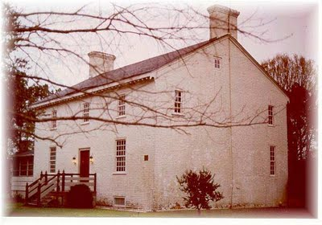* Upper Wolfsnare House. Of the three noted historic homes, only one stands today – the brick house Thomas Walke III built in 1759 at today’s 2040 Potters Road, Virginia Beach on Upper Wolfsnare Creek, an important waterway in 1759.
* Fairfield Manor. Four years after Colonel Thomas Walke I’s death, his executors in 1697 purchased the land from Tully Emperor to become the home of his second son, Colonel Anthony Walke I (1692 – 1768). Fairfield Manor House was located just south of present day Virginia Beach, Kempsville (in the vicinity of Locke Lane and Kempsville Colony, near Kempsville Park). Fairfield was a grand house with black servants, blacksmiths, wagon-makers, saddlers, and tradesmen imported from England. Fairfield belonged to five generations of Walkes, i.e., Colonel Anthony Walke I (1692-1768), Colonel Anthony Walke II (1726-1779), Reverend Anthony Walke (1755-1814), Anthony Walke (1778-1820), and David M. Walke (1800-1854), until it was destroyed by fire March 1865.
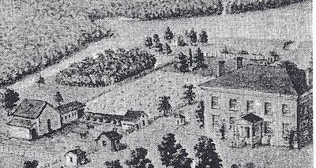The First Ferry Farm House (Walke Manor House) is shown above in General Thomas Hoones Williamson’s 1812 watercolor picture.
* First Ferry Farm House. Colonel Anthony Walke II made plans for a second house at Ferry Farm (near Lynnhaven Parish Church) and bequeathed the land to his second son, William (1762-1795) who built the 1st Ferry Plantation House (Walke Manor House) in 1782 for his half brother Reverend Anthony Walke. It was owned by Walkes until it was destroyed by fire in 1828. The house was replaced by a smaller one in 1830.
On October 21, 1914 Lewis Walke and his son, Roger S. Walke, visited the Ferry Plantation and found the tomb of Lewis Walke’s great-grandfather, William Walke (1762 – 1795), Colonel Walke II’s first son by his second wife Mary Moseley. The tomb was several hundred yards from the Ferry House with the stone lying flat on the ground. Sometime in the 1930’s Ann Talbot Parks had this gravestone moved to the Old Donation Cemetery. The inscription is no longer legible, but was recorded by Lewis Walke back in 1914. It reads, “Here lie the Remains of WILLIAM WALKE late a Magistrate & Representative of this County Who departed this Lifethe 1st of Janry., 1795 Aged 33 years In Life Esteemed in Death lamented”
(References 3, 4, 14-17, 120, 145, 147, 182, 212, 213).
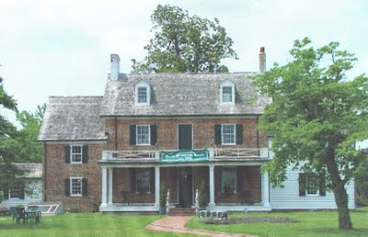_____________________The second Ferry Farm Plantation House built in 1830
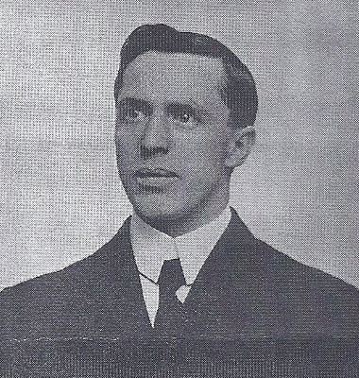
Slade Charles M. Barnett (1869 - 1940) and his wife purchased Ferry Farm Plantation in 1898. In Oct 1912 Stella died from toadstool poisoning. This was one of his three homes (his others were a home in New York City and the Charles M. Barnett House at 521 Fairfax Avenue in Norfolk as listed on the Historical and Cultural Inventory of the City of Norfolk). Barnett was in the shipping and oyster business, and he shipped the famous Lynnhaven Oysters all over, including to New York’s Waldorf Astoria Hotel and Grand Central Station. Though his New York connection, the church was able to obtain a $7,000 loan from a New York bank. As a member of the vestry during reconstruction of the burned-out church he was close friends with Church Warden Judge White. He and his wife Stella Barnett held oyster roasts for church members at their Ferry Farm Plantation home alternating with Judge White at his White Acre home, both roasts located next to the Lynnhaven River (Reference 57).
Captain John Saunders II (1754 - 1834) was the great-grandson of Reverend Jonathan Saunders (Rector of Lynnhaven Parish from 1695 – 1700) and son of Captain Jonathan Saunders (1726 – 1765).
During the years preceding the war, there was much debate in the social circles at Lynnhaven Parish Church over the growing rebellion against Great Britain. John Saunders chose to be loyal to King George III and joined the Queen's Loyal Virginia Regiment. Captain John Saunders’ Regiment would eventually find its way to Yorktown in September 1781 under the command of General Lord Cornwallis, but Saunders was not among them as he was ordered to Charleston, after it had been captured, to command the garrison there.
Before the war ended, Captain Saunders II sailed for England in November 1782 and in 1789 married Arianna Jekyll. In the same year, John moved back to North America where, having been trained as a lawyer, he was appointed a judge of the Supreme Court of New Brunswick, Canada. Here he lived out the rest of his life (References 1-page 78, 74, 94, 95, 96, 102, 118, and 130).
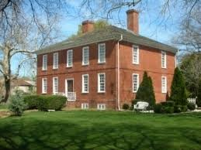Pembroke Manor was built in 1764 by Captain John Saunders I (1726 – 1765), the father of Captain John Saunders II (1754 - 1834). The manor stands today on Constitution Drive, just off Independence Blvd. near Virginia Beach Blvd. As a result of his choosing to side with the British, in 1779 Captain Saunders II was called before the Princess Anne County Safety Committee, declared a British subject, and had Pembroke Manor confiscated. The grave of Captain John Saunders I was moved from Pembroke Manor without remains to the Old Donation Cemetery and is the oldest grave site in the cemetery. The inscription on his tomb stone reads –
SACRED TO THE MEMORY OF
CAPT. JONATHAN SAUNDERS
who was a person of great piety and a most
humane Disposition
being beneficent to all
as far as his ability Reached
An easy unoffensive, obligating behavior
adored all his actions
was a kind Husband
tender father a sincere friend
he died universally Lamented
on 21st January 1765
in the 39th year of his age.
(Reference 160)
Sarah Thoroughgood (1759 – 1851). According to Amy Waters Yarsinske in her book “Virginia Beach, A History of Virginia's Golden Shore,” (page 78), Colonel Adam Thoroughgood, a descendant of the first Adam Thoroughgood, was an officer in George Washington’s army who was wounded at the battle of Yorktown (October 1781). While Adam was off fighting, the British overran Adam’s plantation estate and commandeered it for a British headquarters. The British told Adam’s wife, Sarah, that they would provide her husband a “parole of honor” if he would return home from the battle. In the tradition of Thoroughgood wives, Sarah replied with rebellious indignation, “I would rather see him dead.” After the war and Thoroughgood’s death, Sarah went on to marry a gentleman named Ingraham, only to see him die. The parallel between the first Thoroughgood and his wife Sarah one century before ends here, as the second Sarah did not marry a third time but instead moved in with her sister in Norfolk until Sarah’s death in 1851 at the age of 92 (Reference 1 - page 78).
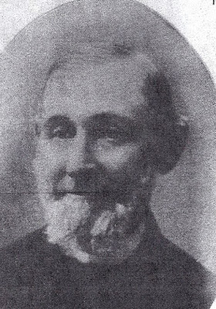Thurmer Hoggard IV (1819-1902). (1819-1902). Serving for a time as Princess Anne County Treasurer, Thurmer was an influential citizen of the county. He lived in his ancient family home known as Poplar Hall and there had a shipbuilding business on Broad Creek. His shipyard is believed to be the first navy yard in America. At the early age of 23 he was appointed Lay Reader by the late Bishop Meade and later elected by the Vestry as a delegate to the Diocesan Council of Virginia. He worshiped at Old Donation until services ended around 1844 and then switched to Emmanuel Episcopal Church in Kempsville. There he continued as a delegate to the Diocesan Council for 60 successive years and also served as a Senior Warden. In 1882 he came to rescue the burned out Old Donation Church by holding annual pilgrimages to the open shell of Old Donation so the county could not take possession of the land. He was the only living Episcopalian who had worshipped at Old Donation before it burned. After Hoggard’s death in 1902 his son, Captain Thurmer Harding Hoggard V, a Confederate veteran, and two daughters Mary and Fannie Hoggard continued annual services at Old Donation. Thurmer Hoggard not only saved the church but also the vestry records which he handed to Judge White, who in turn handed them to the Richmond Court House. They were later edited and published by George Carrington Mason in 1949. Malcolm Higgins located these two vestry books (1723 – 1911) in the Library of Virginia (the official Commonwealth of Virginia depository) in Richmond and had the records photocopied. They now reside in the Rector’s office at Old Donation. In a cavity within the cornerstone of Donation Church, there is a time capsule, placed there in 1916, containing short sketches prepared by Thurmer. What is said on these documents remains unknown until they are uncovered in some distant and far off time (References 1–page 95, 3, 44, 75 and 157).
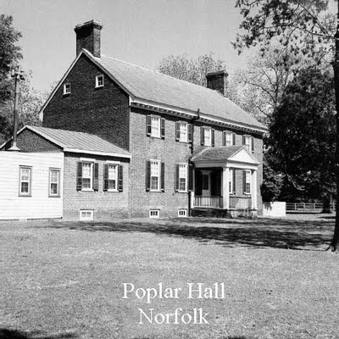Poplar Hall stands today in Norfolk on Broad Creek at the intersection of Poplar Hall Drive and Stuart Circle. The Georgian Flemish-bond brick style house was built by Thurmer Hoggard IV’s grandfather, Captain Thurmer Hoggard (1728 - 1779) in about 1764. The house was named for the row of Lombardy poplars brought from England and planted between the house and the creek. The house stayed in the Hoggard family for 190 years, surviving three wars and numerous fires and storms. In 1991 Poplar Hall was designated a Virginia Historic Landmark. During the yellow fever epidemic of 1855, many Norfolk families found refuge with the Hoggard family, and Poplar Hall's lawn was covered with tents sheltering the community. Today the front is mostly sheltered from the road by large poplars lining the front walk (Reference 159).
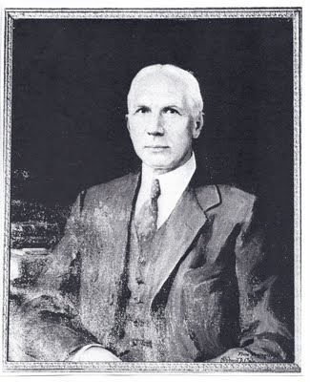The above portrait of Judge White was unveiled and hung a year after his death in the Circuit Courtroom of the 1822 Courthouse building.

