THE WAR OF 1812 SOCIETY IN VIRGINIA PARTICIPATES MAY 3 2014 IN A JOINT GRAVE MARKING CEREMONY WITH THE THOMAS NELSON JR CHAPTER VASSAR
Three members of the War of 1812 Society participated in a joint ceremony with the Thomas Nelson Jr Chapter, VASSAR at the Ware Episcopal Church Cemetery in Gloucester County on Saturday May 3rd

Hugh Markham assisted with everything and was the photographer; Charles Belfield installed the1812 grave markers, participated in the color guard, unveiled one grave 1812 marker and was the 1812 Musket Firer; and Mike Lyman who coordinated the event with the SAR and the church, researched the service of the 1812 & Rev War patriots to be honored, participated in the color guard; gave greetings and information about the 1812 veterans and presented the society wreath

The event was attended well and several societies presented wreaths and/or their colors besides ours. Included are: The VA Huguenot Society, The Richard Henry Lee Chapter, The Thomas Nelson, Jr Chapter, The Williamsburg Chapter and the Norfolk Chapter, VASSAR. One descendant of the Tabb family was there and was assisted by VASSAR President Bill Broadus in the Rev War unveilings

The programs below show more details. Since this year is the 200th anniversary of the penning of the National Anthem by Francis Scott Key the anthem was sung by everyone. A nice touch!

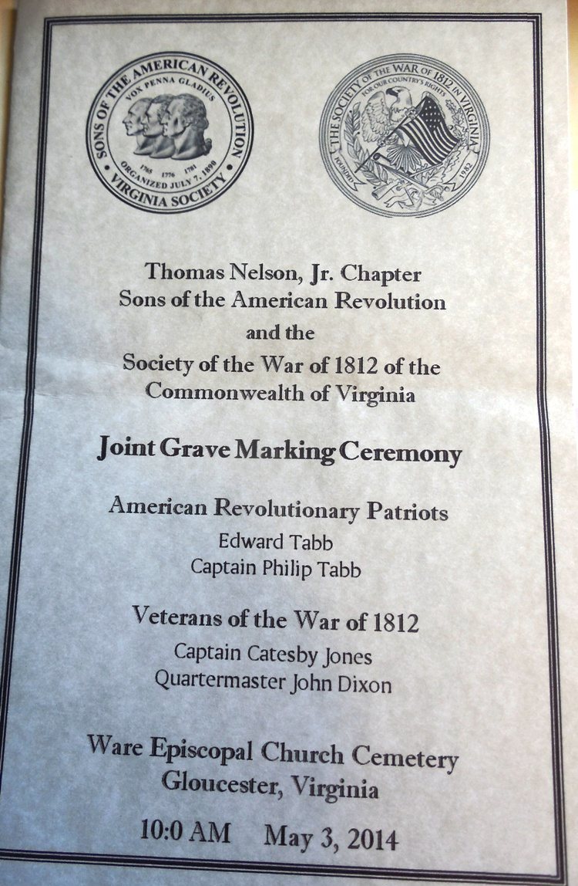
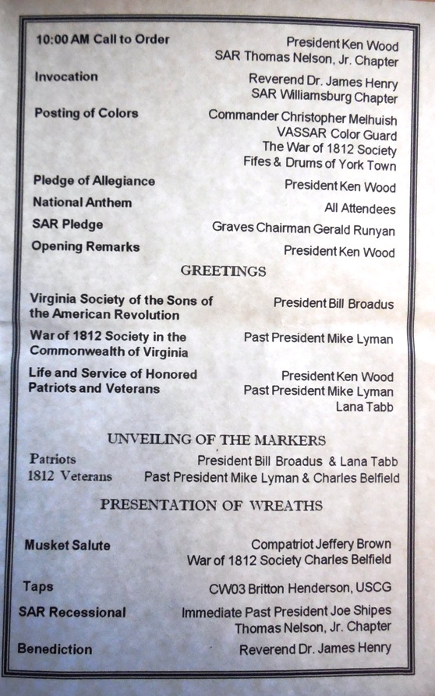
BELOW ARE THE GRAVESTONES OF THE WAR OF 1812 VETERANS THAT WERE HONORED
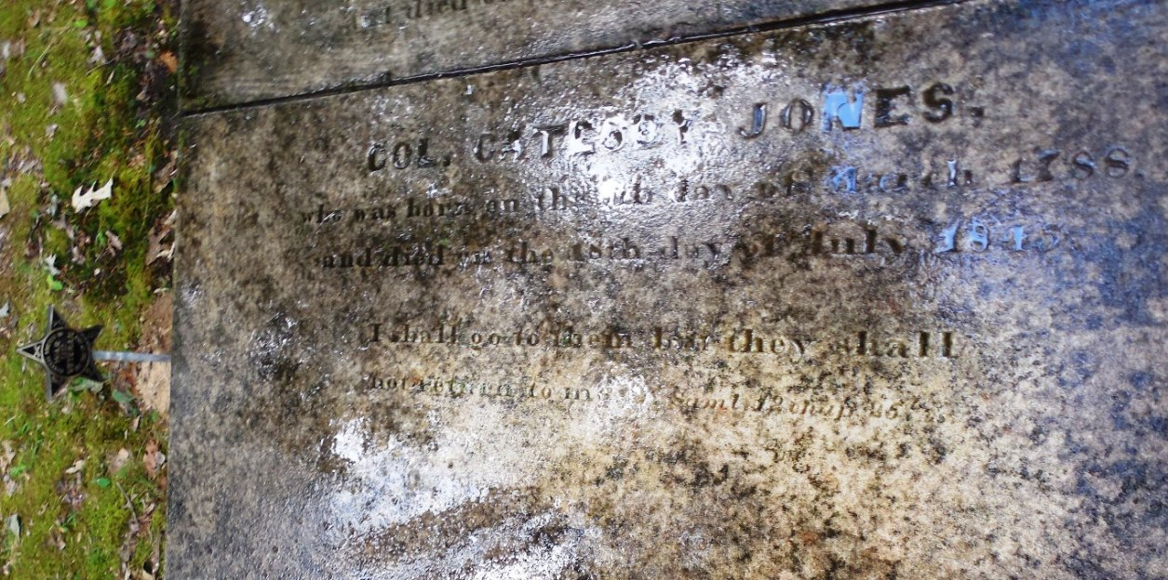
ABOVE IS THE GRAVESTONE OF CAPTAIN CATESBY JONES AND BELOW THE GRAVESTONE OF QUARTERMASTER JOHN DIXON
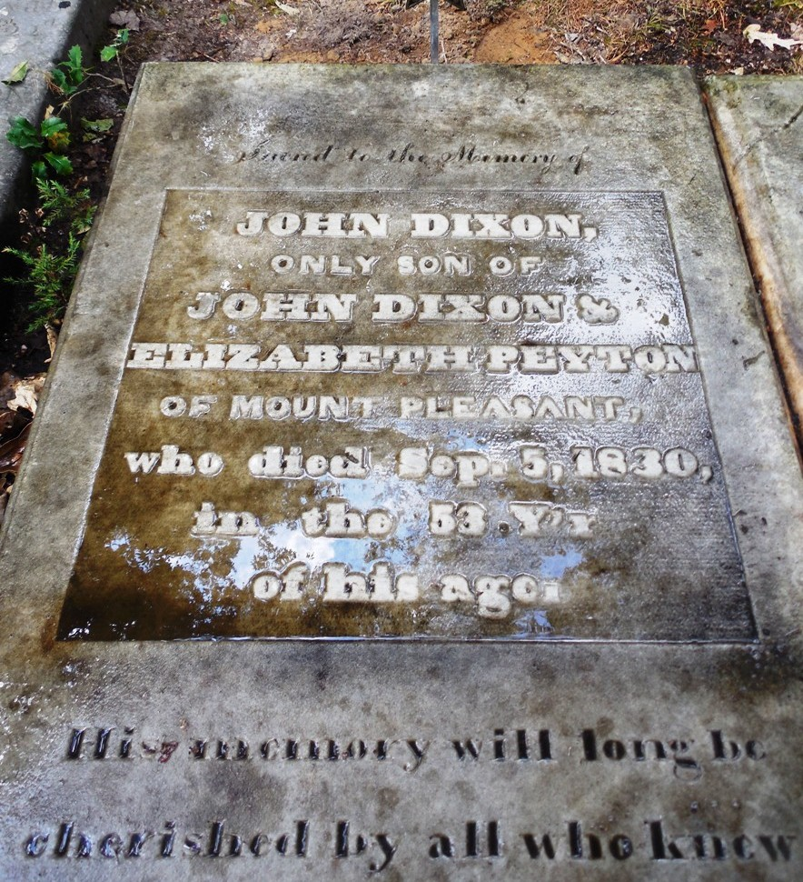
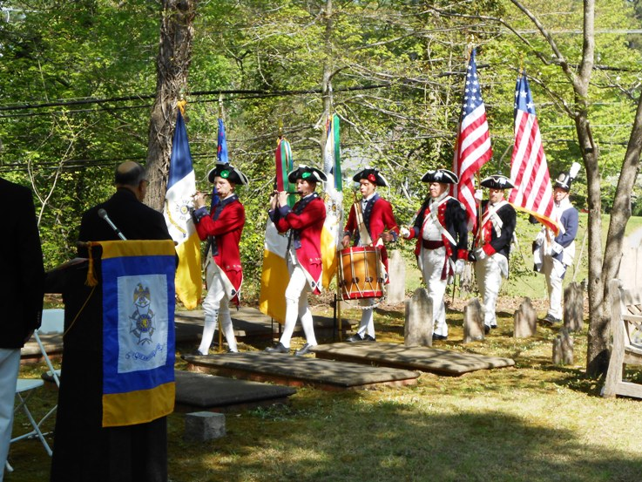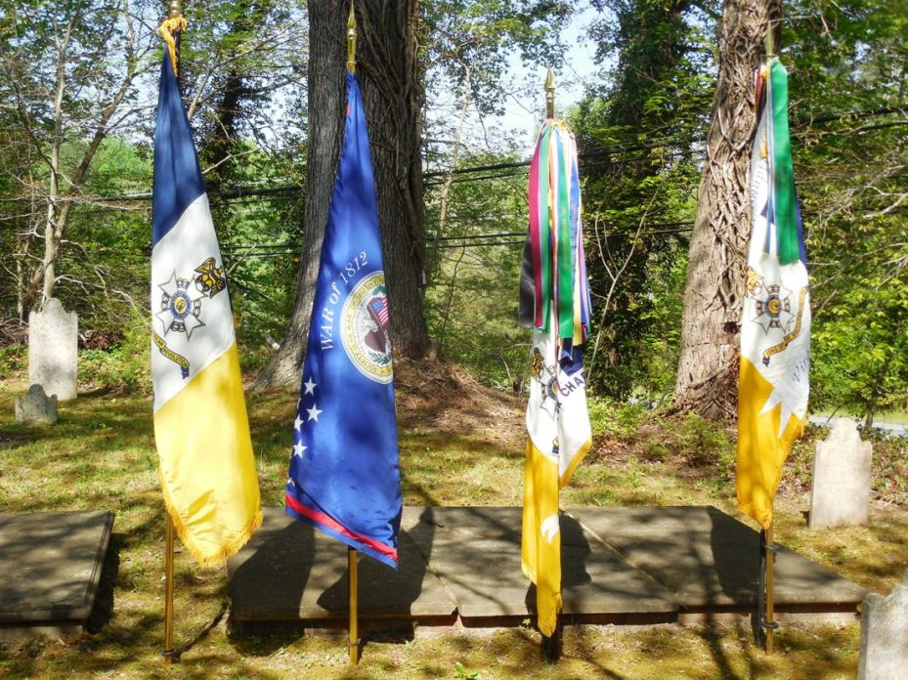
THE ABOVE SOCIETIES PRESENTED THEIR COLORS
L/R: VIRGINIA SOCIETY SONS OF THE AMERICAN REVOLUTION FLAG; WAR OF 1812 SOCIETY IN THE COMMONWEALTH OF VIRGINIA FLAG; THE THOMAS NELSON JR SAR CHAPTER FLAG AND THE RICHARD HENRY LEE CHAPTER, SAR FLAG
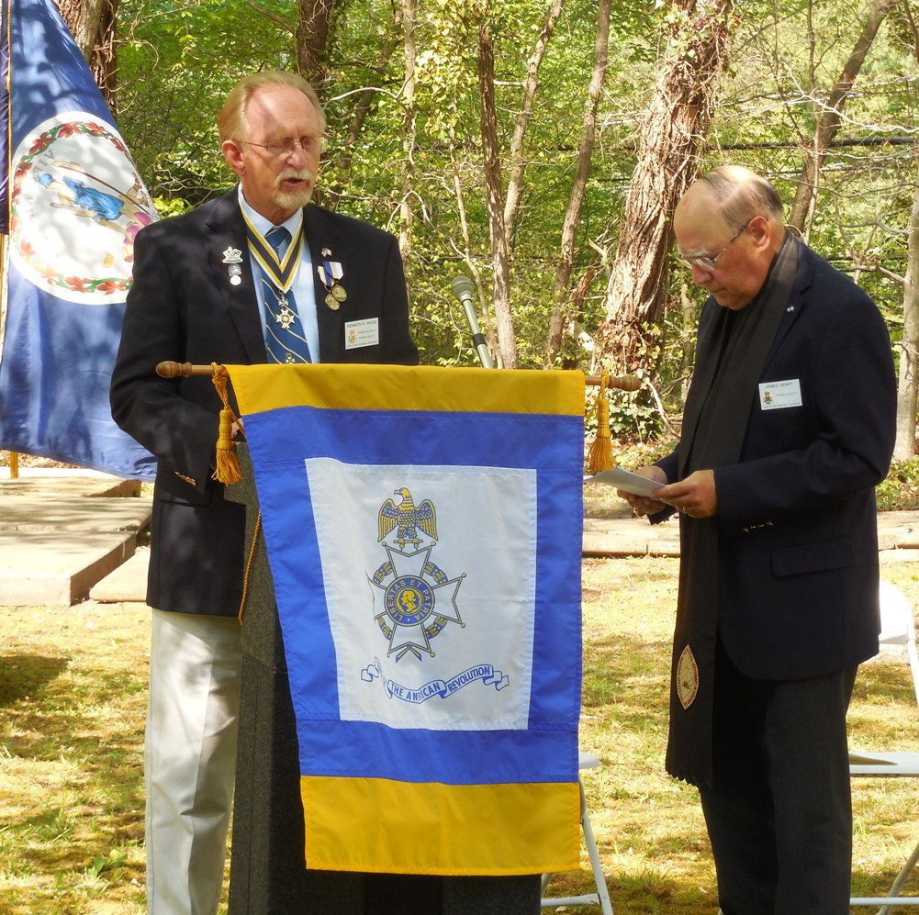
PRESIDENT KENNETH WOOD OF THE THOMAS NELSON JR CHAPTER WAS MASTER OF CEREMONIES AND HIS CHAPLAIN , REVEREND JAMES HENRY GAVE THE INVOCATION AND THE BENEDICTION AND THEY BOTH TOGETHER PERFORMED THE UNVEILING OF MARKERS RITUAL
PRESIDENT OF VASSAR, BILL BROADUS GAVE GREETINGS FROM THE VIRGINIA SOCIETY SAR AND BELOW PAST PRESIDENT MIKE LYMAN GAVE GREETINGS FROM THE VA SOCIETY OF THE WAR OF 1812
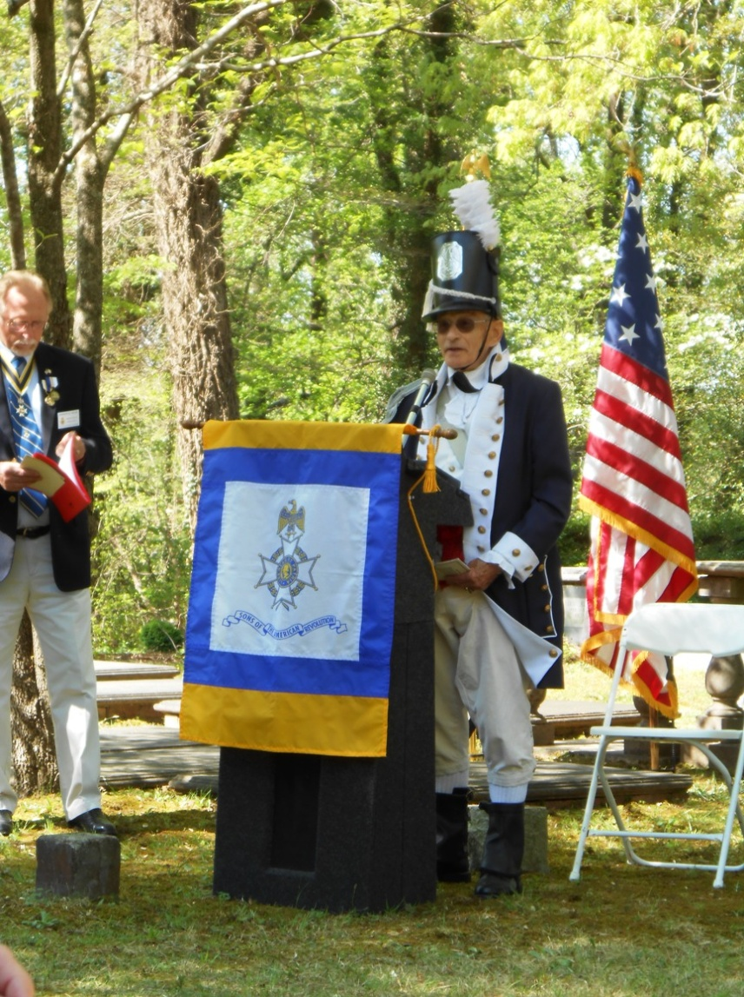
BELOW SHOWN ARE THE WREATHS THAT WERE PRESENTED BY NUMEROUS SOCIETIES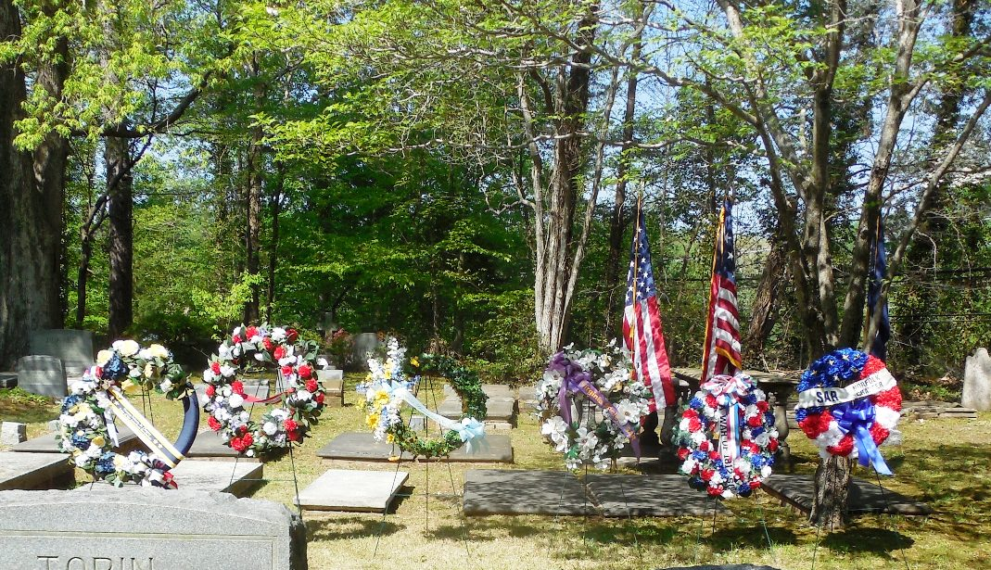
THE SAR GRAVEMARKERS FOR PATRIOT EDWARD TABB AND HIS SON CAPTAIN PHILIP TABB WERE JOINTLY UNVEILED BY PRESIDENT BILL BROADUS AND DIRECT DESCENDANT, LANA TABB. THEY ARE SHOWN BELOW
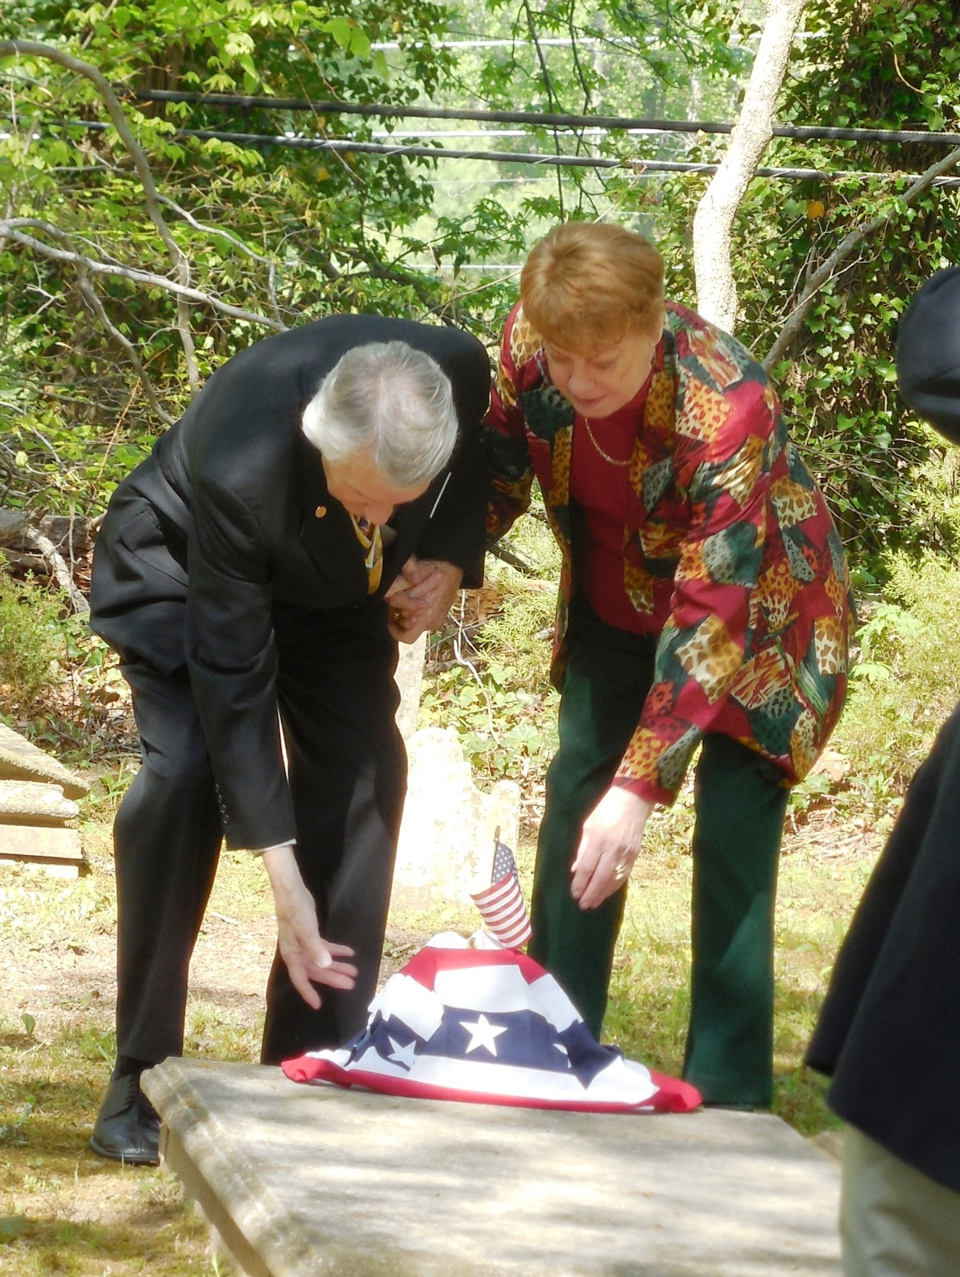
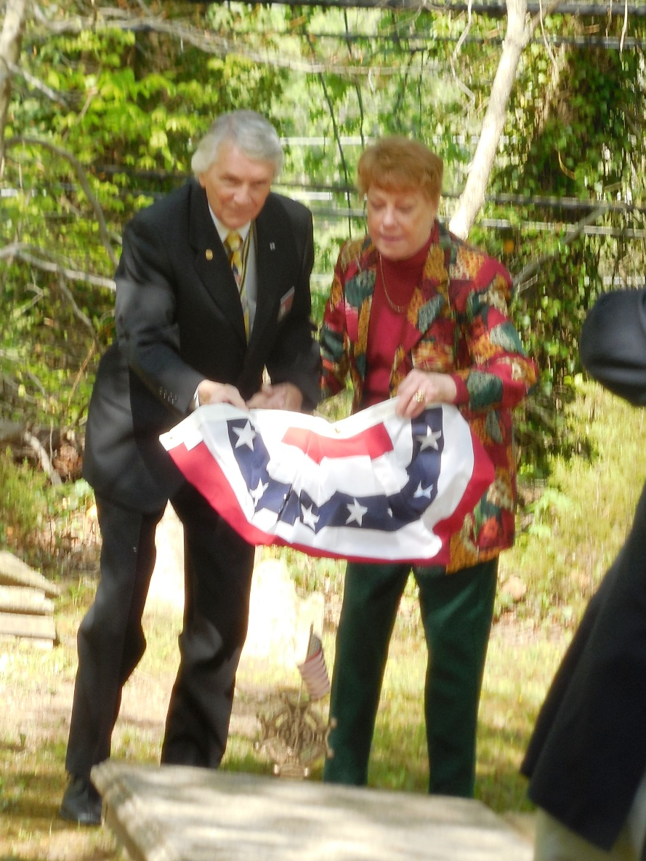
WAR OF 1812 MEMBER, CHARLES BELFIELD UNVEILED THE WAR OF 1812 GRAVE MARKER FOR CAPTAIN CATESBY JONES AND MIKE LYMAN UNVEILED THE MARKER FOR QUARTERMASTER, JOHN DIXON. PHOTOS BELOW
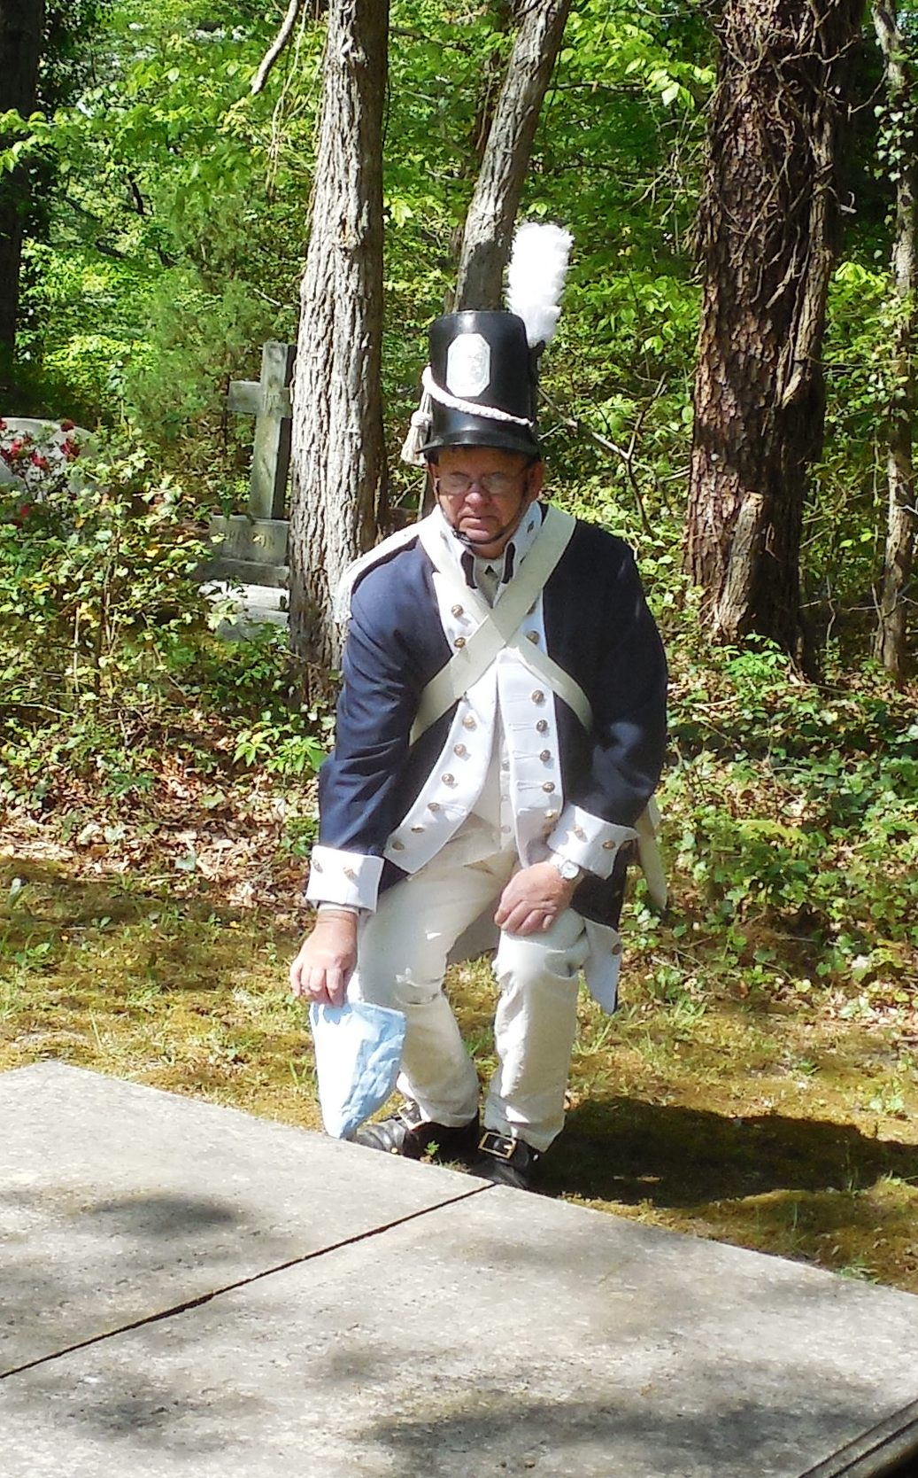
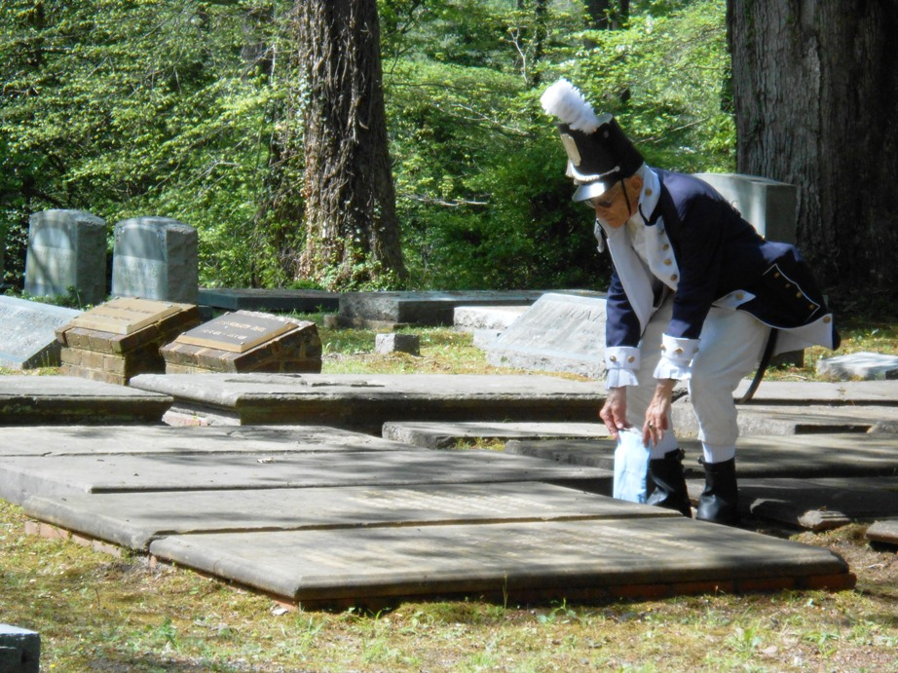
THE MUSKET FIRING PARTY THAT GAVE THE SALUTE CONSISTED OF COMPATRIOT JERRERY BROWN OF THE VASSAR COLOR GUARD AND CHARLES BELFIELD OF THE WAR OF 1812 SOCIETY
THEY ARE SHOWN FIRING BELOW
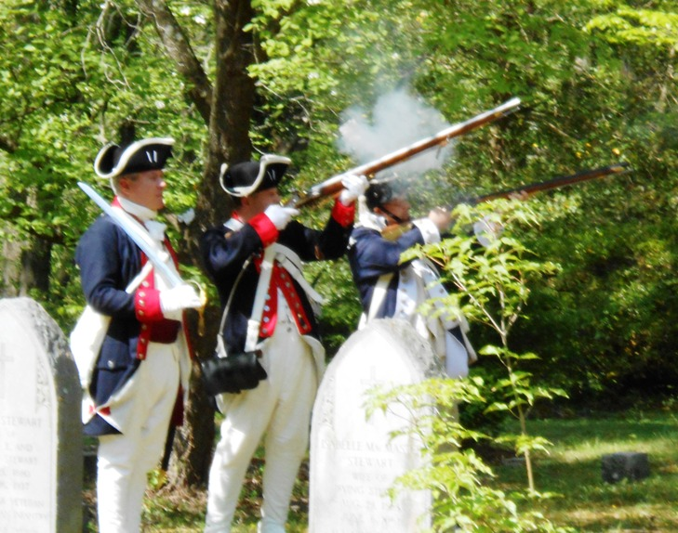
A GROUP PHOTO TAKEN AFTER THE CEREMONY OF THE WREATH PRESENTERS IS SHOWN BELOW
