Society Holds Its Annual Meeting and Luncheon in Petersburg June 7, 2014

Society of the War of 1812 in the Commonwealth of Virginia

ANNUAL MUSTER
Saturday, June 7, 2014 - Petersburg, Virginia
Maria’s Café & Italian Restaurant
Attire: Coat & Tie (James Monroe Tie: preferred for members)
Schedule of Events:
10:00AM – BUSINESS MEETING (members only)
Maria’s Café & Italian Restaurant
21 West Old Street (Old Towne)
Petersburg, Virginia 23803
12:30PM– LUNCHEON (guests welcome)
Maria’s Café & Italian Restaurant – Sicilian Buffet
Porcellini, Ziti, Chicken Marsala, salad, etc.
*This is a dual luncheon with the Virgina Society Order of the Founders & Patriots
Guest Speaker: Mrs. Nancy Gailey Heuser
Topic: Organization & March of the Volunteers at the Battle of Fort Meigs
At the meeting at Maria’s Restaurant, reports from officers and Committee chiefs were received, officers were elected, and tentative plans were made for the next fiscal year commencing July 1, 2014.
At the meeting at Maria’s Restaurant, reports from officers and Committee chiefs were received, officers were elected, and tentative plans were made for the next fiscal year commencing July 1, 2014. This was the Agenda:
- Call to Order – John Dickie
- Invocation – REV Larry Aaron
- Pledge of allegiance – Dennis Fritts
- Approval of the minutes – February 2014 – Shane Newcombe
- Introduction and Greetings to New Members – Charles Poland
- Report of Officers
- Report of Committees
- Old Business
- New Business
Amendments to the Constitution - Thad Hartmen
June 14th Joint Grave Marking – Thad Hartman
Ken Williamson, Member Virginia Society. Grave marking for two Ancestors: John Walter Harbin and Rezin Harbin. Bryantown, MD.
Representatives at 1812 functions this Summer – Mike Lyman.
New projects – Mike Lyman and Dennis Fritts

- Report of Nominating Committee and Election of Officers for 2014-2016 - John Dickie
- Benediction – REV Larry Aaron
- Adjournment – John Dickie
Minutes of the meeting:
Annual Membership Meeting Minutes
10 AM Saturday, June 7, 2014
- Call to Order & Opening Remarks – President John Dickie
- Invocation – Rev Larry Aaron
- Pledge of allegiance – 1st VP Dennis Fritts
- Minutes of the previous BOD meeting (Previously approved by e-mail vote.)
- Report of Officers and Committees
First VP Report
- Reported that the proposed Officers Duties were approved at the Feb. BOD meeting
- Presented a talk on War of 1812 to the Wythe County Historical/Genealogy Society Workshop
- Conducted a Grave Marking at Glade Springs, Va
- Working with several other County Historical Societies to do talks and grave markings
- Gave a report on the Kroger Card Program. Need more members to participate to make it even more successful. 9 members currently use the card with 3 members accounting for 99% of the participation. Members can buy gift cards on their Kroger cards for credit for our society.
Historian’s Report
- Peter reported that the War of 1812 Symposium will be held at Fort Monroe in Hampton on June 19-21. There will be various speakers and participation is encouraged. Also reported that the Bicentennial Commission expires July 2015.
- Also reported that there will be a seminar Labor Day weekend 2014 in Alexandria with a grave marking of 8 markers
Committees (Mike Lyman’s Report)
- Mentioned about 1812 article written by him published in the Northern Neck Historical Society Journal.
- Burial Book has had updates and is in continual process and may need a second edition.
- We need someone to assume the duties of Webmaster and Newsletter editor currently manned by Lyman. It was suggested an assistant be assigned to these duties for purposes of transitioning into these duties.
- Grave Marking this year (FY 2014) have included Presidential Wreath Laying for Madison, Monroe and Tyler. Also were 4/12 Lancaster County Court Day, 5/3 Ware Episcopal Church in Gloucester Co, 5/10 Fauquier Co event in Warrenton, 6/7 Blandford Cemetery in Petersburg and 6/14 event at Dumfries Cemetery in Prince William Co.
- Cost for these grave marking have been paid in this years expenses where we reported a surplus of $3,825.
- Grave Markings events scheduled for FY 2015 include 8/30 or 8/31 at the Old Presbyterian Church in Alexandria, Sept 20 Lee Hwy Grave Marking in Fairfax Co, 10/5 Belfield Family grave marking in Richmond Co, Fall 2014 Goose Creek Cemetery in Loudon Co(major event with projected expense of $2000) and Spring 2015 Masonic Cemetery in Fredericksburg (major event with projected expense of $1400).
- Color Guard is in need of new recruits. Pres. Dickie has volunteered to pay for the most expensive item, the coat, for new recruits. This is a very important part of the Society’s role.
Second VP Report
- Walt Sheffield gave greetings to the Blandford Cemetery event and to Petersburg.
Registrar’s Report
- Chuck Poland reported that 17 new members have been recruited this year to the Society. It is the largest single recruitment year we have ever had. Congrats and thanks to Chuck! Reasons for such success is due to recruiting efforts of Mike Lyman, Chuck, the website and SAR contacts.
- New Business
Thad Hartman
- Revisions to the Constitutional Amendments were voted on by the Board to include the new officer positions in Article 4 to include Chaplain and Legal Counsel and passed unanimously.
- In addition, the 5 previous Presidents will serve as board members unless unable to where the current President will appoint.
- Gave info on the Dumfries Cemetery Ceremony on 6/14 at 2pm which will be a major event for 9 1812 veterans and 11 Rev War veterans. The cost to the Society will be $792.
Ken Williamson
- Explained joint grave marking ceremony of his family’s ancestor’s cemetery on 9/7 at 1pm.
Mike Lyman Award
- President Dickie presented to Mike the 2014 General Society Outstanding Member Award for his great efforts to our Society in the many ways and work he has done for the benefit of the VA Society.
Treasurer Report
- President Dickie presented to the Board in the absence of our Treasurer, Shane Newcombe, the financial status of our Society. During FY 2014 we have assets of $24, 245 and reported a surplus of $3,825 with income of $12,343 and expenses of $8,518. As a place holder, President Dickie motioned that the actual receipts and expenditures in FY 2014 constitute a working budget for 2015. Adjustments to the budget will be made at the September BOD Meeting. Moreover budget proposals can b e voted on by e-mail. The report and motion was voted on and passed unanimously.
Nominating Committee
Slate of Officers Proposed for FY2015 –FY2016 are as follows:
President Dennis Fritts
1st VP Walt Sheffield
2nd VP Shane Newcombe
Secretary William(Bill) Nash
Treasurer Shane Newcombe
Registrar Chuck Poland
Historian Peter Broadbent
Quartermaster Shane Newcombe
Chaplain Larry Aaron
Legal Counsel Carter Furr
VP General Capt John Dickie
Five Councilors
John M. Epperly
William (Bill) Collier
James T. Thacker
Charles Belfield
Stuart Butler
Deputy Councilors
Jeremy Utt
Cranston Williams, Jr.

Slate of officers and motion were voted on and passed unanimously.
Incoming President’s Report (Dennis Fritts)
- Upcoming grave markings will be our most prominent project followed by updates to the Burial Book.
- Announced the General Society Annual Meeting on 9/11-14 in Baltimore at the Airport Hotel.
- Mentioned the Kroger Program as very important for our fund raising efforts.

- Benediction – Rev Larry Aaron
- Adjournment – Capt John Dickie

Following this was the luncheon and it was here that new members were inducted and the new officers were sworn in. The luncheon agenda:
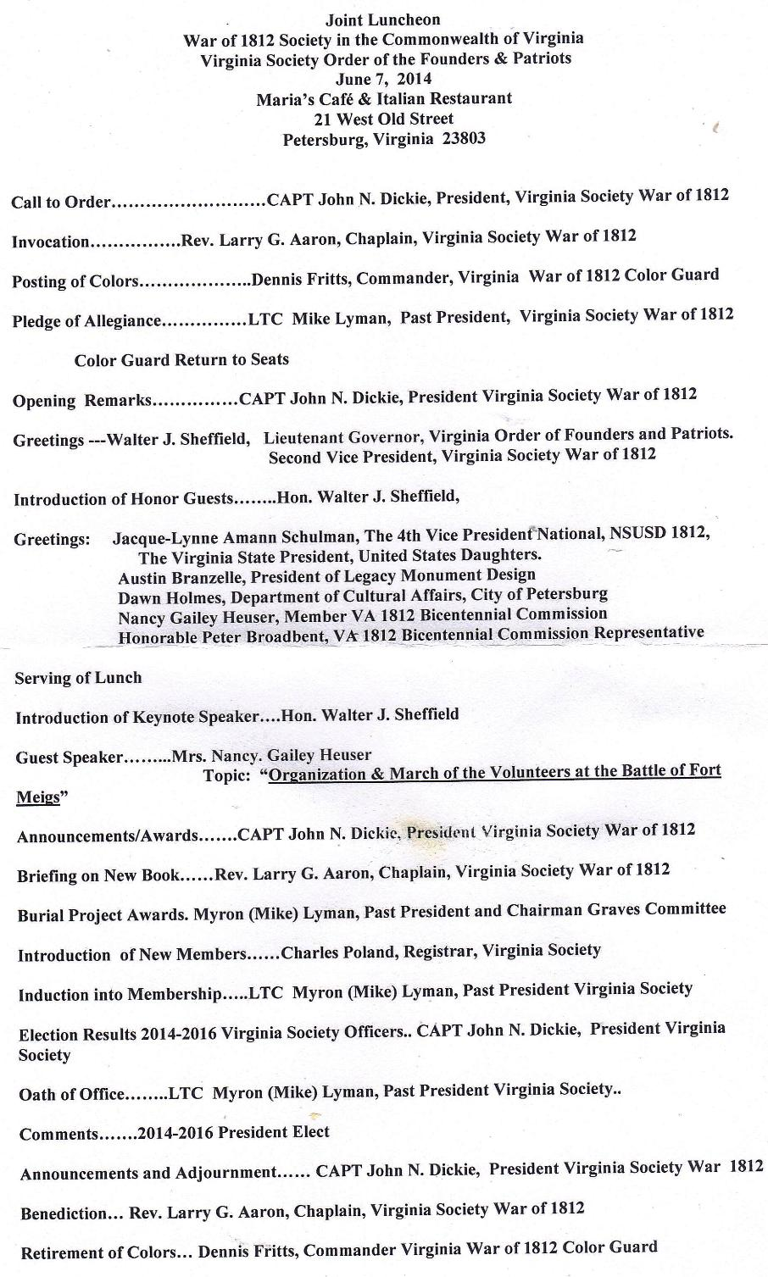
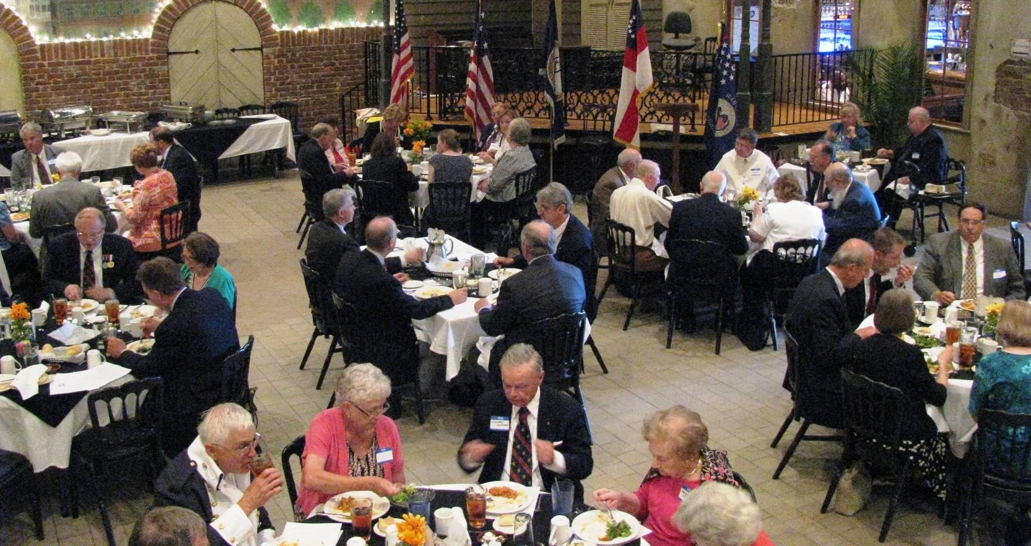
Above some of the attendees are shown. Below the buffet
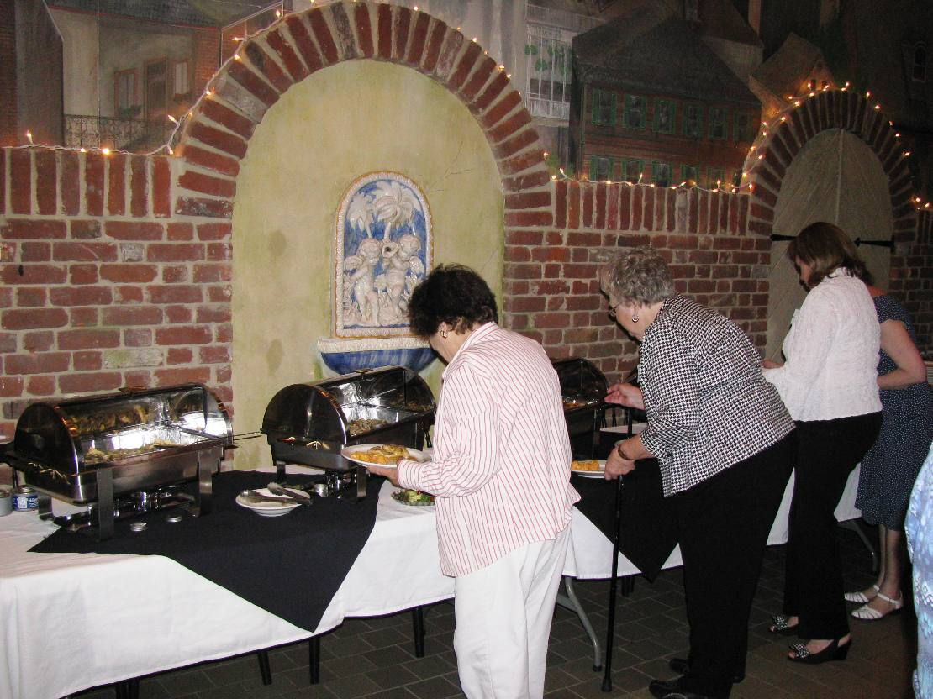
Below the head table
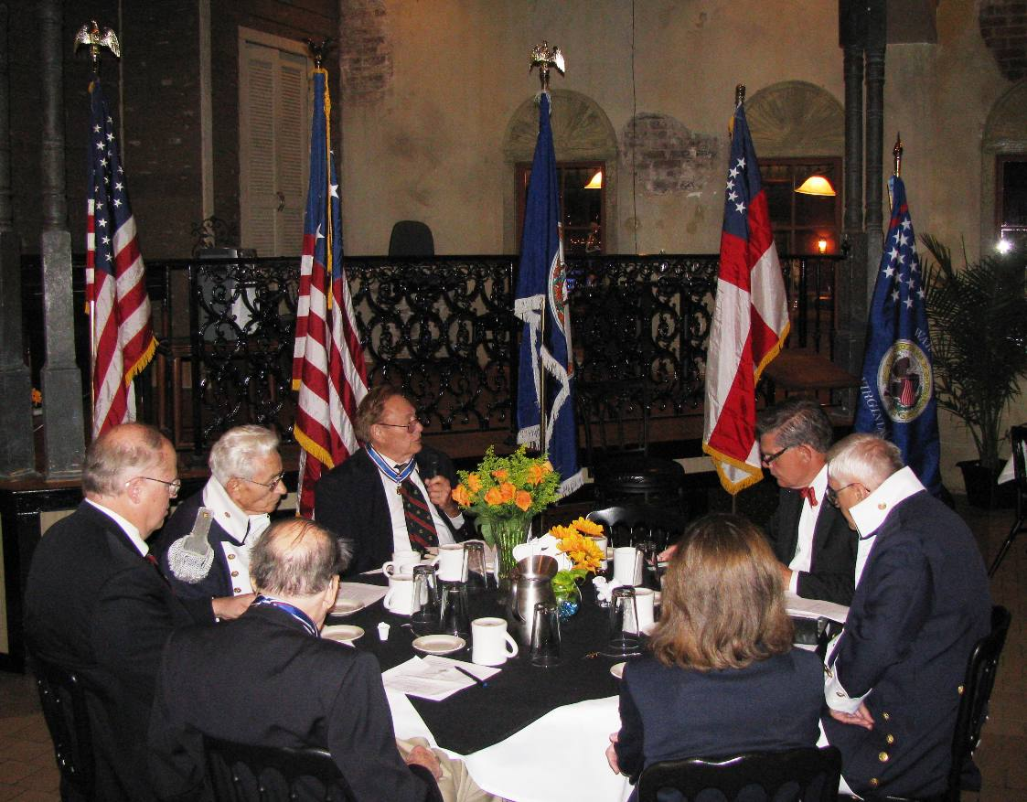
More attendees
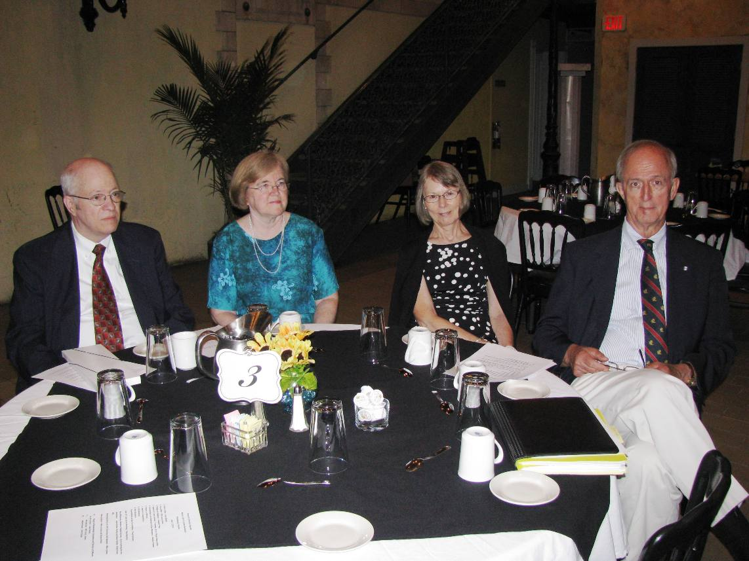
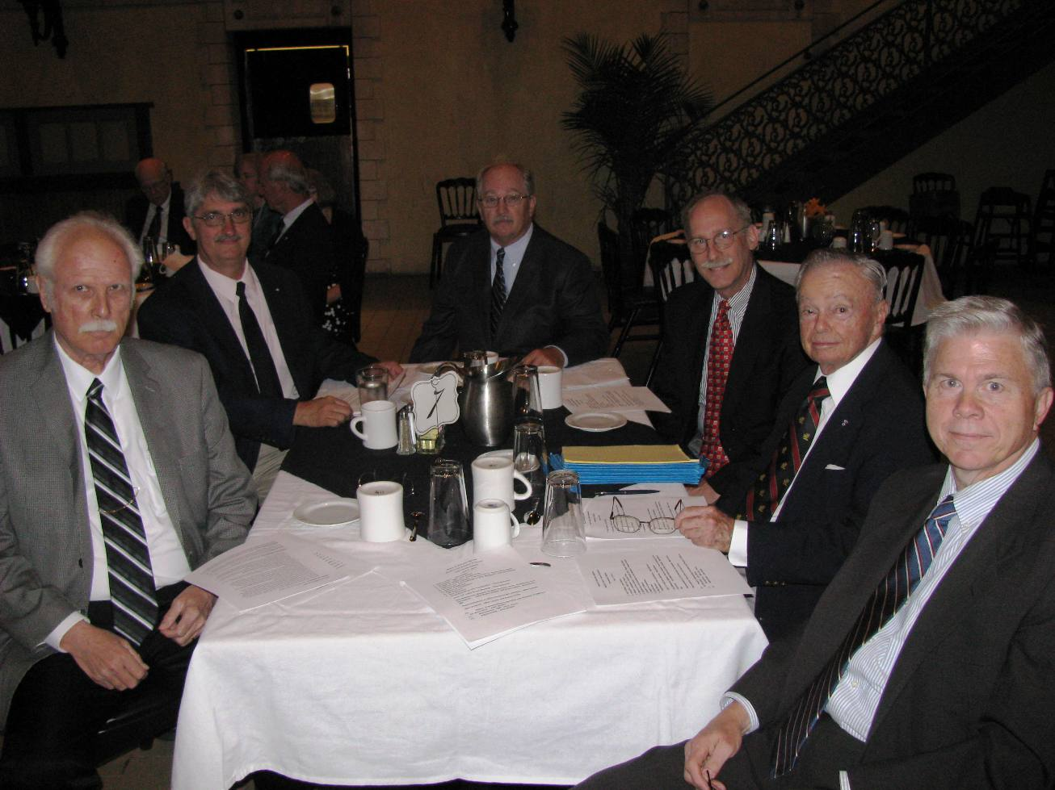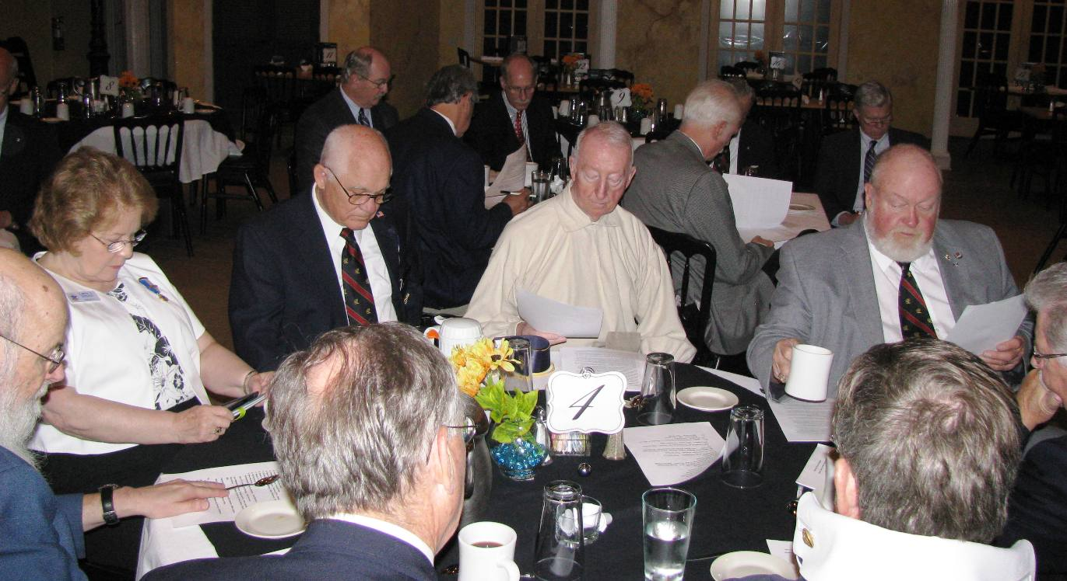
Below is Nancy G Heuser the Guest Speaker
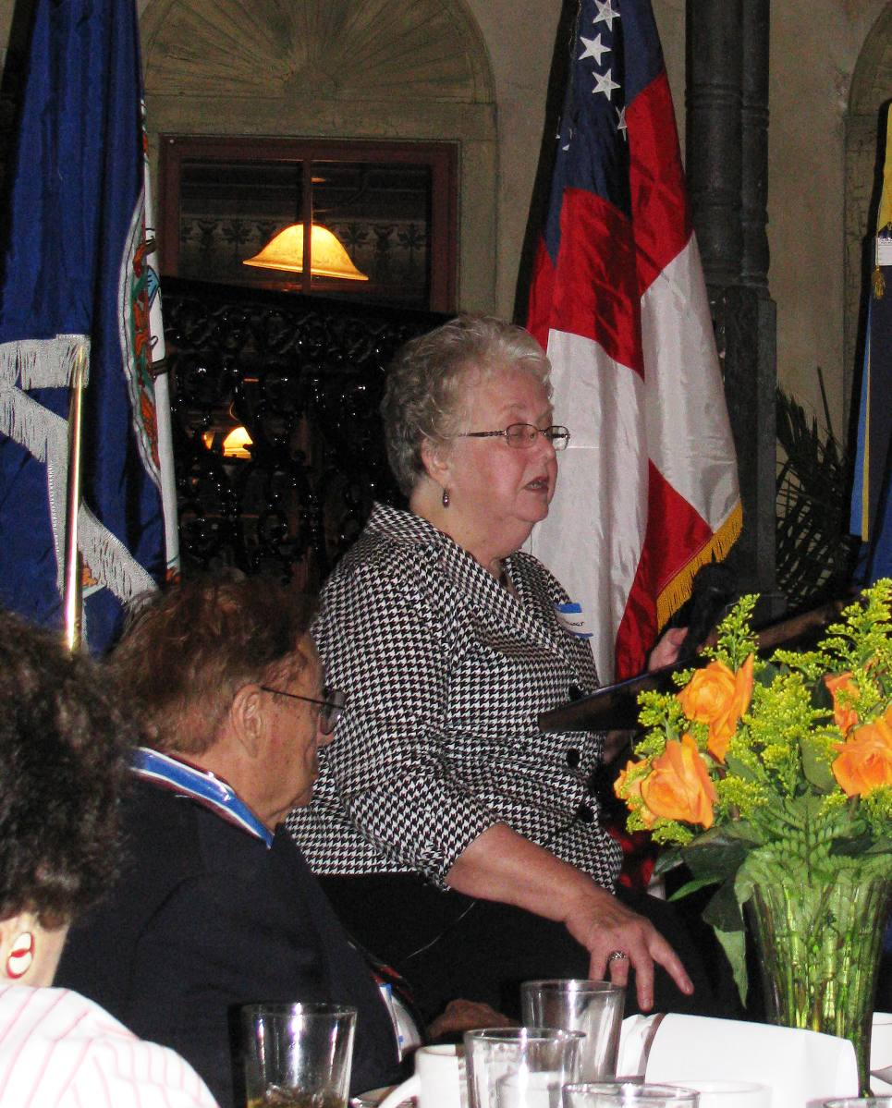
Below Mike Lyman receives an award
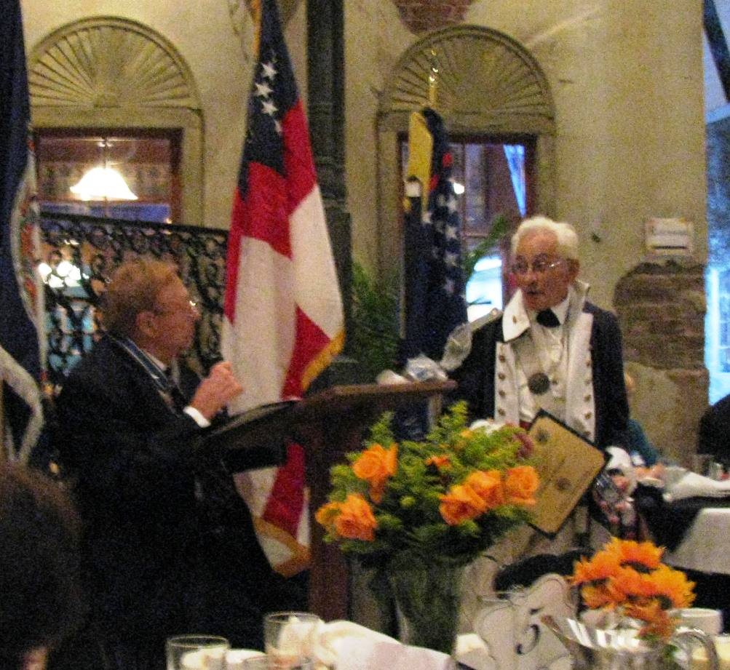
Nine New members are inducted. 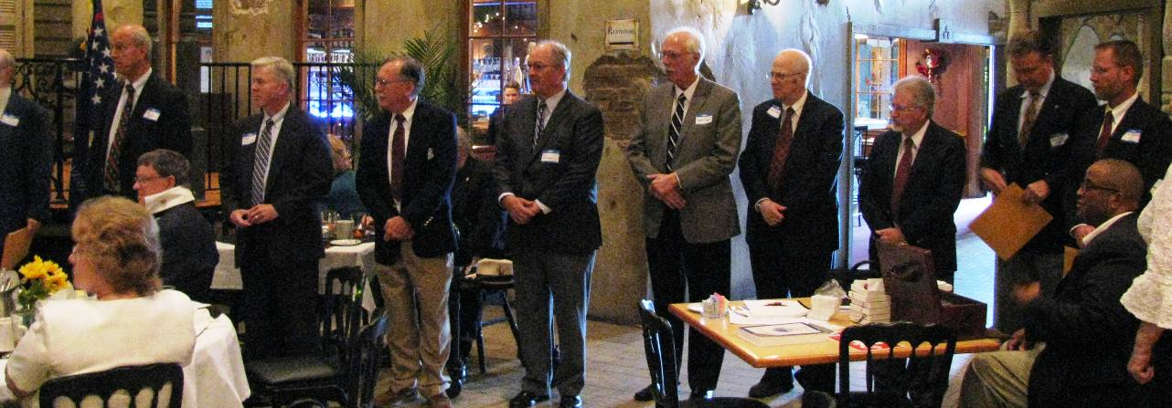
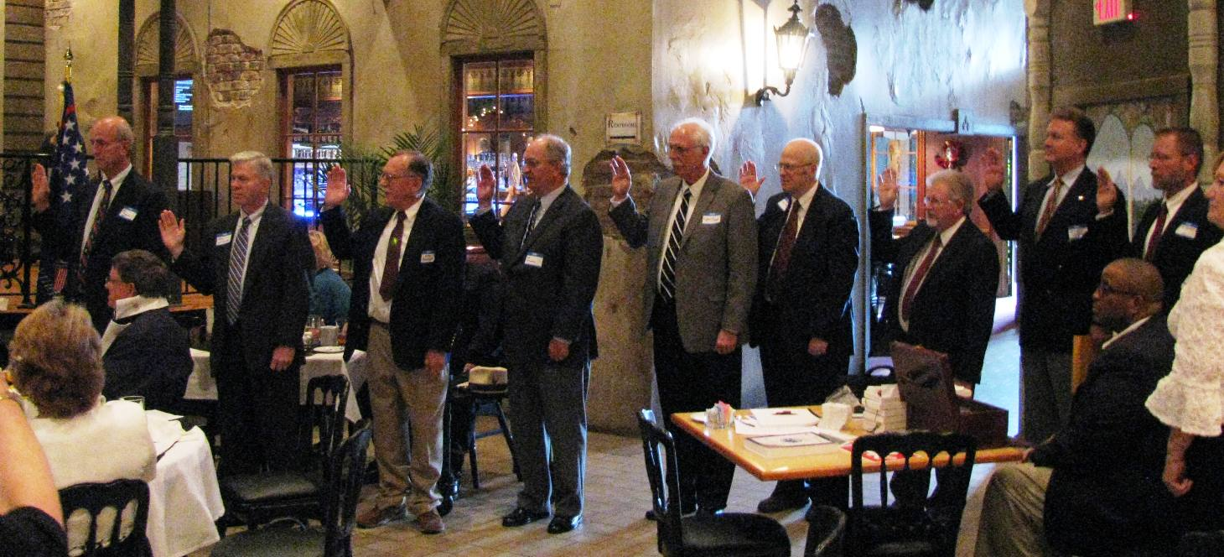

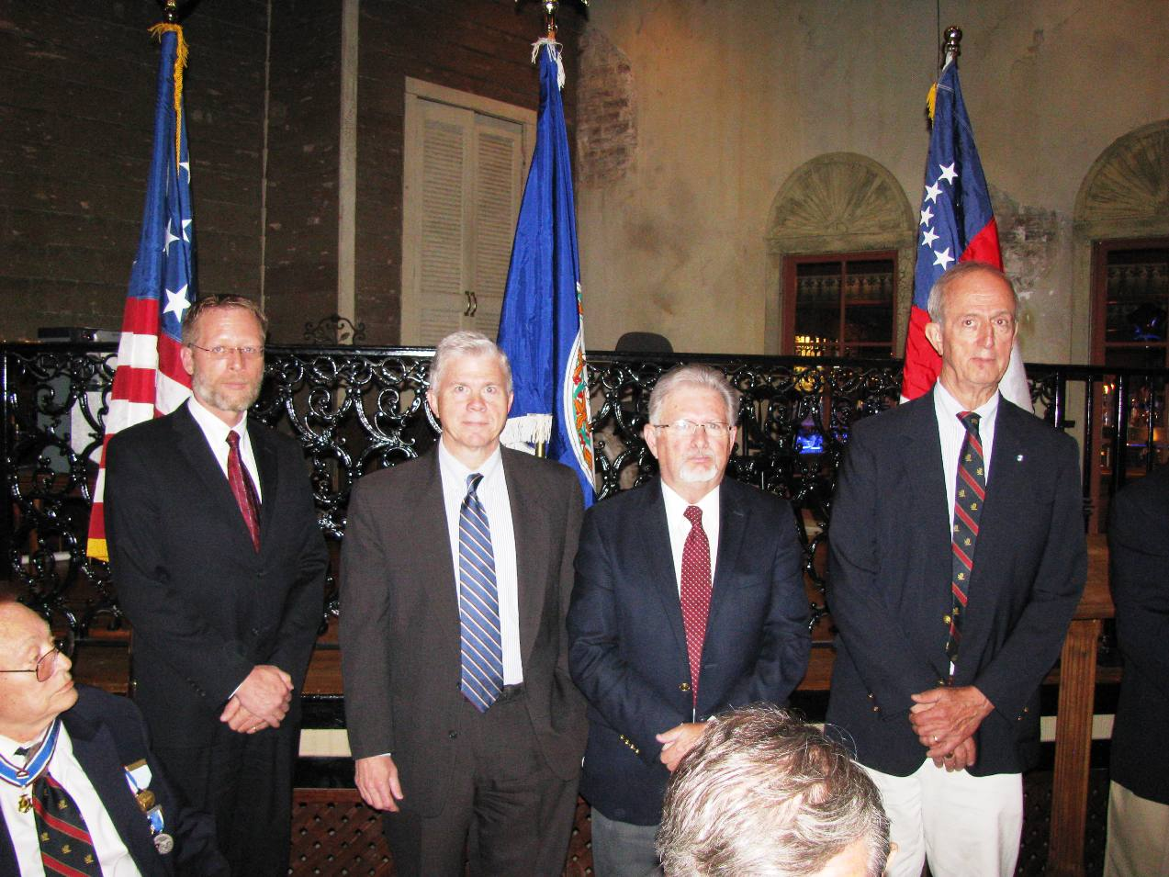
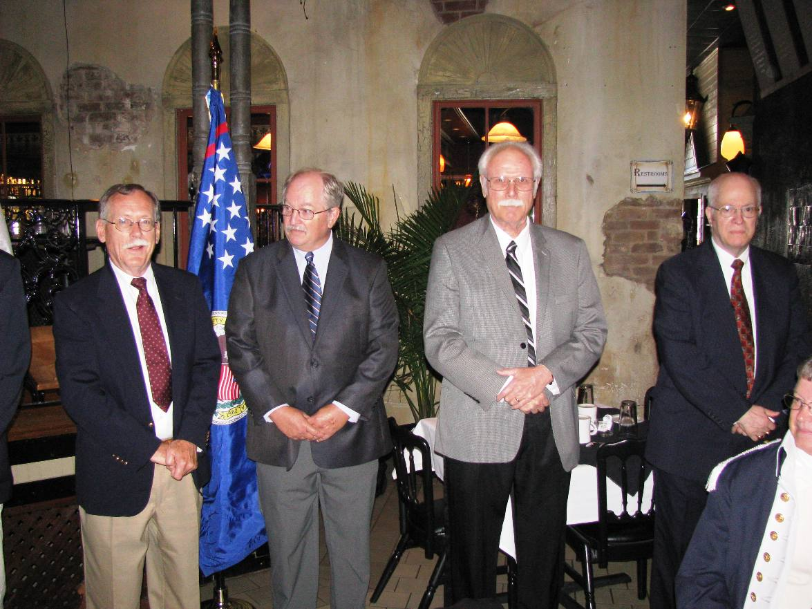
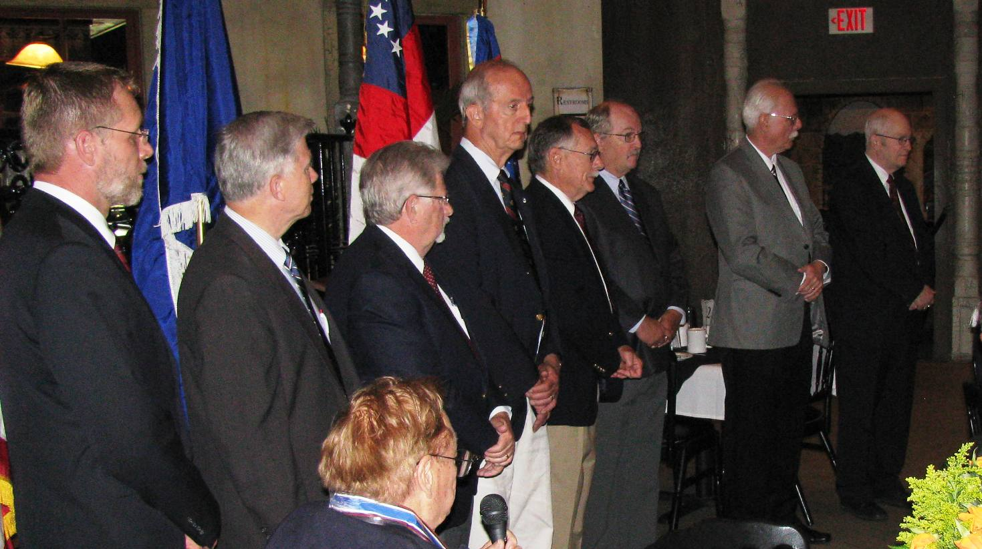
Some individual photos
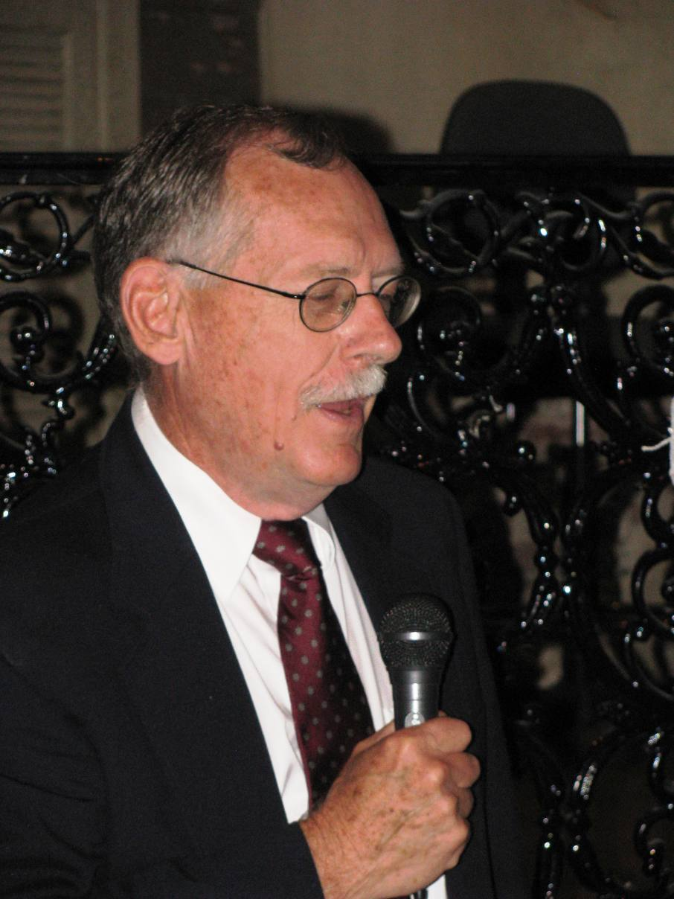
Above Hugh Markham
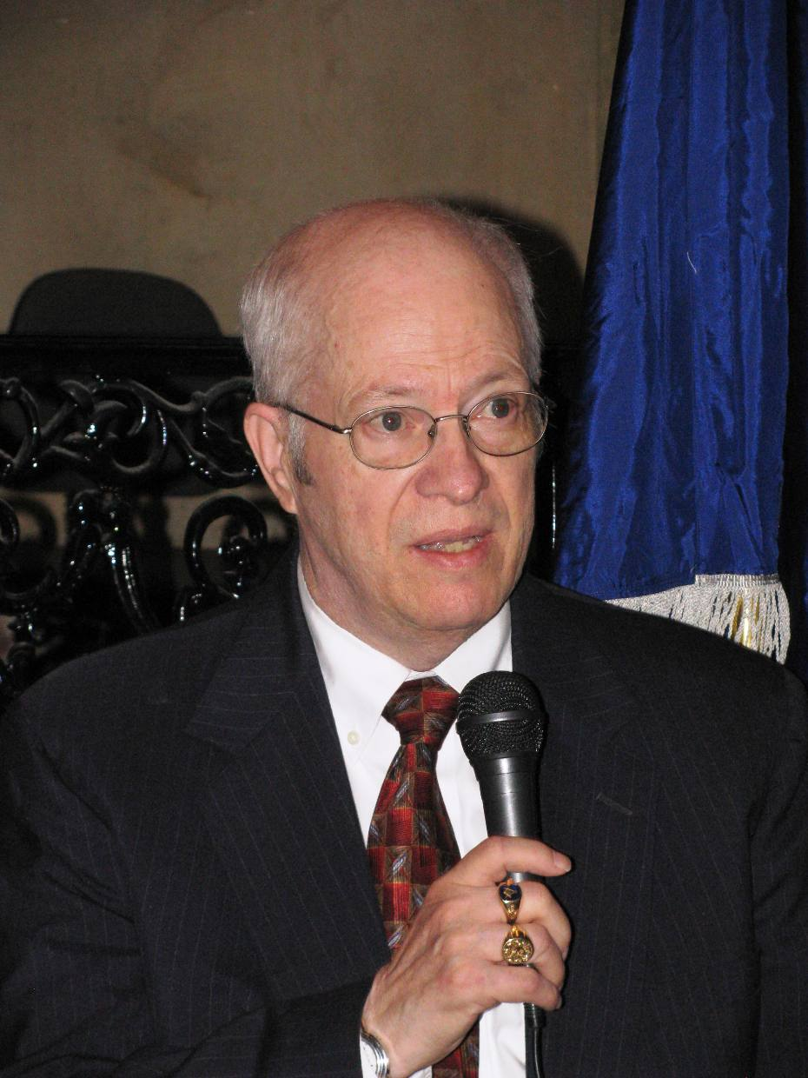
Above David Howard
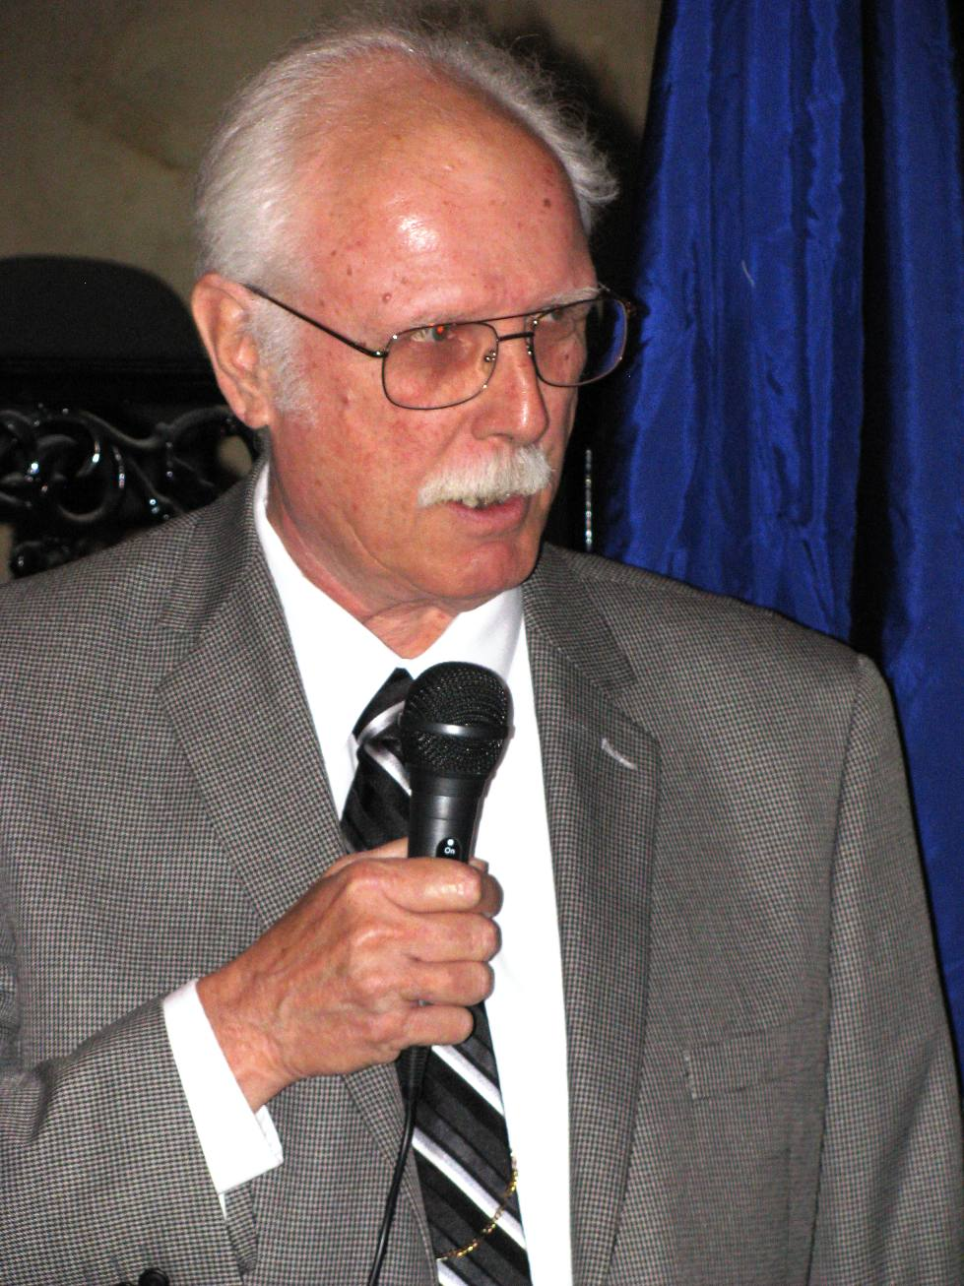
Above Lynn Cupp
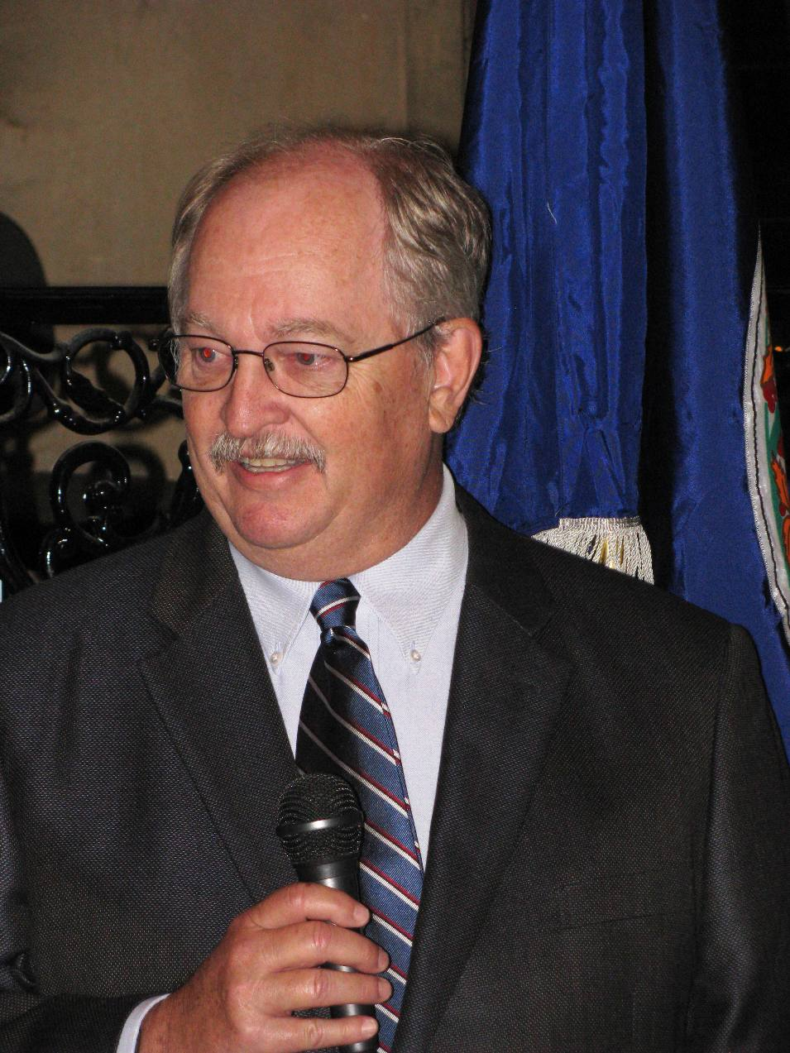
Above
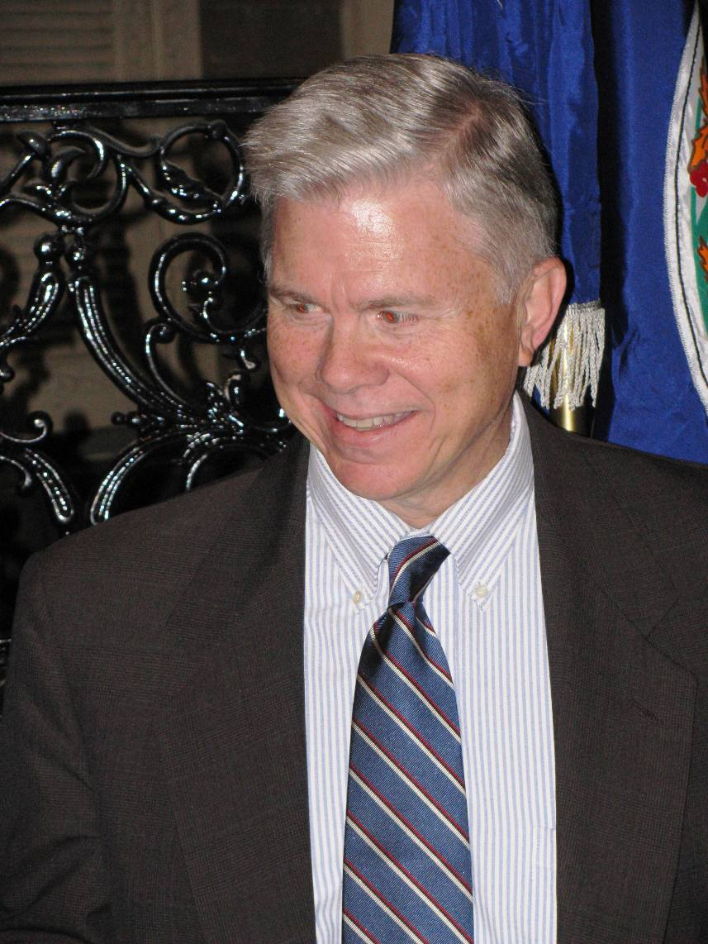
Above Ken Williamson
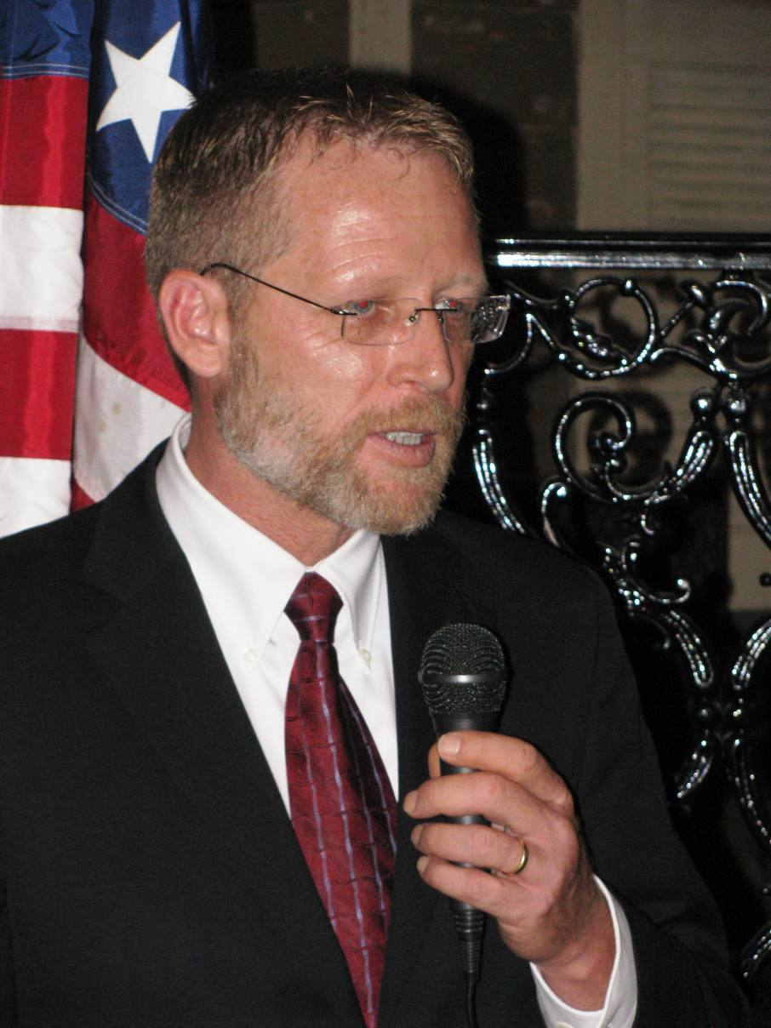
Above Jim Swords
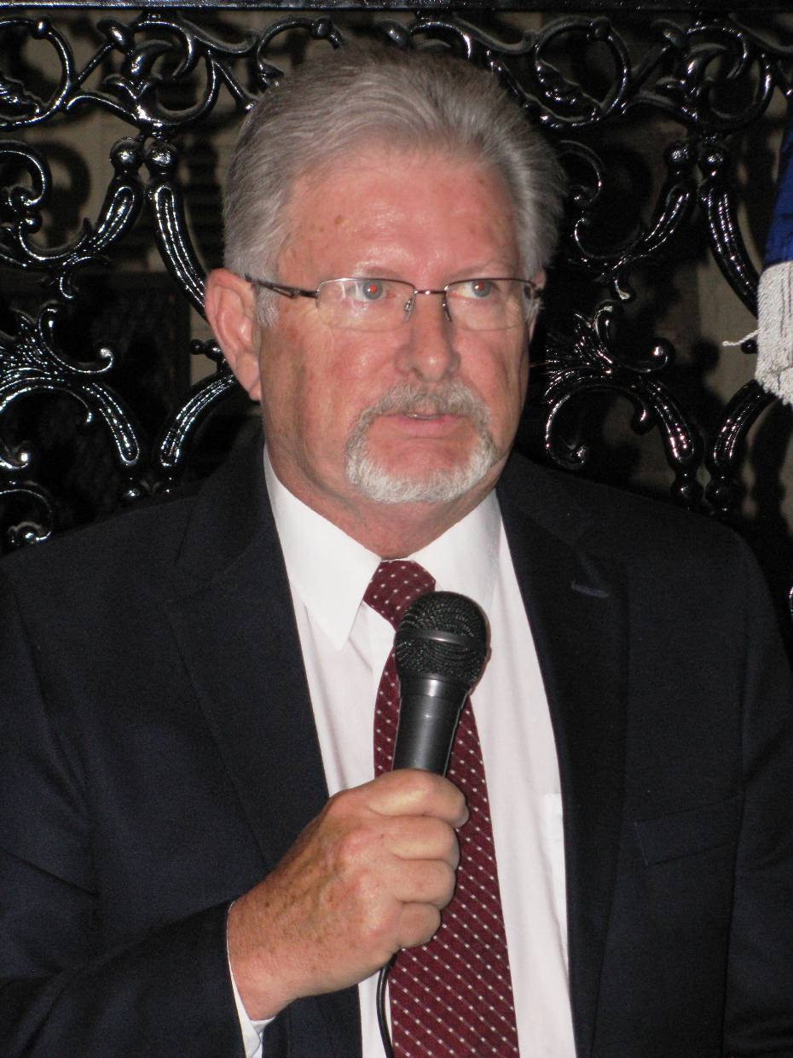
Above Larry Aaron
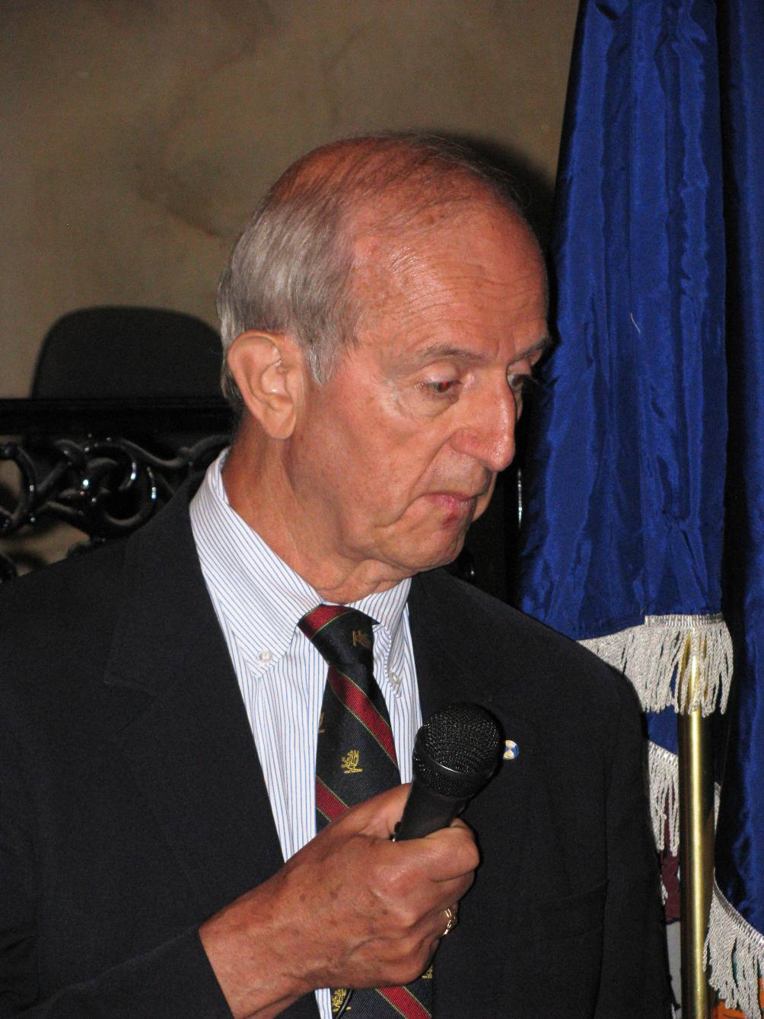
Above Edward Truslow
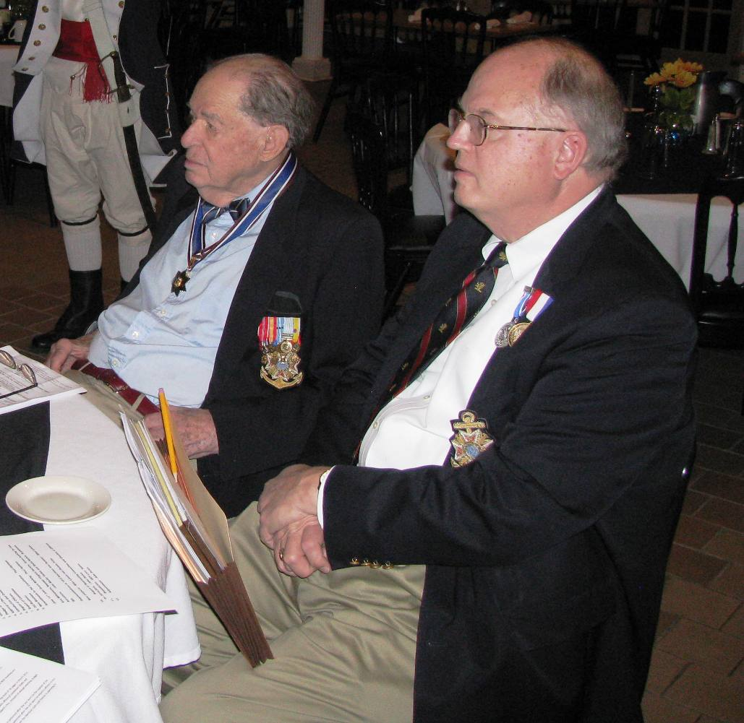
Above L/R Past President Jack Maxwell & Historian Peter Broadbent
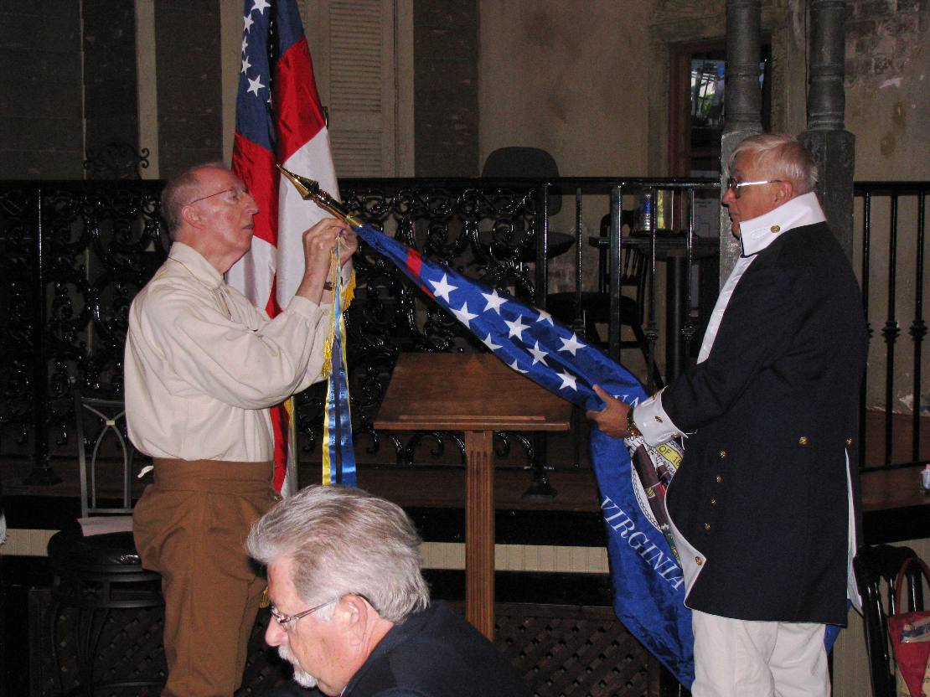
Above; A new ribbon is attached to the Society Colors Below Charles Belfield receives an award