Society Joins Other Societies in Honoring Rev War & 1812 Veterans
On June 14, 2014 the War of 1812 Society in VA joined with other societies in financing, installing and unveiling a monument in the Dumfries Cemetery in Prince William County.
This was a joint ceremony conducted by the Virginia Society, Sons of the Revolution and the War of 1812 Society in Virginia. Contributing to the cost of the monument was the Virginia State Society of the U.S. Daughters of 1812 and the Prince William Resolves Chapter, National Society Daughters of the American Revolution. Interred in the cemetery with names inscribed on the monument were eleven Revolutionary War Patriots and nine War of 1812 veterans.
The program:
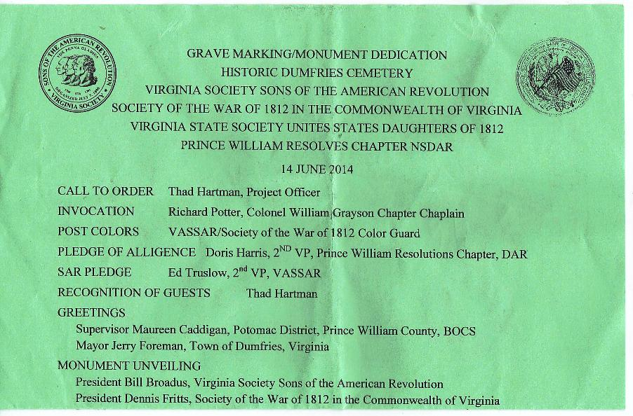
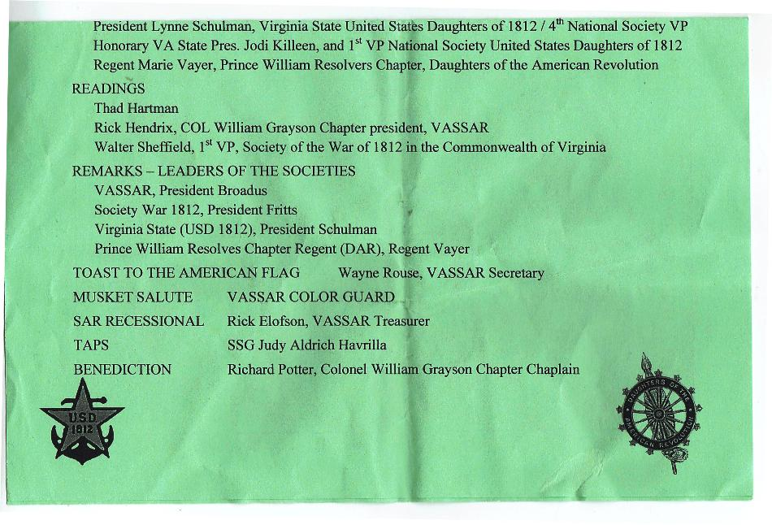

The unveiled monument
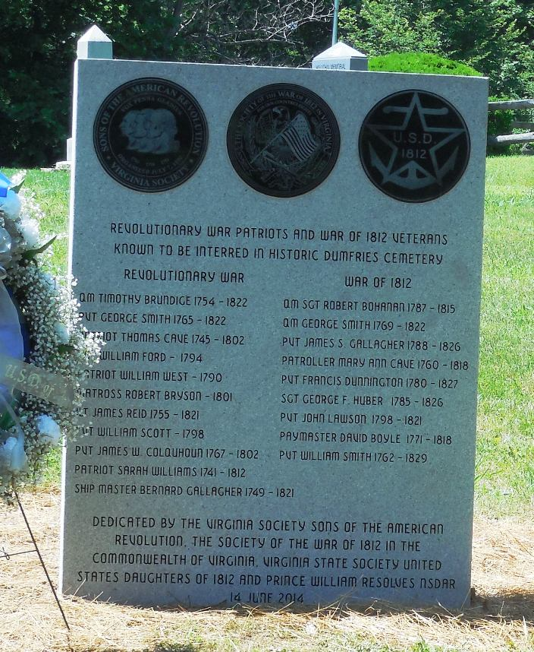

Some of the attendees:
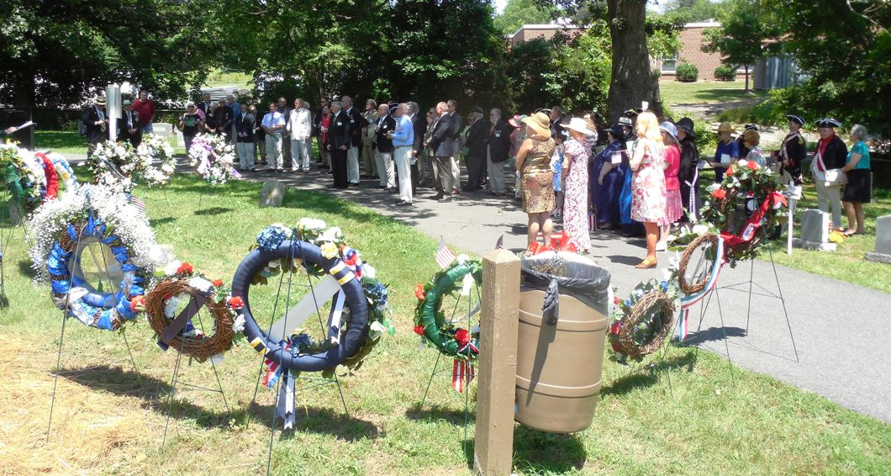
The color Guard advances;
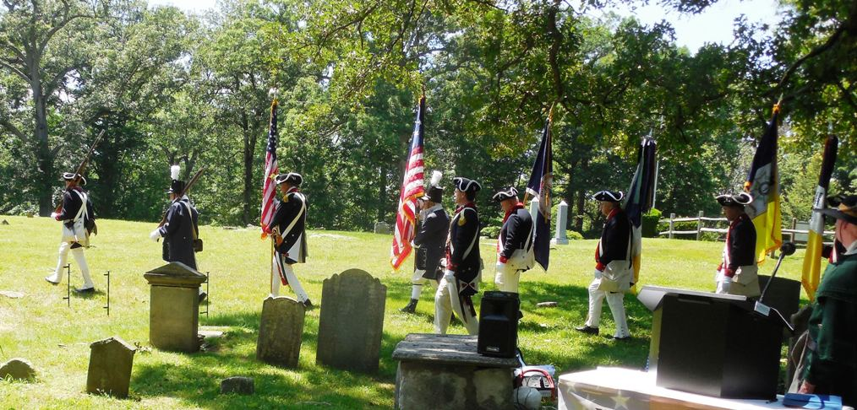

The Color Guard is positioned Mike Lyman and Hugh Markham in War of 1812 attire are part of the combined Guard
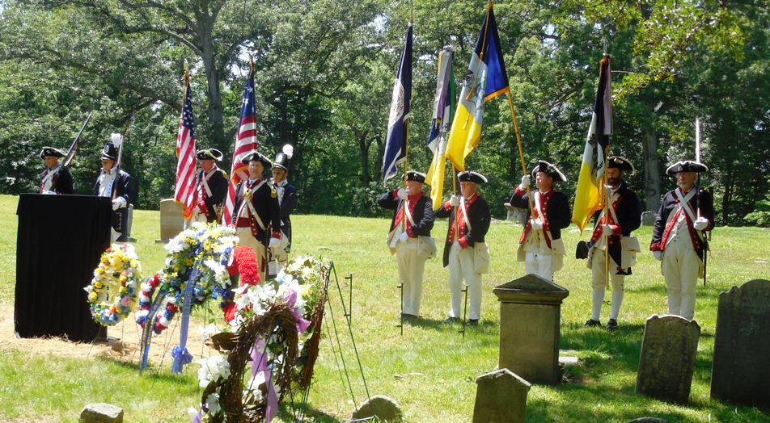
The monument is unveiled by members of each society
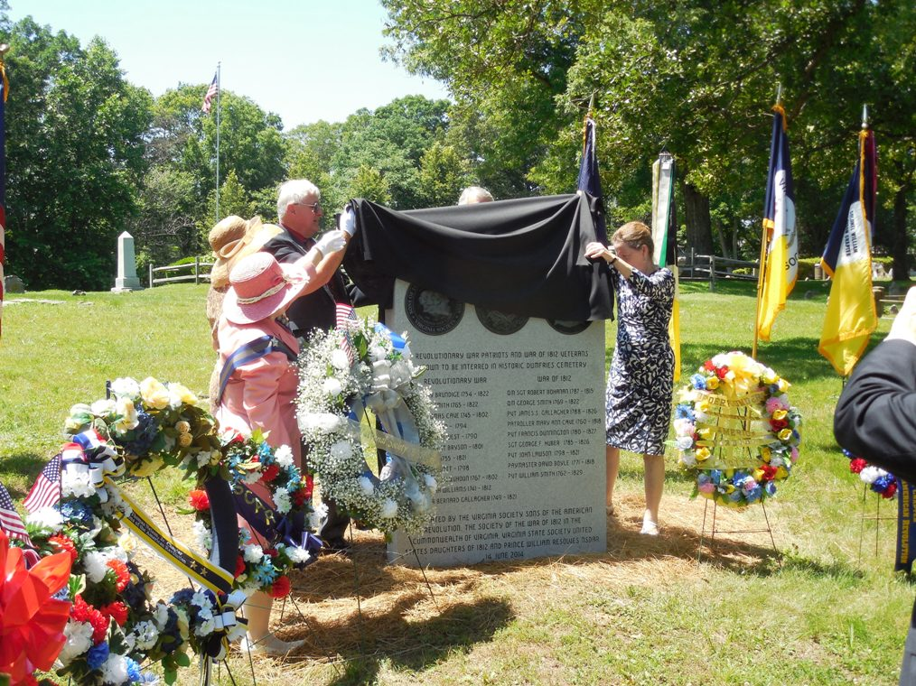

After the unveiling the representatives pose. L/R: Jodi Killeen, 1st VP National Society U.S. Daughters of 1812; Marie Vayer, Regent Prince William Resolves Chapter, NSDAR;
Dennis Fritts. President Elect, War of 1812 Society in the Commonwealth of Virginia; Jacque-Lynn A Schulman, VA State president, USD of 1812; and William Broadus, President VA Society SAR
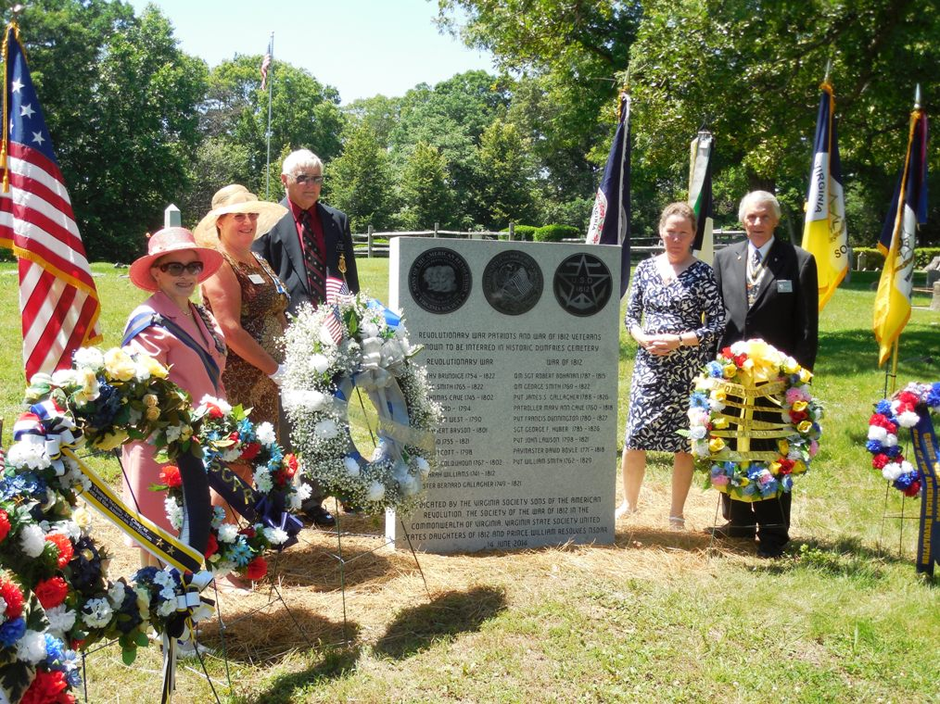

Project Officer and Past President, War of 1812 Society in VA, Thad Hartman
provided details about each patriot being honored
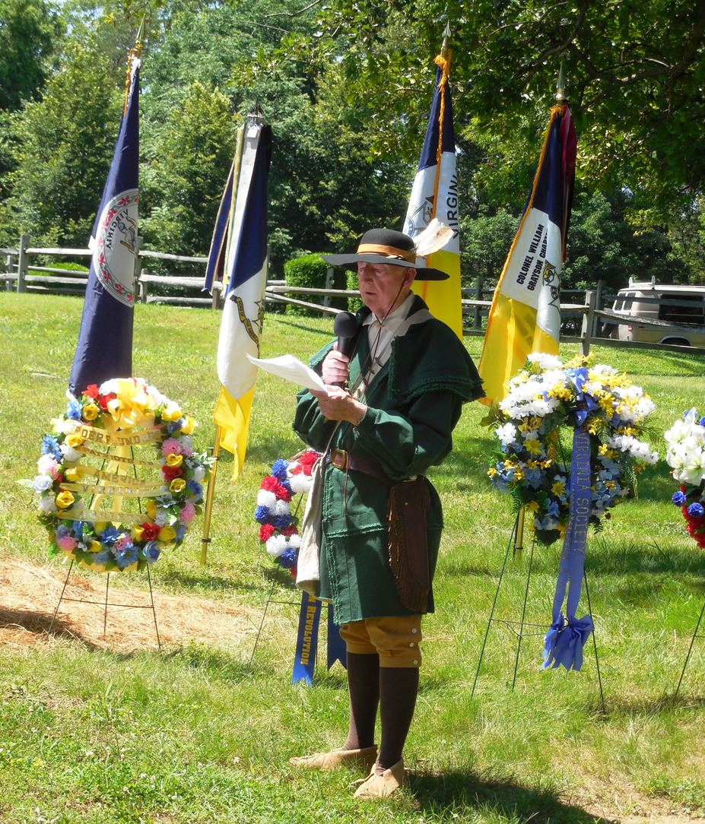

President Elect, Dennis Fritts of the War of 1812 Society in VA gives greetings from the Society
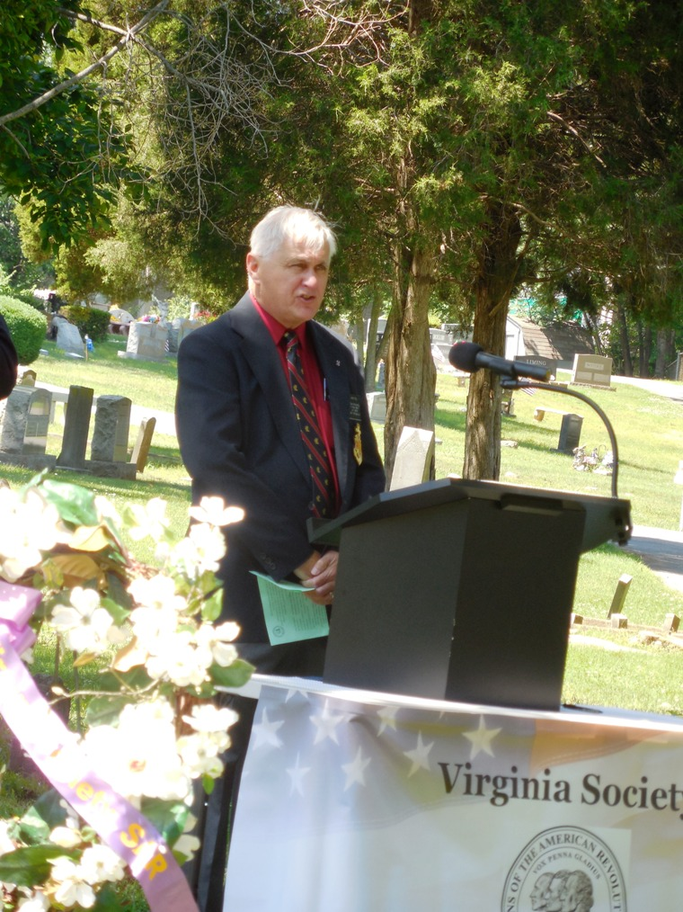

The Wreath Presenters
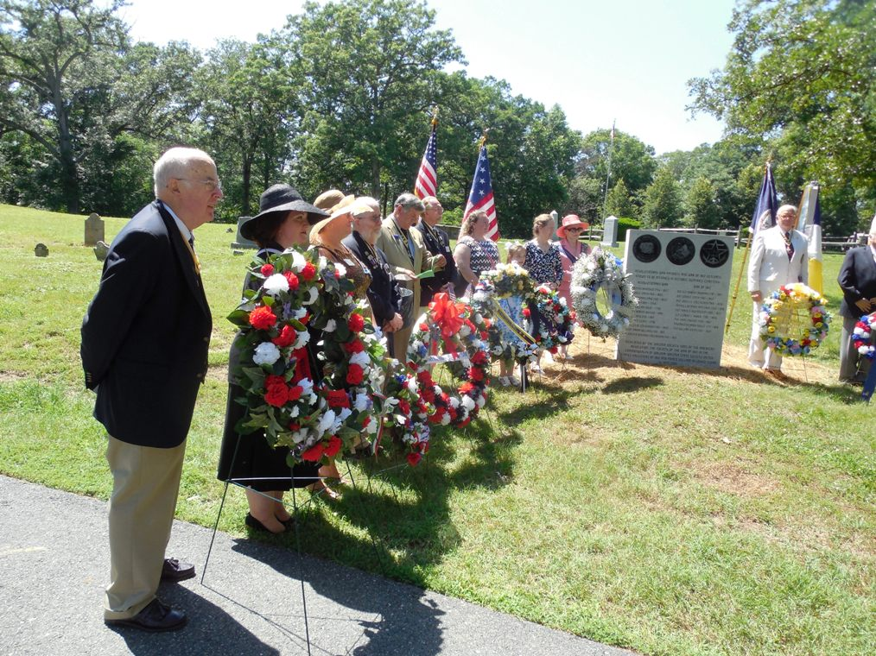
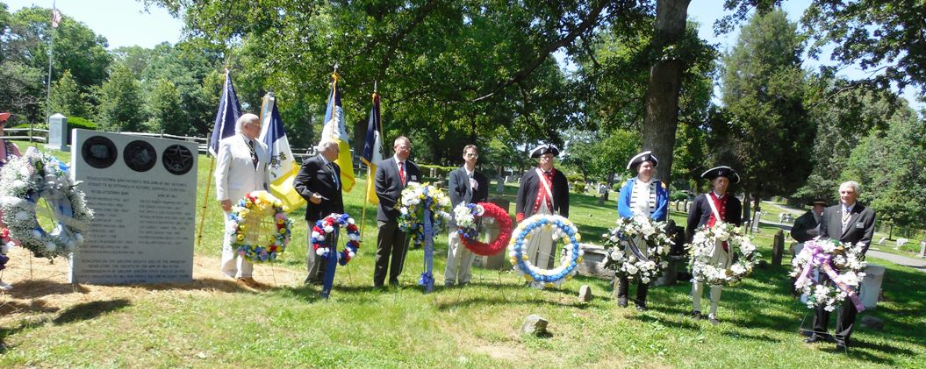

The Society participates in the musket firing party. Our representative is Hugh Markham
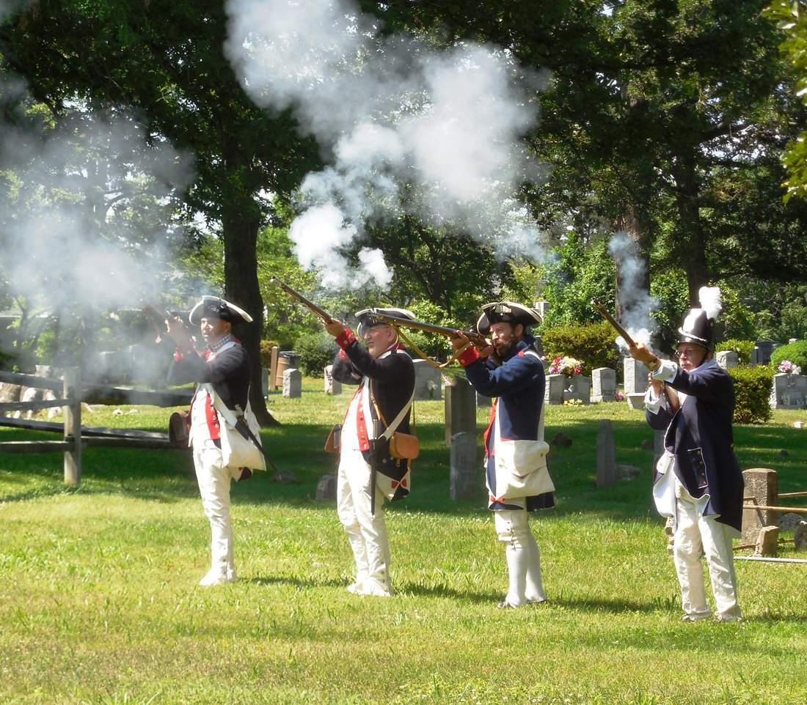

A group photo of the six War of 1812 society members that attended. L/R:
First VP Elect, Walter Sheffield: Past President Mike Lyman; ; member Ed Truslow; Past President, Thad Hartman; Past Registrar, John Epperly; President elect, Dennis Fritts: member Rick Hendrix; and member Hugh Markham
