Society Unveils a Huge Monument Listing War of 1812 Veterans Jun 7, 2013
The War of 1812 Society in the Commonwealth of Virginia conducted a commemoration ceremony at the Blandford cemetery in Petersburg in conjunction with its annual muster. Listed on the monument are the names of ninety four veterans that are interred or memorialized in the cemetery. The monument was financed by the Society and with contributions from the General Society War of 1812 and from the National Society and Virginia State society of the U.S. Daughters of 1812.

Pictured below are photos taken and views of side one and two of the erected monument:

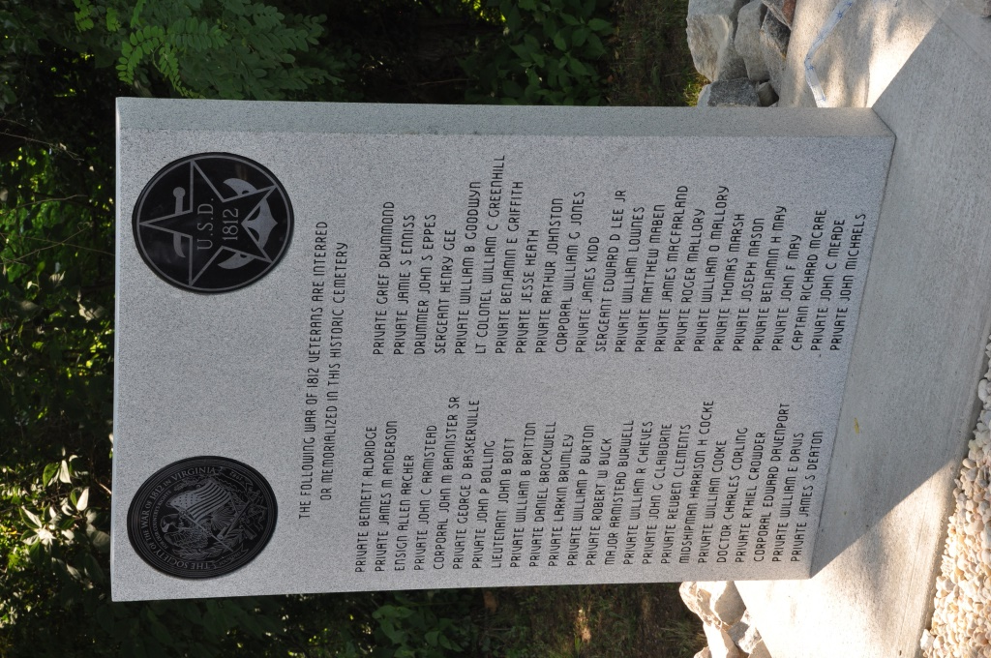

Below is a portion of the program for the event followed by some photos

PROGRAM
Call to order & Welcome: 2:30pm …....Captain John N Dickie (USN Ret.), President Society of the War of 1812, in the Commonwealth of Virginia
Invocation: ……………………….Reverend Larry G. Aaron, D. Min. Chaplain, Society. War of 1812 in Virginia
Presentation and posting of Colors: …War of 1812 Society Color Guard- Mike Lyman, Dennis Fritts, Charles Belfield, Thad Hartman
Pledge of Allegiance : …….led by John (Jack) C Maxwell, Jr., Past President, Society, War of 1812 in Virginia
Introductions: .....................Second Vice President, Walter J. Sheffield, Esq., Society War of n1812 in Virginia
Greetings, Mayor of Petersburg: …………………………………………………....The Honorable, Brian Moore
Greetings City of Petersburg, Department of Cultural Affairs: ……………………… Brian C. Little, Manager
Greetings Blandford Church & Cemetery: ……………………………….Martha Mann Atkinson, Site Manager
Greetings General & Virginia Society, War of 1812: ……..Captain John N. Dickie,(USN, Ret) Quartermaster General & Virginia Society President
Greetings National & Virginia State Society, U.S. Daughters of 1812: ……………...Jacque-Lynne Amann Schulman, 4th Vice President National & Virginia State President
Greetings Virginias War of 1812 Bicentennial Commission: …………Peter E. Broadbent, Jr, Esq., VA Society War of 1812 in Virginia Representative
Information on the Petersburg Volunteers in the War of 1812: …….Nancy G. Heuser, Past Virginia State President, USD1812
Information on the Monument to be Unveiled: … Lt Colonel Myron (Mike) E. Lyman, Sr. (USA Ret), Past President, Society, War of 1812 in Virginia
Unveiling Ritual: ……First Vice President, C. Dennis Fritts and Past President, Lt Colonel Thadeus L. Hartman, (Ret), Society War of 1812 in Virginia
Unveiling: ………………………………………………………………………………………Presidents Dickie & Schulman
Presentation of Wreaths: …. Announced by Charles B. Poland, Registrar, Society War of 1812 in VA
Captain John N Dickie, (USN Ret) representing The General Society War of 1812 as Quarter Master General
Jacque-Lynne Amann Schulman, representing The National Society, United States Daughters of 1812 as 4th Vice President National
Walter J. Sheffield, Esq. representing the General Order of the Founders & Patriots of America as the Deputy Attorney General
Charles Dennis Fritts, representing The Virginia Society War of 1812 in the Commonwealth of Virginia as First Vice President
Deborah Cupp, representing the Virginia State Society, United States Daughters of 1812 as a member of the Fort Norfolk Chapter, United States Daughters of 1812
Donnel Jerry Hubbard, representing The Virginia Society Order of Founders & Patriots of America as Past Governor
Peter E. Broadbent, Esquire, representing The Virginia War of 1812 Bicentennial Commission as the Virginia Society’s representative.
TAPS: …………………………………………………………………………Recording from Arlington National Cemetery
Recessional: ……………………. Reverend Larry G. Aaron, D. Min. Chaplain, Society. War of 1812 in Virginia
Closing Remarks: ……………………………………………………………………………………..President Dickie
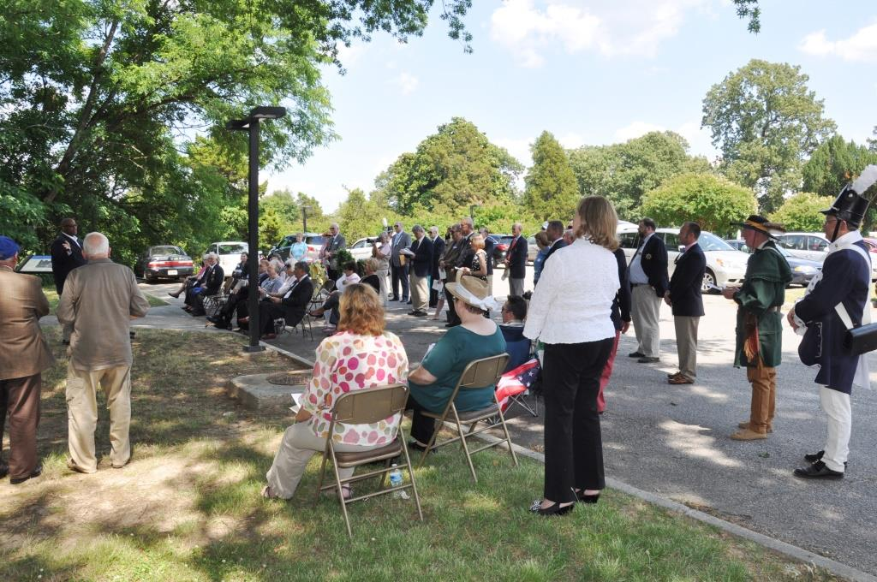
Above are some of the attendees. The monument was erected next to the Visitors Center parking lot.
Below the colors are presented
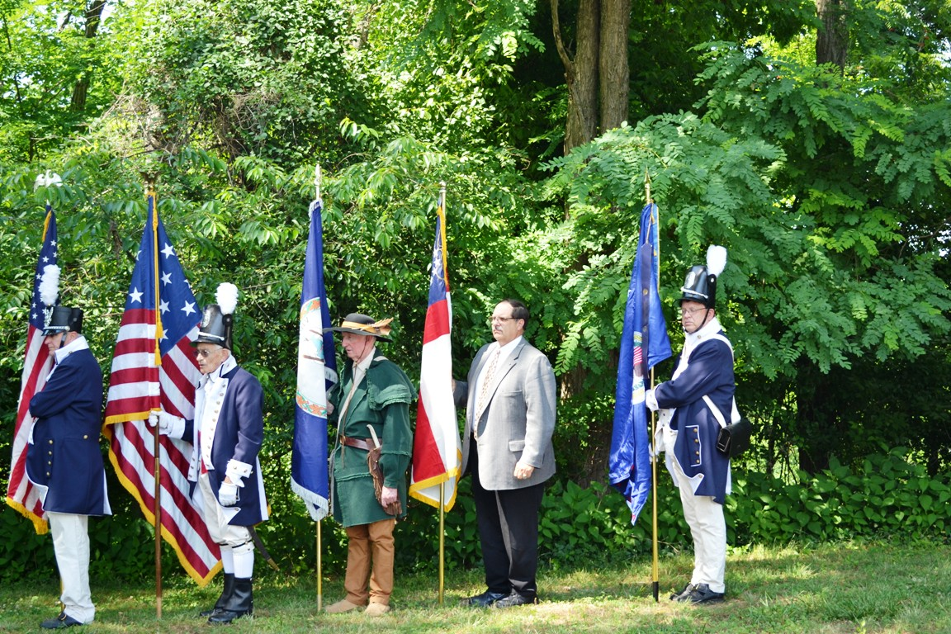
Vice President, Dennis Fritts carries the U.S. flag; Past President, Mike Lyman, the Star Spangled Banner flag: Past President, Thad Hartman, the Virginia flag; Registrar, Doug Graves, the Order of Founders & Patriots of America flag; and member Charles Belfield, the Virginia Society War of 1812 flag
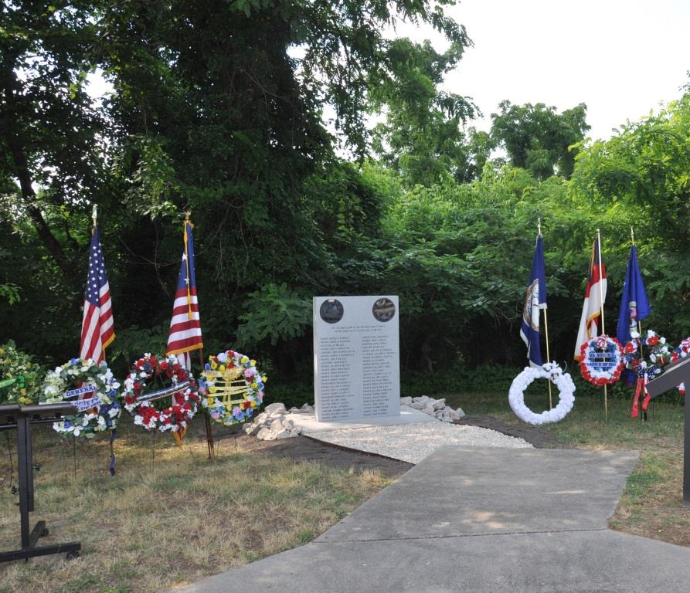
The unveiled monument and wreaths that were presented
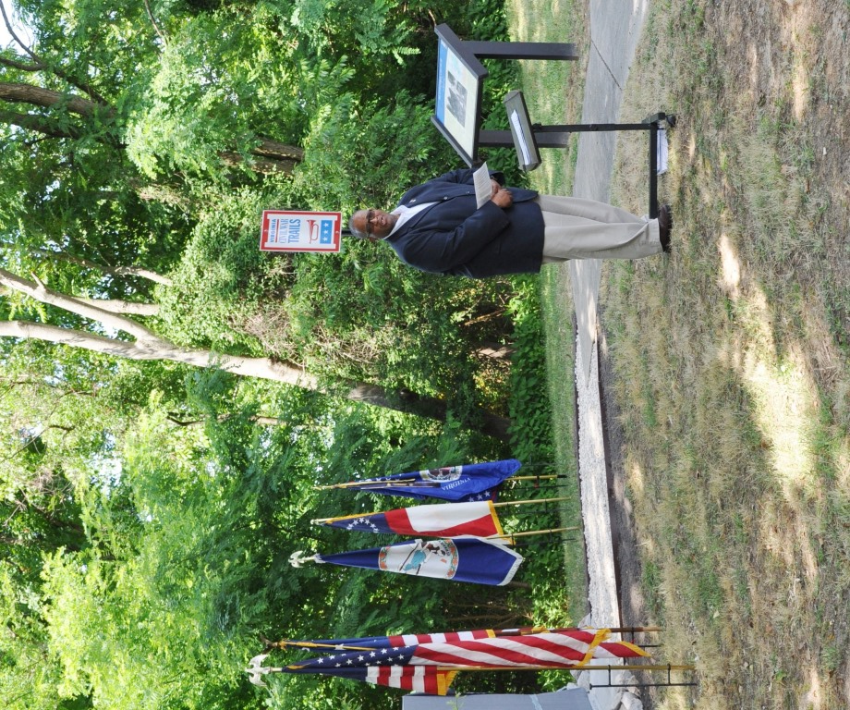
The Mayor of Petersburg, The Honorable Brian Moore welcomes the attendees

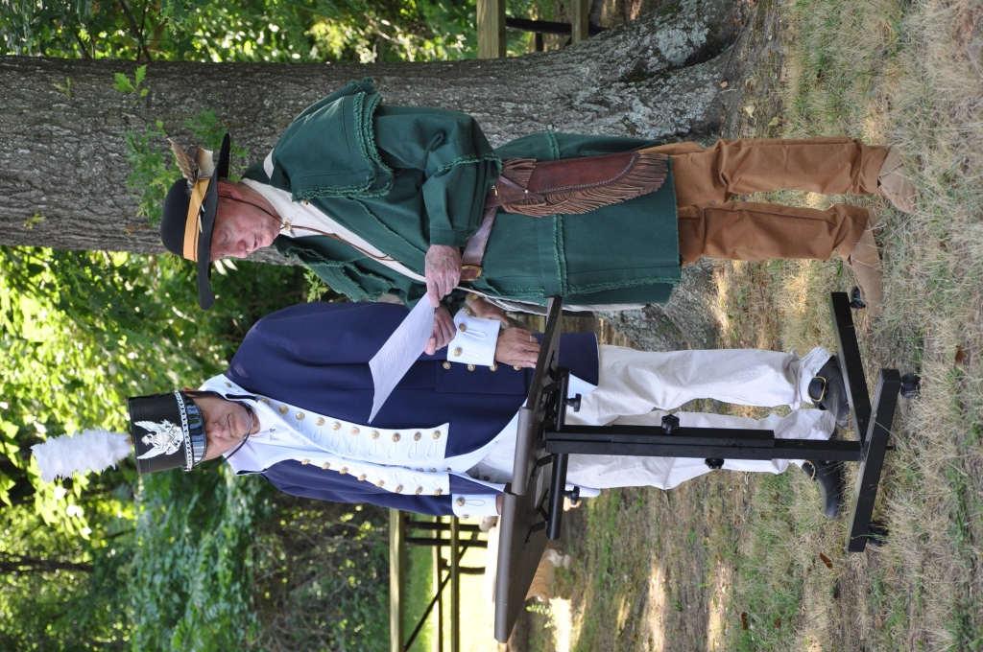
Vice President of the Society, Dennis Fritts (left) and Past President of the Society, Thad Hartman
recite the unveiling ritual
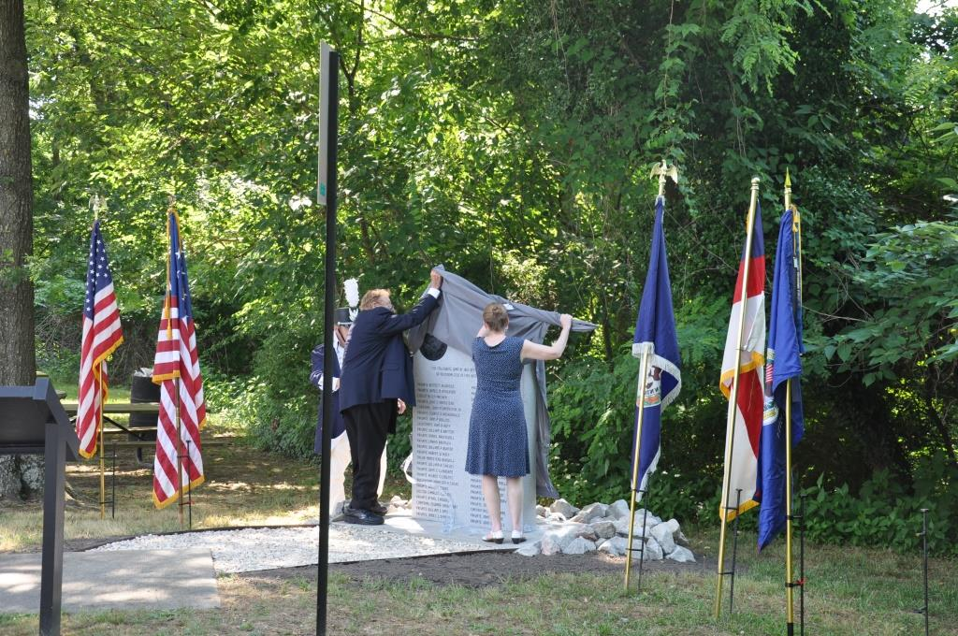
President of the Society, Captain John N Dickie, (USN Ret) and Jacque-Lynn A Schulman, 4th President National and VA State President, U.S. Daughters of 1812 unveil the monument
