War of 1812 Society in the Commonwealth of VA Presents a program to the Bedford County Historical Society August 9, 2014
President Dennis Fritts of the society presented the ceremony and talked about how the county was involved in the war. Also, attending from the 1812 society were members David Howard and Tom Sales. About 25 people were in attendance. The following is from the historical society’s newsletter.
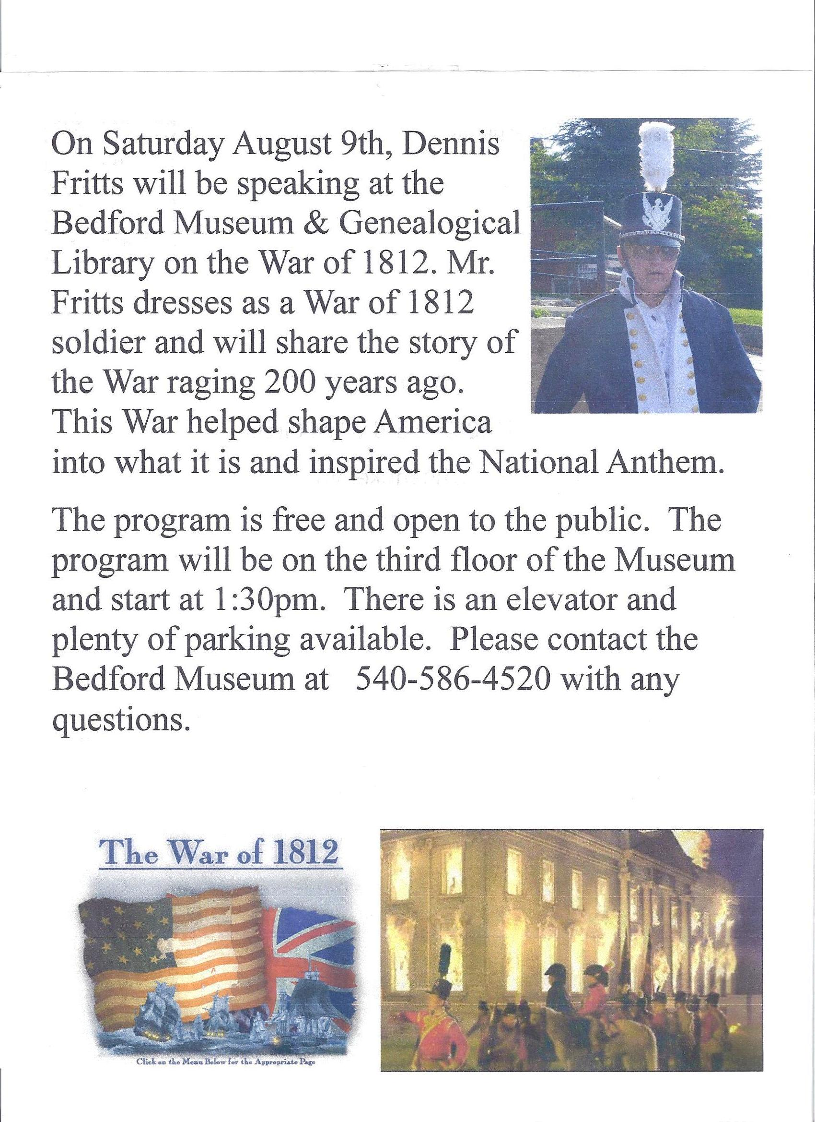
Below are photos taken at the event.
