The Society of the War of 1812 in Virginia holds meeting Sep 19, 2014
In Fairfax, Virginia at the Hyatt Fairfax at Fair Lakes Hotel, the War of 1812 Society held a Board of Director’s meeting. .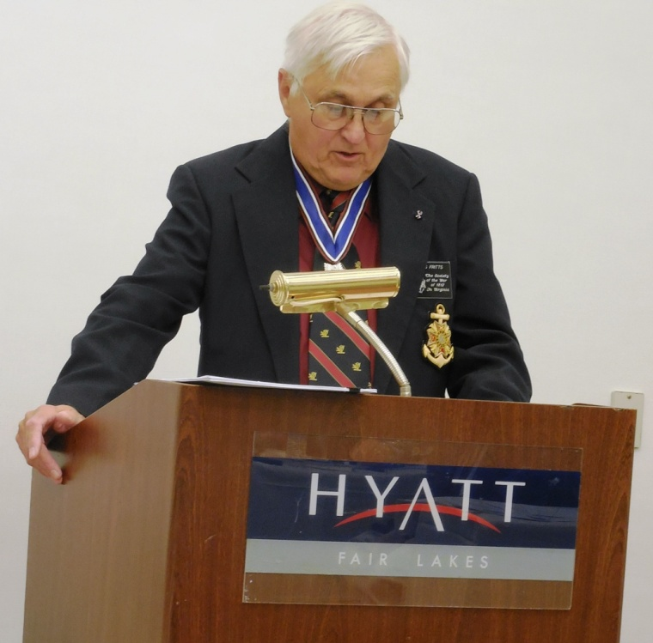
Above President C. Dennis Fritts presides. Some of the attendees are shown below
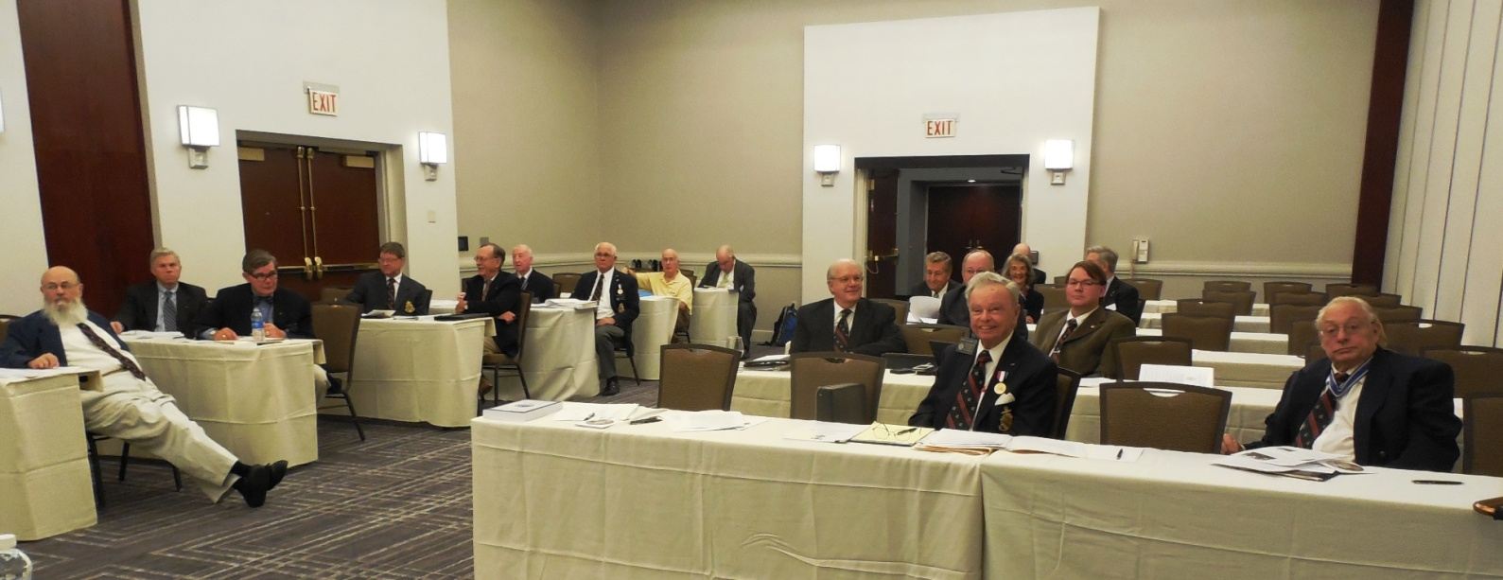
Below is Deputy Councilor, Cranston Williams, Jr is shown giving his report, A group photo of the attendees follows
