War of 1812 Author, Stuart L Butler gives presentation to SAR Chapter on Ft McHenry & the Baltimore Battle in September 1814
Stuart Butler is a Councilor in the Society of the War of 1812 in the Commonwealth of Virginia. He also represented the Virginia Bicentennial Commission by giving a presentation as part of Fairfax City’s Bicentennial of the War of 1812
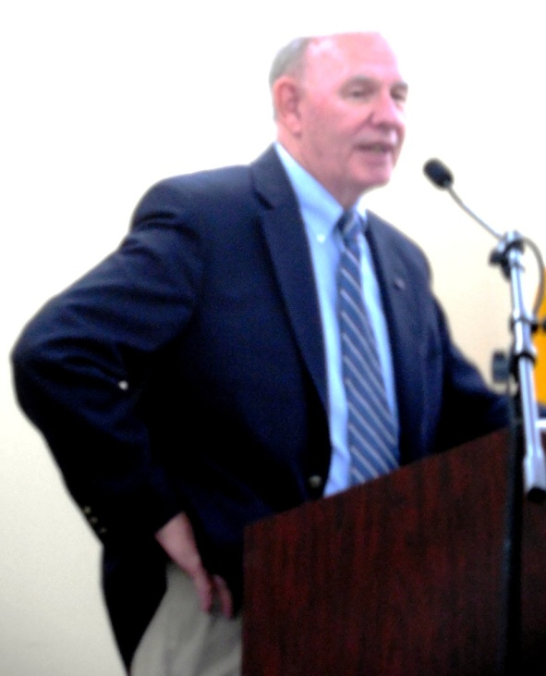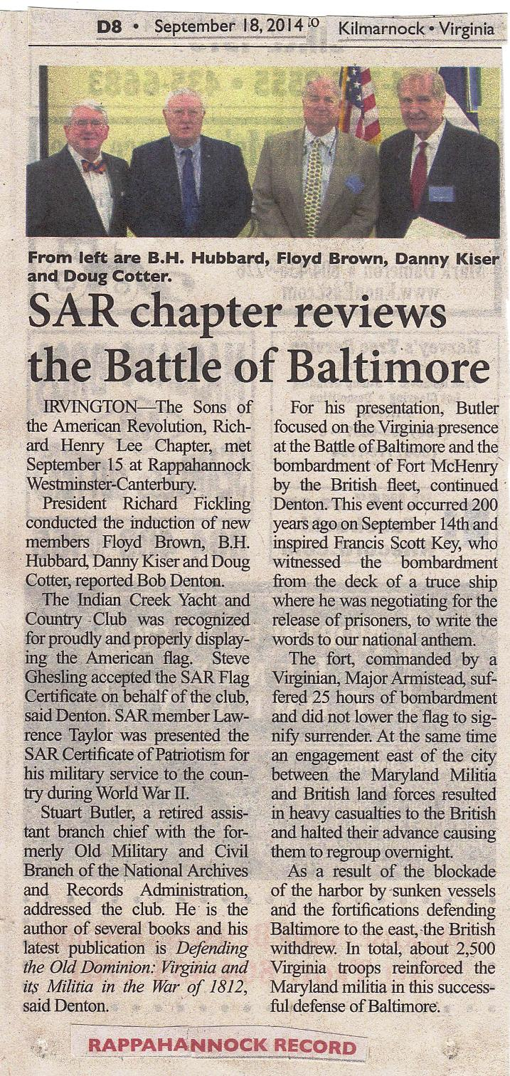
See his name as speaker at 11:30 am below:
Below he represents the VA Bicentennial Commission of the War of 1812 by presenting a wreath at the grave marking ceremony that day at 3:30 pm. He is shown in the center with the VA Bicentennial Commission’s wreath. On his right is Mike Lyman, representing the General Society War of 1812 by presenting a wreath. On his left is The Mayor of Fairfax County, The Honorable R. Scott Silverthorne. The Star Spangled Banner flag is displayed on his left as well as the gravestone of Captain Rezin Willcoxon who was being honored and remembered in the grave marking ceremony.
