SOCIETY HOLDS MEETING AND MEMBERS ATTENDS VASSAR BANQUET FEB 2O-21 2015
Officers and members of The Society of the War of 1812 in the Commonwealth of Virginia held a business meeting at the Omni Hotel in Richmond on February 19th. They then attended a social gathering. The next evening several of the War of 1812 society officers and members attended the VA Society Sons of the American Revolution banquet at the hotel. Some photos taken at the meeting and at the banquet are shown below.
At the Board of Managers meeting the attendees sat at tables arranged in a square. Photos taken by Mike Lyman show each side of the square seating
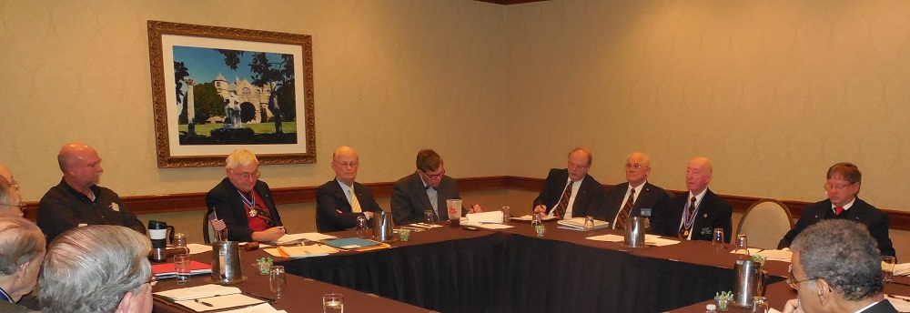
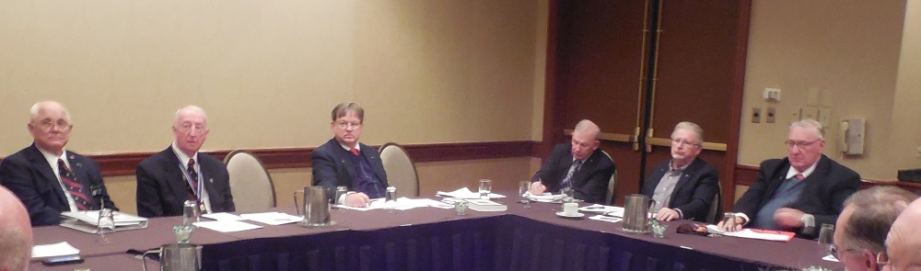
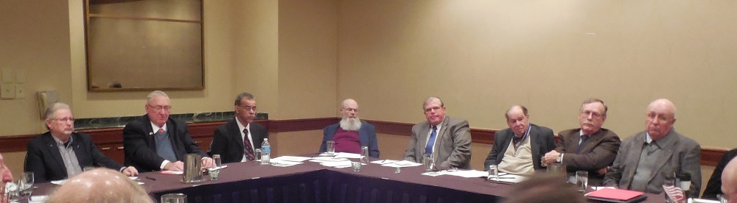
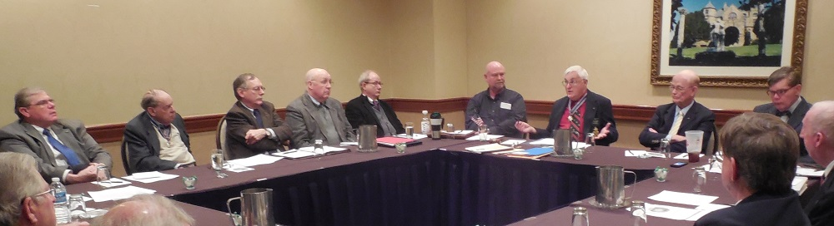
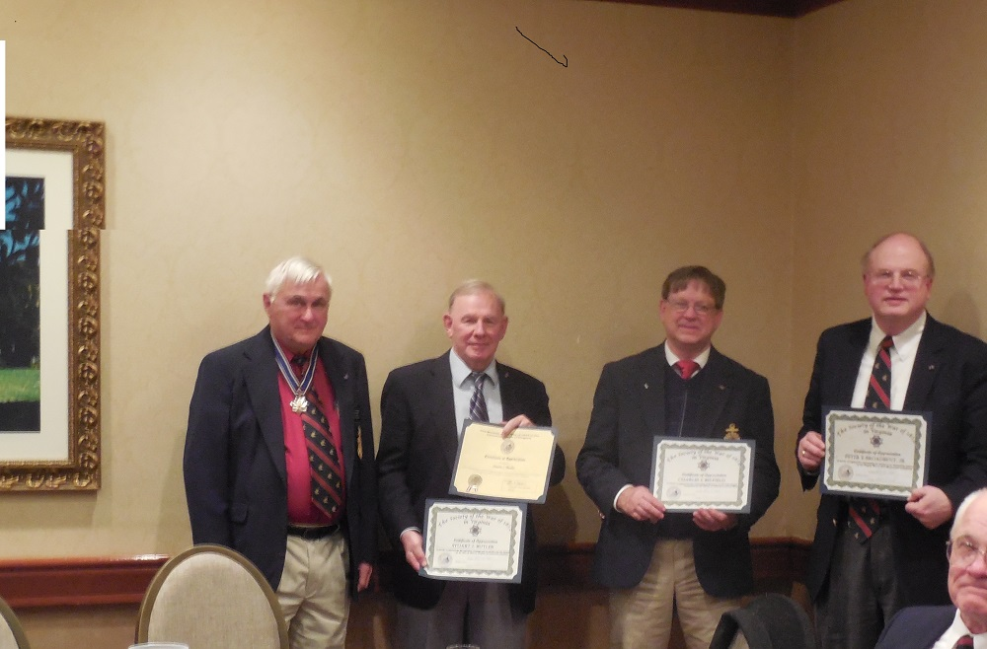
Above President Fritts (left) provided Certificates of Appreciation T Stuart Butler, Charles Belfield and Peter Broadbent Some other members also received awards at the meeting that were not in attendance
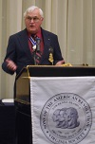
Above President Fritts is shown giving greetings at the VASSAR banquet
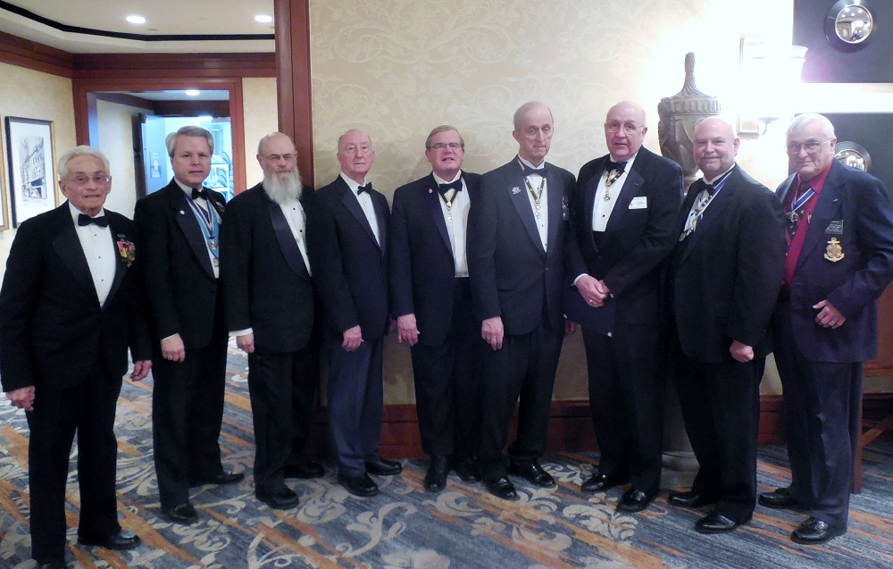
After the VASSAR banquet several War of 1812 society members gathered for a photograph
L/R: Mike Lyman-Past President, Joe Dooley- dual member; Chuck Poland- Registrar, Thad Hartman- Past President, Tom Whetstone- member, Ed Truslow-member; Bill Collier-Councilor, Mike Tomme-dual member, and Dennis Fritts-President

