Society Participates in James Monroe Birthday Celebration Hollywood Cemetery Apr 28, 2015
The 257th birthday of 5th U.S. president, James Monroe was conducted at the Hollywood Cemetery in Richmond at the President’s Circle portion of the cemetery at 11am on April 28, 2015.The presidential wreath was presented by the Commanding General of Fort Lee. Following, a separate ceremony was continued by the James Monroe Memorial Foundation. A scan of the program and some photos taken follow. This plaque at his birthplace in Westmoreland County summarizes his life.
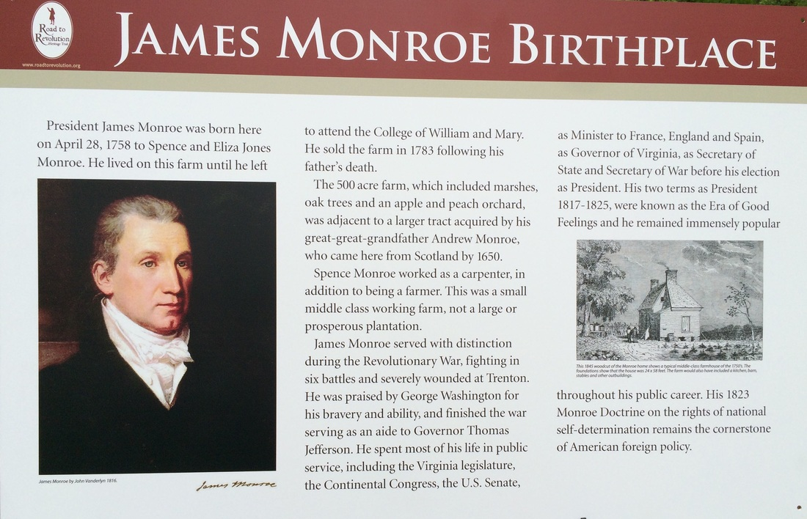
Below is the invitation from the commanding general of Fort Lee, Major General Stephen R Lyons and photos of him presenting the wreath
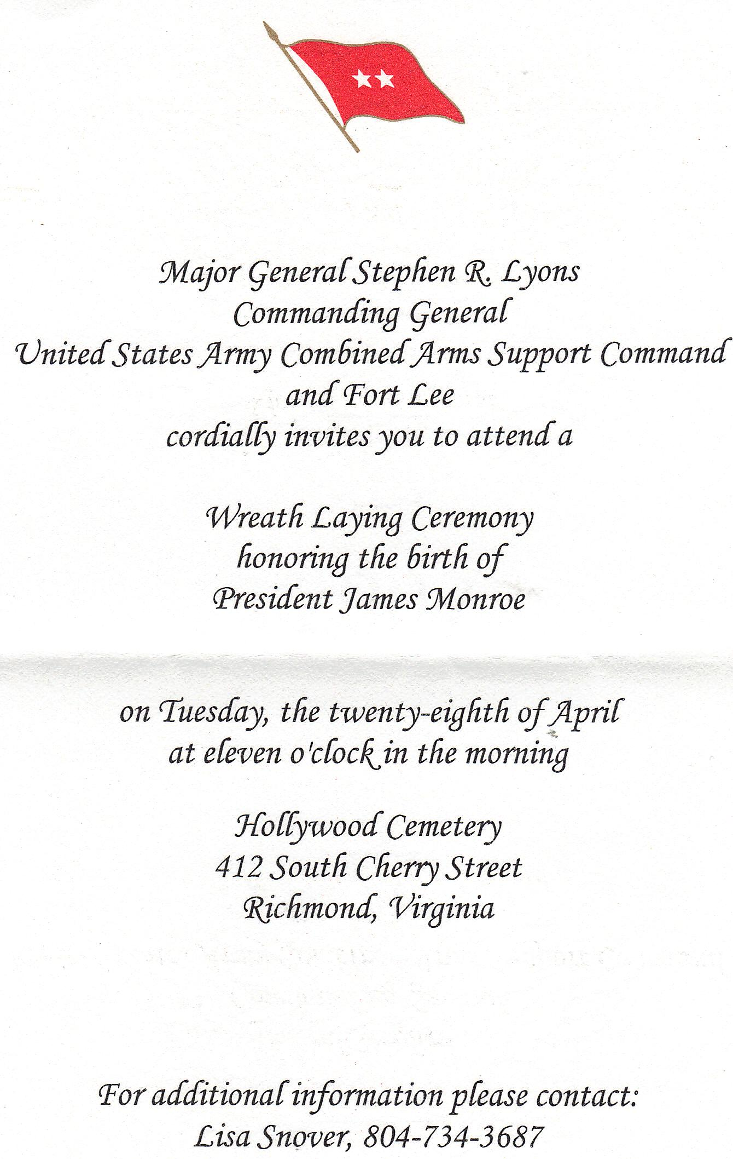
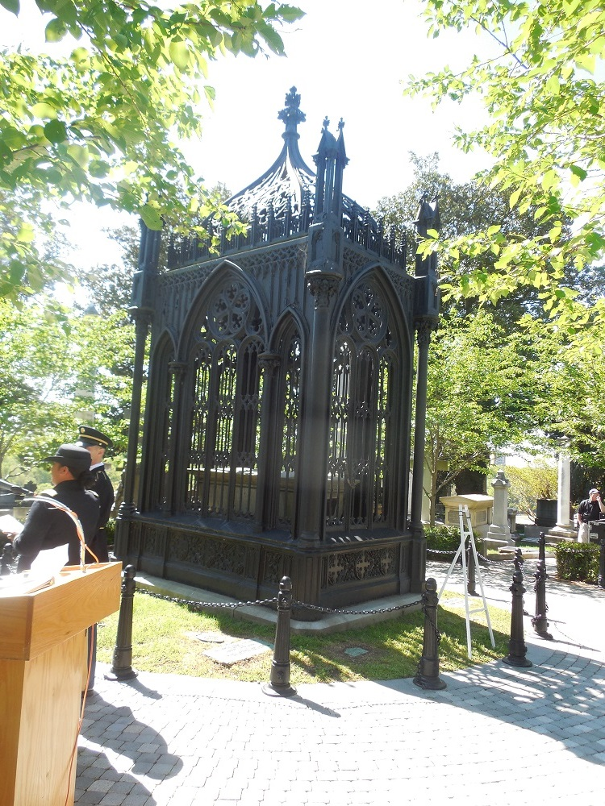
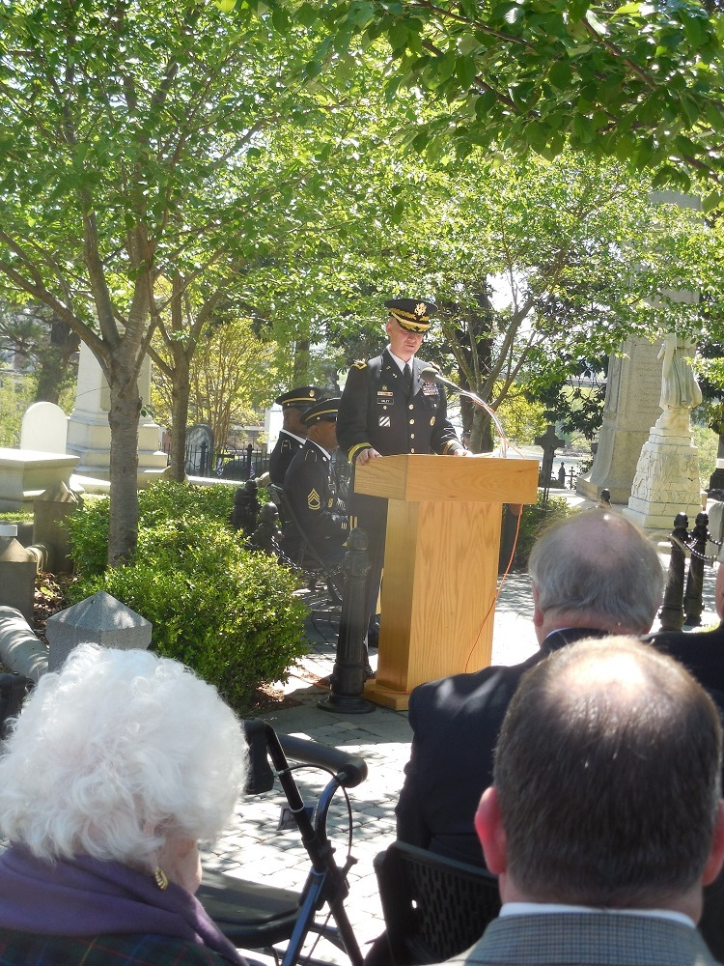
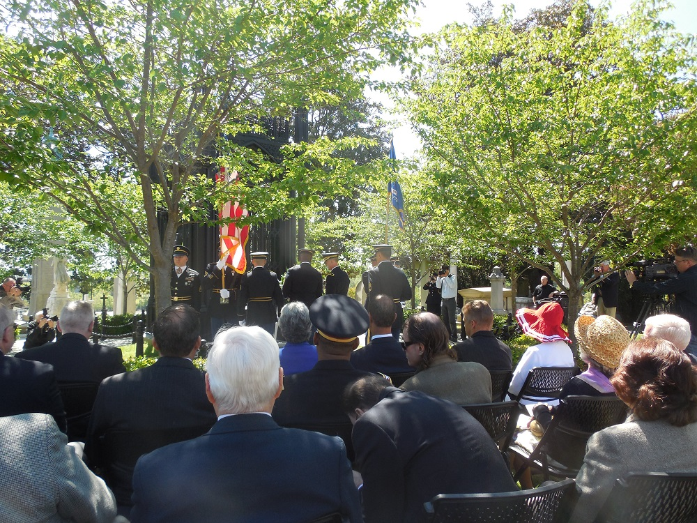
The program for the James Monroe Memorial Foundation is shown below:
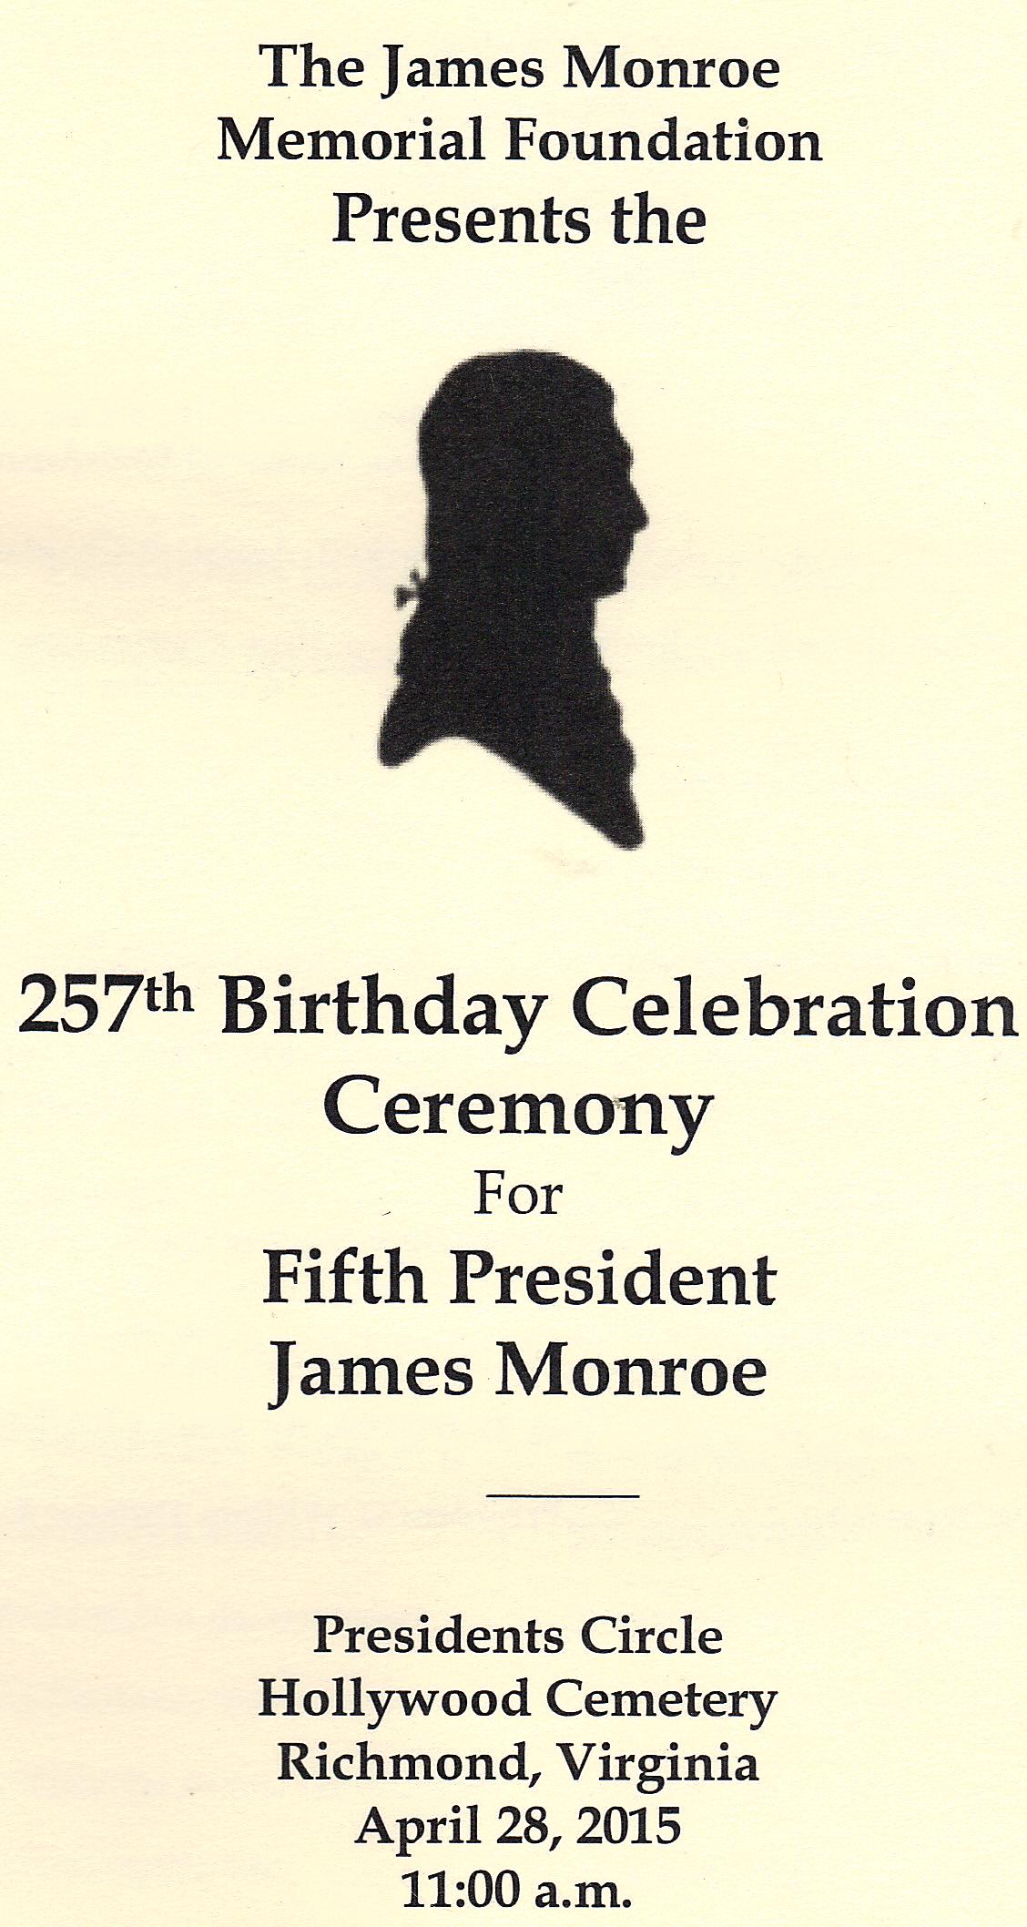
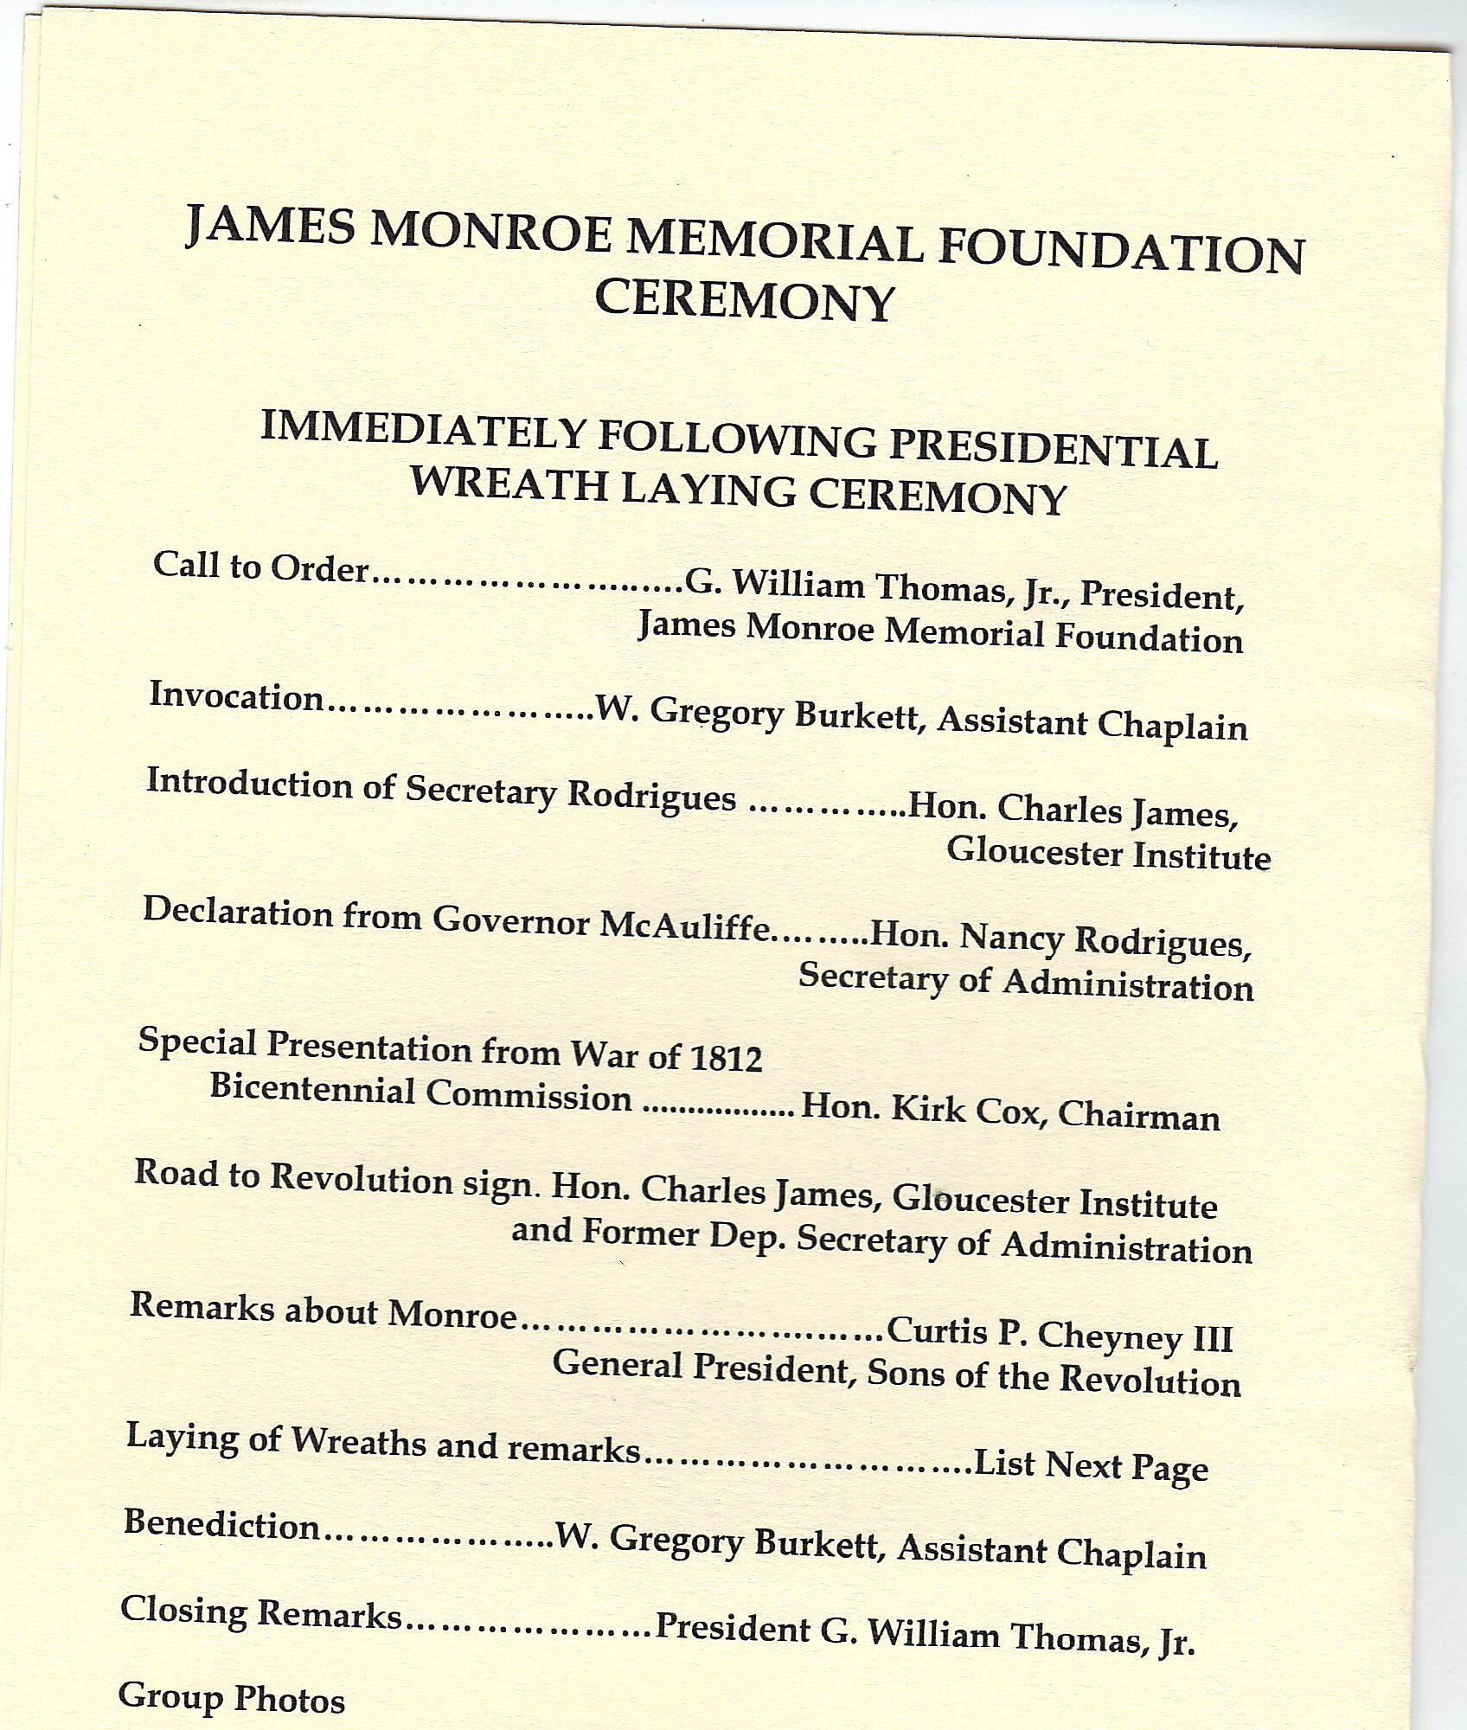
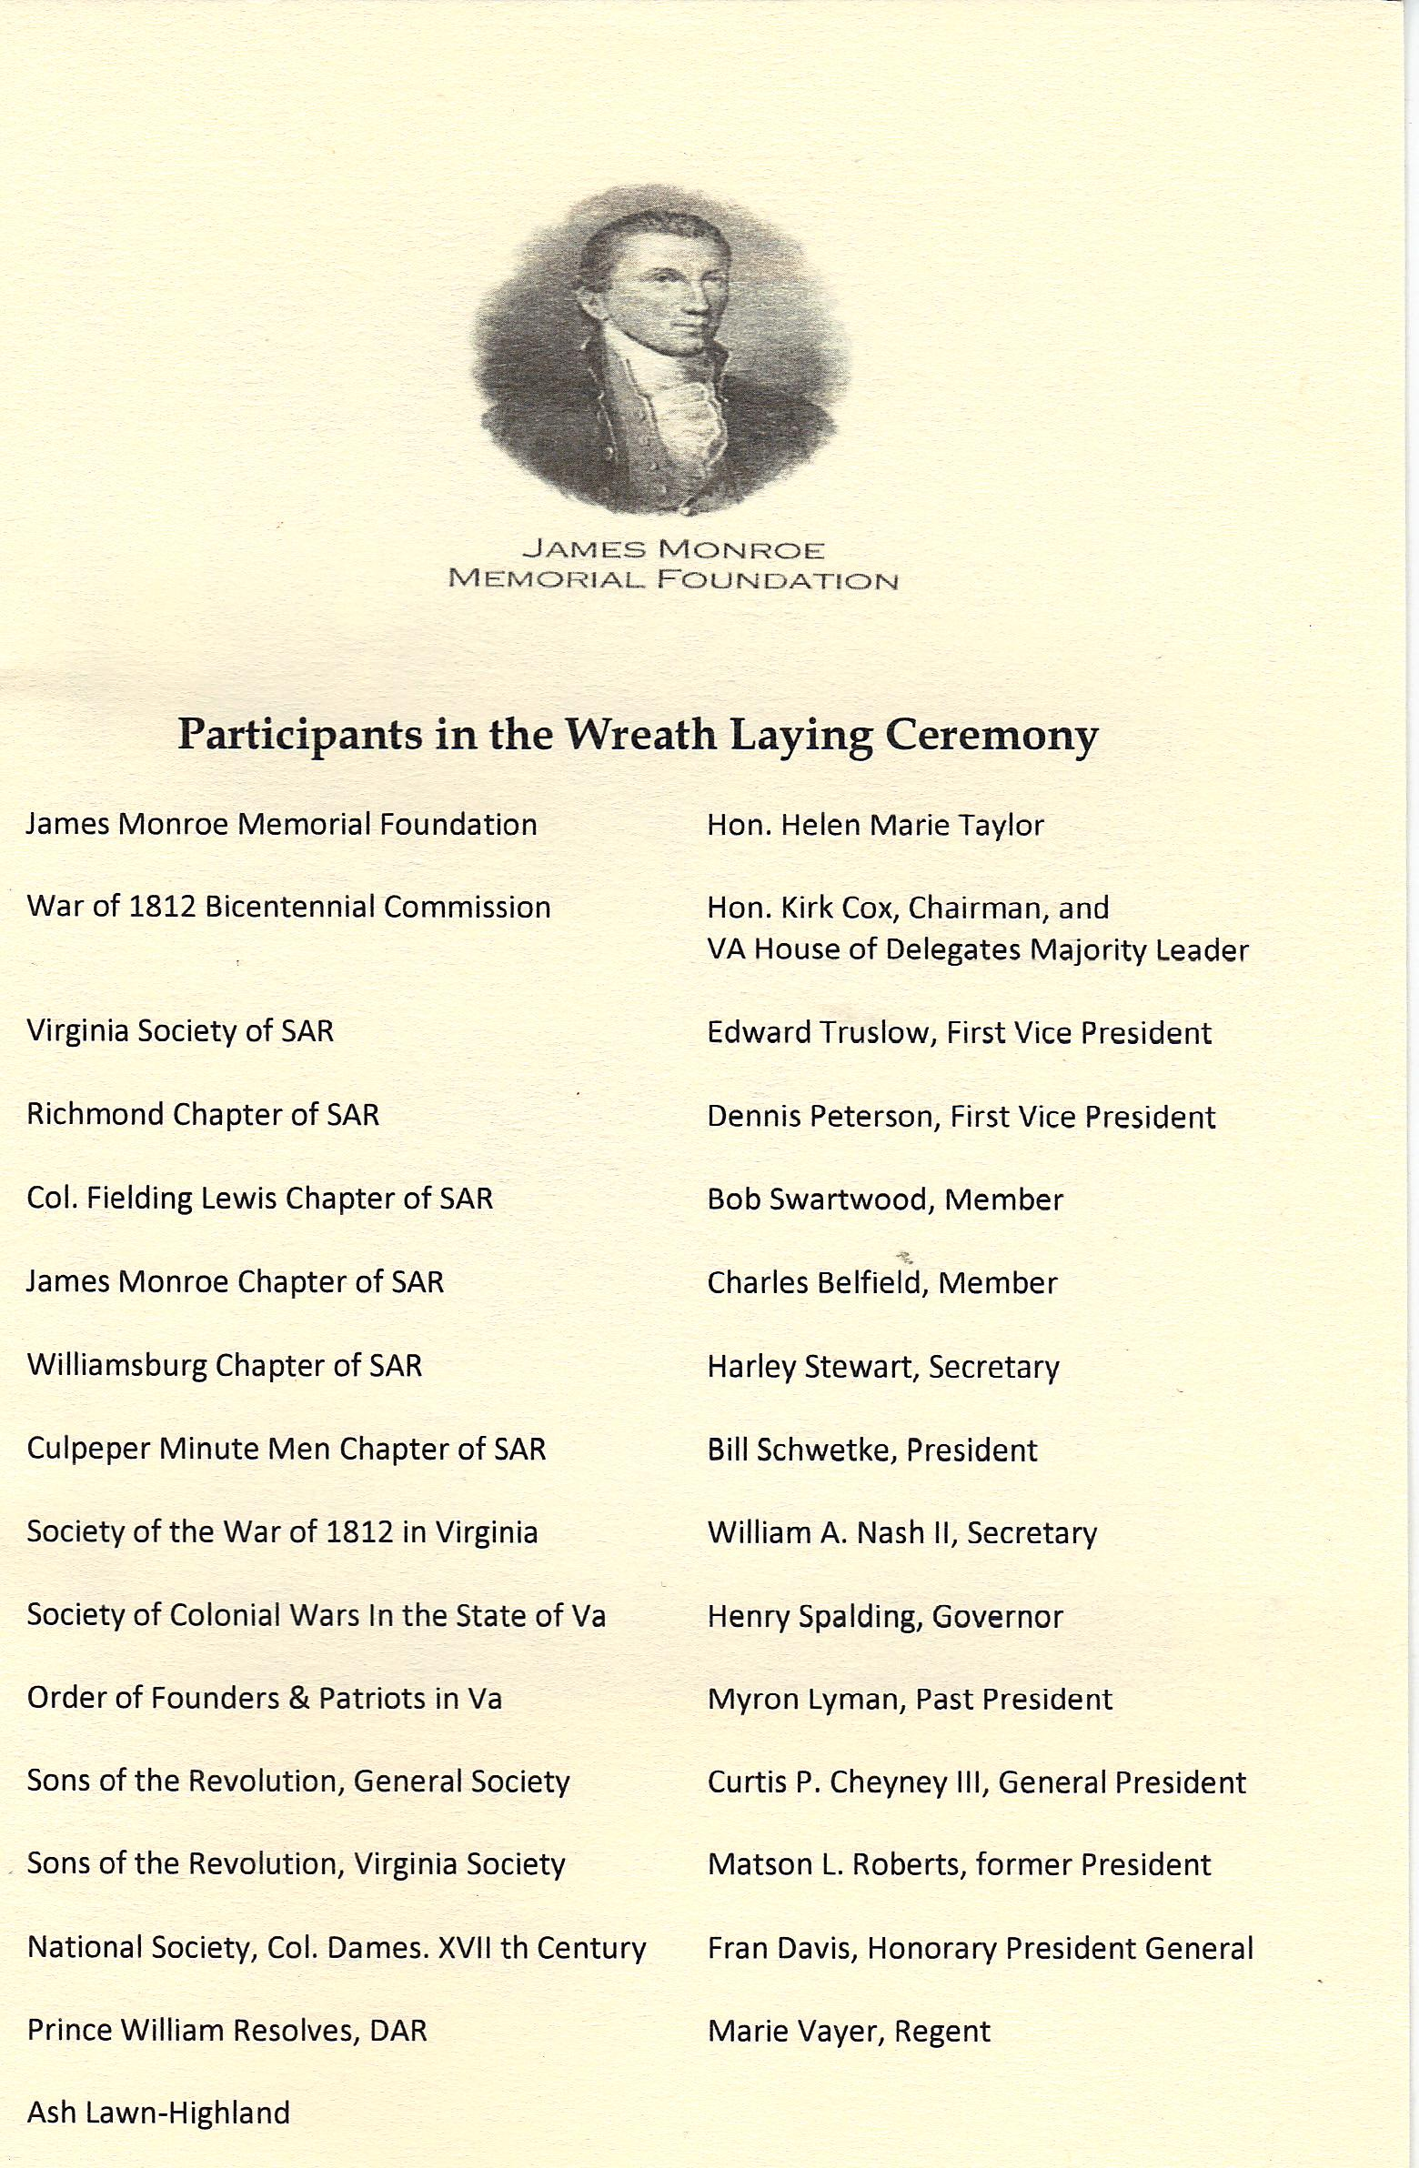

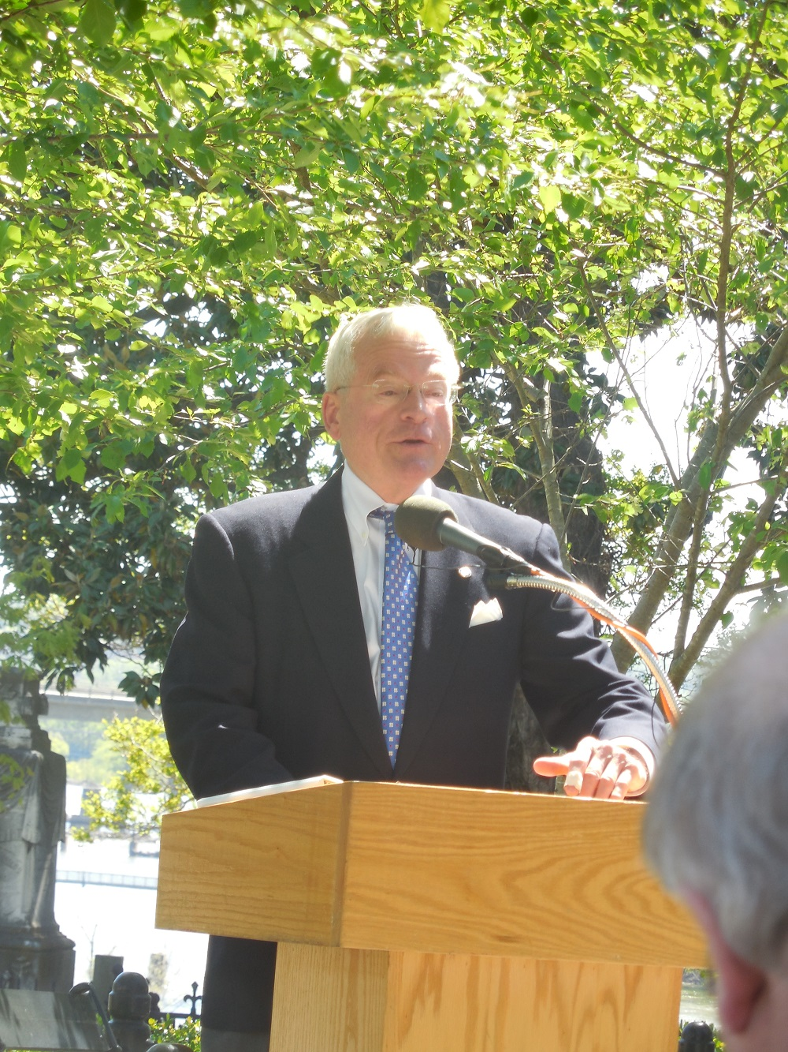
Above President of the Foundation, G. William Thomas presides
Below the Honorable Charles James of the Gloucester Institute
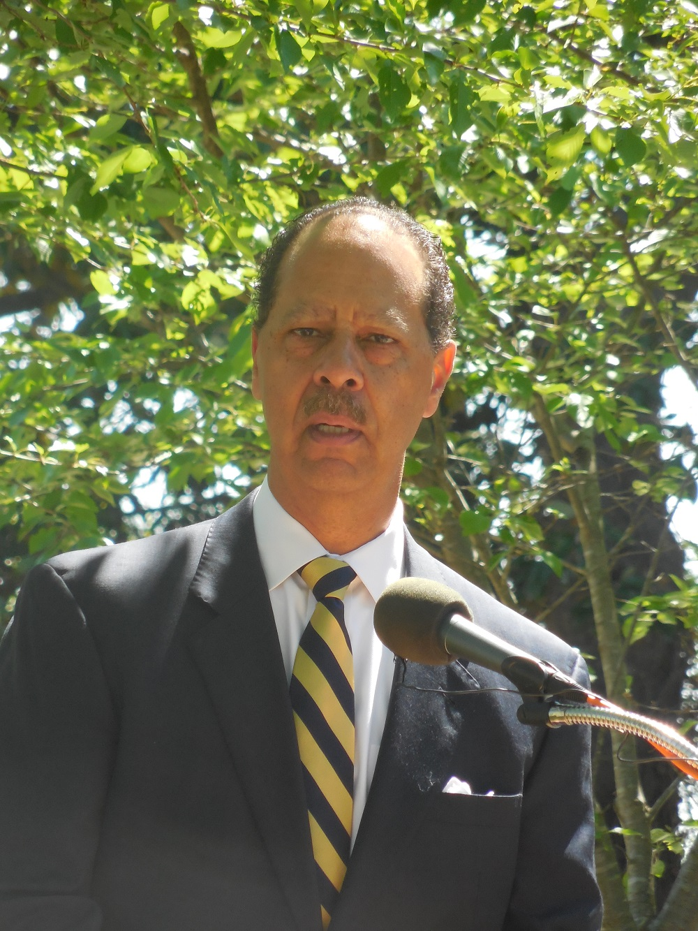
Below the Honorable Nancy Rodrigues, Secretary of Administration reads the VA Governor’s proclamation announcing April 28th as James Monroe Day
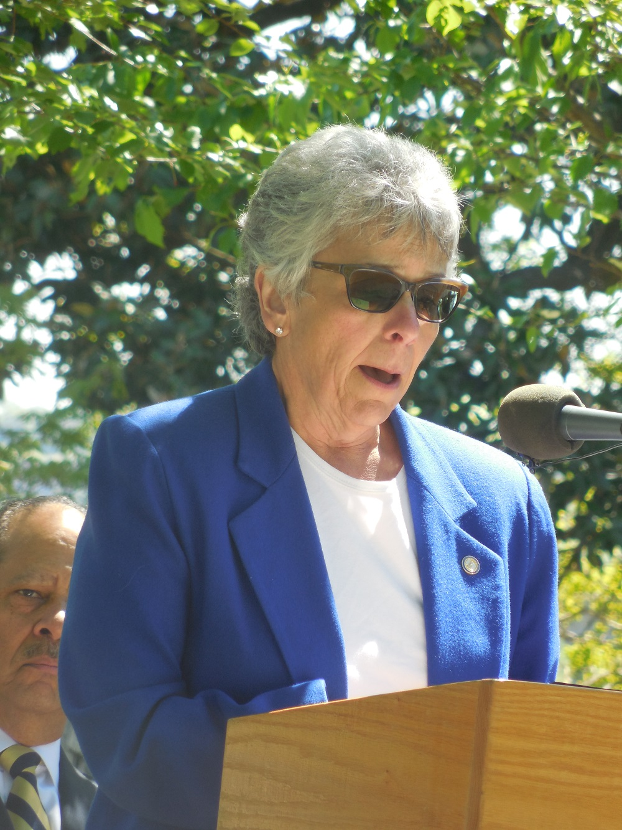
Below the Honorable Kirk Cox, Chairman of the Virginia War of 1812 Bicentennial Commission presents an award to Peter E. Broadbent, Jr., Esquire, The Society of the War of 1812 in the Commonwealth of Virginia’s representative to the Commission an award
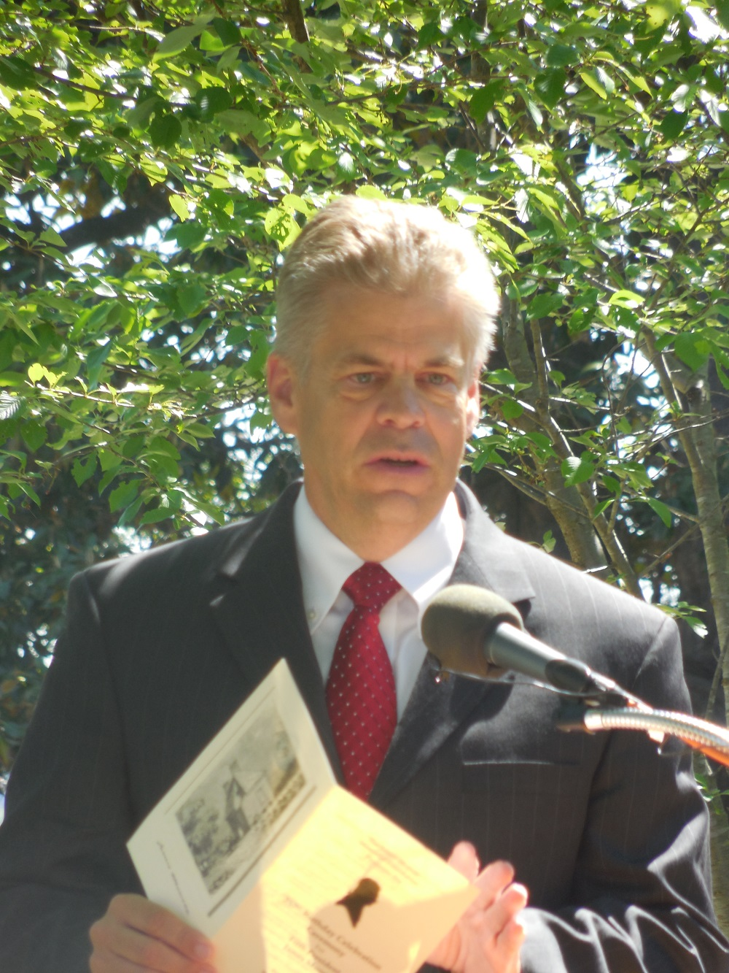
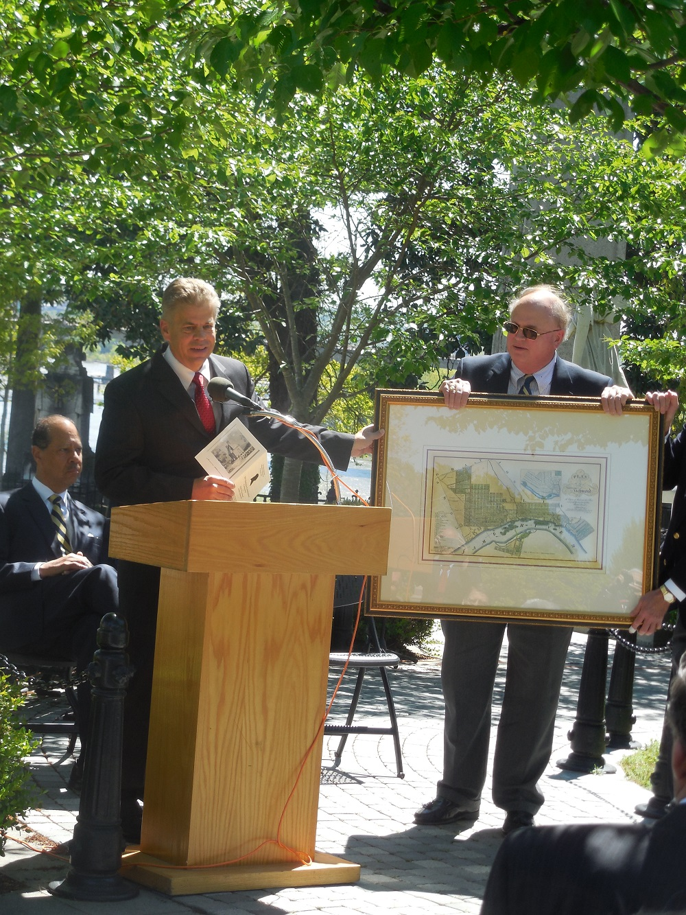
Below Broadbent announces the participants in the wreath laying ceremony.
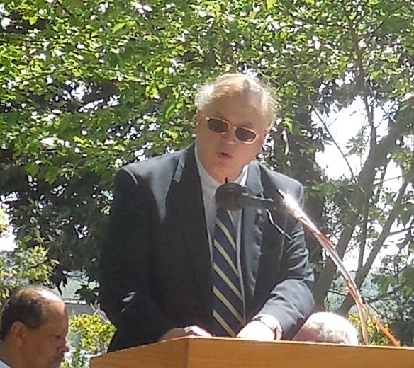
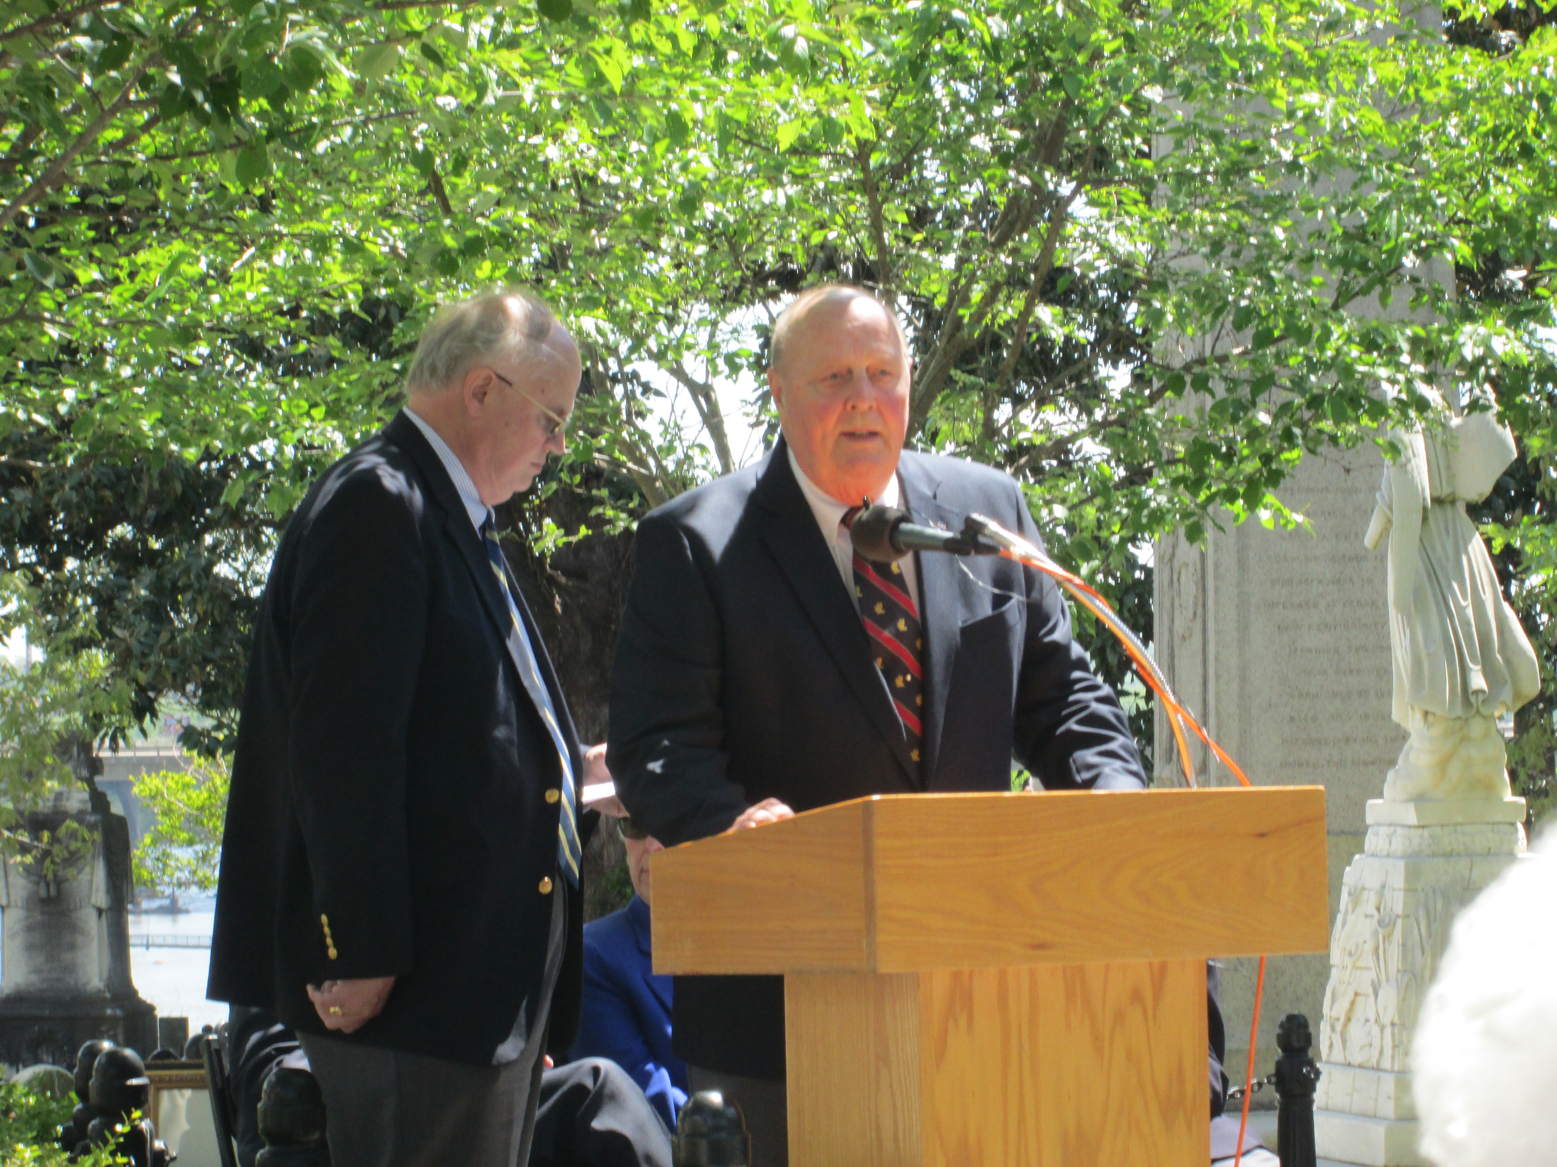
Above member Ronald Depue, after presenting the Society’s wreath, gives remarks. Below attending members beside Peter Broadbent gather for a group photo by the Monroe tomb
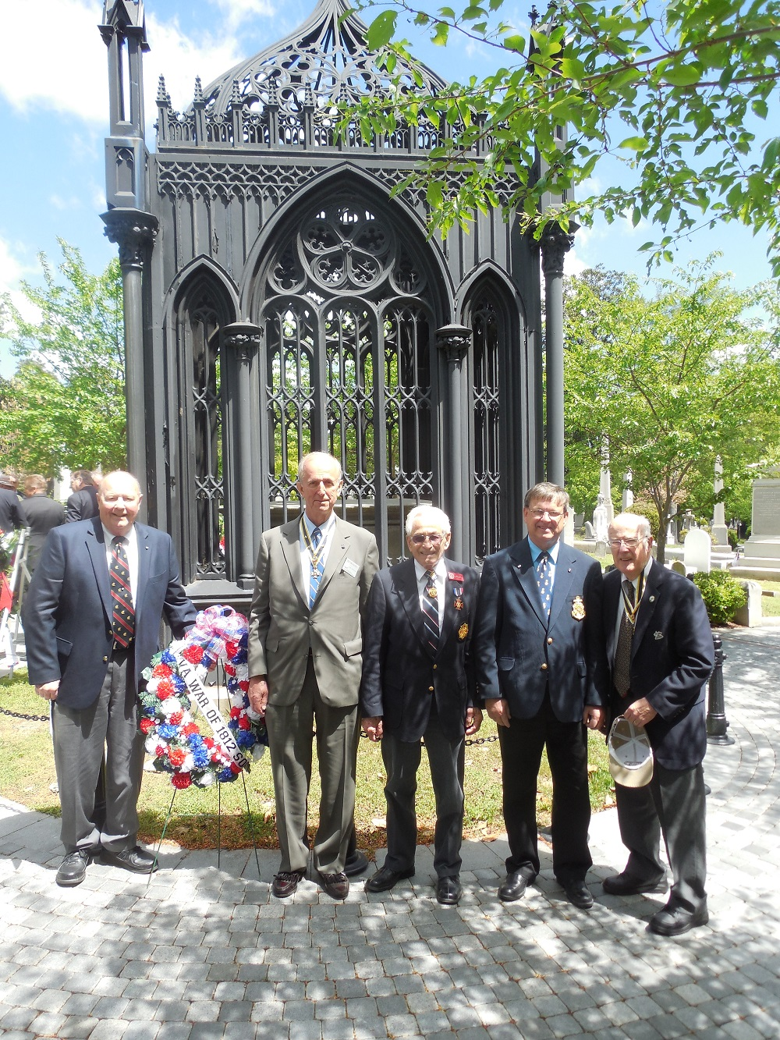
Left to right: Ron Depue, Ed Truslow, Mike Lyman, Charles Belfield and

