SOCIETY PARTICIPATES IN HIGHWAY MARKER UNVEILING OCT 1 2013
A new Virginia highway road sign involving the War of 1812 in Virginia was unveiled Oct 1, 2016 on U.S Route 3 in Lancaster County where it crosses the Rappahannock River from Middlesex County. The sign commemorates the flight of sixty nine slaves escaping to freedom to the British fleet from the Corotoman Plantation on April 2, 1814
Participating from the Society of the War of 1812 in the Commonwealth of Virginia was 2d Vice President, Stuart L Butler, who was one of the guest speakers providing the details of the event and Past President, Mike Lyman who unveiled the sign and presented the society’s wreath. Below is the unveiled sign, newspaper articles regarding the ceremony, and some selected photos.
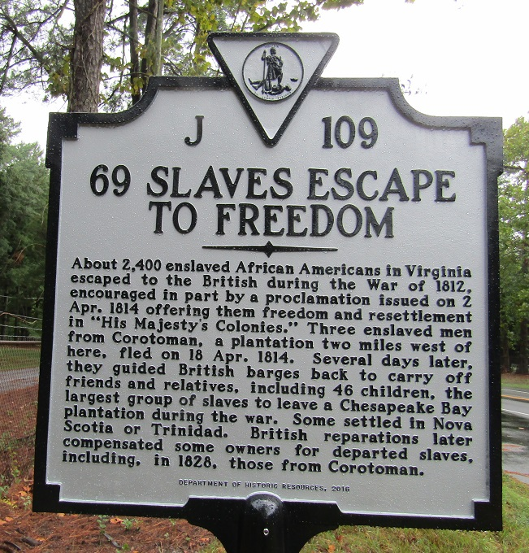

Below is a pre-event newspaper article giving details regarding the event
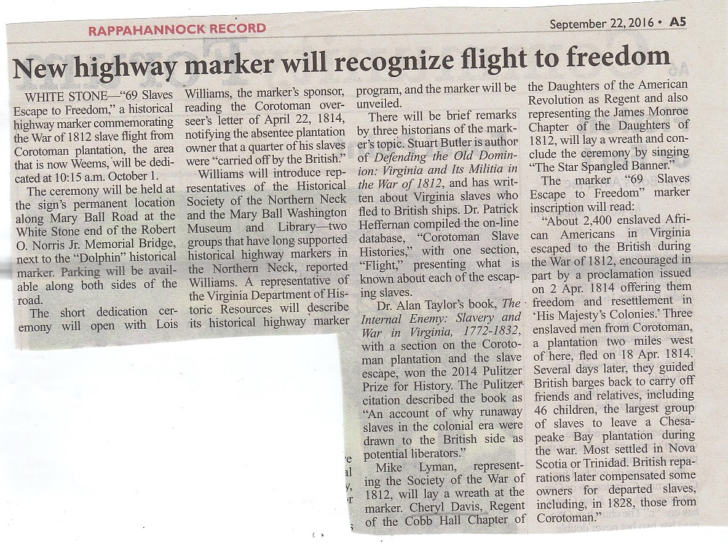
The below photo shows the sign by Route U.S. 3 as it comes from the Norris Bridge into Lancaster County
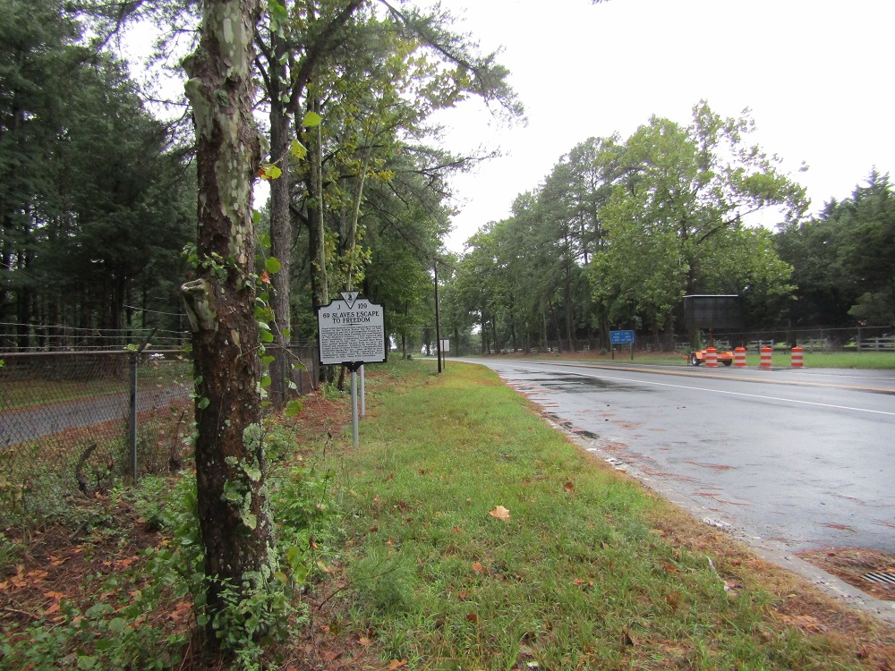
Below the representative from Virginia Department of Historic Resources describes the sign program. On the left is Lois Williams who sponsored the sign and on the right is Dr Alan Taylor
Note the photo shows the War of 1812 society flag and the society wreath that was presented

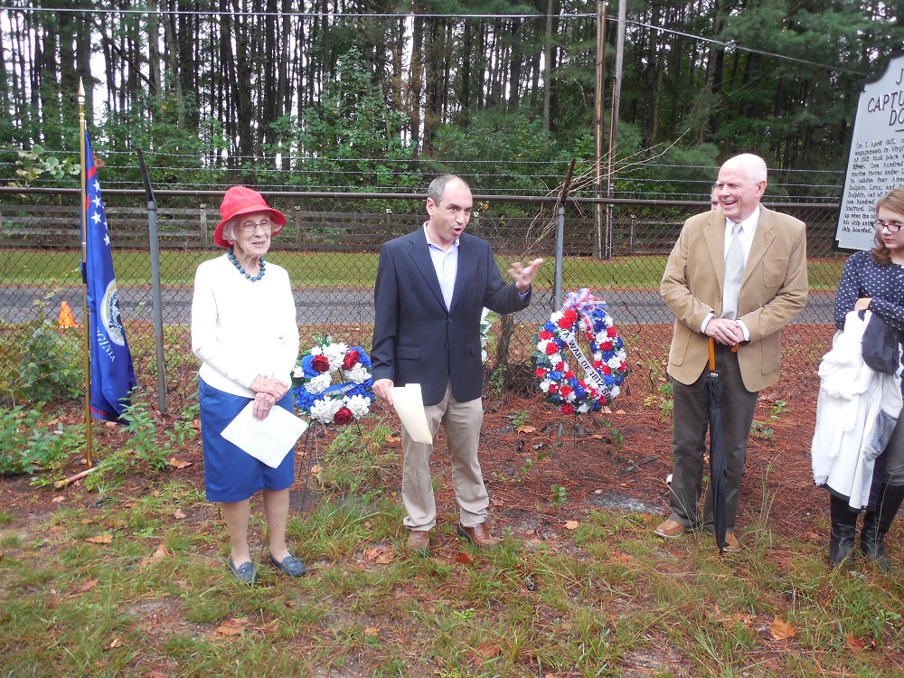
Below photo shows Lois Williams presenting the program
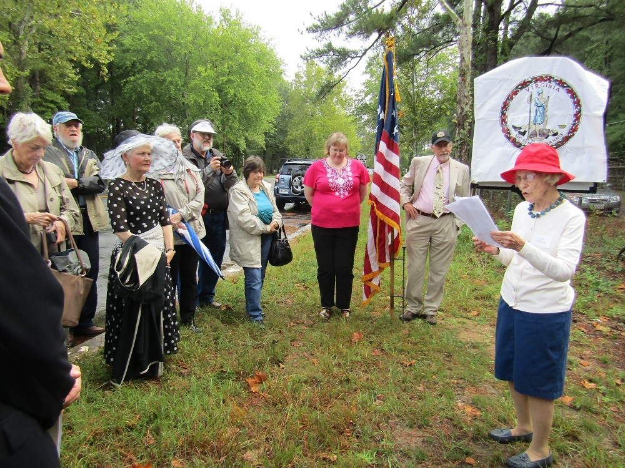
The two below two photos show Stuart Butler talking about the event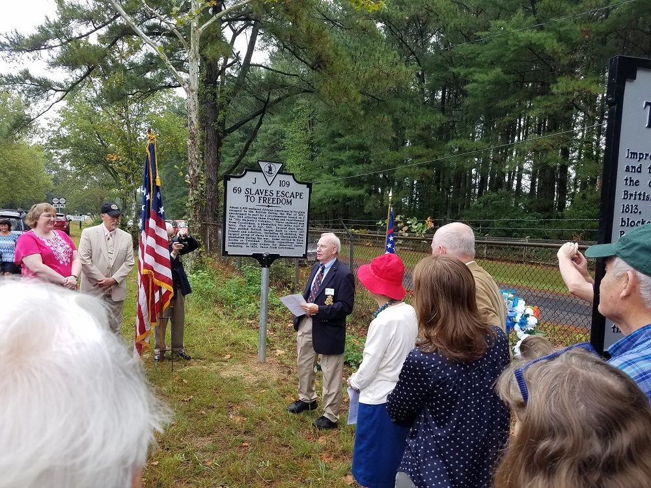
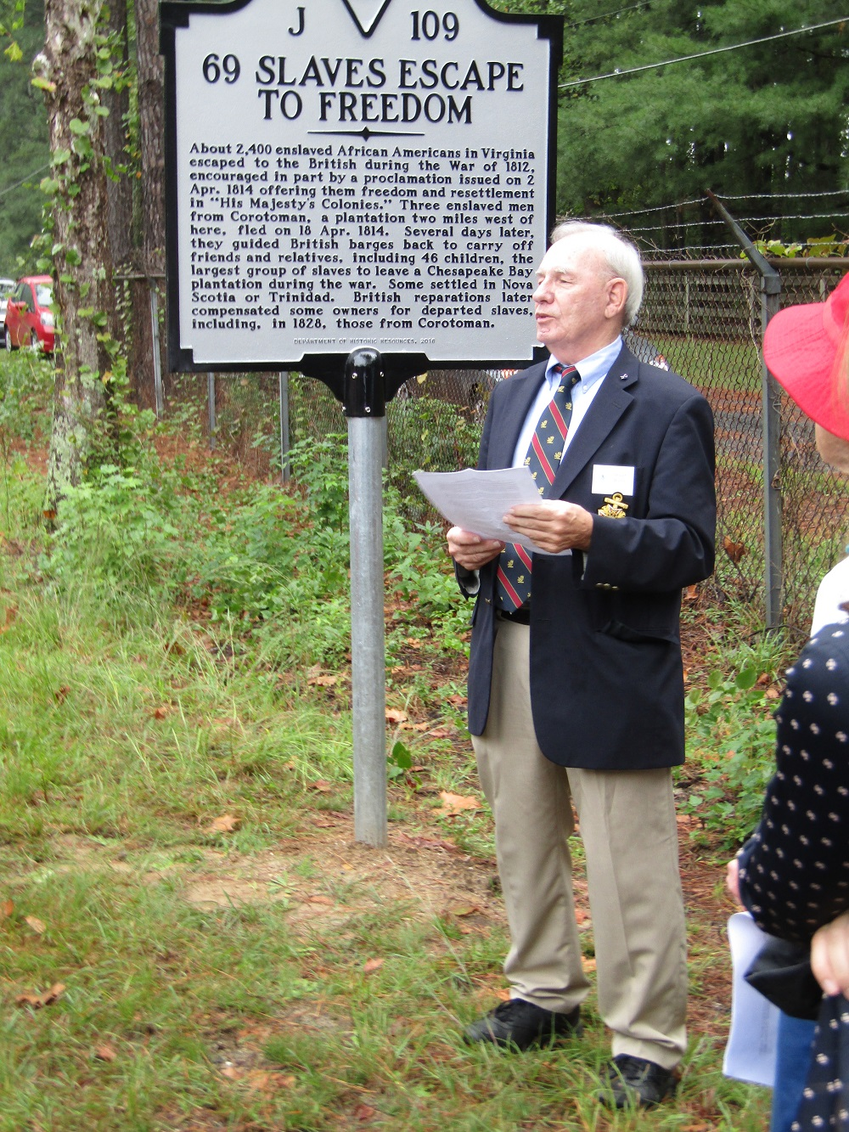
Below author, Dr Alan Taylor speaks about the escaping slaves
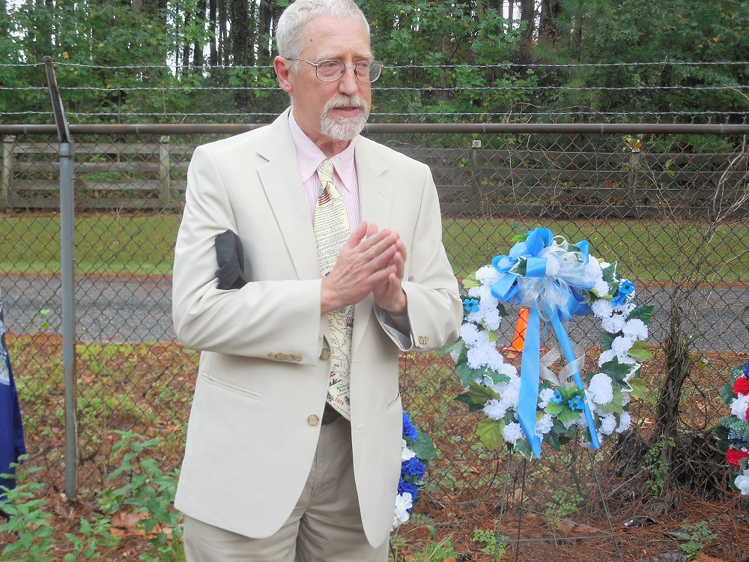
Below Patrick Heffernan speaks about each slave that escaped
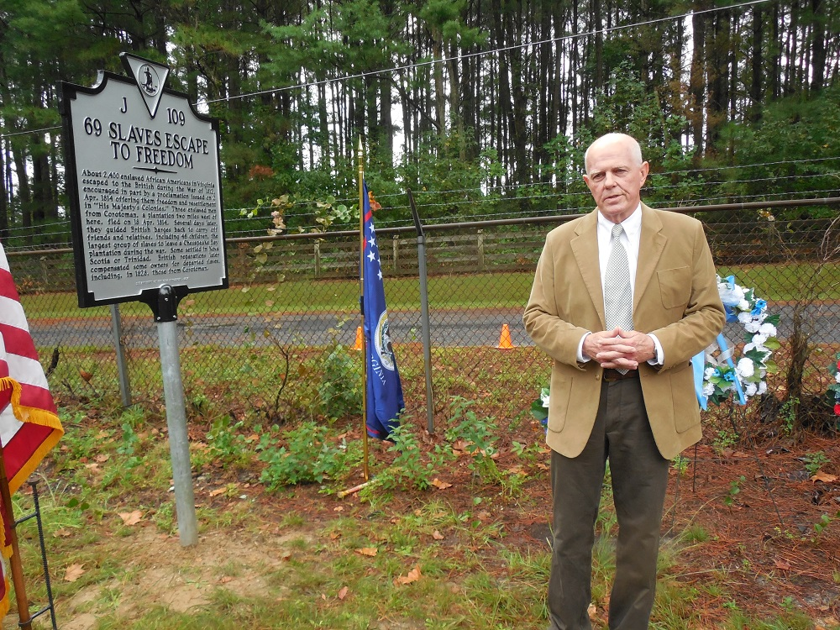
Below Mike Lyman unveils the sign
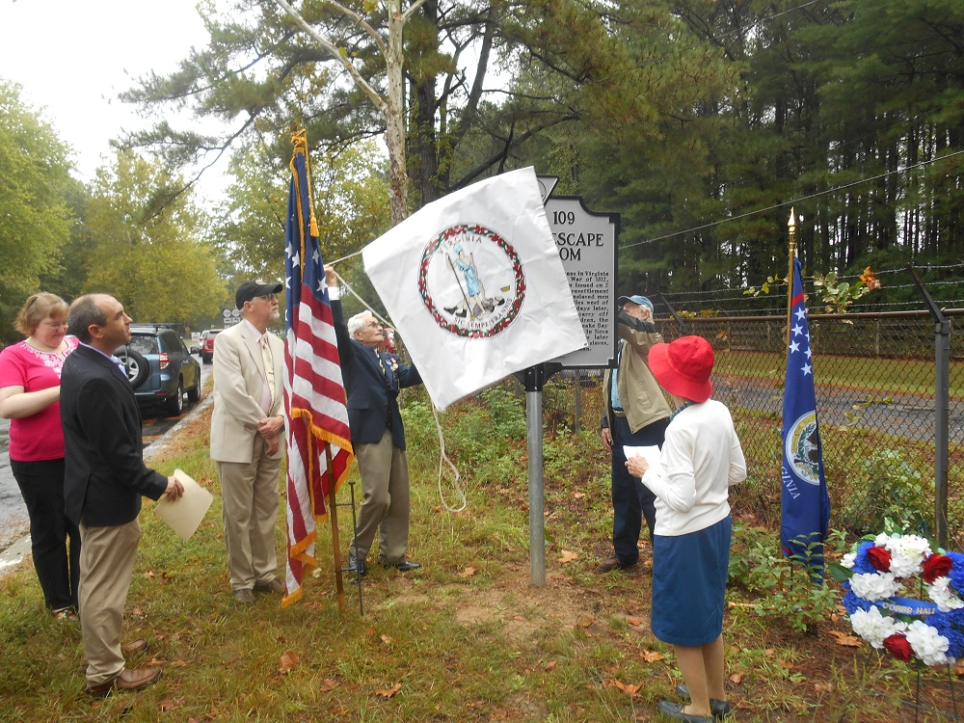
Below is Mike Lyman ready to present the wreath on his left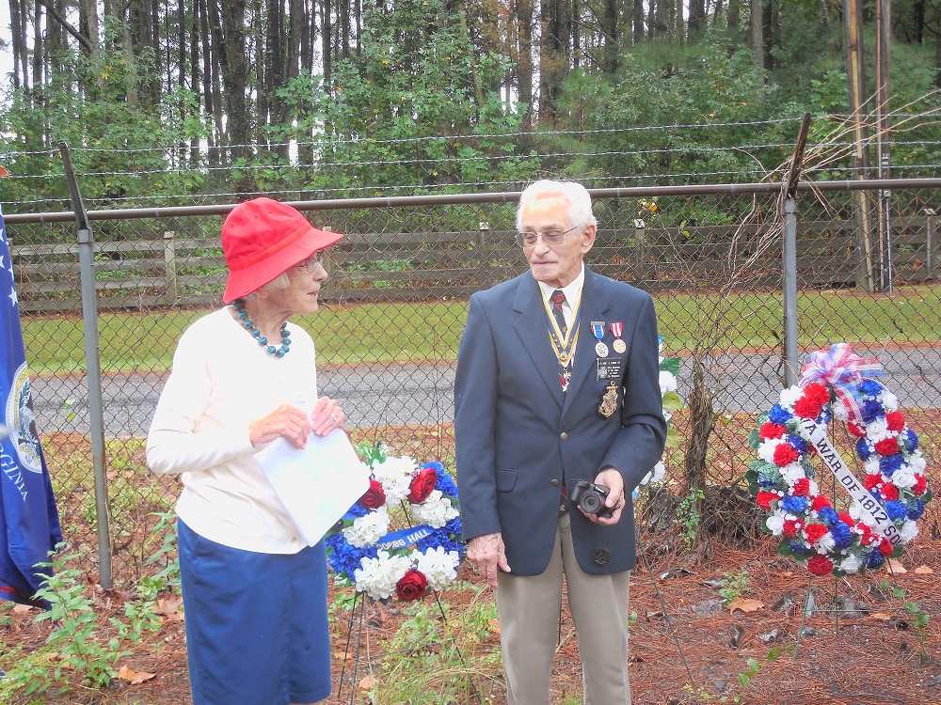
Below Dr Cheryl Davis as representative of the VA Society U.S. Daughters of 1812 presents her society’s wreath
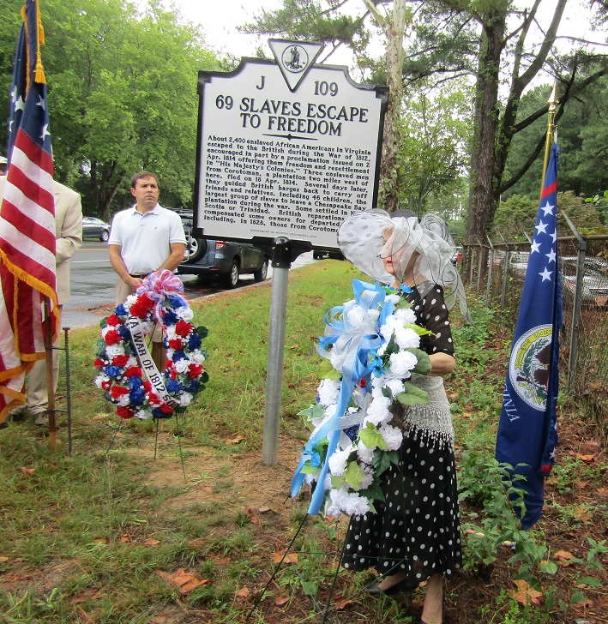
After the ceremony Mike Lyman and Stuart Butler are shown with others by the unveiled sign
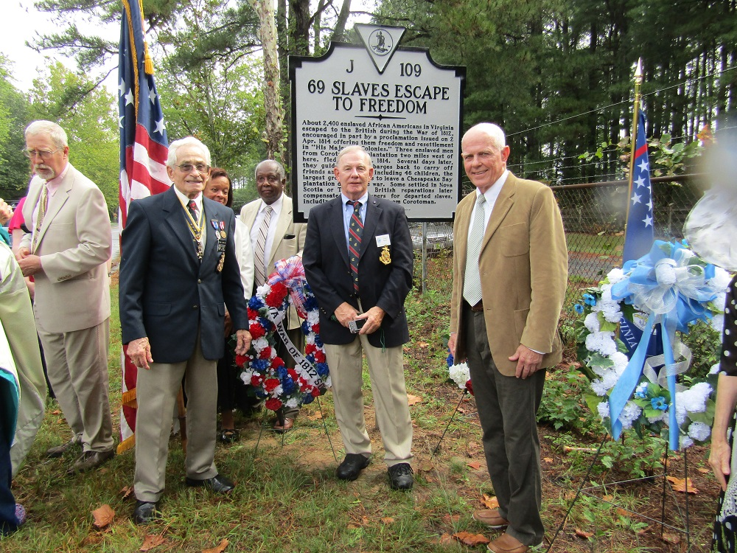
Below is the after the event news release
