Society Participates in Ceremony Honoring Two War of 1812 Veterans
At the Shockoe Hill Cemetery in Richmond on October 9th 2016, four War of 1812 members attended and participated. The ceremony was conducted by the Friends of Shockoe Hill Cemetery and new Veterans Administration headstones were dedicated. The headstone for Private John Rowland had been installed, however because of the rainy weather the one for Private Hilary Baker had not.
Below the program and photos are shown
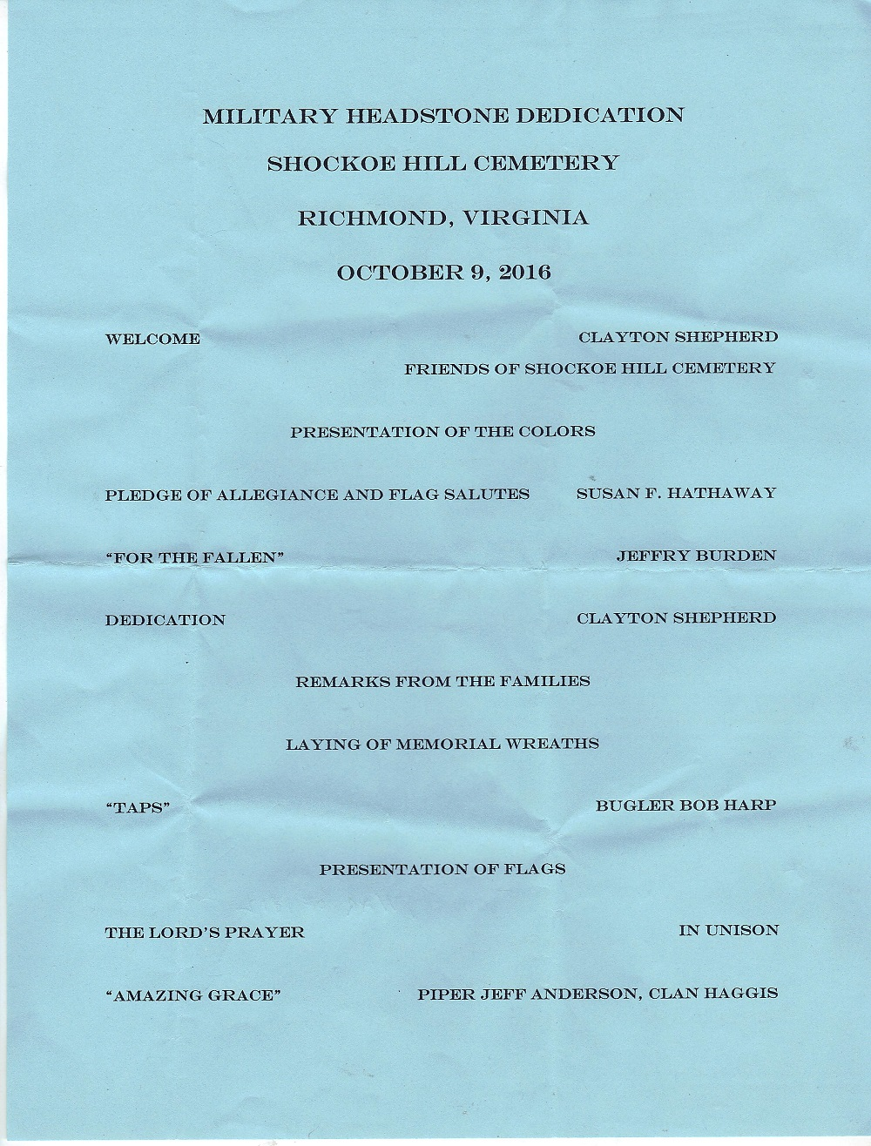

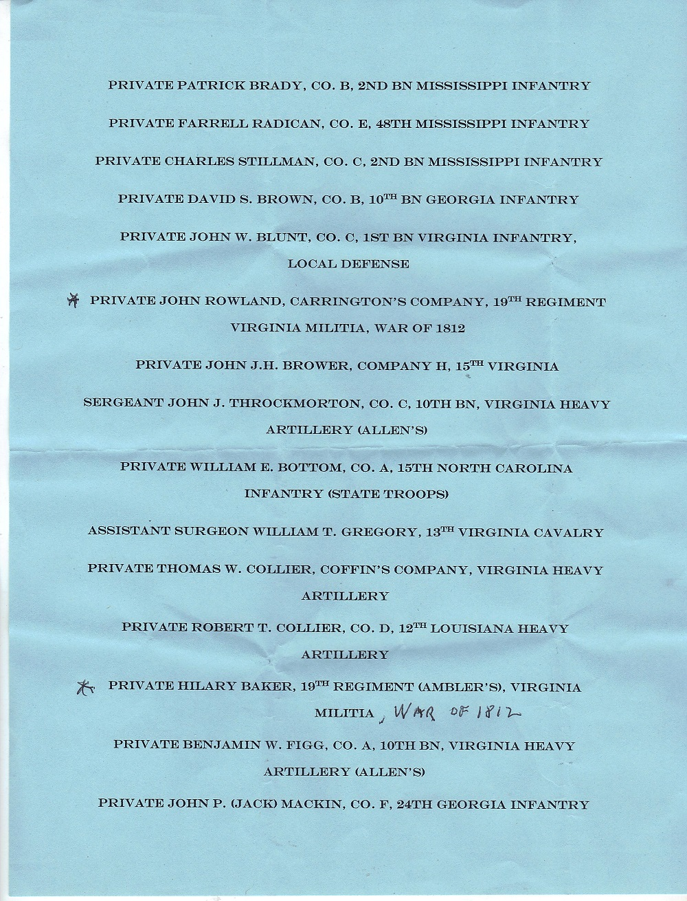
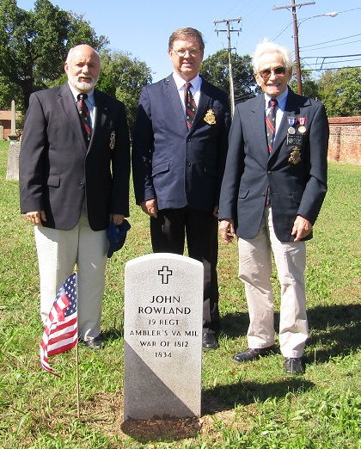
Above L/R are Society Quartermaster James Thacker, Color Guard Chairman, Charles Belfield and Mike Lyman, Past President
Below waiting for the ceremony to begin are Jim Thacker’s grandson, Jim Thacker, Charles Belfield and Secretary Bill Nash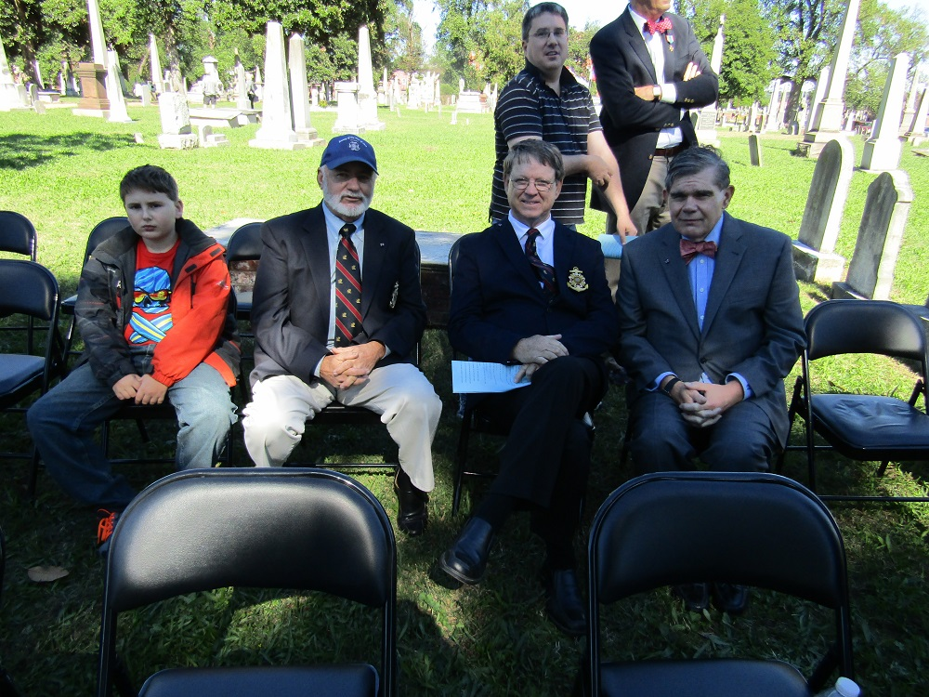
Below shows Clayton Shepherd the master of the ceremony who is president of the Friends of the Shockoe Hill Cemetery
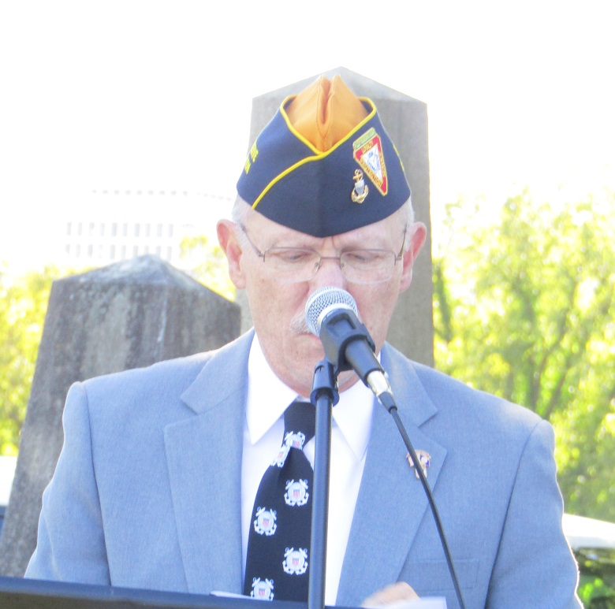

Below shows Jeffry Burton giving the script, “For the Fallen”
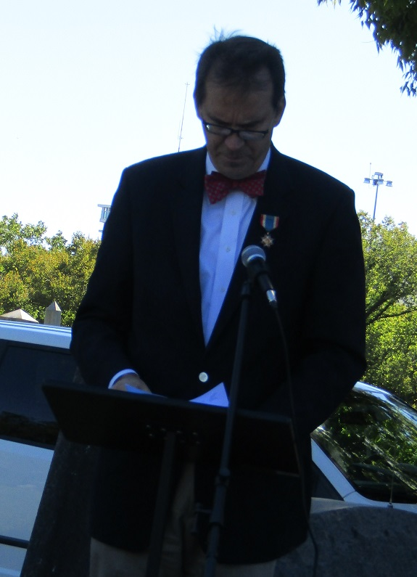
Below Board member of the Friends of Shockoe Hill Cemetery and also a descendent of one of the confederate soldiers being honored is Barbara New Lagrasse
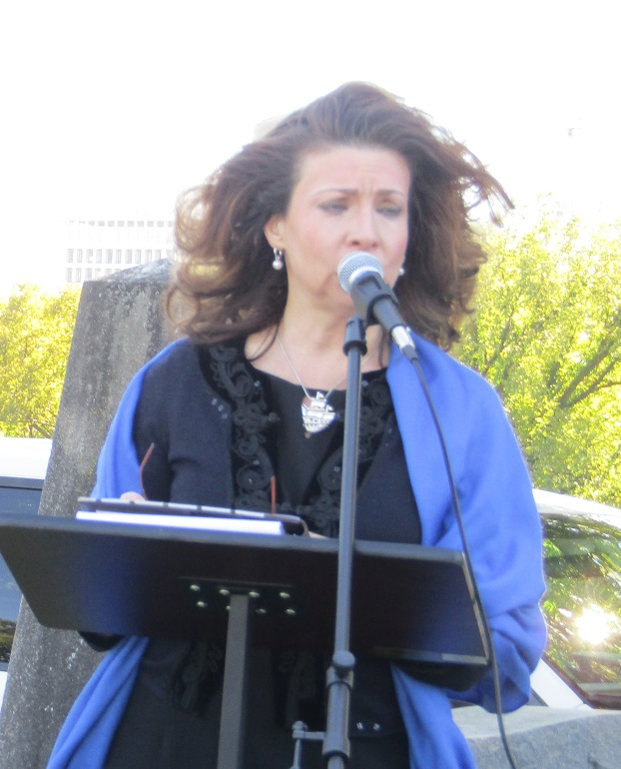
Bill Nash, Secretary of the War of 1812 Society presents the society wreath and one for the General Society War of 1812 as well
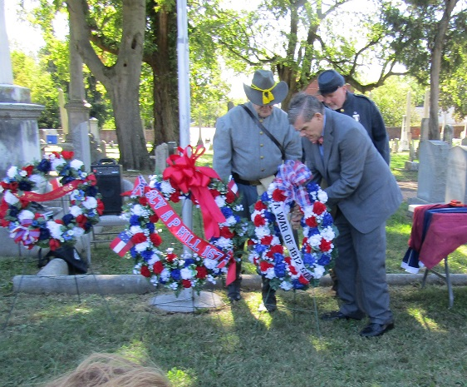
After the ceremony the four War of 1812 attendees at the ceremony gather behind the society wreath
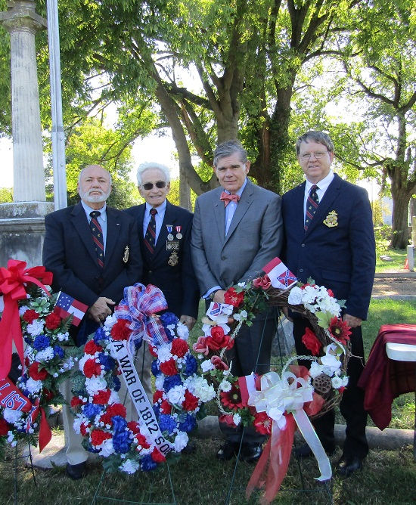
Shockoe Hill Cemetery in Richmond contains the remains of more than 400 War of 1812 veterans. This is probably more than any other cemetery in America. A few years back in conjunction with the Virginia Society Sons of the American Revolution a plaque stating that this number of War of 1812 veterans are interred in the cemetery was dedicated. Shown below are three of the attending War of 1812 society members behind this memorial. L/R: Jim Thacker, Charles Belfield and Mike Lyman
