Society Member Fascinates Youth with War of 1812 Stories
Charles Belfield in the fall of 2016 in the Northern Neck of Virginia counties has been conducting programs about the War of 1812 and other wars to many groups and societies.
He has been busy speaking to different groups in the Northern Neck about the War of 1812 and the involvement of the Northern Neck Militia. The first one was to the Chesapeake Academy a private school with about 100 students and faculty. The display he had set up represented the War of 1812 and other periods of history. As the students arrived they were able to view and touch the items he had displayed and ask questions. The story of the event was carried in the local paper, the Rappahannock Record.
The next group was for senior adults at the King George County YMCA. There he spoke about the war and the battle of the little white house on the Potomac River at Fort Belvoir in Fairfax County. The picture shown below contains about half of the group he gave the presentation to.
The third group was the Northern Neck Christian Association. Here he played an ancestor Thomas Meriweather Belfield, a soldier with the Northern Neck Militia and gave a first person account of the war and his ancestors part in the defense of the Northern Neck. He dressed in the militia uniform ordered by Governor Barbour during the War of 1812

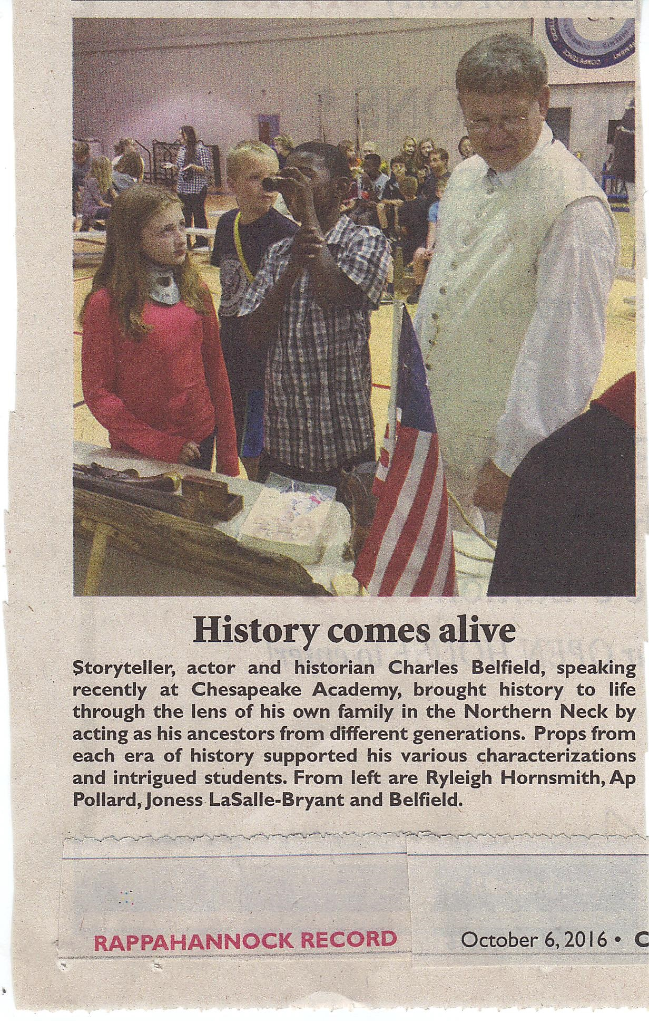

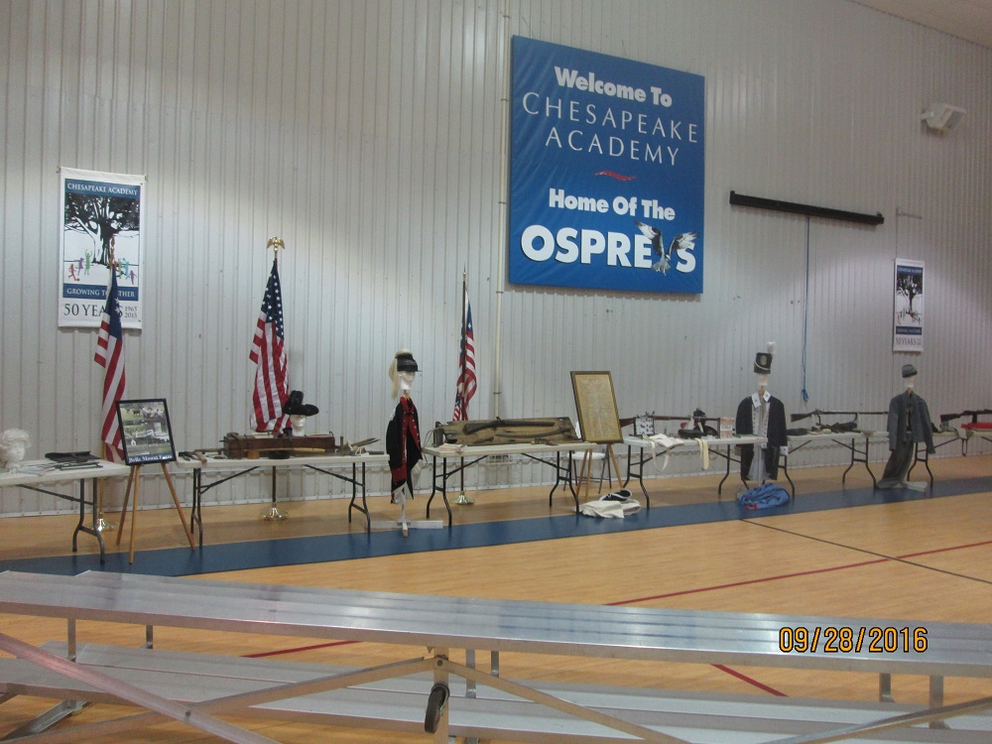

Along with 1812 George Beckett, he attended Montross Day in Westmoreland County where he gave two presentations that included the War of 1812. Also displayed was the Society Banner which is not shown
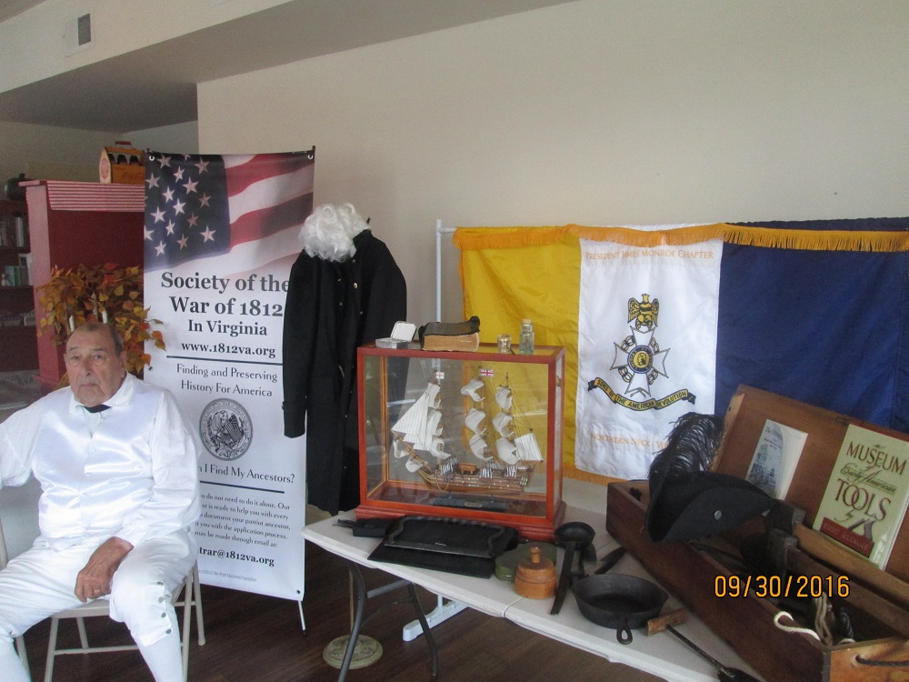

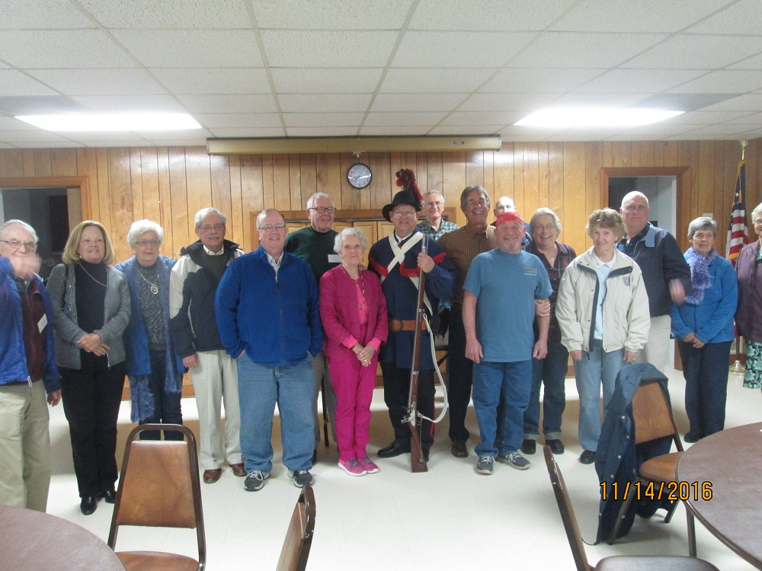

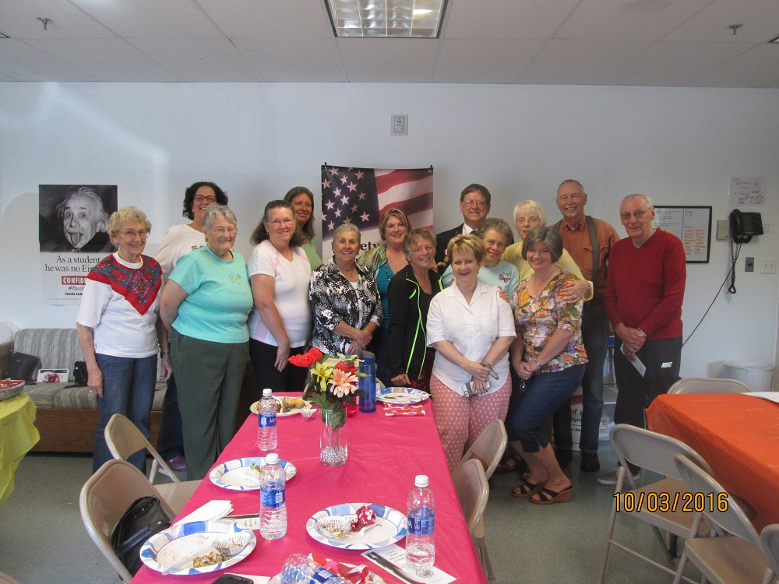
The next photo shows him in the War of 1812 militia uniform
