Society of the War of 1812 Meets February 10 2017 in Richmond
The Society of the War of 1812 in the Commonwealth of Virginia Board of Directors Meeting was held at 2:00 PM, Saturday February 10, 2017 in the Omni Hotel in Richmond. President Chuck Poland presided. Some of the main things brought out in the meeting were:
- The many activities of the Society Color Guard since September 2016 were reported upon by Color Guard commander, Charles Belfield. He indicated that in addition to using the colors in several society ceremonies, he also used the them with War of 1812 relics and mementos as displays in addressing school and church groups, and also while being the guest speaker at the U.S. Daughters of 1812 meeting.
- He indicated that more attired members are needed in the guard. To this end the society agreed to provide $250 to any member toward the expense of acquiring an 1812 uniform.
- An antique 1920 General Society flag was purchased by the society for use in the color guard. It is being repaired with new silk material and with a restored pole and hopefully it will soon be available
- A CD was distributed to attending members that contains an additional 691 new write-ups containing genealogical data of War of 1812 veterans buried in Virginia. The book published for the society, Burials of War of 1812 Veterans in the Commonwealth of Virginia by Heritage Books in 2012 contained 4442 burials with this data. These additions bring the total to 5133. Editor and compiler, Mike Lyman reported that with the assistance of Billy Simmons, the Assistant Editor that they are still compiling more burials and soon will be preparing an addendum to the book. They have added about 150 new War of 1812 veteran burials with the genealogical data since September 2016.
- The society plans to participate in these events in the next six months. In all of these the public is welcomed: (1) A Virginia Historical Road sign unveiling for General John Hungerford at Leedstown in Westmoreland County, at a date TBA in late February or March is pending an announcement by VDOT (2) A dedication ceremony of a restored obelisk in the Shockoe Hill cemetery in Richmond for War of 1812 surgeon, Daniel N Norton at a date TBA in March is also pending an announcement by the friends of the cemetery society (3) A ceremony honoring the inauguration of James Monroe as President at the James Monroe Law Library in Fredericksburg on March 5th (4) A ceremony honoring James Madison’s birthday at Montpelier in Orange County on March 16th (5) A ceremony honoring President John Tyler’s birthday in the Hollywood Cemetery in Richmond on March 29th (He was a captain in the War of 1812); (6) A ceremony honoring President James Monroe’s birthday in the Hollywood cemetery in Richmond on April 28th (7) A ceremony honoring James Monroe’s birthday at his birth place near Colonial Beach in Westmoreland County on April 29th (7) A grave marker unveiling ceremony for a War of 1812 soldier interred in the Yeocomico Church cemetery in Westmoreland County on May 2d (8) A ceremony unveiling War of 1812 grave markers for one or two War of 1812 veterans in the Hollywood cemetery in Richmond on May 3rd (9) The Color Guard will be participating in parades TBA on July 4th (10) An unveiling plaque ceremony naming nine War of 1812 veterans and eighteen Revolutionary War patriots memorialized in the Pohick Church cemetery in Lorton, Fairfax County on June 5th.
- The society announced it would hold its annual membership meeting and luncheon at the Westwood Club in Richmond on May 3rd
- The society plans to provide a plaque at the former home of War of 1812 veteran Captain William Henderson, in Westmoreland County which was burned by the British during the war and which a new home was subsequently constructed between the two remaining chimneys.
- The society plans to expand its member presentation of awards to outstanding cadets in the ROTC programs at the many colleges in Virginia
- The society is considering establishing several districts in Virginia where members reside so they can be active in promoting and participating in separate War of 1812 functions not provided by the state society.

Some photos taken during and after the meeting and at the following evening’s banquet by VASSAR are shown below:
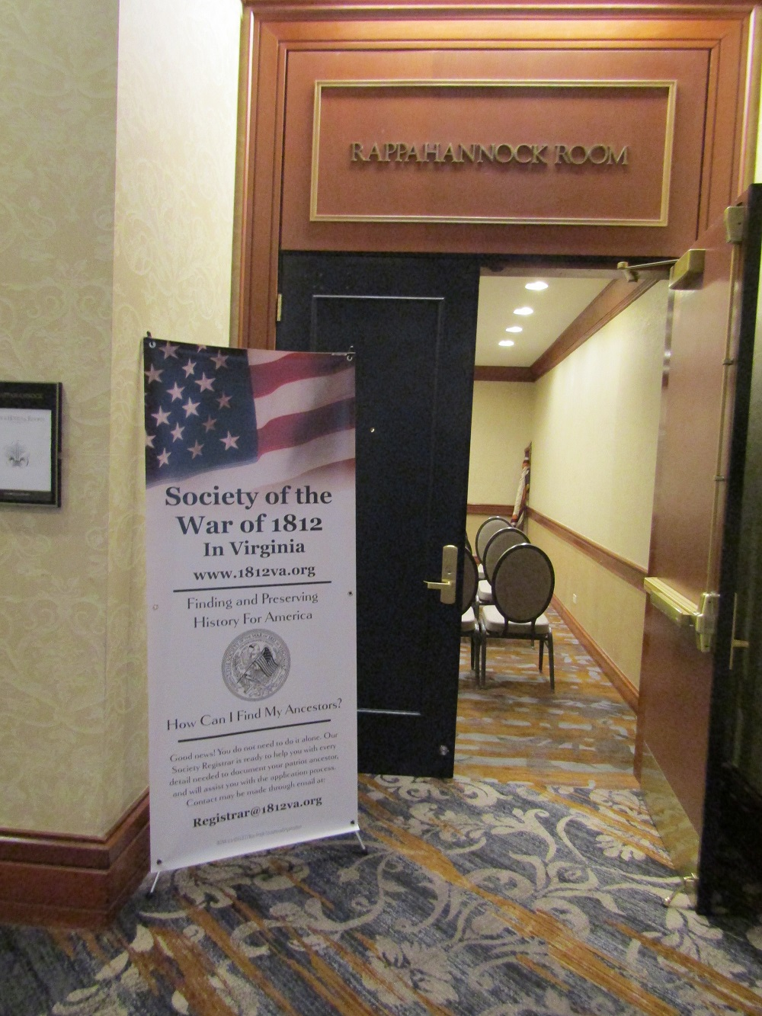
The meeting room entrance with the 1812 display is shown
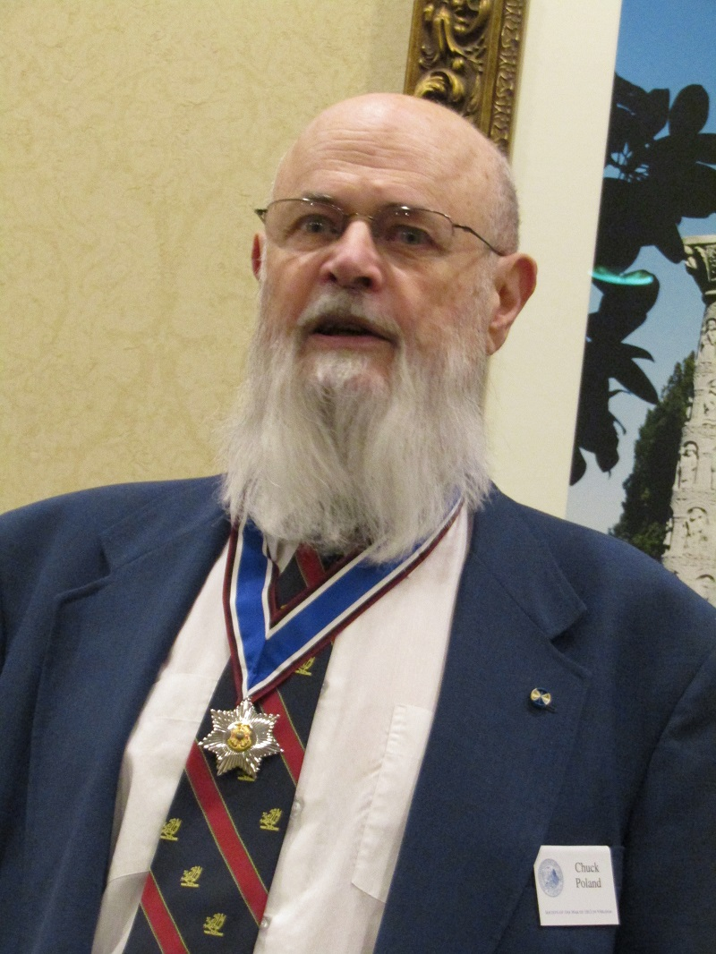
President Chuck Poland presides
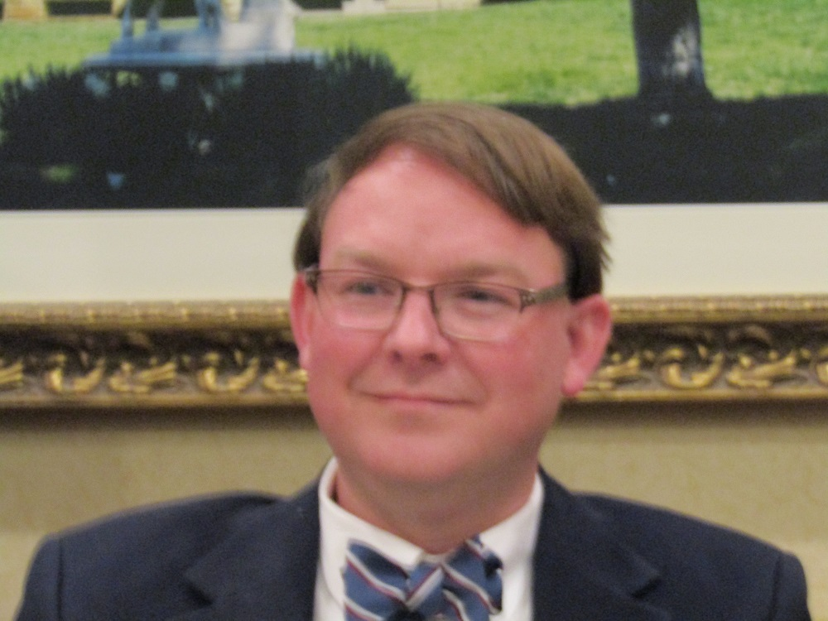
Treasurer Shane Newcombe reports
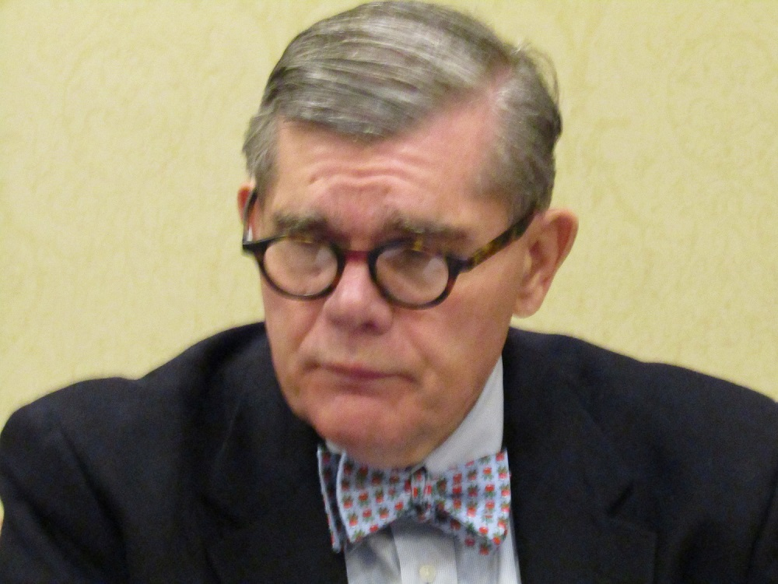
Secretary Bill Nash records the proceedings
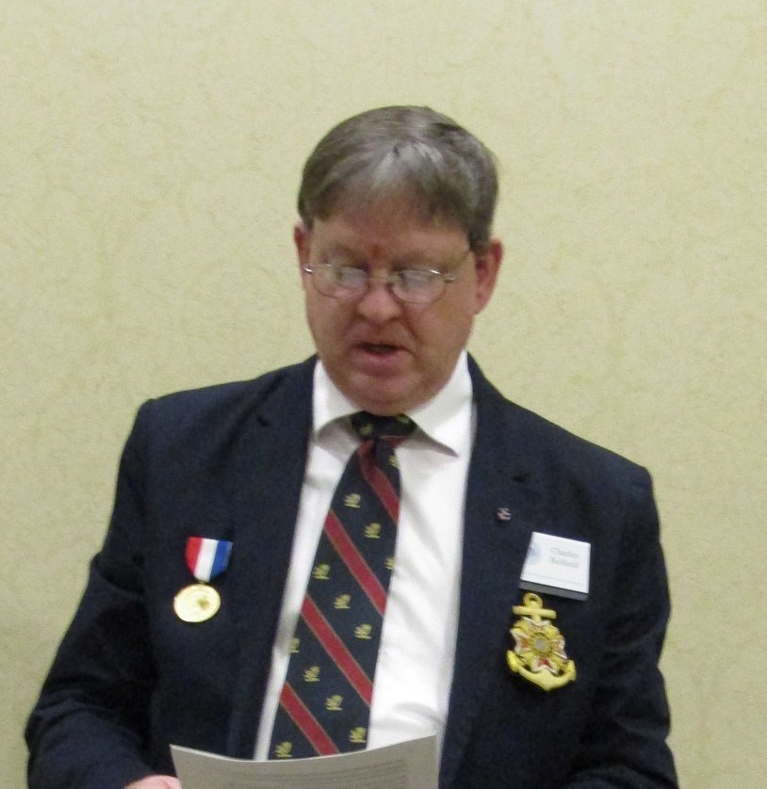\
Color Guard Commander, Charles Belfield reports
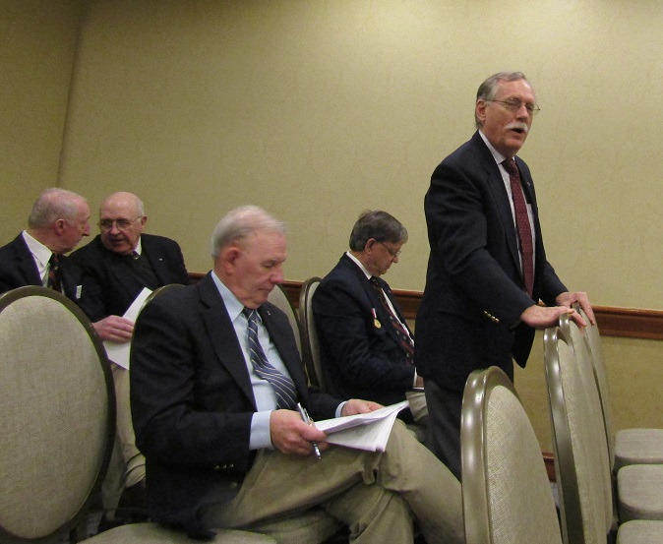
Registrar Hugh Markham reports and shown are other BOD members
After the meeting some of the members of the Society that attended poise with a partially restored General Society flag at the entrance to the meeting room
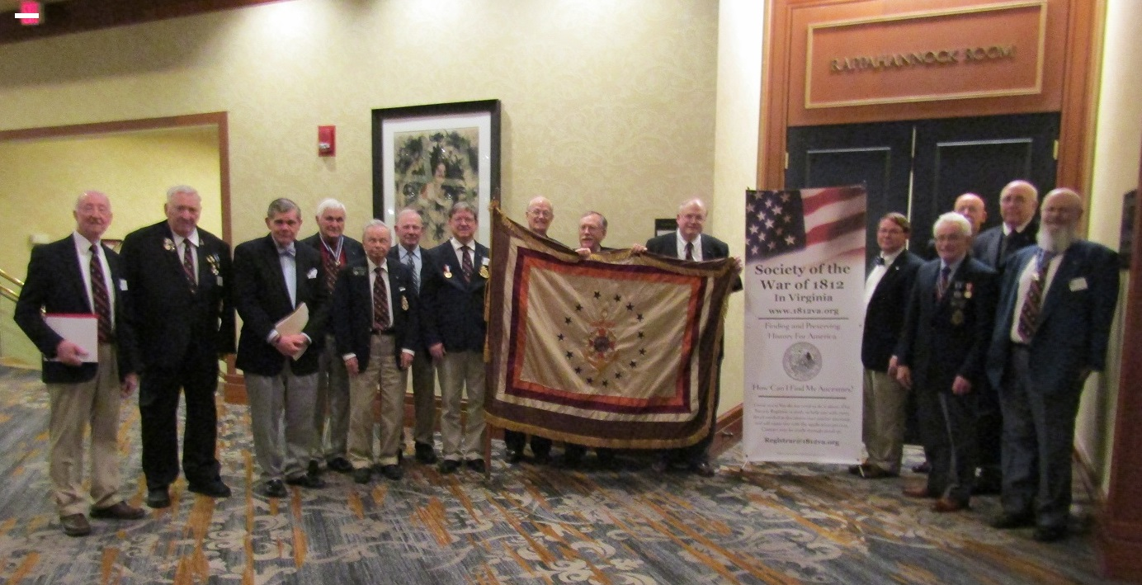
The next evening at the VA Society Sons of the American Revolution (VASSAR) Banquet, President Chuck Poland gave greetings from the War of 1812 Society
