Society Honors 47 1812 Vets in Ceremony Oct 6 2018
The War of 1812 Society in the Commonwealth of Virginia in a joint ceremony with the Virginia Society Sons of the American Revolution (VASSAR) in the Old City Cemetery in Lynchburg at 11am October 6 2018 unveiled two plagues. One plaque listed 16 interred Revolutionary War Patriots and the other 47 War of 1812 veterans. Below is information about the cemetery, the program used and some photos taken. Permission to use photos taken by members of the society, Dick Fickling and Paul Walden have been received and much appreciated. Below a map shows the location of the cemetery.
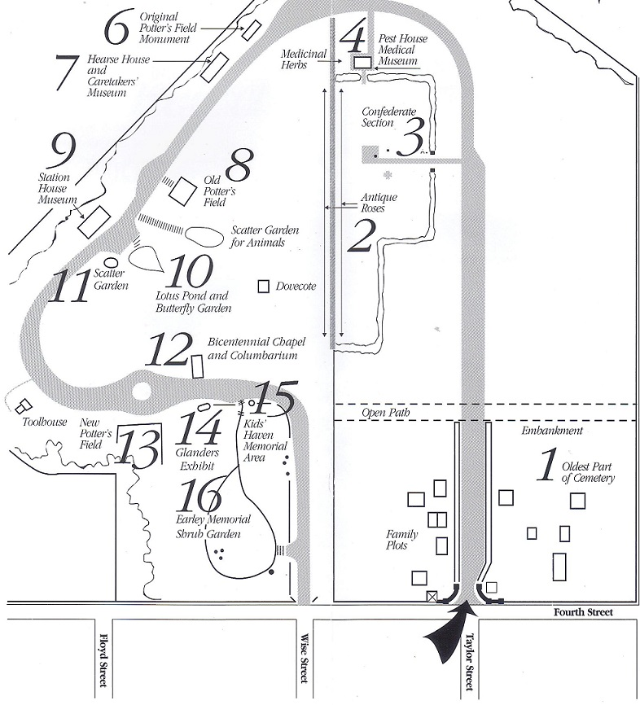
At the entrance to the cemetery the below portions of the displays were photographed.
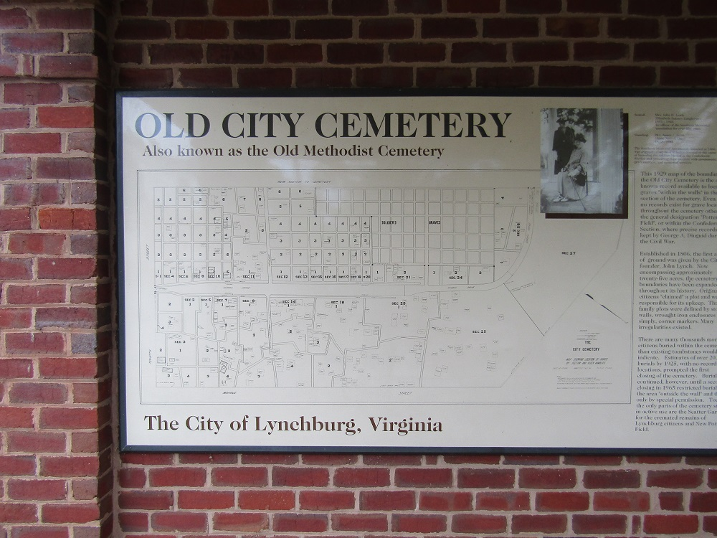
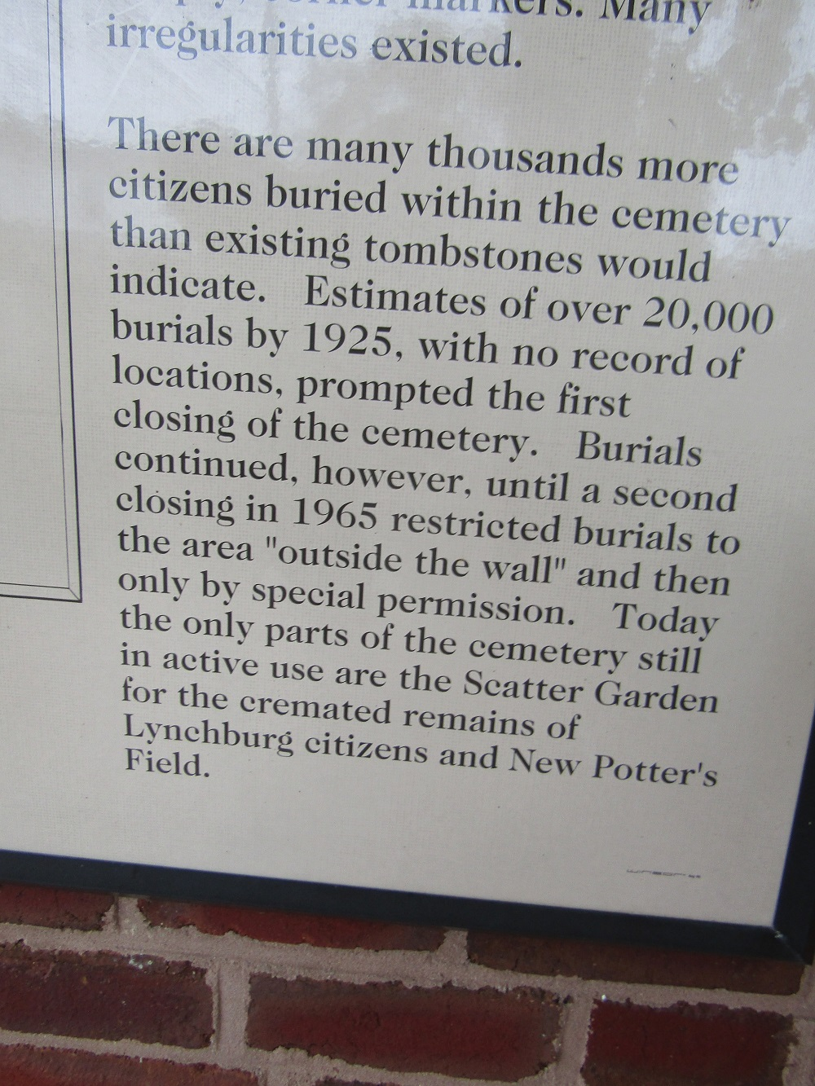
It was noted that the majority of the old sandstone gravestone inscriptions in the cemetery can no longer can deciphered, thus the plaques do not contain by any means all of the Revolutionary War patriots and War of 1812 veterans buried there.

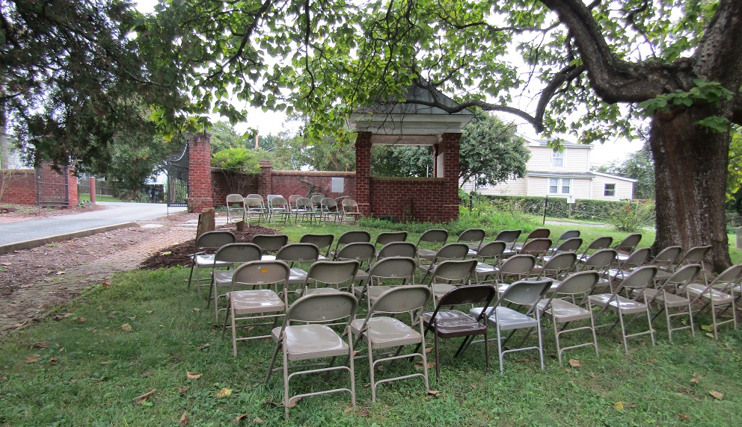
The above photo shows the entrance to the cemetery at the junction of 4th and Taylor streets where the plaques were mounted before the ceremony by Denise A McDonald, Executive Director and her staff. Below is the revised program
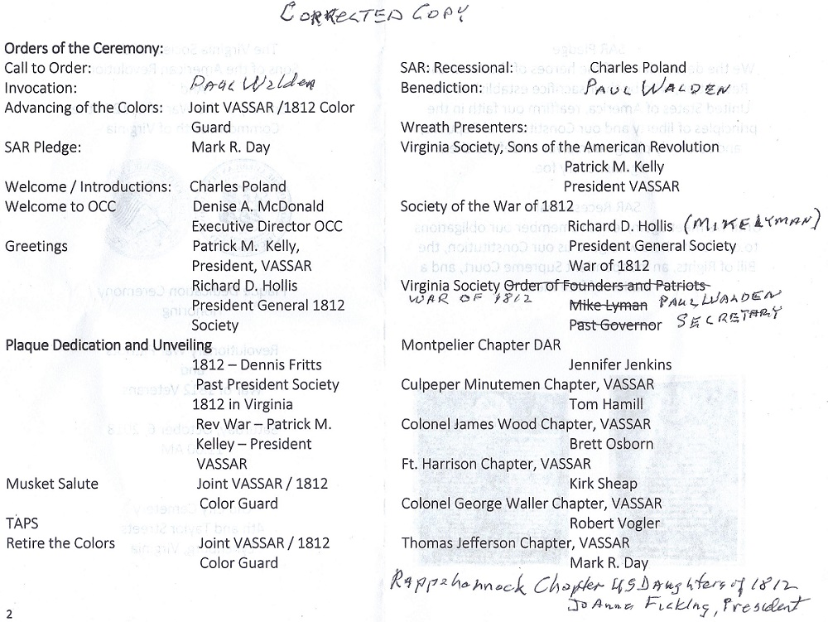
Below Chuck Poland, past president of the War of 1812 Society in Virginia was master of Ceremony

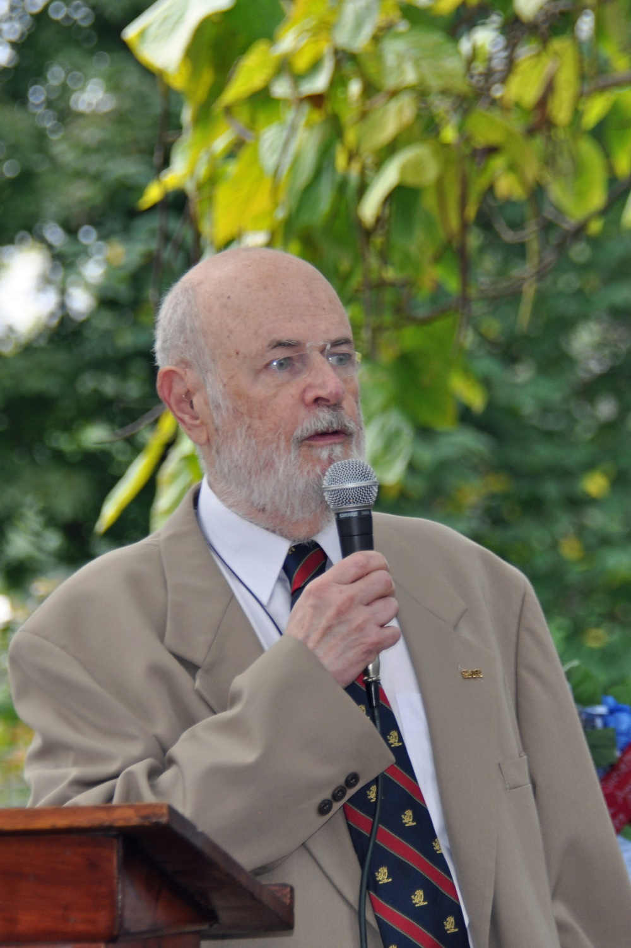
Below Paul Walden is shown as chaplain giving the invocation
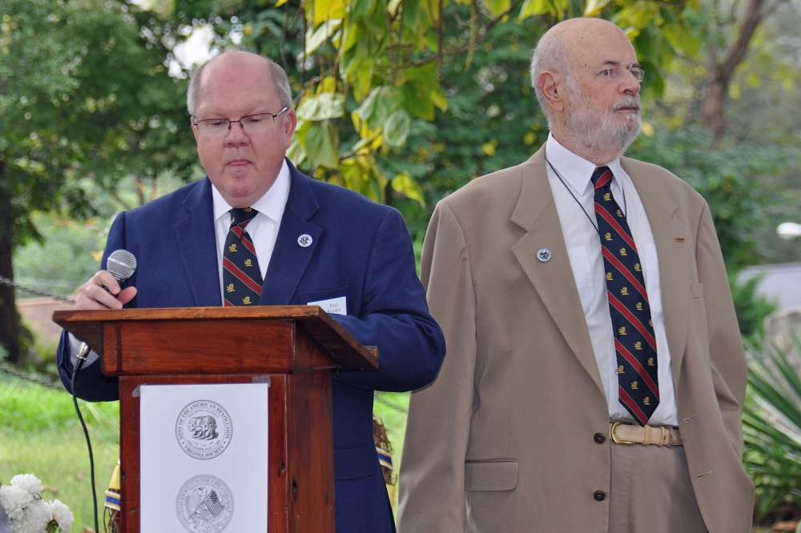
The combined VASSAR and War of 1812 Color Guard presented the colors for the pledge of Allegiance.
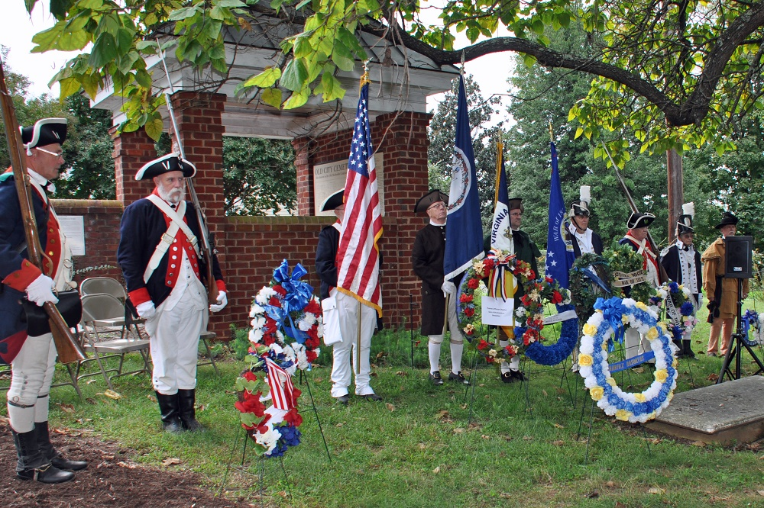
Below shows President Kelly giving greetings to the attendees
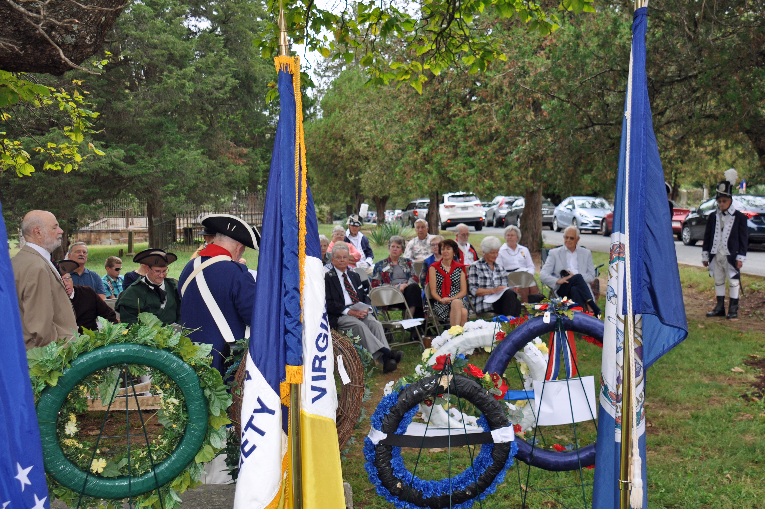

Below Mike Lyman gave greetings from the General Society as a member of the Grant Committee
Also he talked about the names on the two plaque and the burial source books from which they were derived
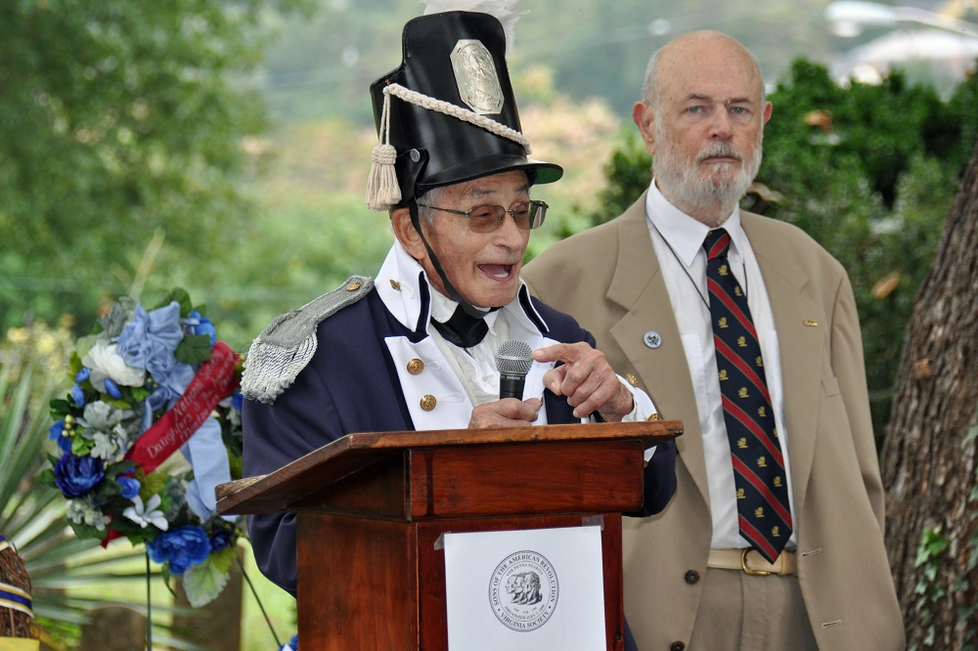

President Pat Kelly is shown after unveiling the Revolutionary War plaque
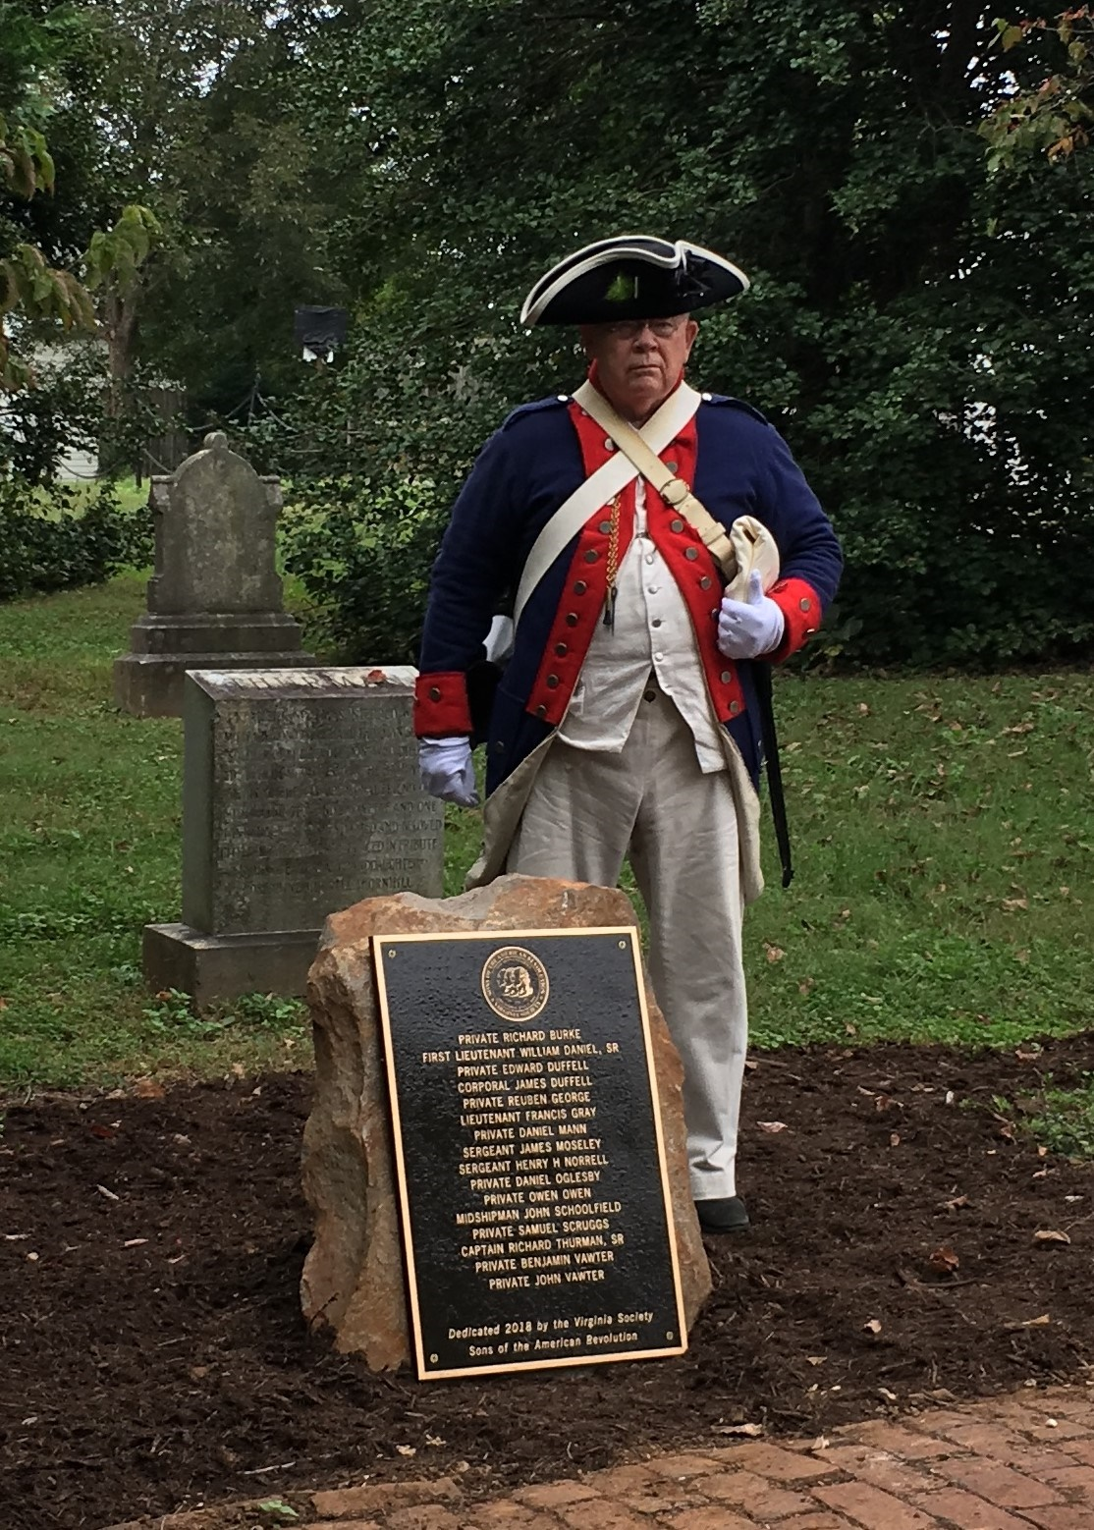
A closer view of the Revolutionary War plaque.
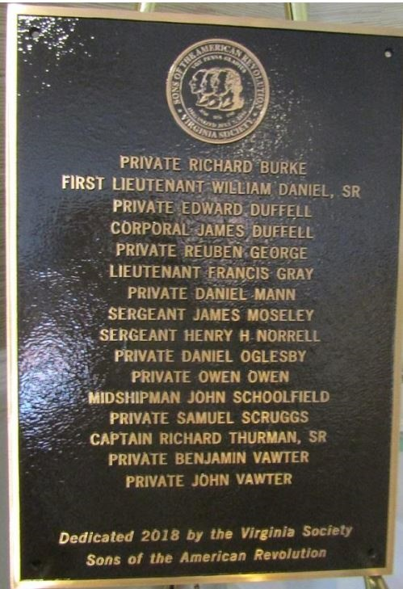

Dennis Fritts, past president of the War of 1812 society in VA is shown unveiling the War of 1812 plaque

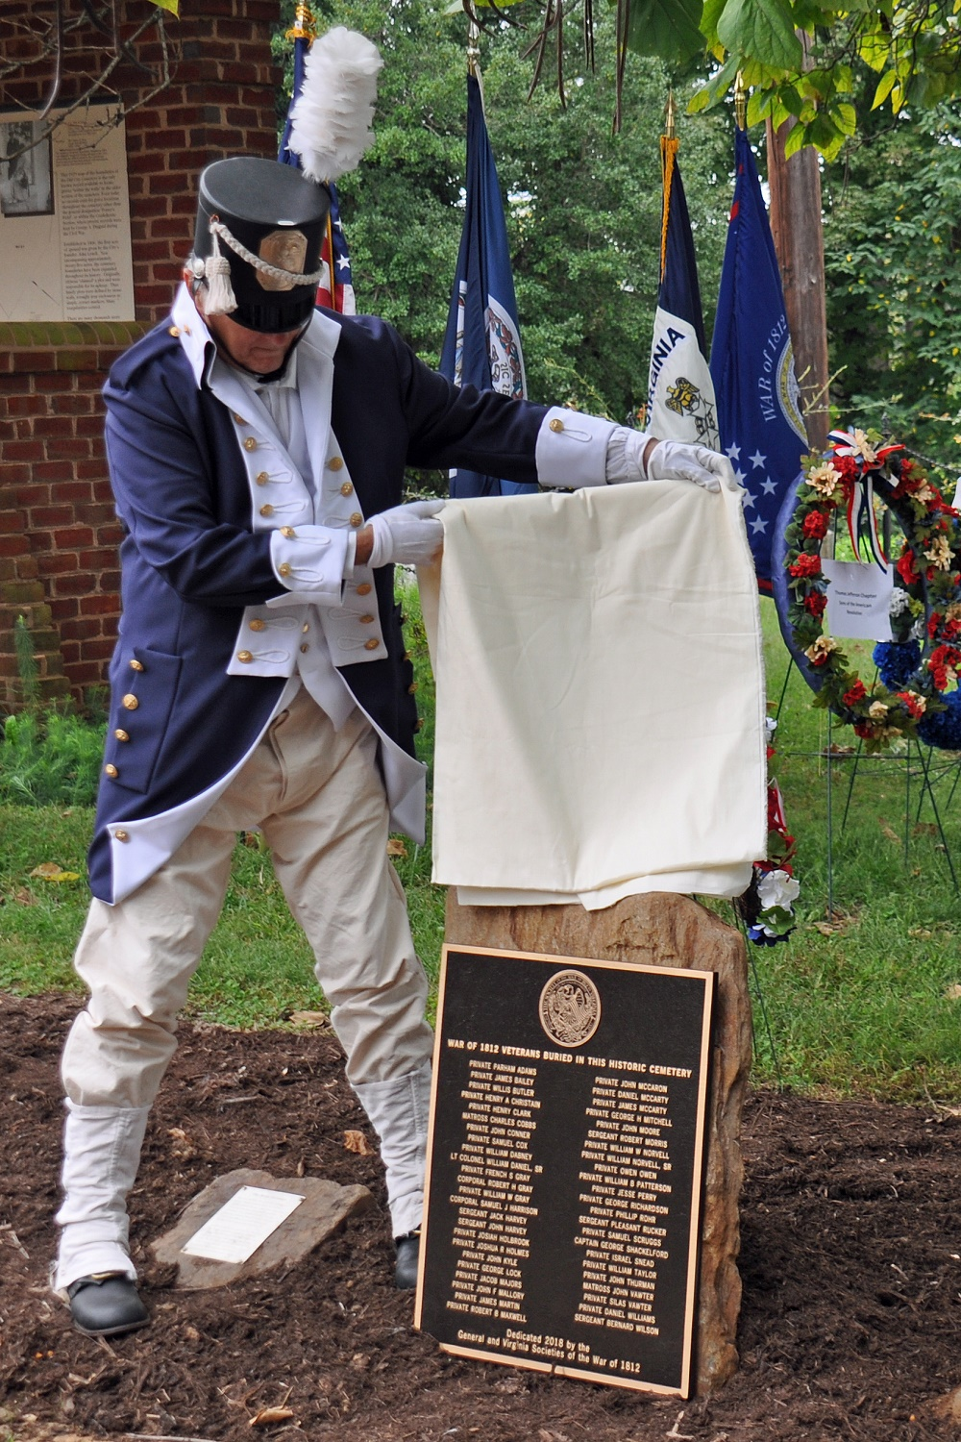
A closer view of the plaque
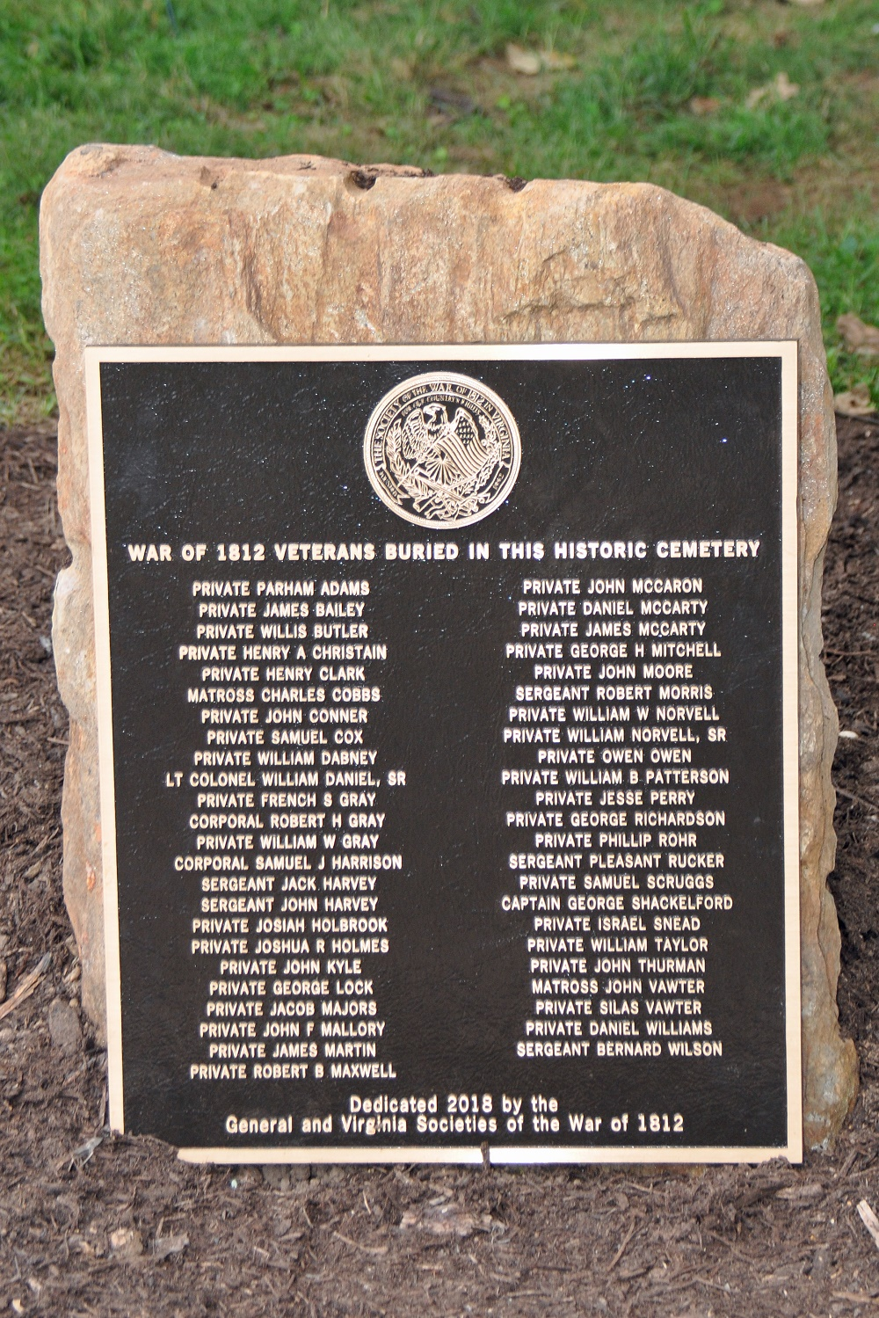
Wreaths are presented
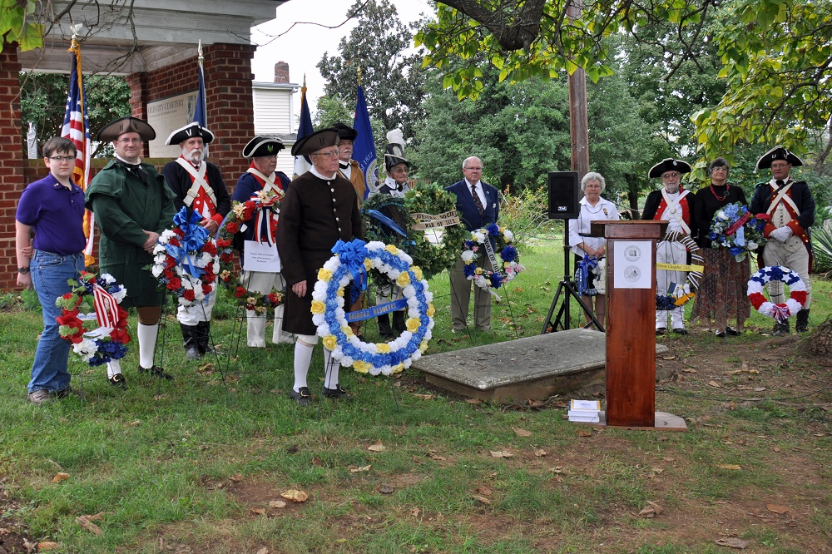
A musket salute is given by the VASSAR color Guard
