Society Conducts Board of Direction Meeting 14 September 2019 in Fairfax, VA
The BOD (Board of Direction) meeting of the Society of the War of 1812 in the Commonwealth of Virginia was held 2 to 5pm in the Fairfax Marriott at Fair Oaks Hotel, located at11787 Lee-Jackson Highway, Fairfax, VA. The photo below shows the officers and members that attended.
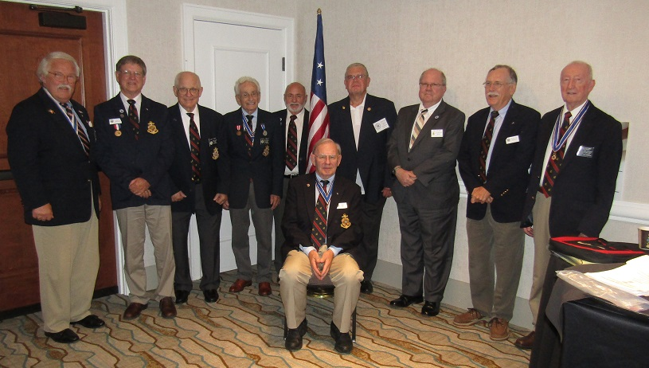
Sitting is President Stuart L Butler. Left to right is Jim Russell, member; Charles Belfield, Councilor and Color Guard Chairman; John Epperly, Councilor and Past Registrar; Mike Lyman, Past President, Jim Thacker, Quartermaster and ROTC Awards Chairman; Tom Whetstone, Councilor; Paul Walden, Secretary; Hugh Markham, Registrar; and Thad Hartman, Past President and Founding member. Not shown are two prospective members that attended and perhaps others. The minutes follow

