Society Presents Wreath at Ceremony 21 Sep 2019 in Portsmouth
President Stuart L Butler and other officers and members of the War of 1812 Society in the Commonwealth of Virginia on 21 September 2019 attend and participate in a ceremony honoring Revolutionary War patriots memorialized in the Cedar Grove Cemetery in Portsmouth. This Cedar Grove cemetery has gravestones of numerous War of 1812 veterans, some of which were being mentioned in the ceremony as descendants of the Rev War patriots being honored. President Stuart L Butler presented the War of 1812 society wreath. The program and photos taken follow.
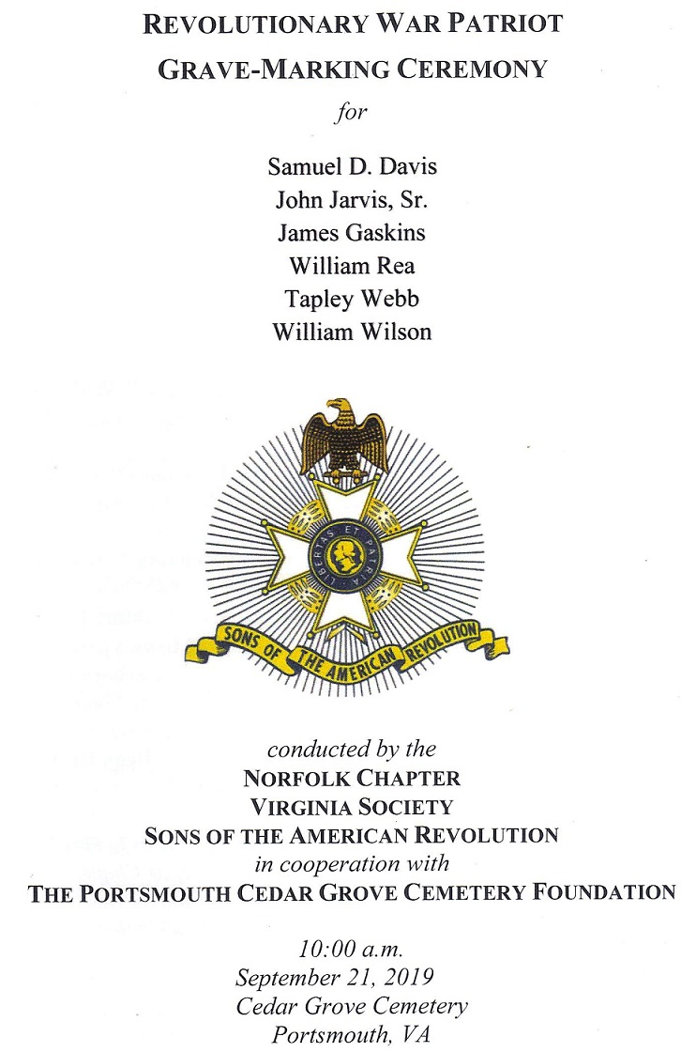
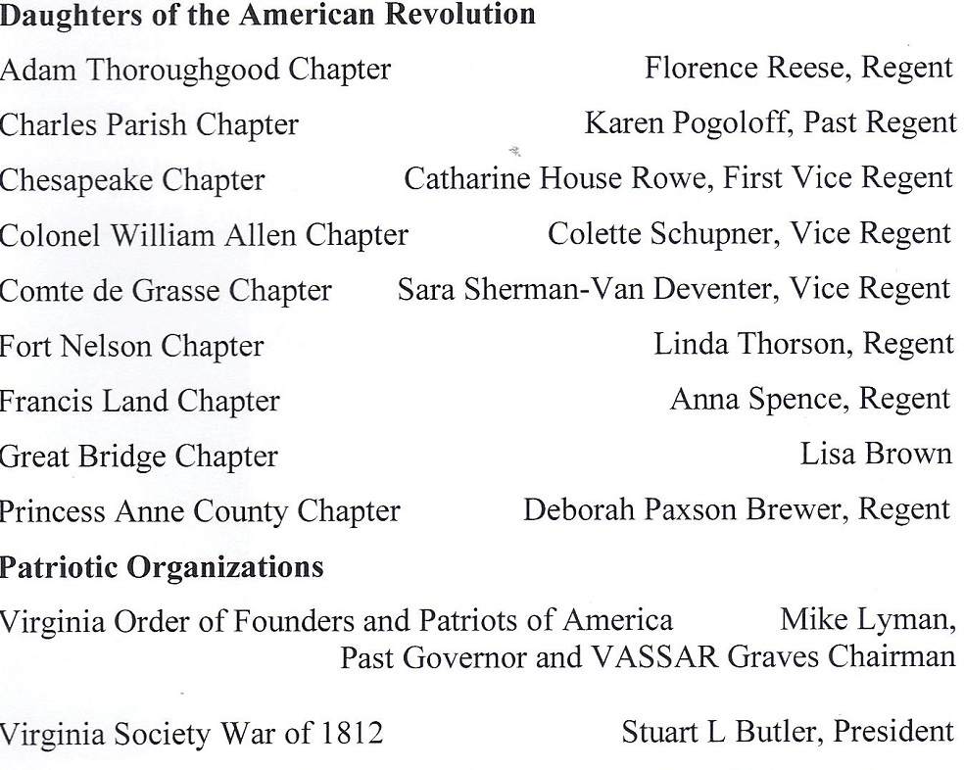
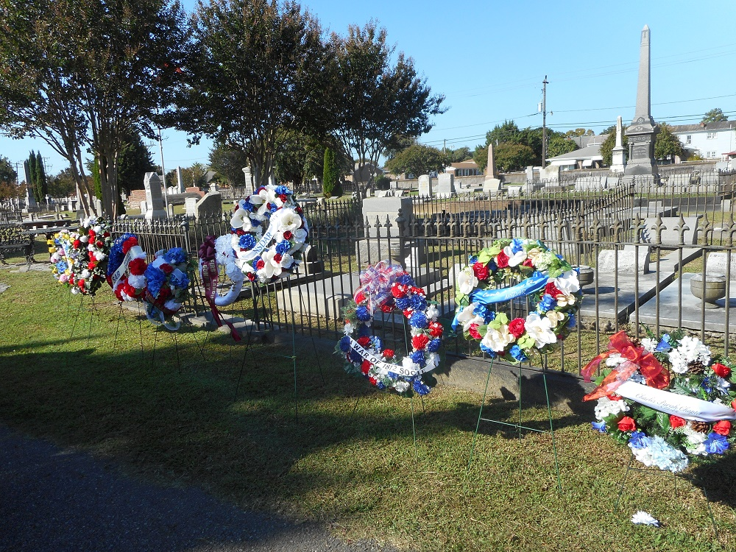
Above center shows the society wreath that was presented
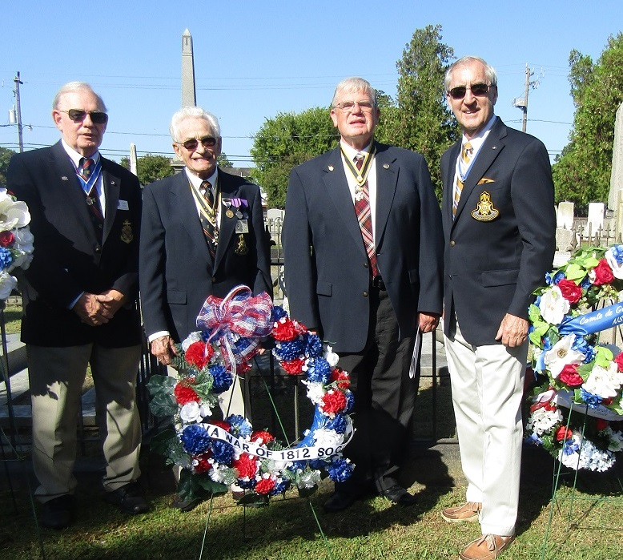
Above (L/R) President Stuart Butler; Past President, Mike Lyman; Councilor Tom Whetstone; and applicant Ken Hawkins

