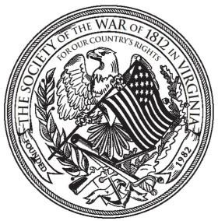

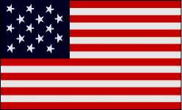
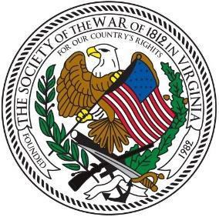
The Virginia War Cry
“EVER FORWARD”

Volume 22, Number 1 [Spring 2020]
Editor: J. Thomas Whetstone

Finding and Preserving History for America

NEXT MEETING: ANNUAL MUSTER June 22 , 2020
Westwood Club, 6200 W. Club Ln., Richmond, VA, 23226
[Monitor the Society Webpage for any changes in plans.]
After canceling our spring gatherings due to the Coronavirus pandemic, it is most important that we regroup at this muster to organize for success for our remaining events of 2020. Lord willing and the Creek don’t rise further, see you in Richmond.

TABLE OF CONTENTS
2 President’s Message
3 From the Editor
4 Virginia Society Officers
5-7 Secretary’s Minutes BOD Meeting 2/7/2020
8 Upcoming Events
9-25 Photo Journal: April 2019-April 2020
26-27 Book Review
28-29 Essay Contest Rules

Spring 2020 Virginia War Cry page 2
PRESIDENT’S MESSAGE April 20, 2020
Defenders

As most, if not all, of you know by now the James Monroe birthday ceremonies at the Monroe birthplace in Westmoreland County and the Hollywood cemetery have been canceled. Other Society related events scheduled for May in conjunction with the Virginia Sons of the American Revolution have also been canceled and are awaiting new dates. As soon as new dates for some of these events can be established, they will be posted on the Society website.

As President of the Virginia Society, I intend to visit Hollywood Cemetery on James Monroe’s birthday, April 28, 2020, and lay a wreath as I did for John Tyler’s birthday last month. I should be there at 2pm on April 28, 2020, to lay the wreath. All members so inclined are welcome to join me in this event, of course, practicing spatial distancing. The choice to do so is purely voluntary, of course.

As far as I know, our June 22, 2020, annual muster is still scheduled. I will be contacting the Westwood Club to confirm that event. I will inform the Society of any changes in that regard as soon as I can.

I hope we can all resume our normal lives in the near future and until we do, I know all will remain safe and secure in following the health guidelines set forth by the Commonwealth of Virginia.

Sincerely,

Stuart L. Butler
President
Society of the War of 1812 in Virginia

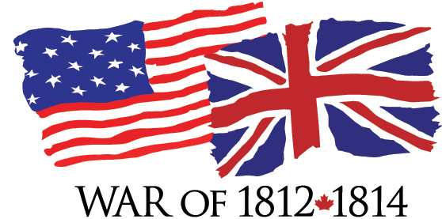
Spring 2020 Virginia War Cry page 3

FROM THE NEW EDITOR
Yes, I am green, being a new recruit as editor of the Society of the War of 1812 in the Commonwealth of Virginia Newsletter. We hope you find this issue of interest and value. I will welcome any suggestions for future improvement.
Since our last newsletter of over a year ago, much has occurred and, during the shutdowns due to COVID-19, much of our ceremonies have been cancelled. The Photo Journal, drawing on the monthly website postings of Mike Lyman, seeks to document our participation in ceremonies and other public initiatives over the past year. Reviewing these can remind and encourage us to resume our patriotic, genealogical, historical, and educational commitments to honor the veterans of the Second American Revolution, the War of 1812.
J. Thomas Whetstone, D.Phil.
Editor (757) 482-2893, twhetstone1@cox.net

* My War of 1812 Ancestor:

Peyton Madison was a private in Capt. Reynold’s Company, 39th U. S. Regular Infantry commanded by Col. John Williams with Lt. Col. Thomas Hart Benton. On March 29, 1814 the 39th made the main frontal assault on the hostile Creek Indians behind breastworks at the Battle of Horseshoe Bend on the Tallapoosa River, Alabama. Peyton Madison received a gunshot wound during this battle which was overall commander General Andrew Jackson’s decisive victory in the Creek War of 1813-1814.

Peyton Madison was 19 years-old, with fair complexion, dark hair, blue eyes, and 5 feet 10 inches in height when he volunteered at Batesville, Tennessee about August 14, 1813; he was honorably discharged at Mt. Vernon, Alabama on August 9, 1814. He moved to Alabama in 1817 and would acquire over a thousand acres of land in Greene County. His daughter, Cynthia Ann Madison, on August 5, 1847, married William Jackson McDonald, Jr., a son of William Jackson McDonald, Sr. (also a War of 1812 veteran, who fought at the Battle of the Holy Ground on December 23, 1813) in Greene County, Alabama. I am a 6th generation direct descendant of both Peyton Madison and William Jackson McDonald, Sr.

Spring 2020 Virginia War Cry page 4
Finding and Preserving History for America

OFFICERS 2018-2020 OFFICERS**
Nominated for 2020-2022

President Stuart L. Butler Paul Walden
First VP J. Shane Newcombe James M. Green
or Bill Collier
Second VP James M. Green Jr. Kenneth Hawkins
Secretary Paul A. Walden Jim Russell
Treasurer J. Shane Newcombe J. Shane Newcombe
Registrar Hugh A. Markham Hugh A. Markham
Historian Peter E. Broadbent Jr. Peter Broadbent, Jr.
Quartermaster James Thacker Sr.
Counsel Carter B. S. Furr Carter B. S. Furr
VP General Charles B. Poland Stuart Butler

COUNCILORS 2018-2020

Charles Belfield John Thomas (Tom) Whetstone III
William (Bill) Collier Kenneth (Ken) Williamson
John M. Epperly

**TO BE ELECTED AT ANNUAL MUSTER, JUNE 22, 2020

Spring 2020 Virginia War Cry page 5
Spring 2020 Virginia War Cry page 6

Spring 2020 Virginia War Cry page 7
Spring 2020 Virginia War Cry page 8
Watch for Upcoming Events. For example, this is a preliminary notice
for the Katocin and Ebenezer church ceremonies—times TBA.
WATCH FOR CHANGES.

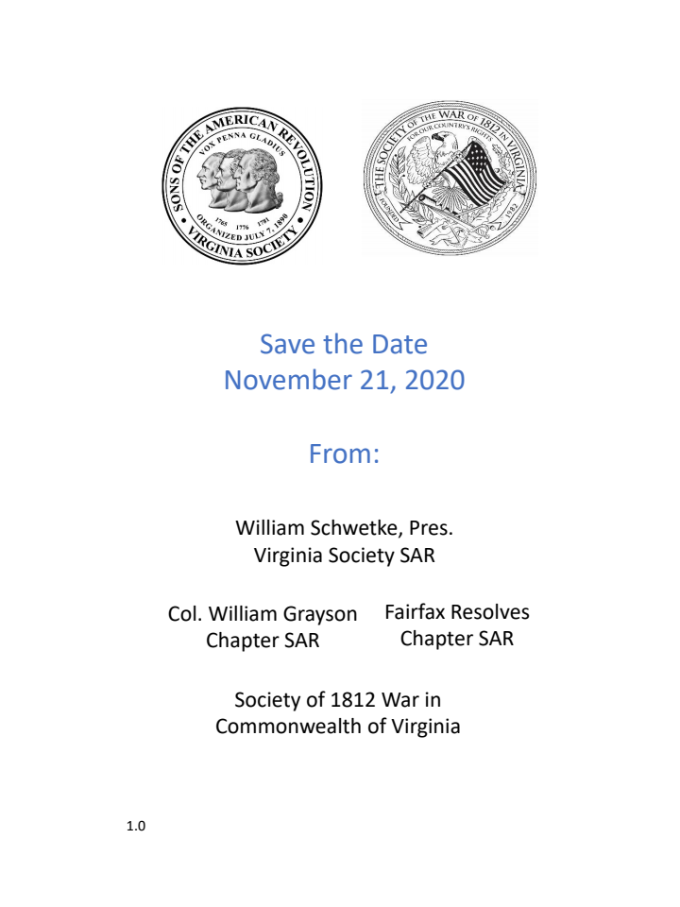

Spring 2020 Virginia War Cry page 9

Society of the War of 1812 in the Commonwealth of Virginia
PHOTO JOURNAL
Summary of Activities April 2019-April 2020

* President Butler Presents Society Wreath for Monroe’s Birthday April 28, 2020
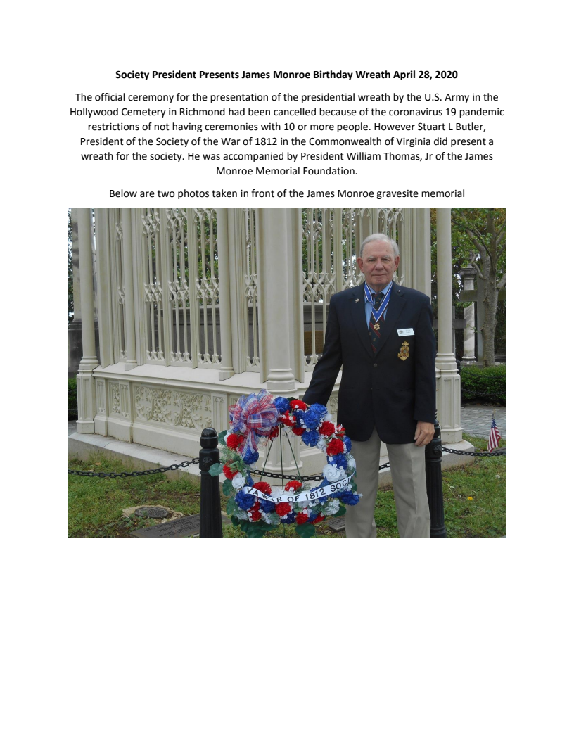

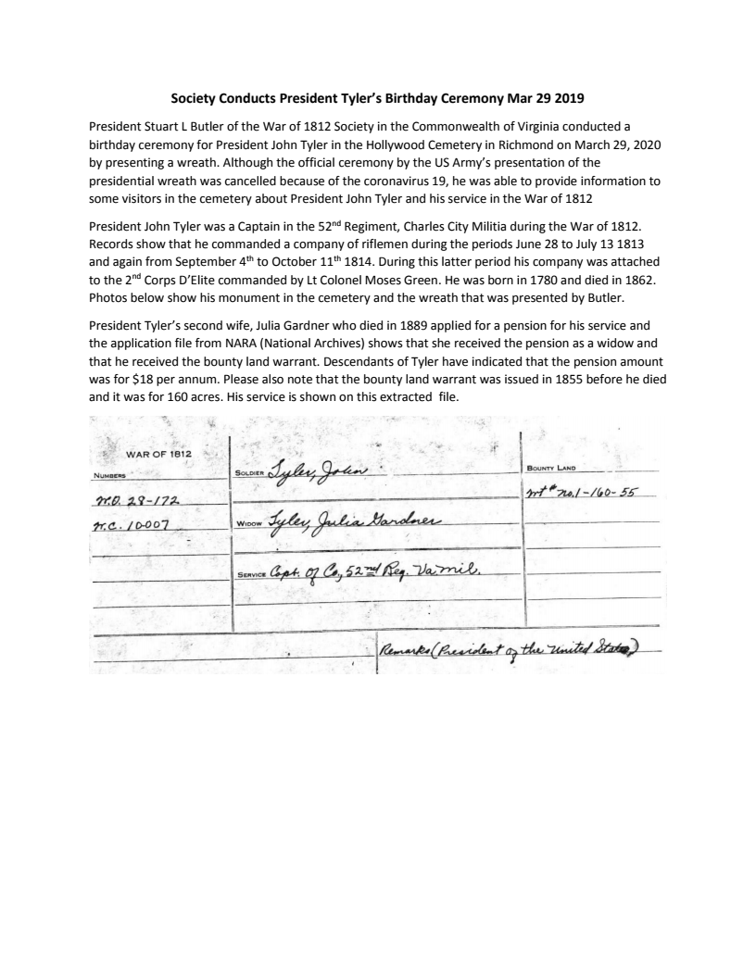
Spring 2020 Virginia War Cry page 10

* President Tyler’s Birthday Ceremony March 29, 2020
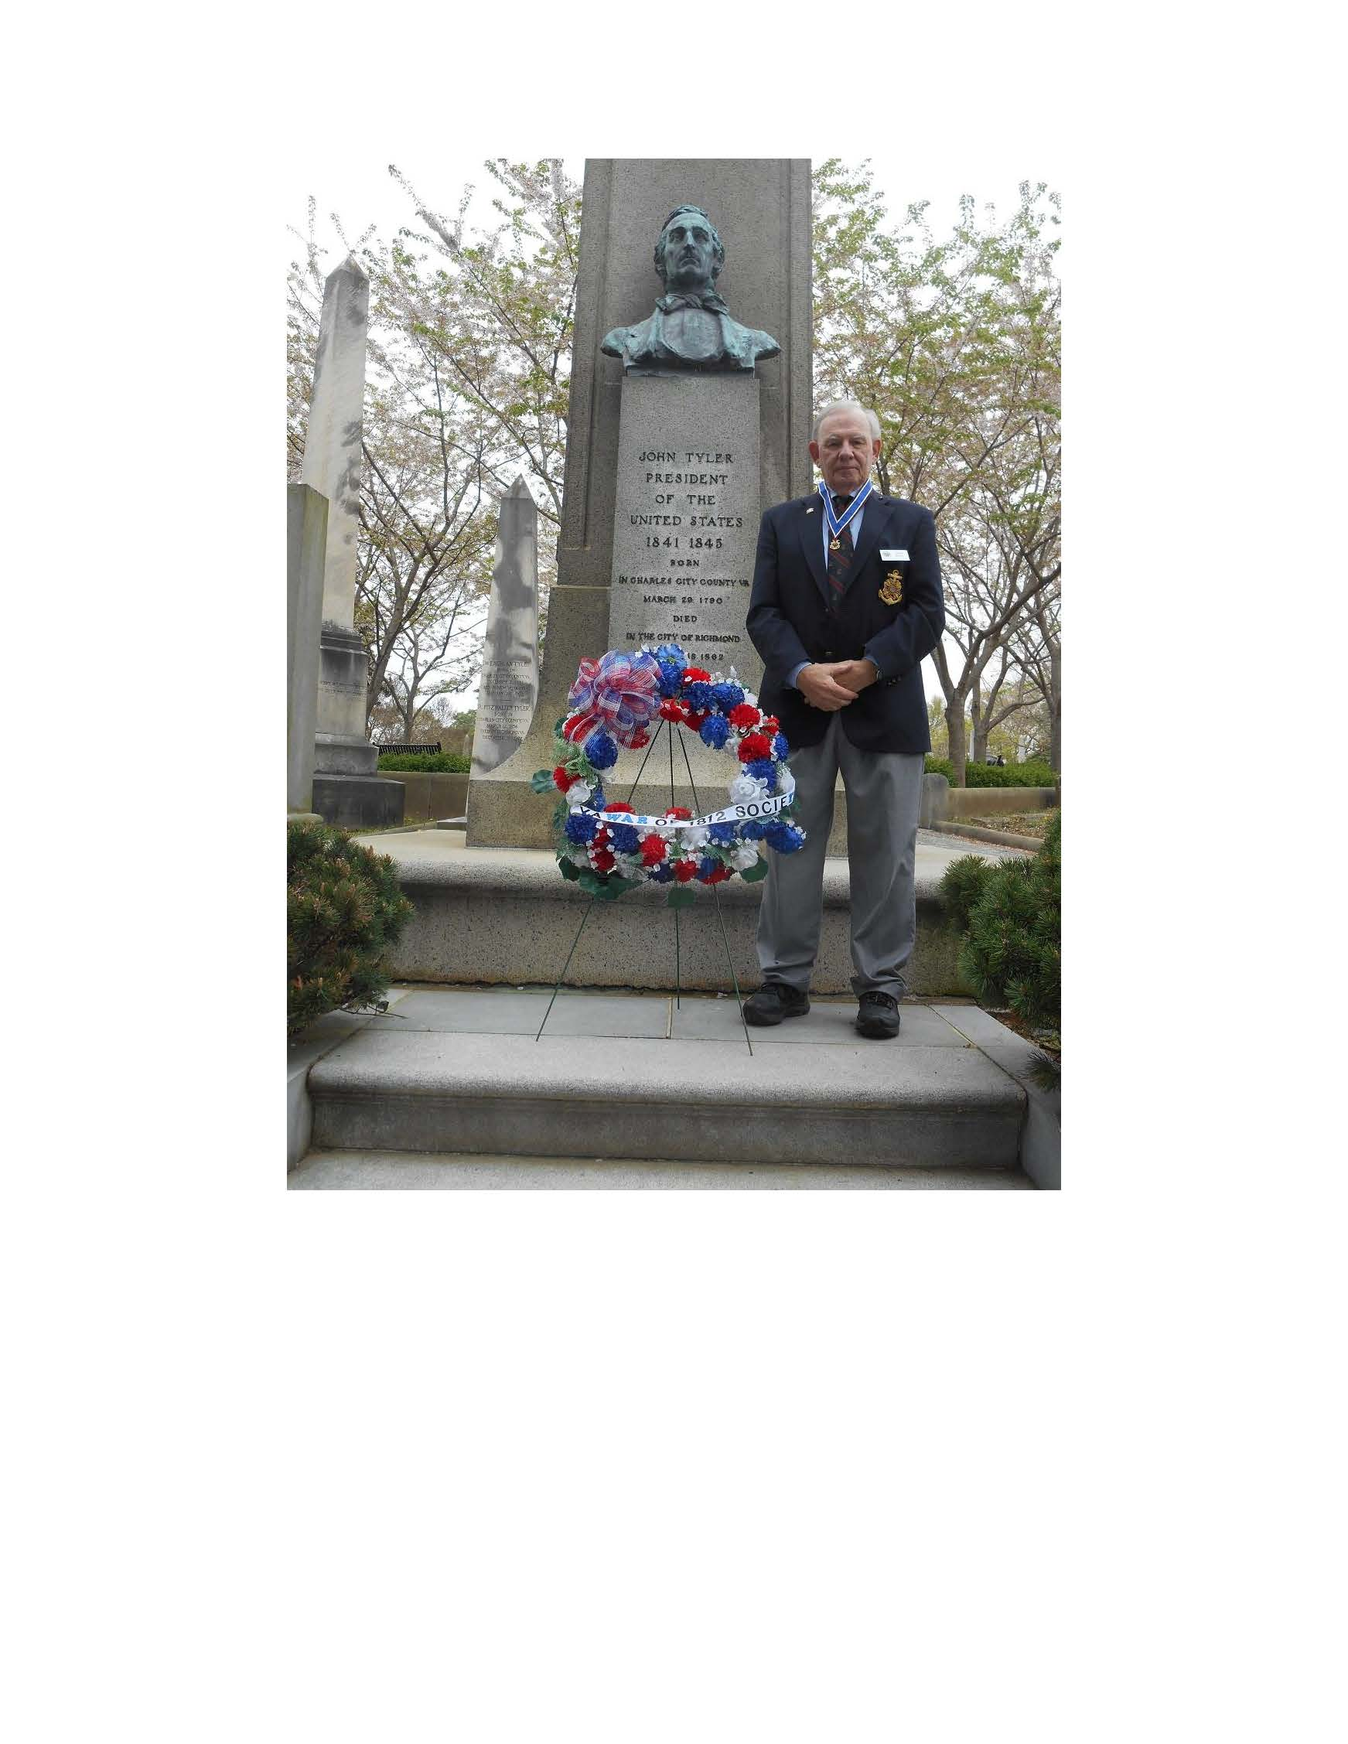

*Society Issues New Essay Contest Rules for HS Students Feb. 15, 2020 [See last two pages.]
Spring 2020 Virginia War Cry page 11

* War of 1812 Society Updates Handbook Feb. 10, 2020

* Society Meets in Richmond Feb. 7, 2020
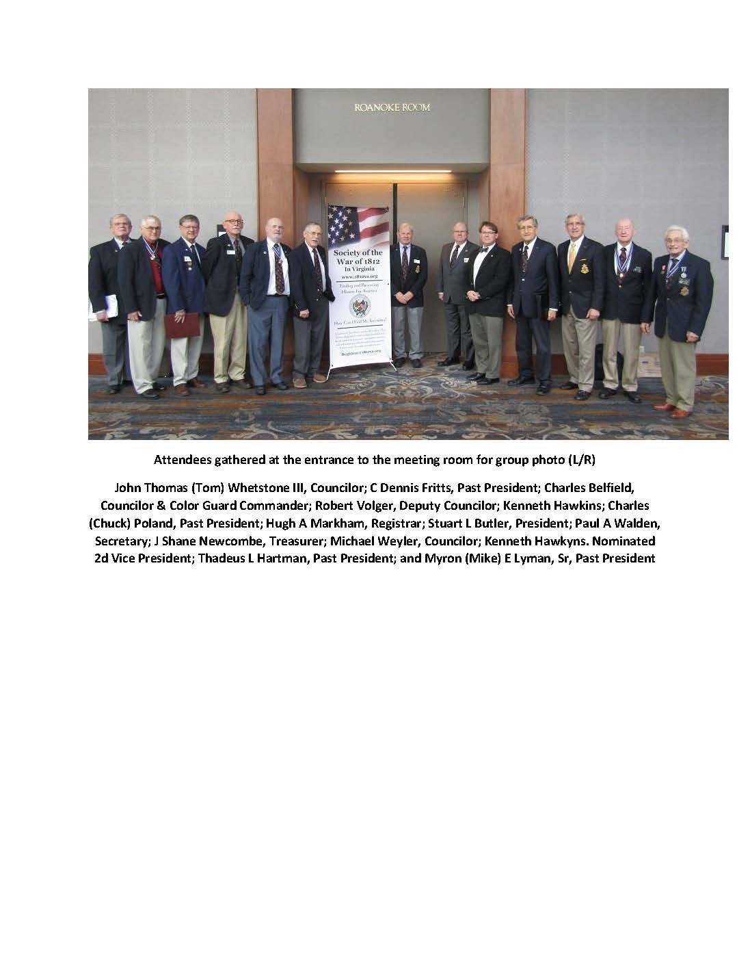

Spring 2020 Virginia War Cry page 12

* Society Attends and Gives Greetings at VASSAR Annual Banquet
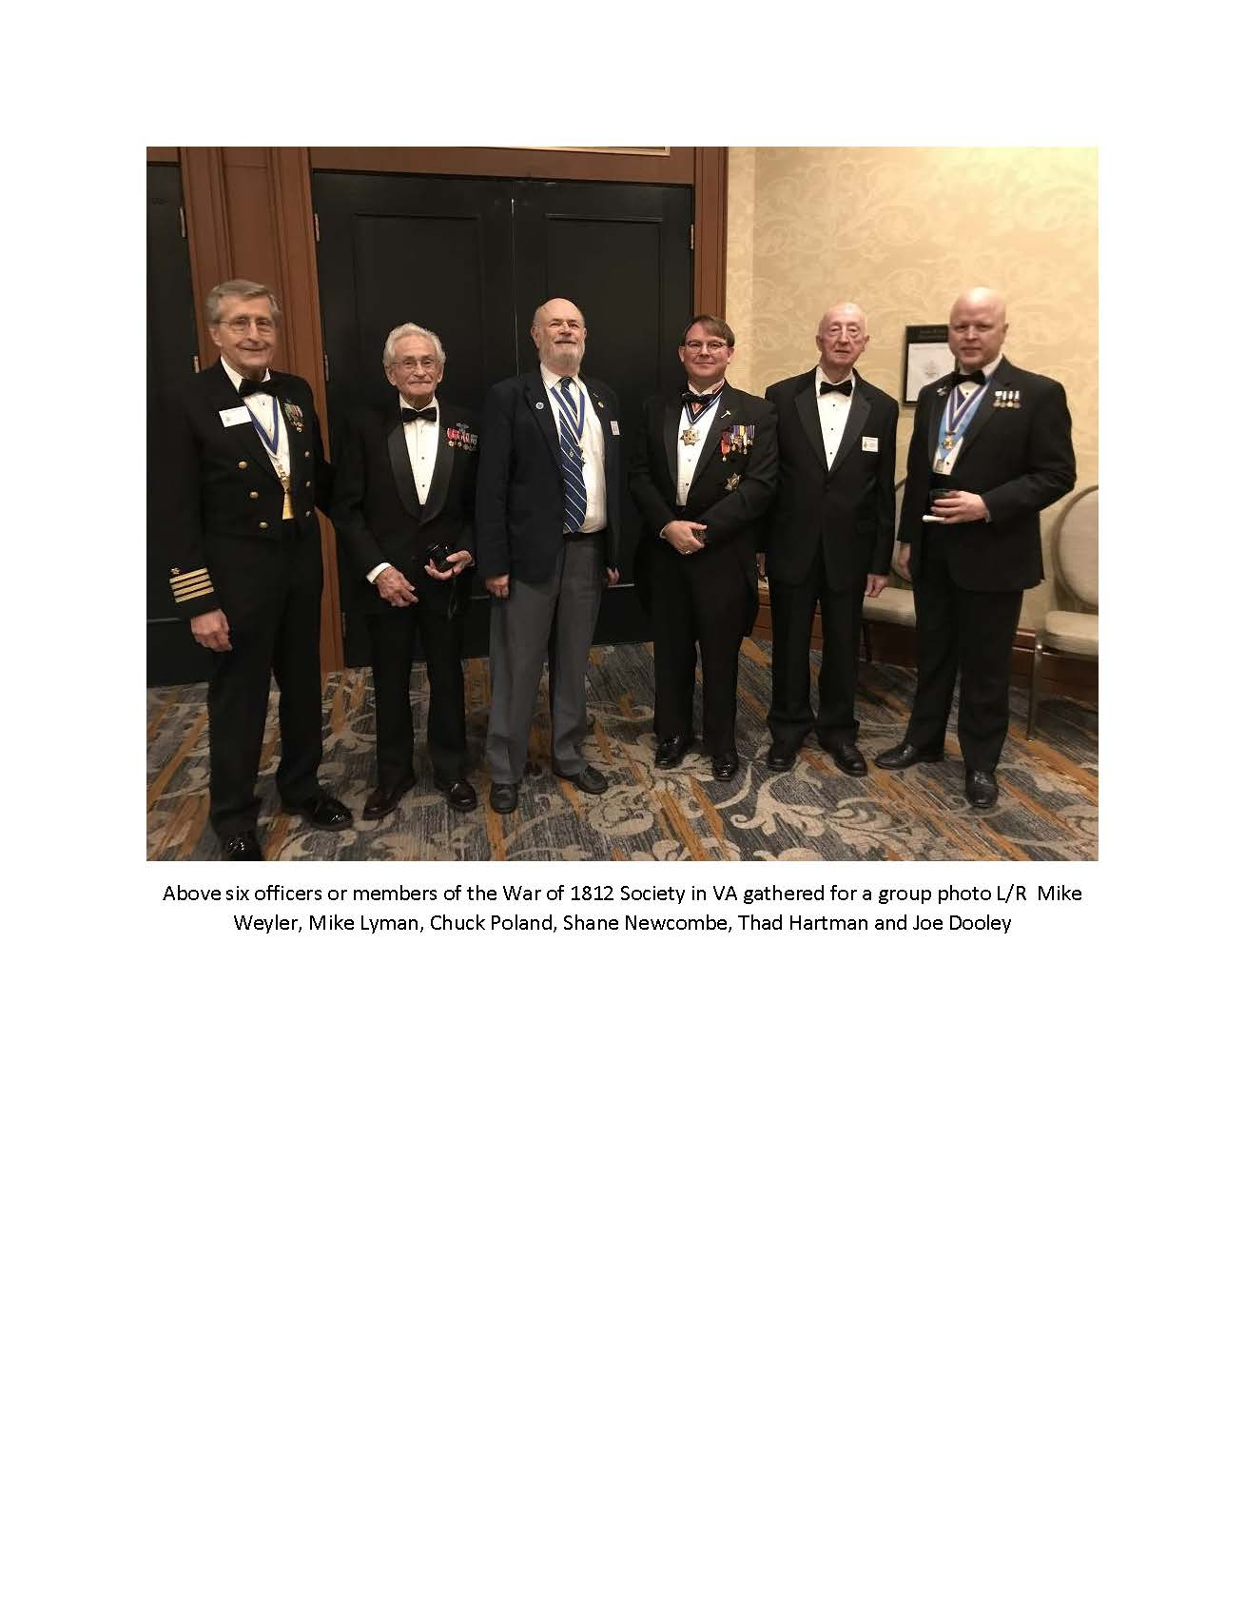
Spring 2020 Virginia War Cry page 13
* Society Conducts Ceremony on Veterans Day for Four War of 1812 Veterans
&
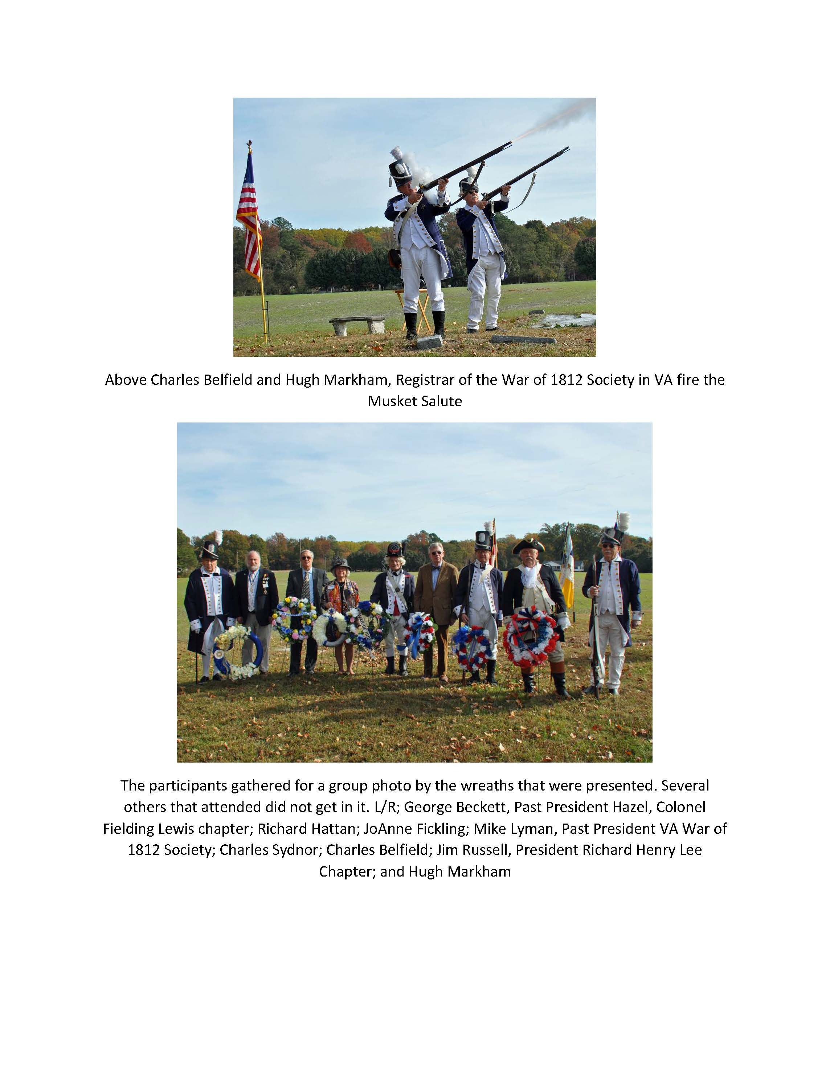
* Conducts Joint Marker Unveiling with SAR on Veterans Day
Spring 2020 Virginia War Cry page 14

* Society Presents Wreath at Portsmouth Ceremony
on Sept. 21, 2019

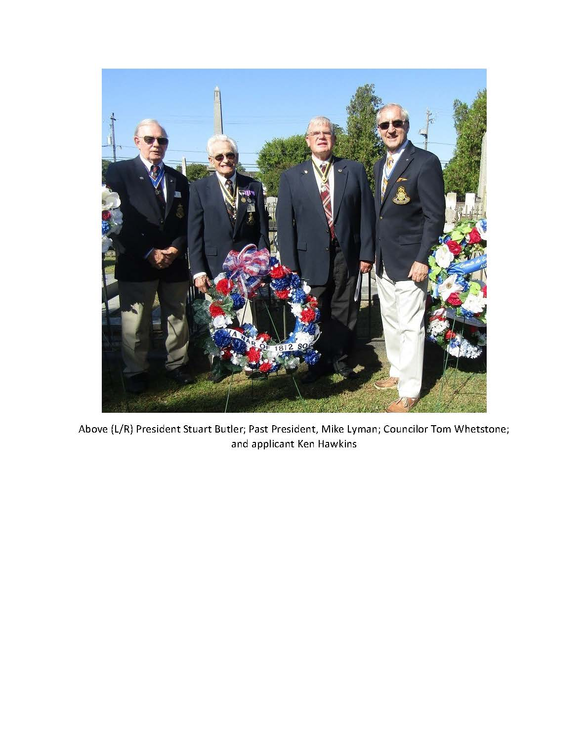

Spring 2020 Virginia War Cry page 15

* Society Meets in Fairfax September 14, 2019

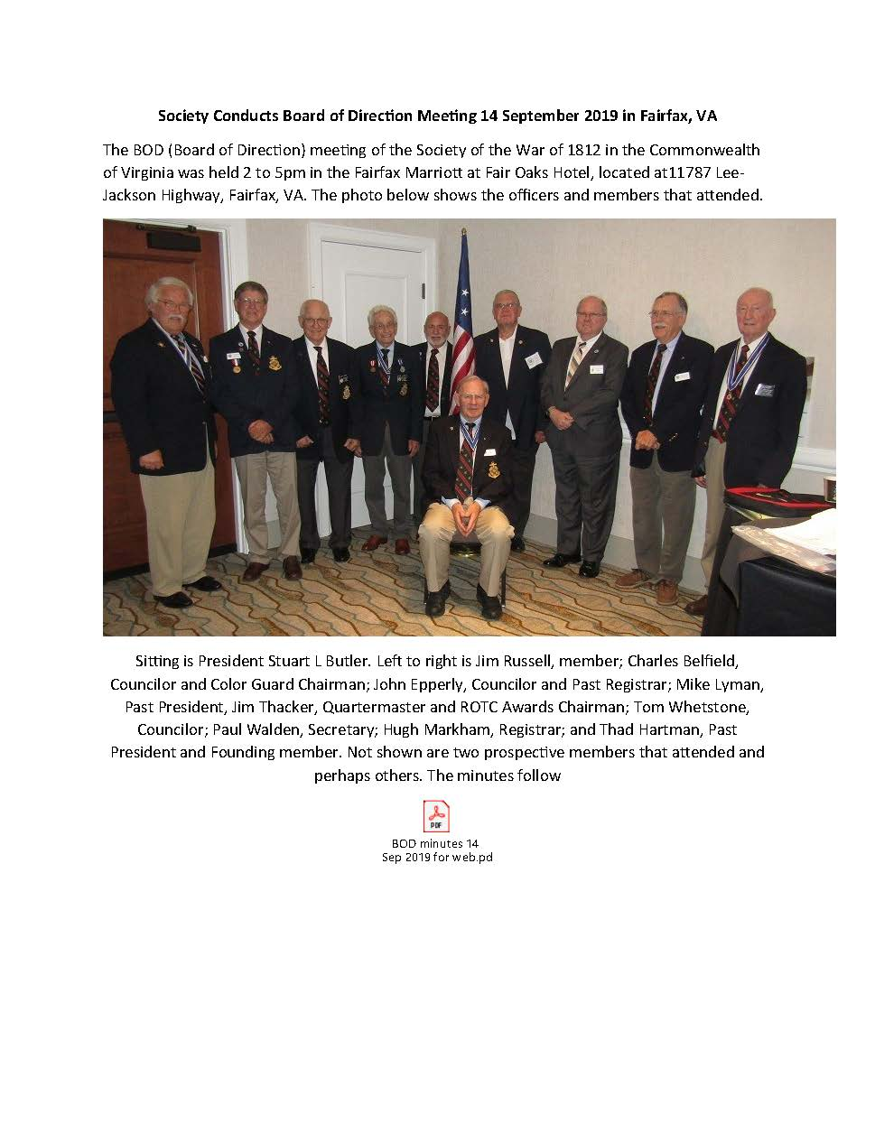
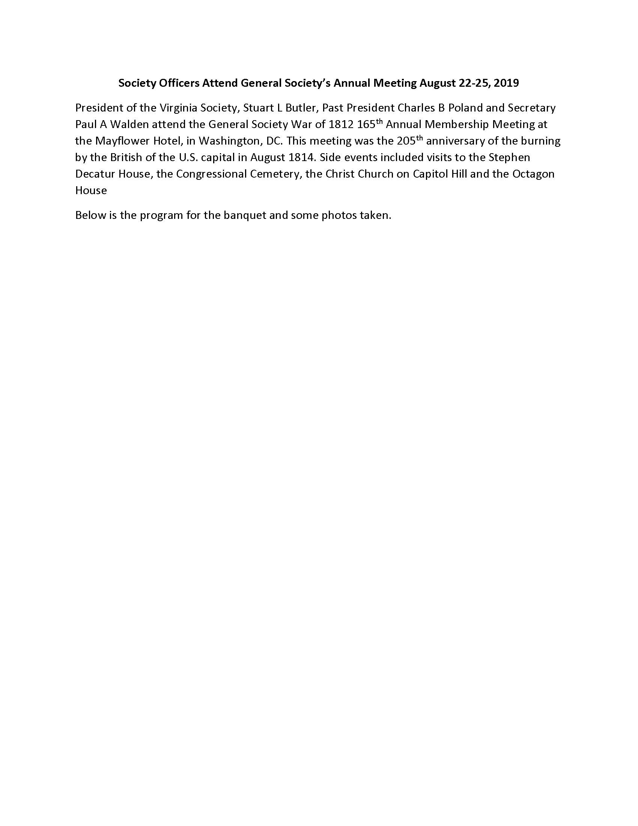

pring 2020 Virginia War Cr page 16

* Officers Attend General Society’s Annual Meeting Sept. 2, 2019

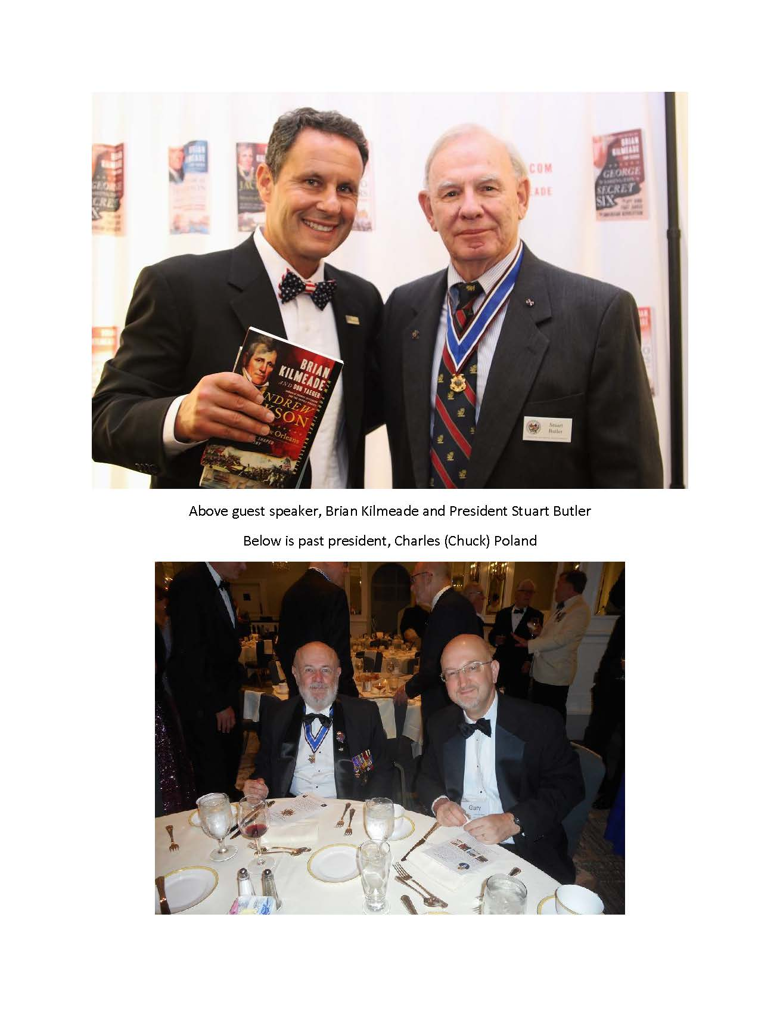

*

*

*

Spring 2020 Virginia War Cry page 17

* Member Charles Belfield Receives Award from US Daughters of 1812

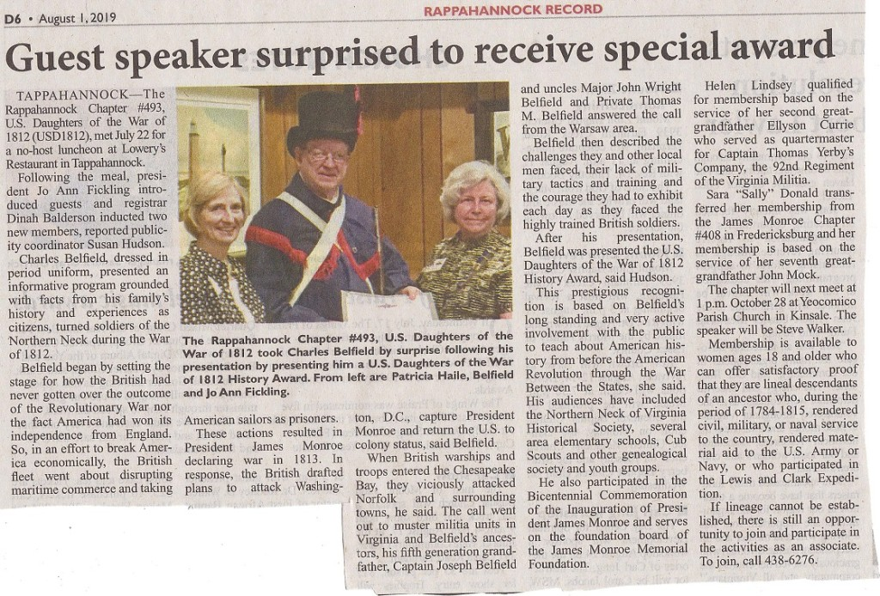
Spring 2020 Virginia War Cry page 18

* Society Participates in Grave Marker Unveiling Ceremony June 22, 2019
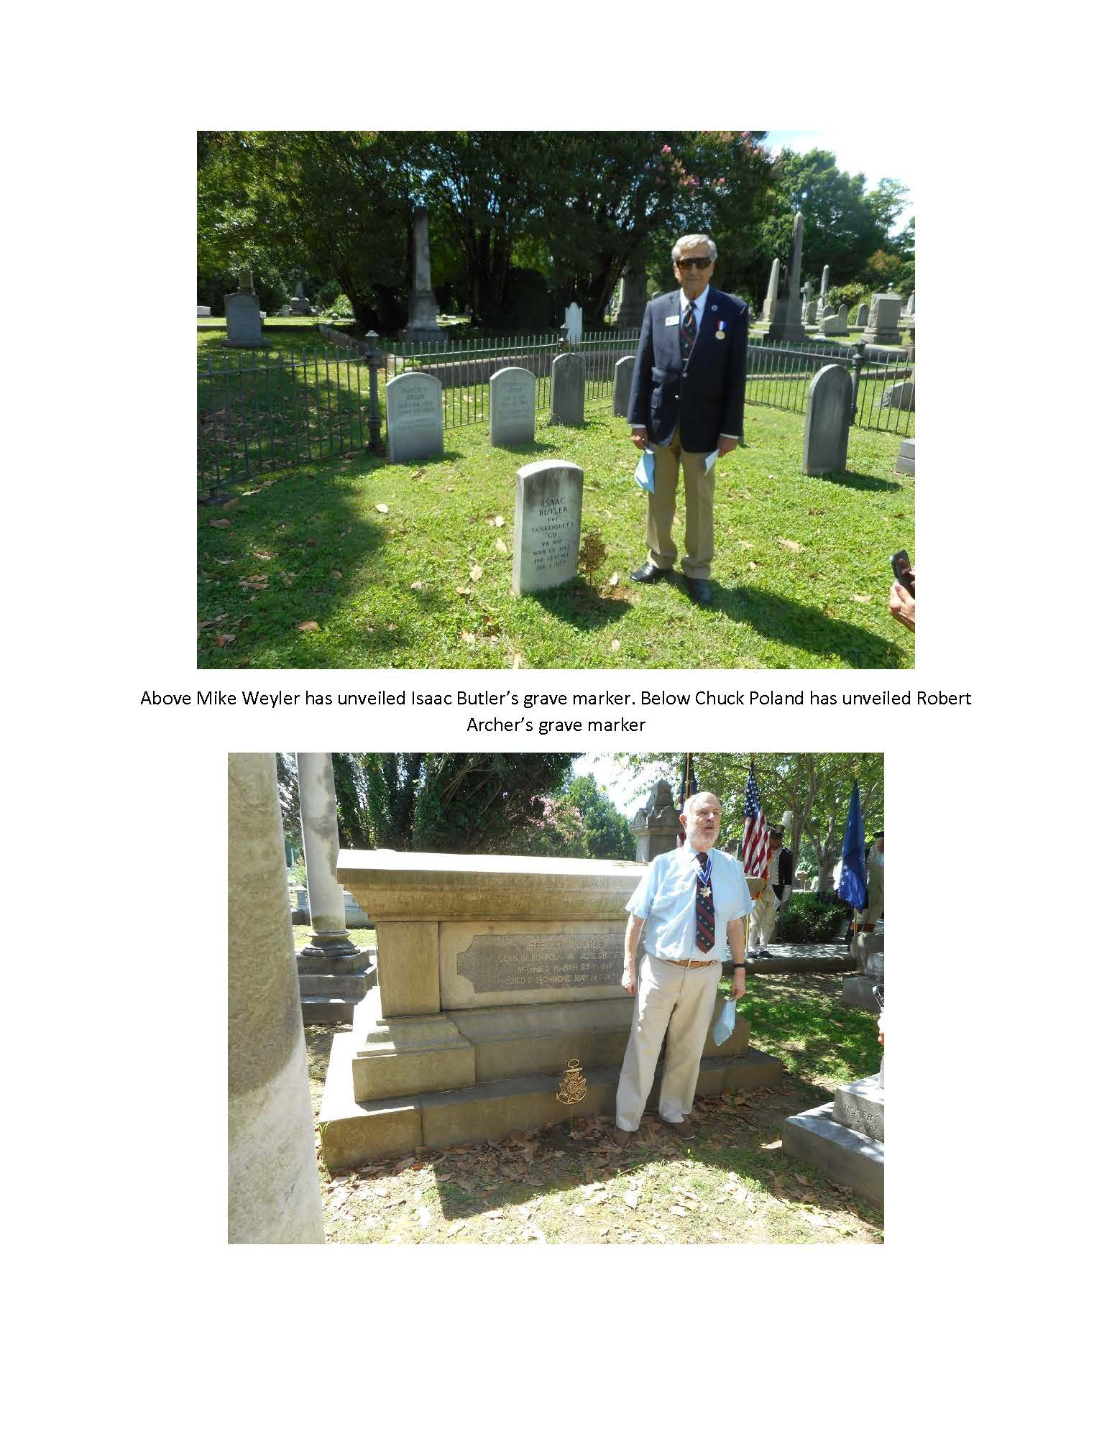

C

Spring 2020 Virginia War Cry page 19

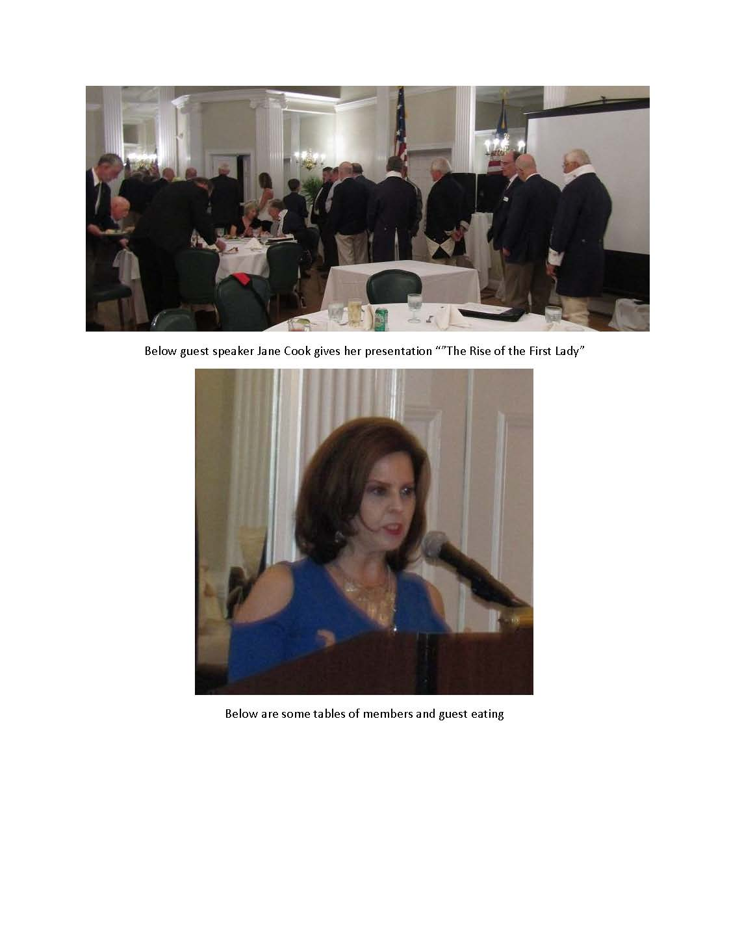
* Society Conducts Annual Muster and Conducts Grave Marker Unveiling June 22, 2019
Spring 2020 Virginia War Cry page 20

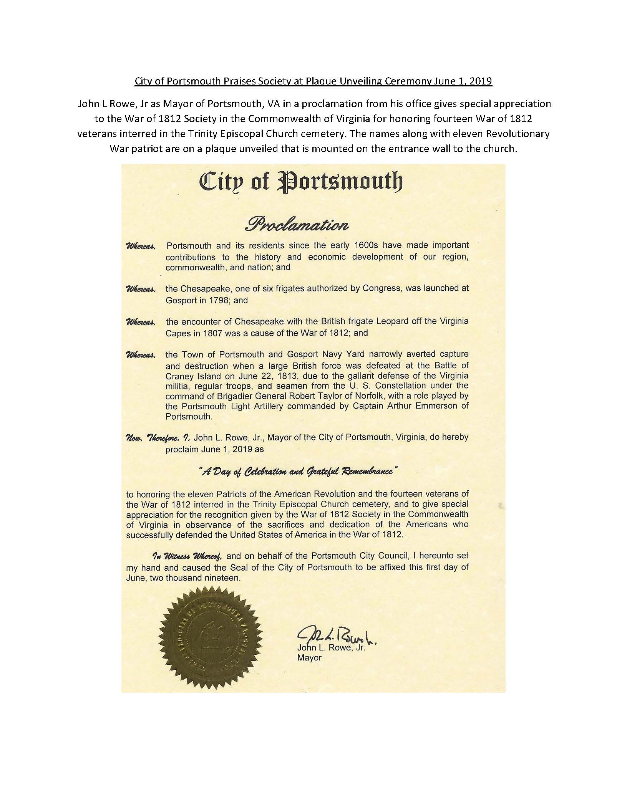
* City of Portsmouth Praises Society at Plaque Unveiling Ceremony June 1, 2019

Spring 2020 Virginia War Cry page 21

* Society and SAR Unveil a Plaque Naming Veterans of the Revolution and War of 1812 Buried at Trinity Episcopal Church Portsmouth June 1. 2019
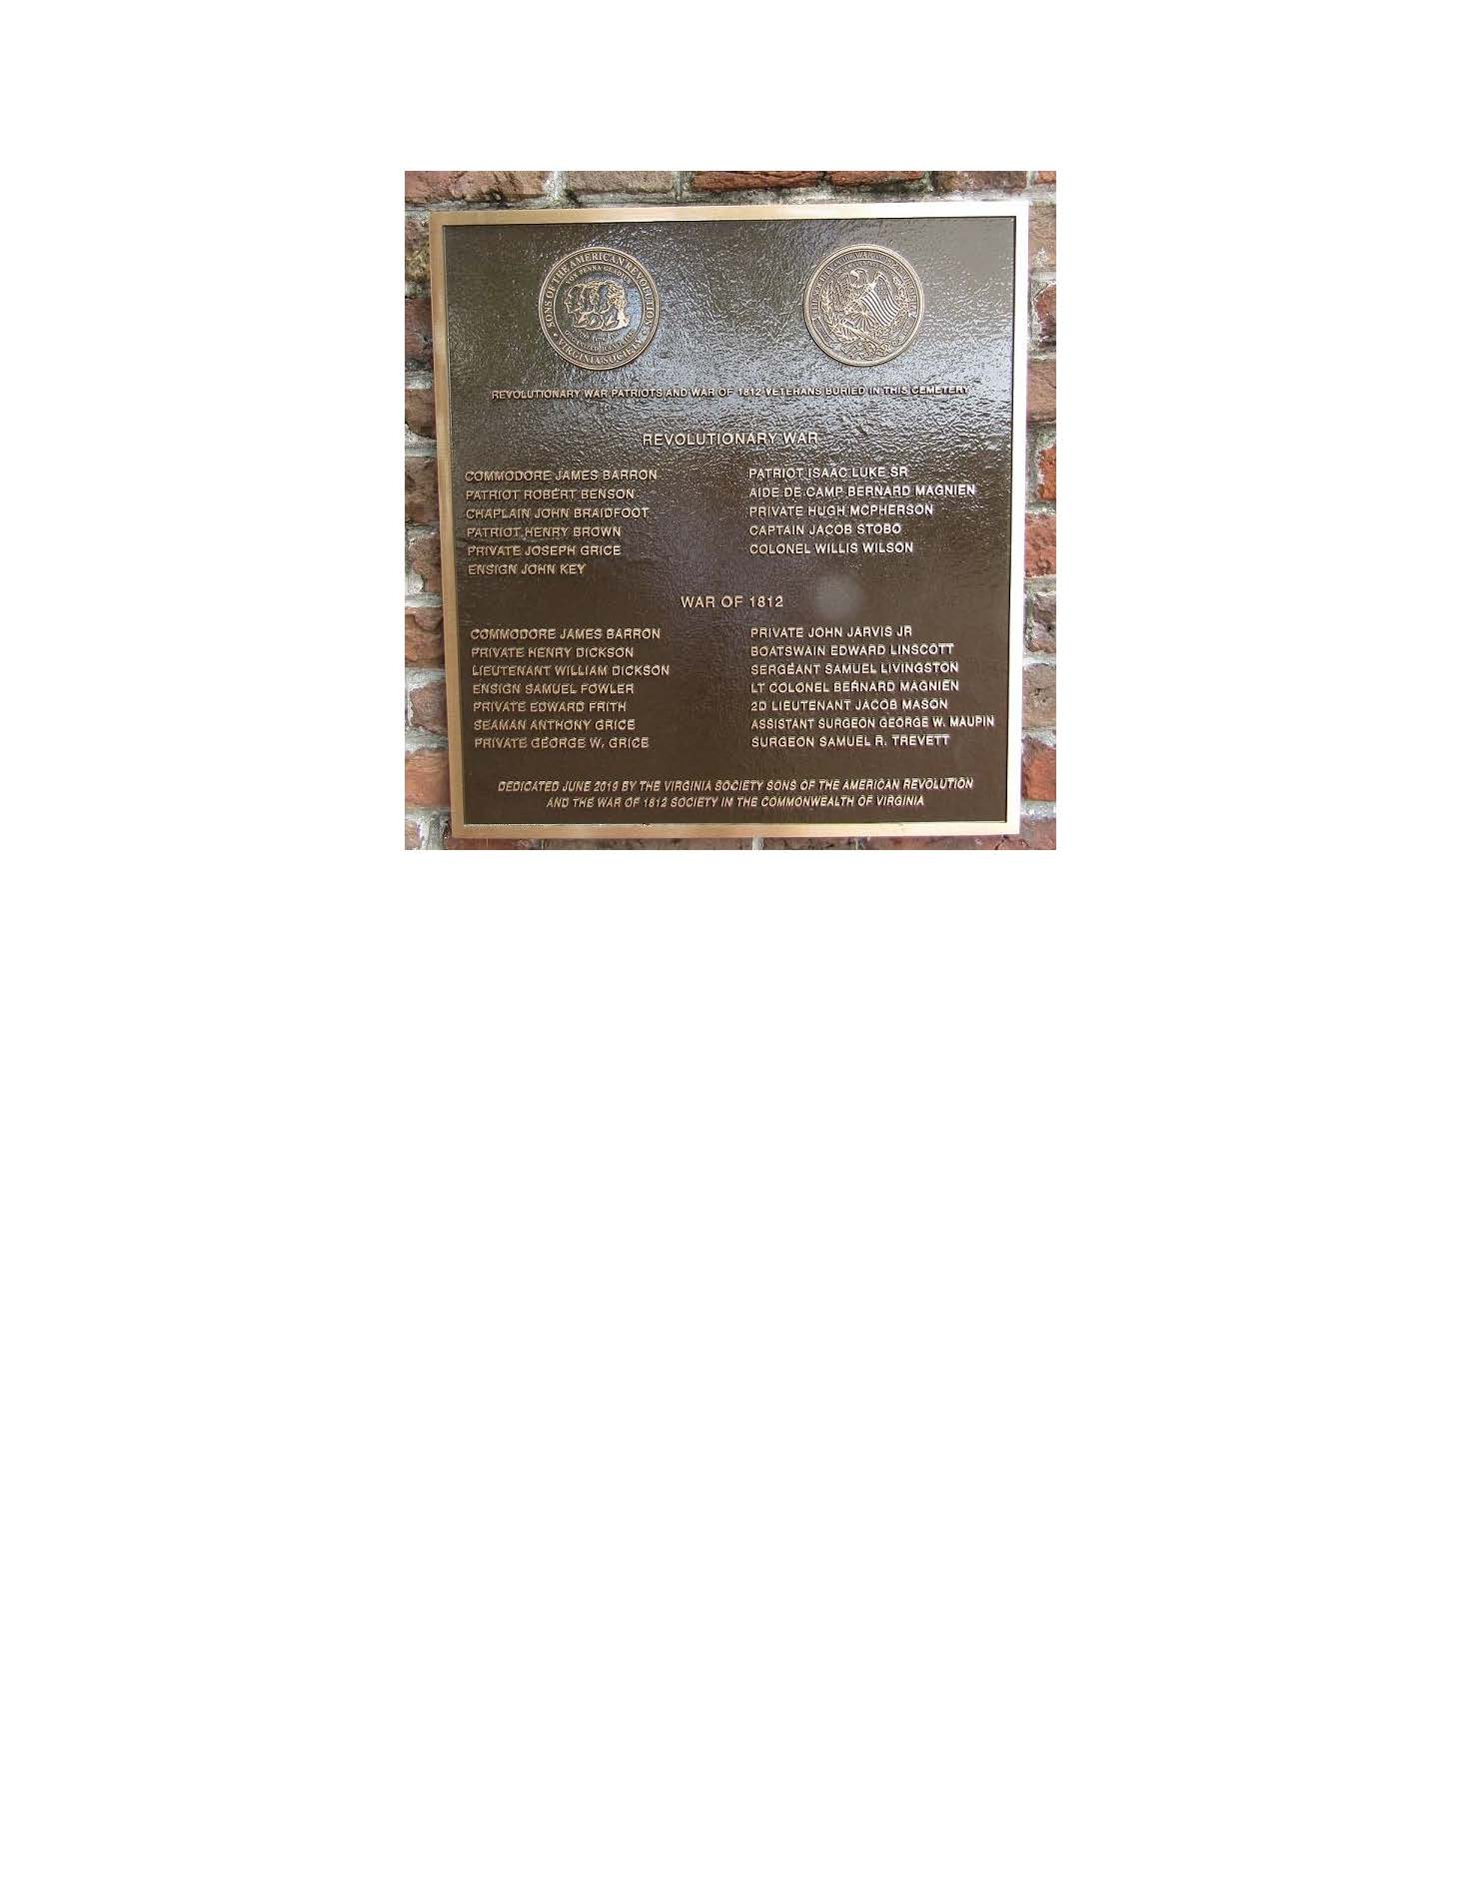

Spring 2020 Virginia War Cry page 22

* Society Officer Presents Wreath on Memorial Day 2019

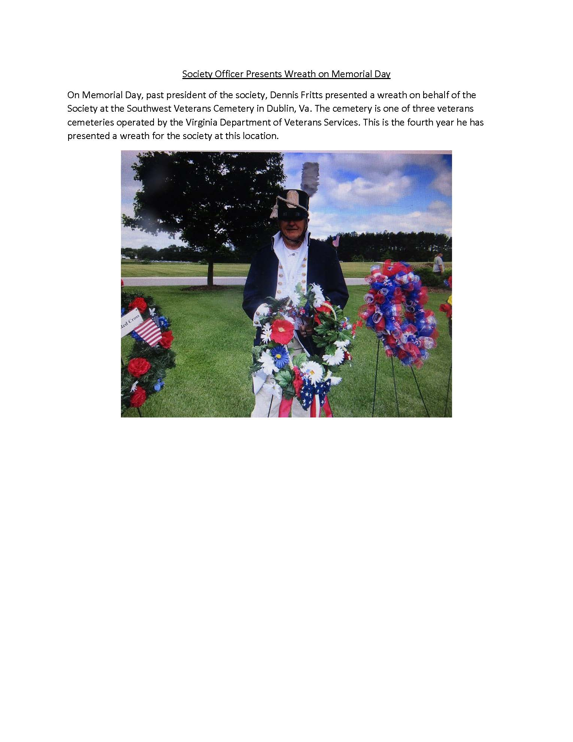
Spring 2020 Virginia War Cry page 23

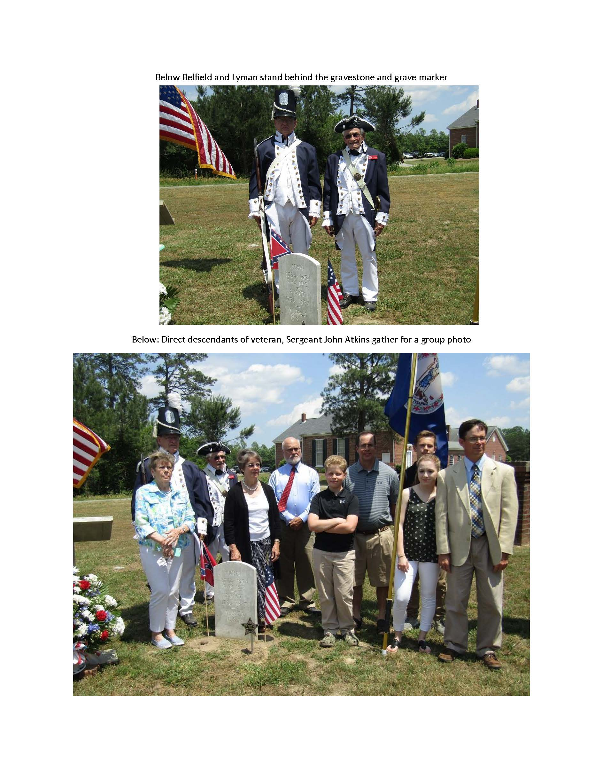
* Society Conducts Grave Marking Ceremony May 26, 2019

Spring 2020 Virginia War Cry page 24

* Society Participates in James Monroe Birthday Ceremony
April 28, 2019

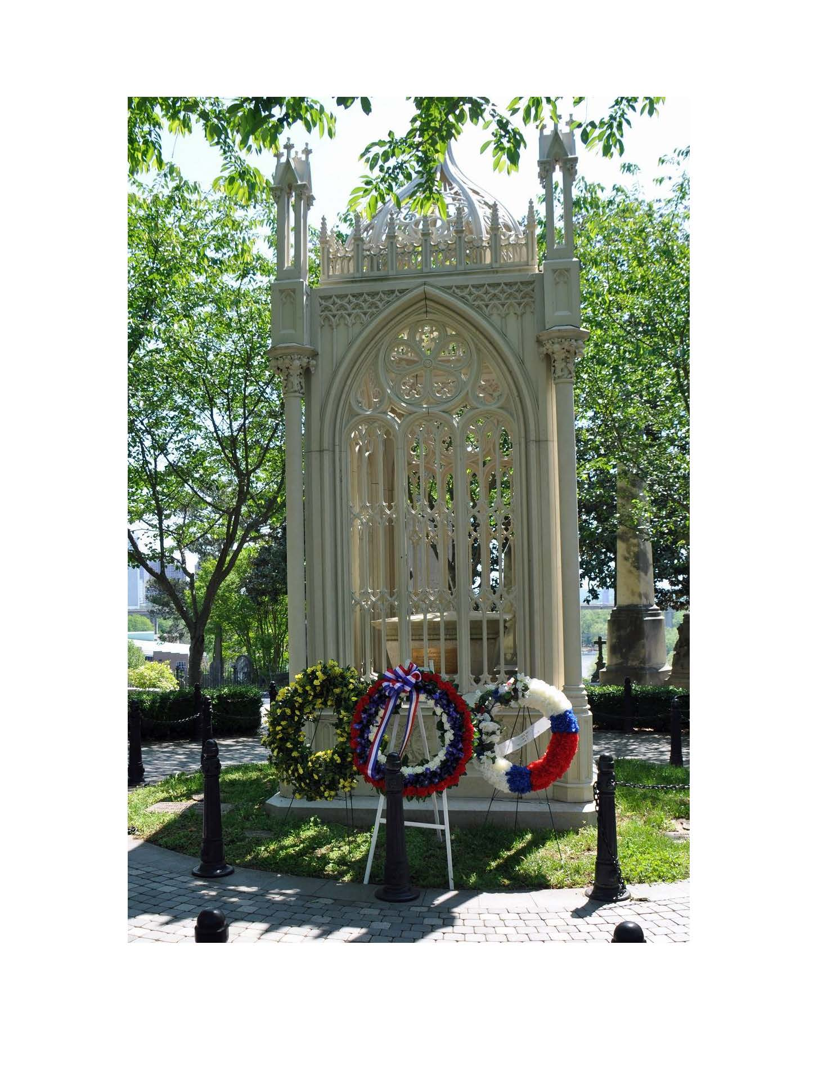

Spring 2020 Virginia War Cry page 25

* Eleven War of 1812 Members Participate in James Monroe Birthday Ceremony April 20, 2019
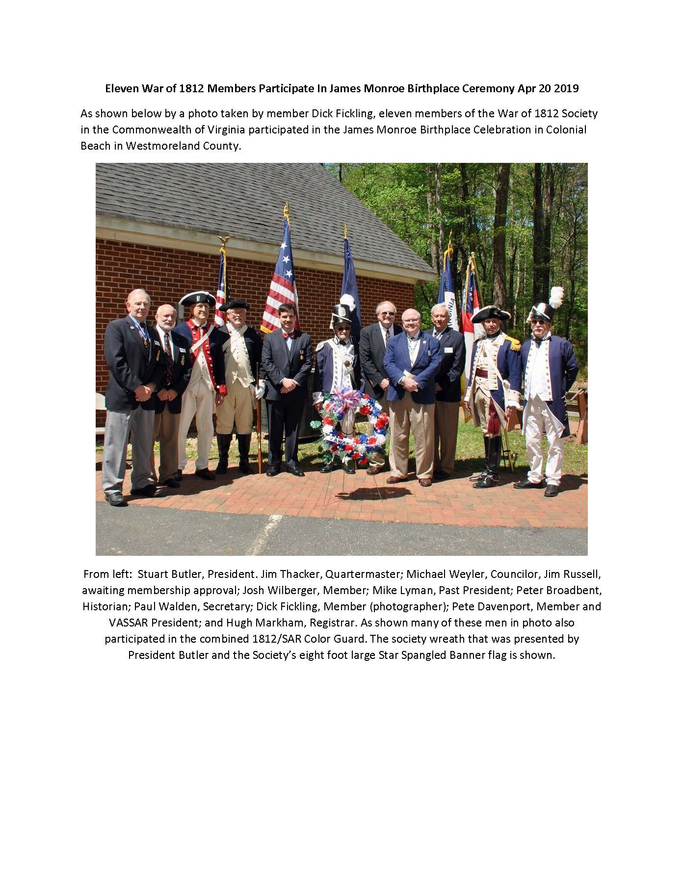

*Society Color Guard Supports Little League Season Opening
April 12, 2019
Spring 2020 Virginia War Cry page 26

* Book Review
Virginia in the War of 1812 , Christopher M. Bonin, McFarland and Company,
Jefferson, North Carolina, 2018, 150 pages. Reviewed by Stuart L. Butler

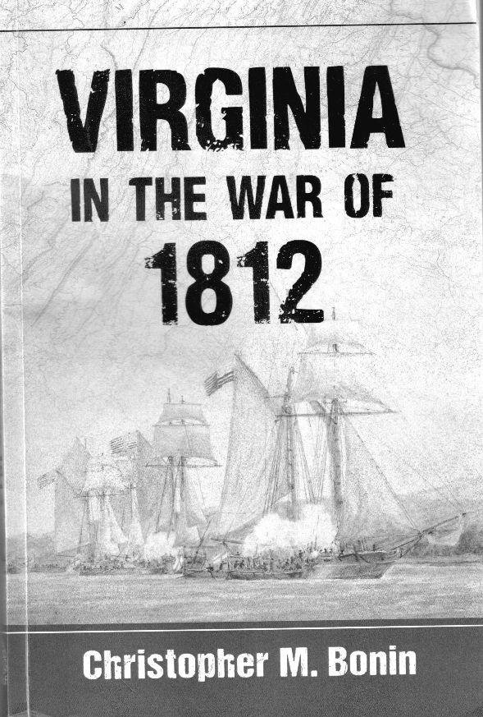

Spring 2020 Virginia War Cry page 27

* Book Review by Stuart L. Butler

Christopher Bonin’s small book on the War of 1812 in Virginia is a re-working of his
M.A. thesis submitted to University of Nebraska in 2015. In general, Bonin’s book is
a brief overview of the military operations both in Virginia and outside, the latter,
depending on where the Virginia militia was operating at the time. The book provides
for both a topical and some chronological treatment of the events occurring in
Virginia during the war. The first several chapters provide the reasons leading up to
the declaration of war by the United States starting with the capture of the USS
Chesapeake off Norfolk in June 1807. Following chapters assess the status and
strengths and weaknesses of military and naval forces of both the United States and
Great Britain. In doing so, the author jumps right into the war years and describes the
military operations which seem to this reviewer to be better treated in later chapters
which examine Virginia’s contribution to the war. Bonin ends his book with two
chapters entitled “Aftermath” and “Conclusion,” which probably should have been
combined in some fashion. The book is written quite well, straightforwardly, and is
informative.

While Bonin consults some standard primary sources such as the Richmond Enquirer
and Norfolk Gazette and Publick-Ledger, and other published first-hand accounts of
Virginian and British participants, but most of his cited sources are based on secondary
books and articles. Missing among the published primary sources and crucial for any
accounting of the Virginia experience in the war is the Calendar of Virginia State
Papers, which consists of edited selections of the incoming and outgoing correspondence
of the governor and his executive council.

The book also could have substituted more recently discovered maps and drawings
from the period than the overly used and now outdated ones from Benjamin Lossing’s
Field Book. An insertion of a chronology of the military events in Virginia for the
period would also have greatly improved the book’s value.

In summary, if a reader only wanted to obtain a very brief and general overview of the
events in Virginia during the War of 1812, Bonin’s book is adequate to that task.
However, if a reader wanted to obtain a more detailed understanding of what
transpired in Virginia, both politically and militarily, an examination into how the
enslaved population was treated by both Virginians and British at the time, and how
Virginia’s government prepared for and defended Virginia, than one should consult
the reviewer’s book, Defending the Old Dominion: Virginia and its Militia in the War
of 1812 (2013). Having both books on the bookshelf, however, would complement
one another and provide the reader, depending on one’s need, with either a general or
detailed look at Virginia during the war. Both books are available through Amazon
and Barnes and Nob
Spring 2020 Virginia War Cry page 28

* Essay Contest Rules

Society of the War of 1812 in Virginia High School Essay Contest Rules
Essays Due June 30, 2020

The Society of the War of 1812 in Virginia encourages Virginia and West Virginia High School students to study the War of 1812, and especially, the role Virginians had in supporting what is often referred to as the “Second War for Independence.”
Subject of the Essay must be on a Virginian who supported the United States in the War of 1812. Suggestions include, but not limited to, James Monroe, James Madison, Dolley Madison, Elizabeth Monroe, William Henry Harrison, John Randolph, and James Barbour.
- Title Page – The title page must include the following:
  - Title of the Essay
  - Applicant’s name, grade, address, phone number & email
  - Applicant’s high school’s name, address & phone number
- Essay Pages – The essay must:
  - Be a minimum of 800 and a maximum of 1,500 words (excluding title page, endnotes, bibliography, page and biography)
  - First page must include the title
  - No applicant information is on the essay pages
  - 12-point Times New Roman font and double-spaced
  - Use 8 ½” by 11” paper with 1” margins on all sides
  - Essay pages are numbered sequentially, starting with“1”
  - No graphics, special covers or bindings are allowed. Please do not staple the pages.
- Bibliography pages – The bibliography must include:
  - Citations in the essay and references in the bibliography must be in accordance with a
(continued)

Spring 2020 Virginia War Cry page 29

widely used, publicly available citation system (Examples include the Chicago Manual of
Style, the MLA Manual of Style, & the MHRA Style Guide).
  - Minimum of 5 references, 3 of which must be published works (encyclopedias or internet sources are acceptable but not considered part of the 3 published works)
- Student Biography page--The biography of the student must be:
  - Limited to one page.
  - Include academic awards and achievements, school activities, community activities and plans for college.

Essays which meet the criteria above will be accepted and judged equally on the following criteria:

  - Historical accuracy
  - Clarity of thought
  - Organization and proven topic
  - Grammar and spelling
  - Documentation

Entries must be received by June 30, 2020. Please mail to Paul Walden, Secretary, Society of the War of 1812 in the Commonwealth of Virginia, P.O. Box 4057, Alexandria, VA22303-0057.

Students submitting essays give permission to the Society of the War of 1812 in the Commonwealth of Virginia to publish their essays on the society website and newsletter.

Judging will occur before the Society’s Fall 2020 meeting. The winners will be announced on the Society’s website: http://1812va.org.

Entries are limited to public, private, and home-schooled high school students in West Virginia and Virginia who are in the 9ththrough 12thgrade.

Prizes: First Place: $750, Second Place:$500.

