On November 21st 2020 at the Ketoctin Baptist Church cemetery in Loudoun County VA, an unveiling ceremony of two new monuments were conducted. One was for a monument listing Revolutionary War patriots buried in the cemetery and the other was for the listing the War of 1812 veterans interred there. The program and photos taken for the War of 1812 unveiling portion follows.
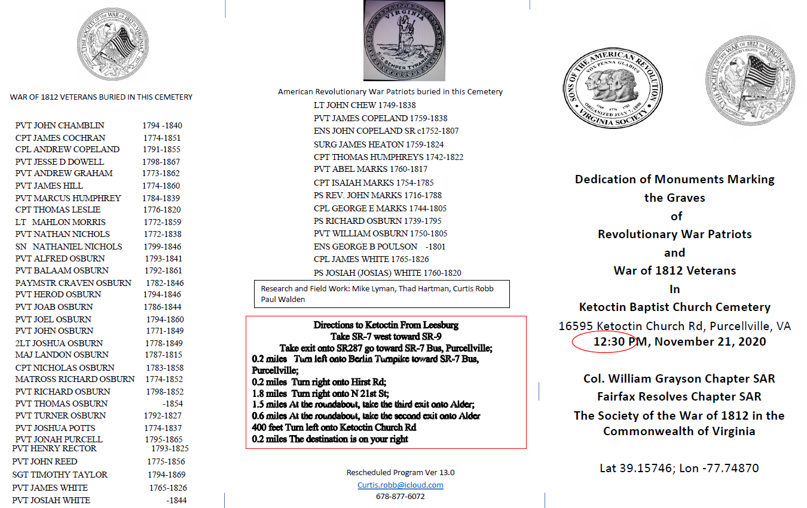
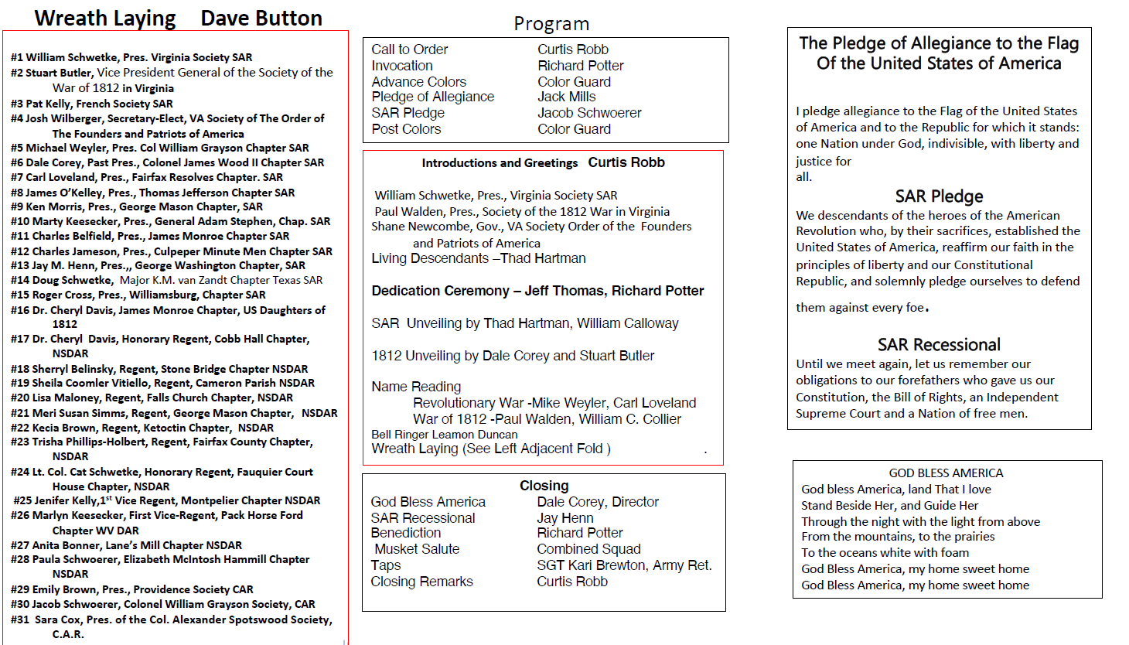
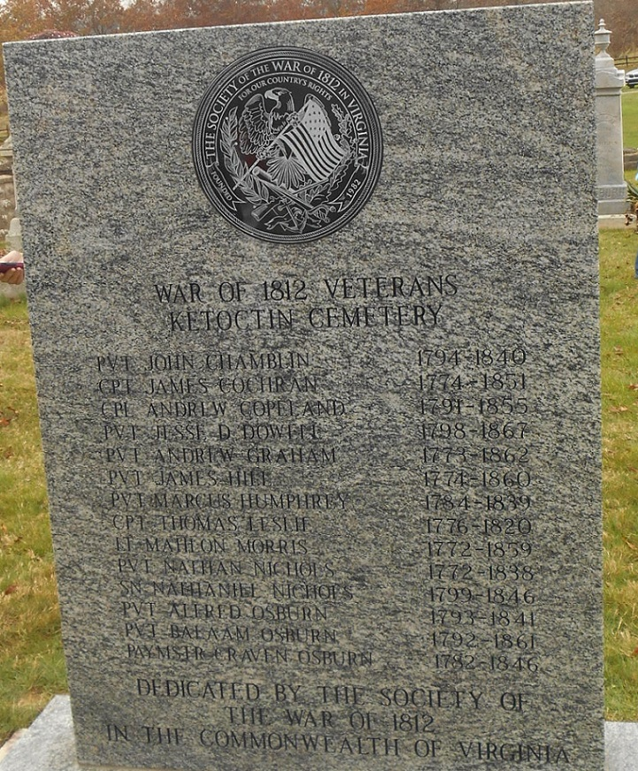
The unveiled front side of the War of 1812 monument
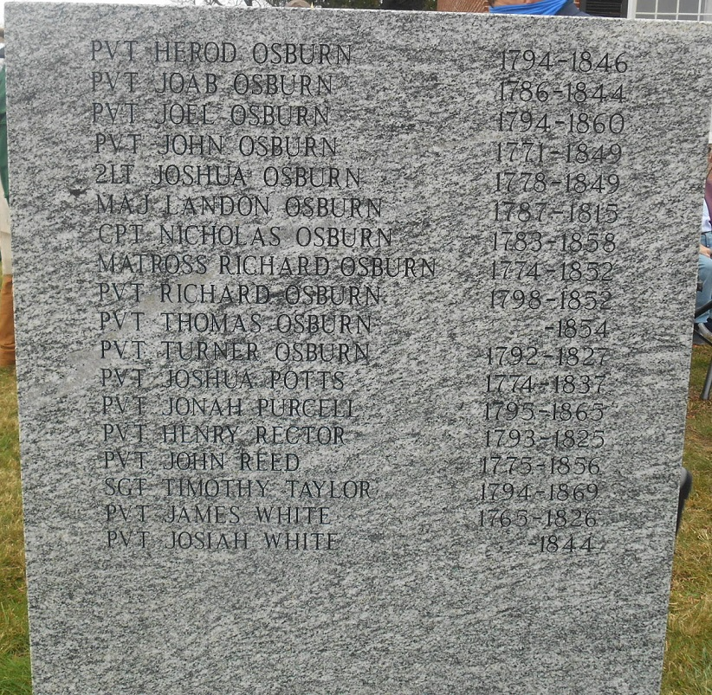
The unveiled backside
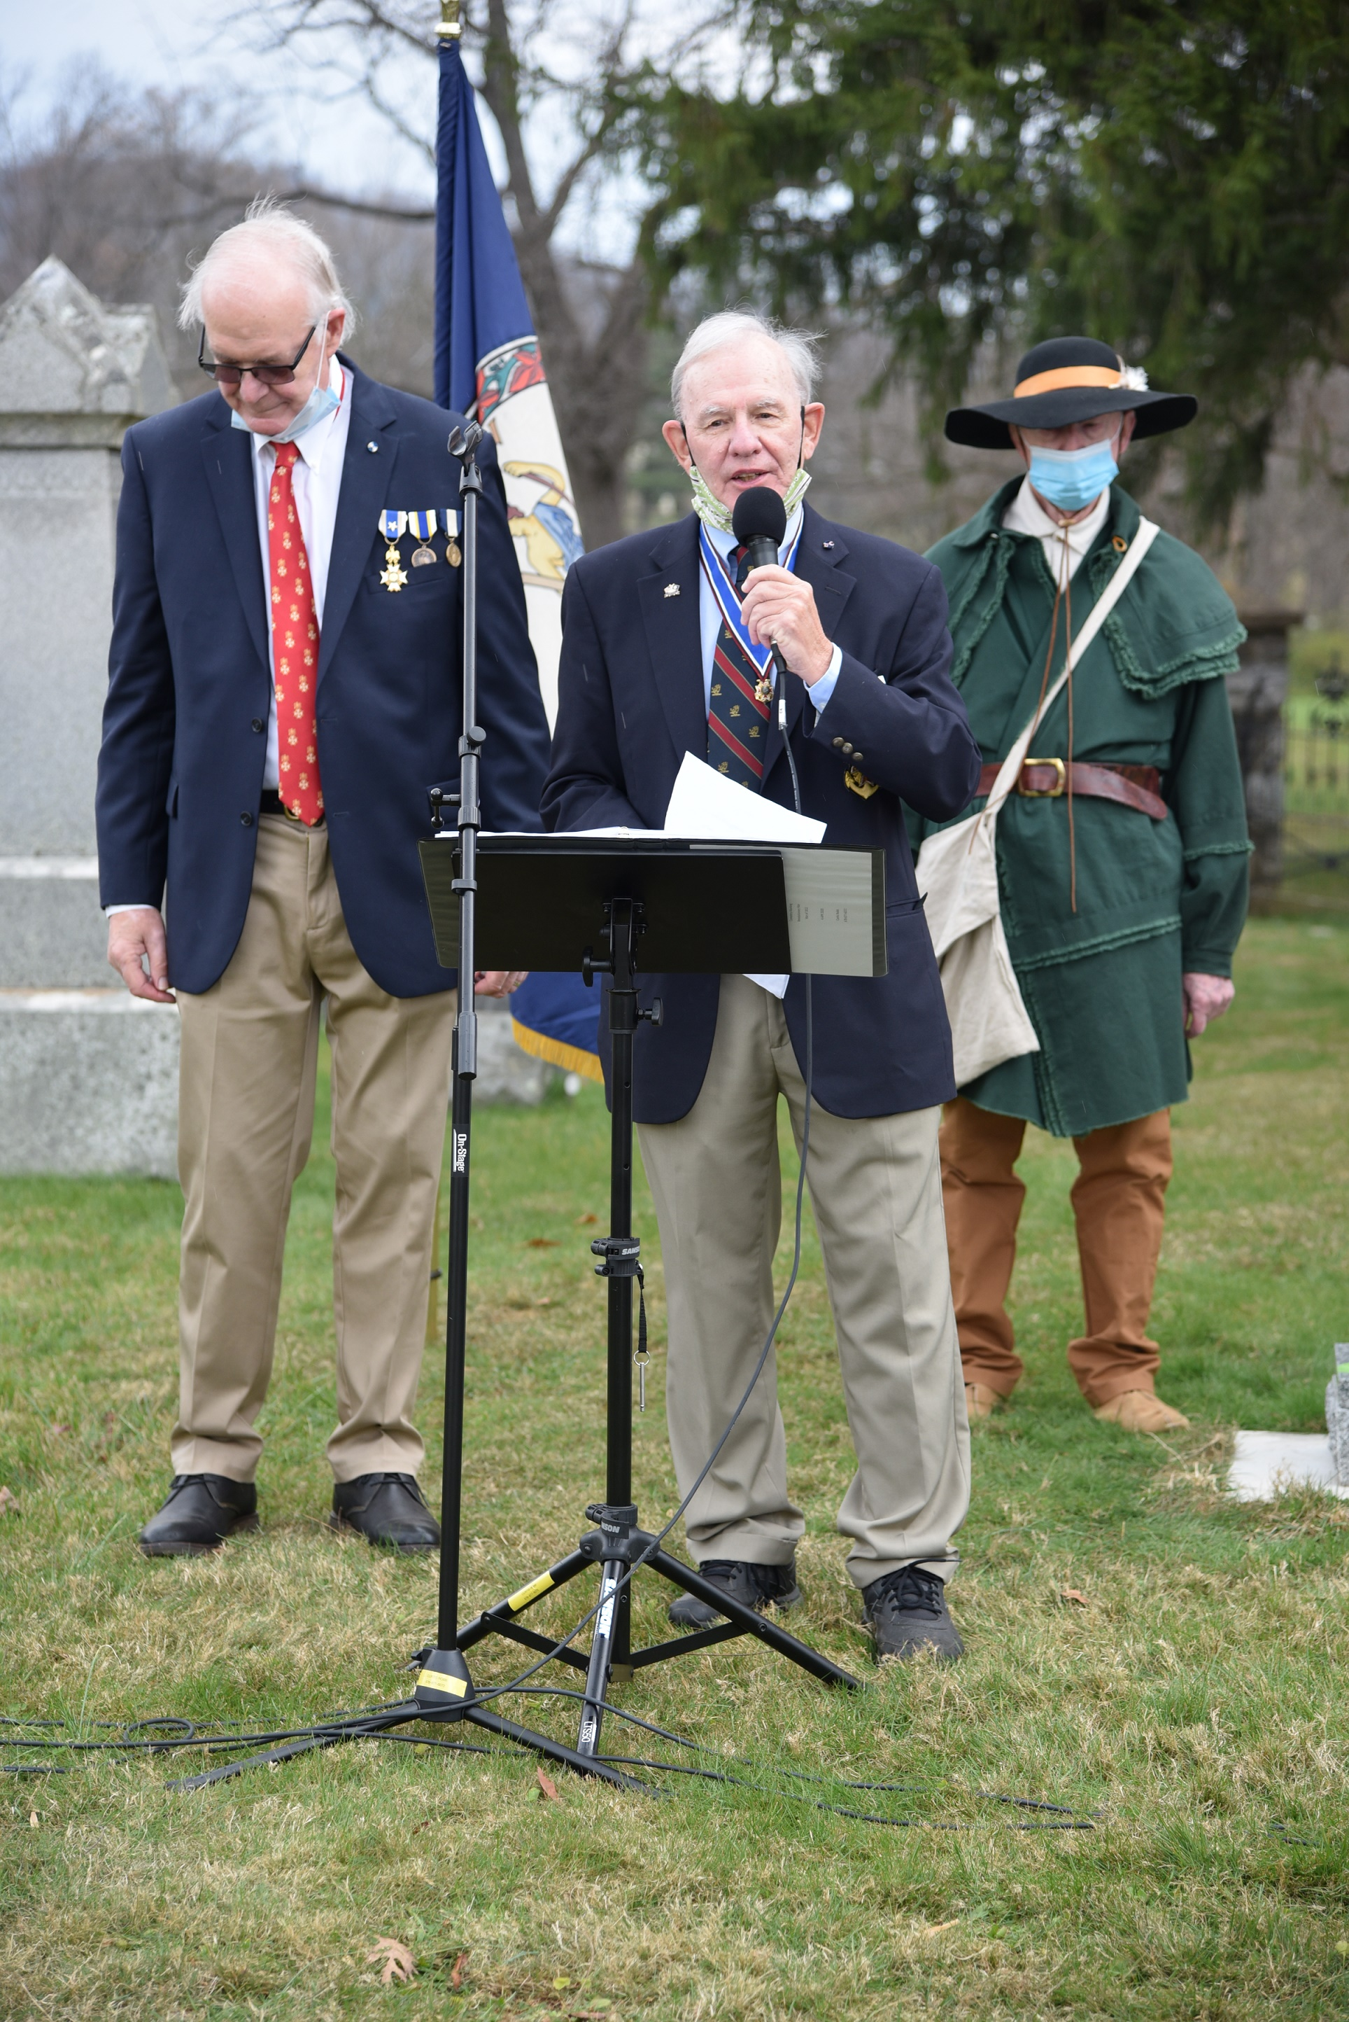
Immediate Past President of the War of 1812 Virginia Society gives greetings
On the left is War of 1812 member, Curtis Robb who presided over the ceremony.
On the left is charter member and Past President, Thaddeus Hartman
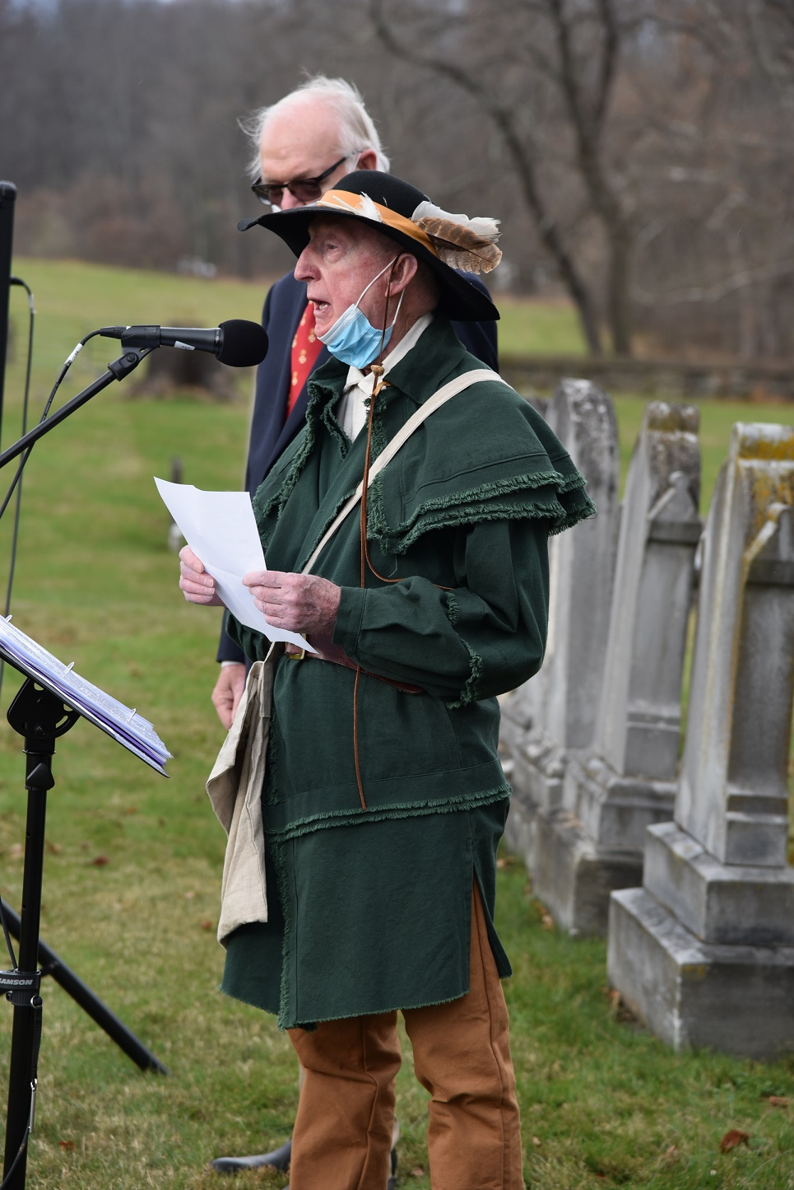
Introducing a direct descendant is Thad Hartnan
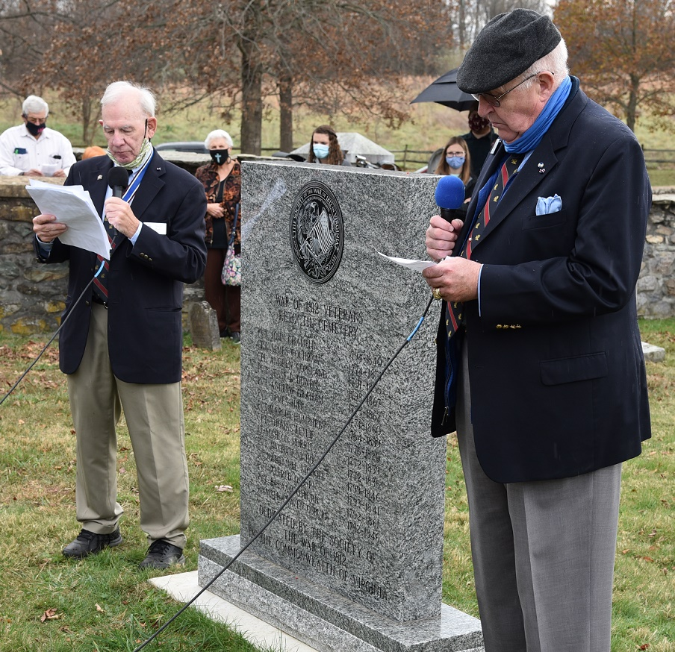
During the ceremony each War of 1812 veteran’s name is read. On the left William Collier, Councilor of the Society
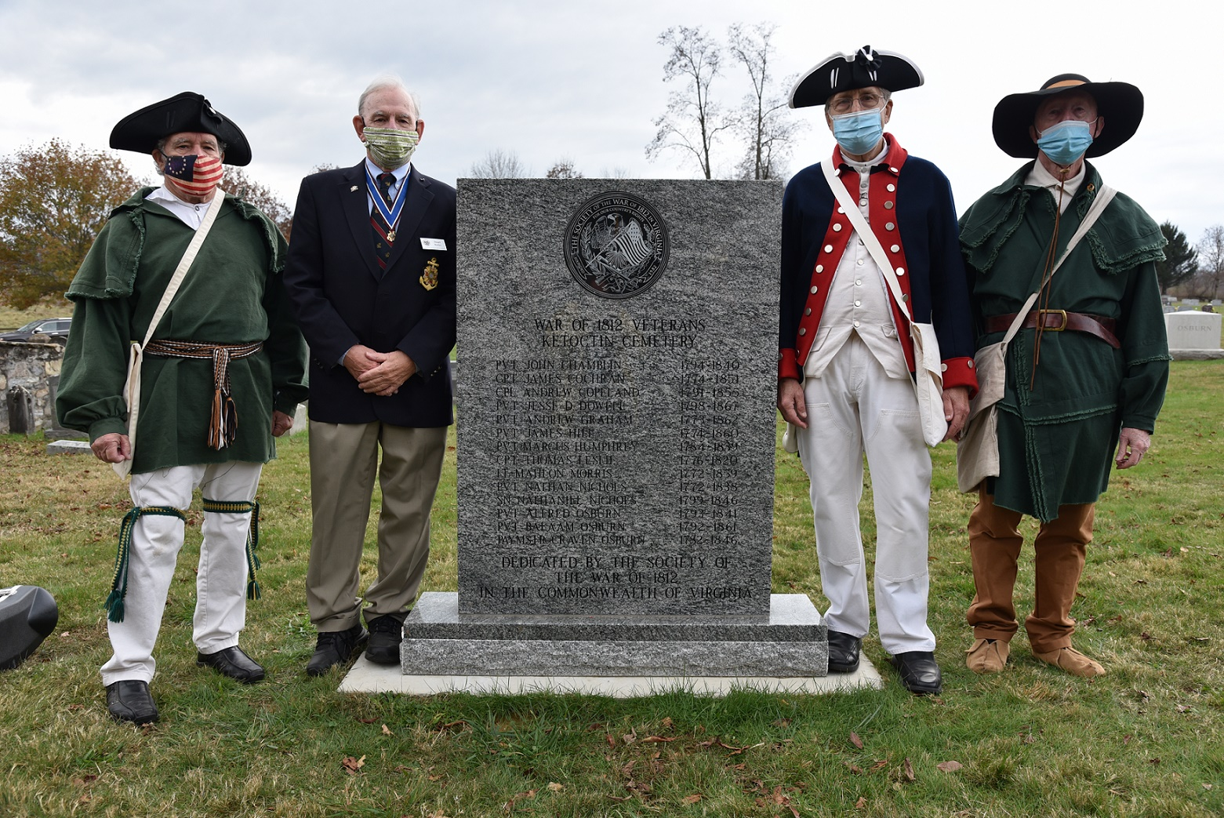
After the unveiling the War of 1812 participants gathered. L/R member Dale Cory, past president Stuart Butler, councilor, Michael Weyler, and past president, Thaddeus Hartman
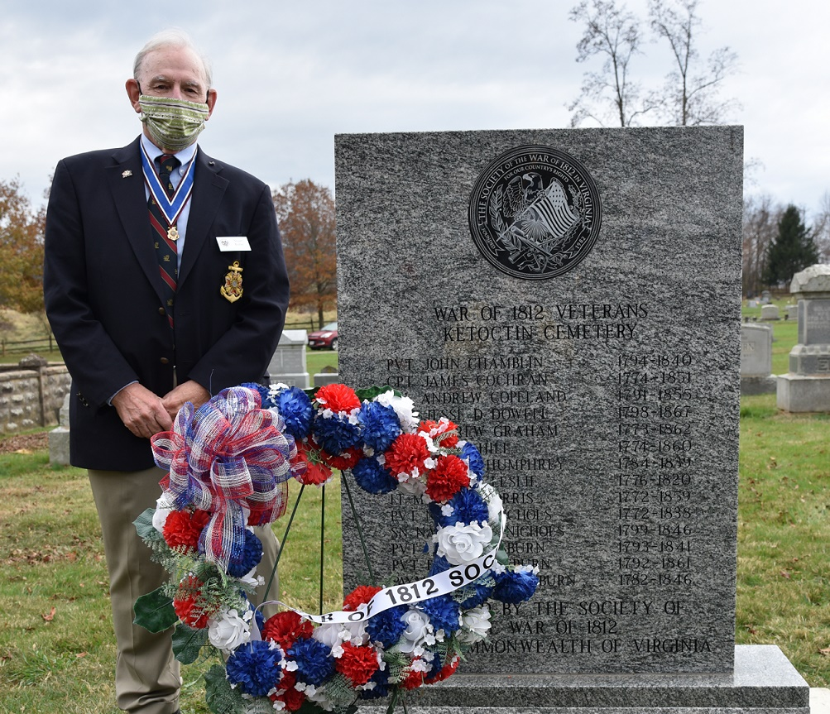
Stuart Butler presents the society wreath
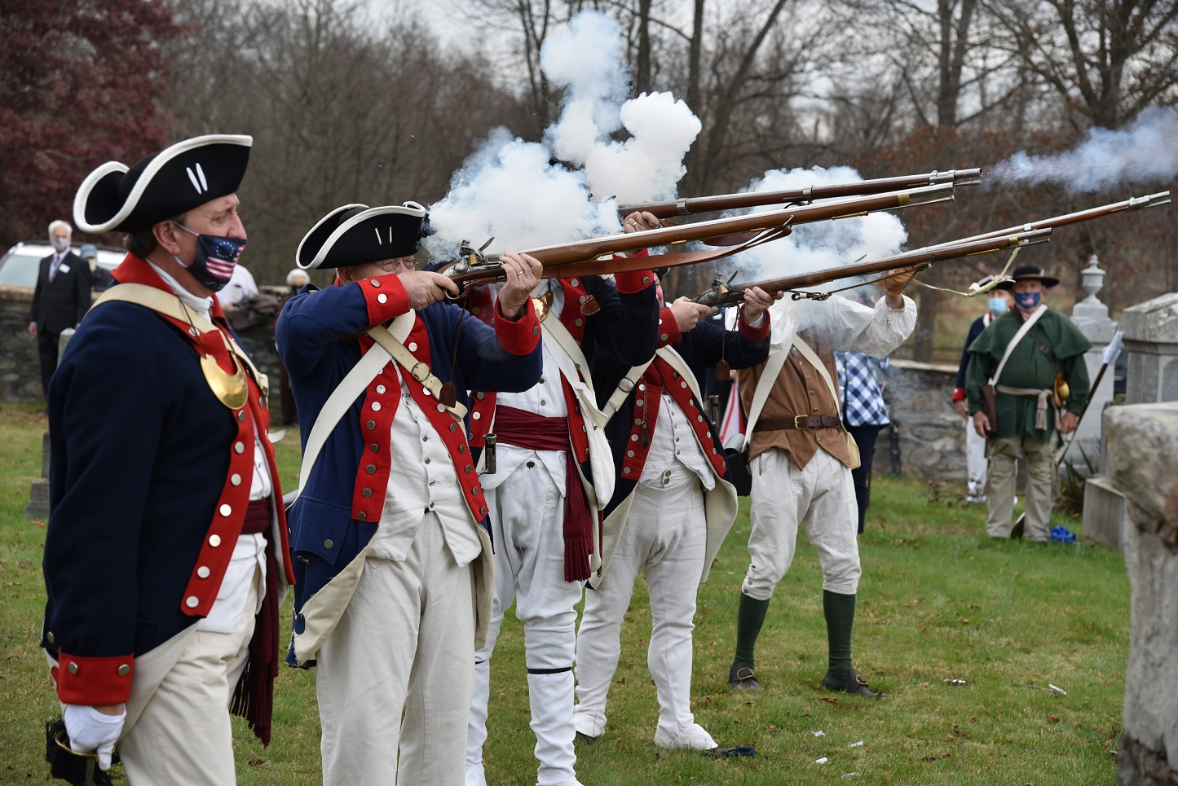
The VASSAR color guard provides the musket salute

