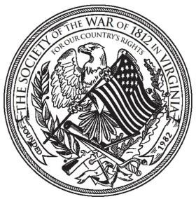
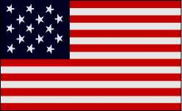
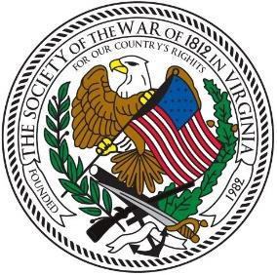
The Virginia War Cry
“EVER FORWARD”

Volume 22, Number 2 [Winter 2020-2021]
Editor: J. Thomas Whetstone

Finding and Preserving History for America

TABLE OF CONTENTS

1 Table of Contents
2-3 President Walden’s Message
4 From the Editor
5 Virginia Society Officers 2020-2022
6-14 Photo Journal
15-17 Minutes July 25, 2020, Board of Directors Meeting
18-19 Minutes September 19. 2020 Zoom Meeting/Muster
20-23 Essay Contest Winner & Essay

Winter 2020-2021 Virginia War Cry page 2

PRESIDENT WALDEN’S MESSAGE

Fellow Virginia Defenders:

I hope everyone has been safe and healthy his past year during this pandemic. I managed to come down with COVID 19 myself in November and fortunately made a full recovery. Despite the social distancing mandate, our society has had an active year.
I was proud to award our annual essay contest award to Jessee Robinson, a student at Light of the World Academy in Dunnsville, who wrote an essay on James Madison. We are continuing our essay contest in 2021 with the topic remaining Virginians who played a role in the War of 1812. It is open to high school students in Virginia and West Virginia, and details are on the Society website. This is fantastic opportunity to encourage scholarship of the War, which surprisingly many people know little about. So, please spread the word to any high school students in your family or neighborhood.
Due to the COVID-19 pandemic, the society met twice this summer and fall via ZOOM. On July 25, the Board of Direction met and elected the following officers for the 2020-22 term: President, Paul Walden; 1st Vice President, James Green; 2nd Vice President, Kenneth Hawkins; Secretary, Jim Russell; Treasurer, Shane Newcombe; Historian, Peter Broadbent; Legal Counsel; Carter Furr; Registrar, Hugh Markham; Vice President General-National Society, Stuart Butler; and Councilors: Mike Weyler, John Epperly, Bill Collier, John Whetstone, and Charles Belfield. The Fall Muster was also held via ZOOM on September 19 where the 2020-21 slate of officers was ratified by the general membership.
On November 4, I presented a poster describing the service of five patriots of the American Revolution and two of the War of 1812 to the Local History and Special Collections Room in the Kate Waller Barrett Branch of the Alexandria Public Library. This was the result of several discussions on placing a plaque memorializing these patriots on the library grounds; however we were unable to obtain permission to do so. As a consolation, we offered to place a poster in the library memorializing these patriots in time for Veterans Day. The War of 1812 patriots interred at the site are John Morgan and Thomas Smith.
On November 21, 2020, several members of the Virginia Society of the War of 1812 participated in a joint grave marking with the Virginia Society Sons of the American Revolution honoring 32 veterans of the War of 1812 and 14 veterans of the American Revolution interred at the Ketoctin Baptist Church in Loudoun County, Virginia. Stuart Butler, Vice President General of the Society of the War of 1812 in Virginia, presented a wreath and unveiled the marker. He and Defender Bill Collier read the names of the War of 1812 Veterans. Due the current COVID 19 restrictions, there was a limited attendance at the service. However, the ceremony was taped and is available online at http://1812va.org/. Our society appreciates the work Mike Lyman and Thad Hartman did in researching these burials and the ground work involved in ordering the beautiful monument placed there. I had the honor myself of spending a couple of very cold Saturdays this past winter on my hands and knees trying to read the tombstone inscriptions.
On December 5, a virtual commemoration of the Battle of Great Bridge was conducted by the Great Bridge Chapter, NSDAR and the Norfolk Chapter, Virginia SAR. I presented a wreath on behalf of our society. Defender Kenneth Hawkins served as one of the speakers for the ceremony. The Battle of Great Bridge (December 9, 1775) was significant in that the victory of Virginia militia forces led to the departure of Royal

Winter 2020-2021 Virginia War Cry page 3

Governor Dunmore and the British power from the Colony of the Virginia in the early days of the American Revolution.
I am planning to continue our efforts in marking the many graves of War of 1812 veterans in Virginia. The next event will be the monument dedication at Ebenezer Church in Loudoun County that we had to postpone due to the pandemic restrictions. It is surprising how many of these veterans’ gravesites are unmarked and in some cases, in jeopardy of being lost to time and neglect. In fact, I recently located one in the back yard of a home in my neighborhood. I have been unsuccessful so far however in contacting the home owner to get permission to mark this grave.
Thank you again for your support and patriotism, and my sincere wishes that 2021 will be a better year for all of us.

Fraternally,

Paul Walden
President
Society of the War of 1812 in the Commonwealth of Virginia

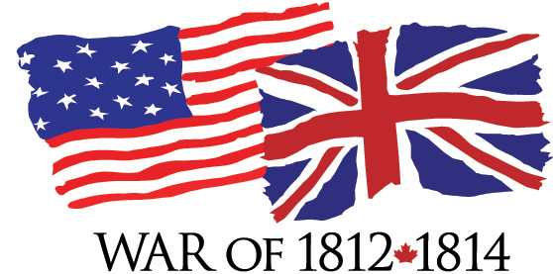

Winter 2020-2021 Virginia War Cry page 4

FROM THE EDITOR
We hope you find this issue of interest and value. Please send me any suggestions for future improvement. Since our last newsletter, the plague of COVID-19 has required cancellation of many of our ceremonies although we did have productive meetings online via Zoom on July 25 and September 19. The Photo Journal, drawing on the monthly website postings of Mike Lyman, documents our activities since last summer. Reviewing these and previous issues can remind and encourage us to resume our patriotic, genealogical, historical, and educational commitments to honor the veterans of the Second American Revolution, the War of 1812.

This newsletter is a fit place to honor your War of 1812 ancestors.

Please send me a description of them and their patriotic service so I can include them in our next Virginia War Cry.

Since no entries were submitted since the last issue, I take advantage of my position to feature another one of my ancestors. If you are wearied of reading about mine, then you should submit information about yours.
William Jackson McDonald was a corporal in Colonel Carson’s Mississippi Regiment of Mounted Infantry, the unit noted for chasing Red Stick Creek Chief Red Eagle (a.k.a. William Weatherford) who fled after the Battle of the Holy Ground (December 23, 1813). When trapped at the Alabama River, the mounted Red Eagle leapt off the bluff (about 15 feet although some said 50-100 feet high) into the river. Rider and horse disappeared under the water, resurfaced, and swam to the far side and safety, amidst a hail of bullets. This incident is known as “Weatherford’s Leap.”

I am a sixth generation descendant of Corporal McDonald, who settled in Greensboro, Alabama after the war. His son William Jackson McDonald, Jr., married Cynthia Ann Madison, daughter of Peyton Madison, who fought at the Battle of Horseshoe Bend.

J. Thomas Whetstone, D.Phil.

Editor (757) 482-2893, twhetstone1@cox.net

Winter 2020-2021 Virginia War Cry page 5

Finding and Preserving History for America

OFFICERS 2020-2022
Elected and Installed July 25, 2020

President Paul Walden
First VP James M. Green
Second VP Kenneth Hawkins
Secretary Jim Russell
Treasurer J. Shane Newcombe
Registrar Hugh A. Markham
Historian Peter E. Broadbent Jr.
Quartermaster James Thacker Sr.
Counsel Carter B. S. Furr
VP General Stuart L. Butler

COUNCILORS 2018-2020

Charles Belfield John Thomas (Tom) Whetstone III
William (Bill) Collier Kenneth (Ken) Williamson
John M. Epperly

Winter 2020-2021 Virginia War Cry page 6

Photo Journal

President Walden provides War of 1812 data to library

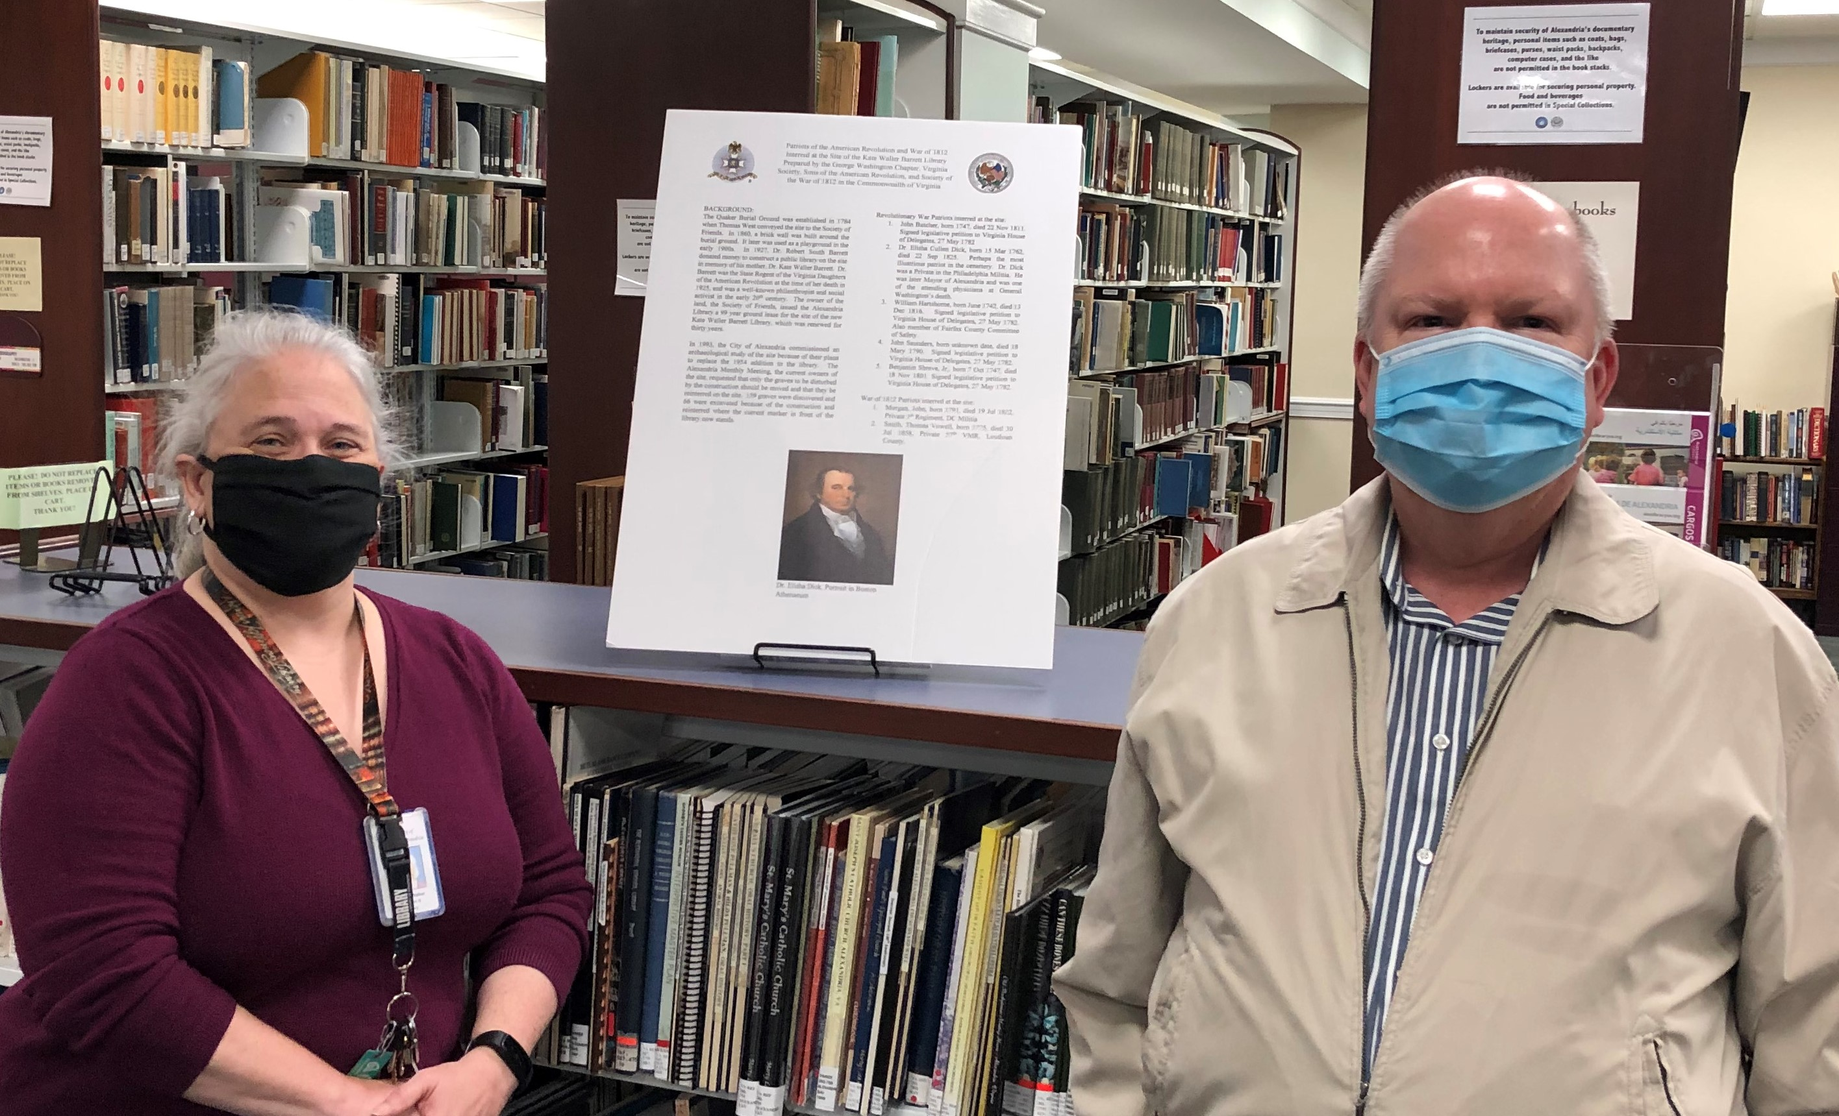

On November 4, Paul Walden, Past President George Washington Chapter VASSAR and current President, Society of the War of 1812 in Virginia, presented a poster describing the service of five patriots of the American Revolution and two of the War of 1812 to the Local History and Special Collections Room in the Kate Waller Barrett Branch of the Alexandria Public Library. This was the result of several discussions on placing a plaque memorializing these patriots on the library grounds; however we were unable to obtain permission to do so. As a consolation, we offered to place a poster in the library memorializing these patriots in time for Veterans Day. The Patriots of the American Revolution who were interred on the library grounds are John Butcher, William Hartshorne, John Saunders, Benjamin Shreve, and perhaps the most famous, Dr. Elisha Dick, one of the attending physicians at General Washington’s death. The War of 1812 patriots interred at the site are John Morgan and Thomas Smith. In the photo, Paul Walden and Ms. Patricia Walker, Local History and Special Collections Branch Manager.
Winter 2020-2021 Virginia War Cry page 7

Ketochin Monument Unveilings

On November 21st 2020 at the Ketoctin Baptist Church cemetery in Loudoun County VA, an unveiling ceremony of two new monuments were conducted. One was for a monument listing Revolutionary War patriots buried in the cemetery and the other was for the listing the War of 1812 veterans interred there. The program and photos taken for the War of 1812 unveiling portion follows.

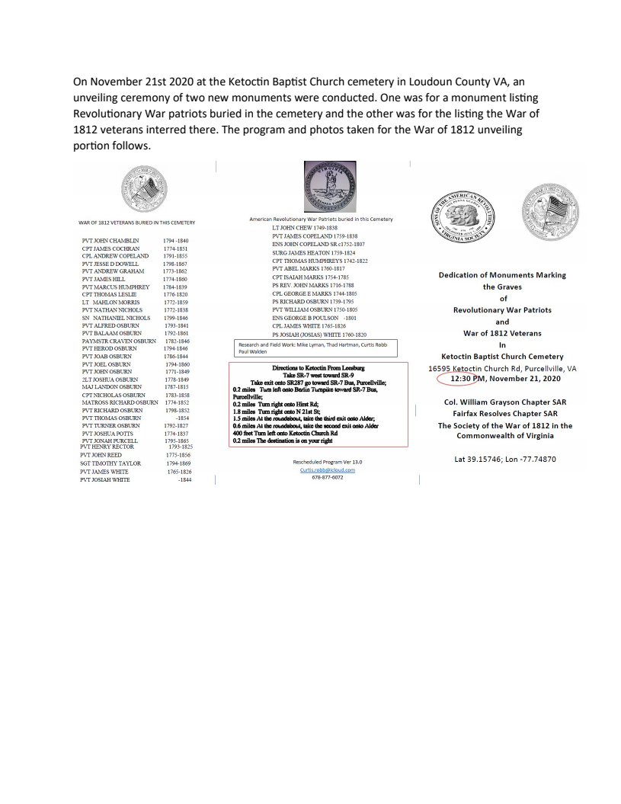

Winter 2020-2021 Virginia War Cry page 8

Ketochin Monument Unveilings (continued)

Immediate Past President of the War of 1812 Virginia Society gives greetings
On the left is War of 1812 member, Curtis Robb, who presided over the ceremony.
On the left is charter member and Past President, Thaddeus Hartman

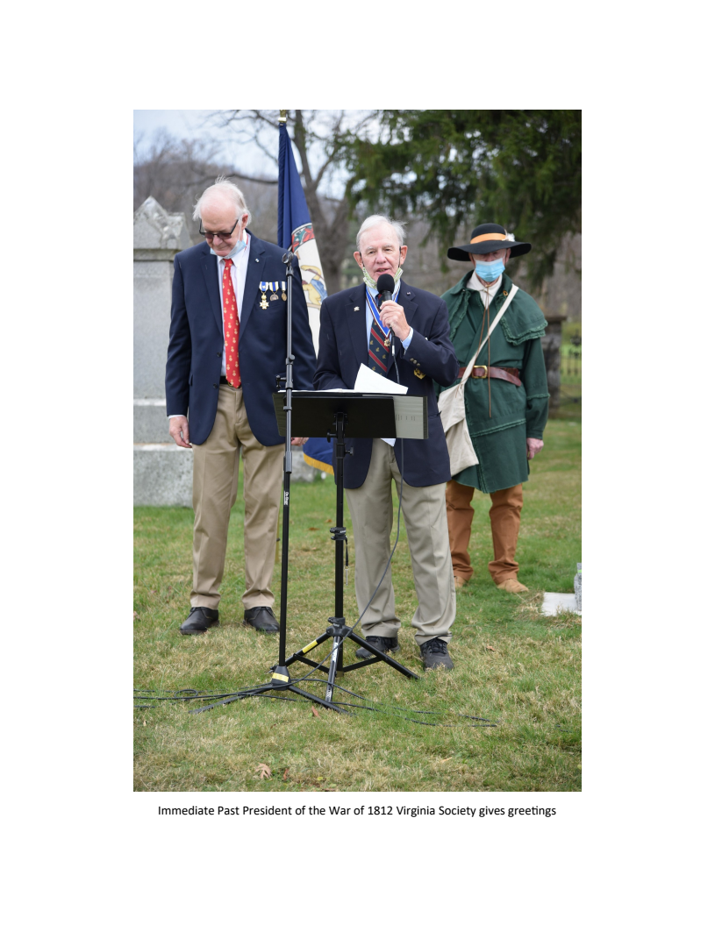

Winter 2020-2021 Virginia War Cry page 9

Ketochin Monument Unveilings (continued)

Introducing a direct descendant is Thad Hartman

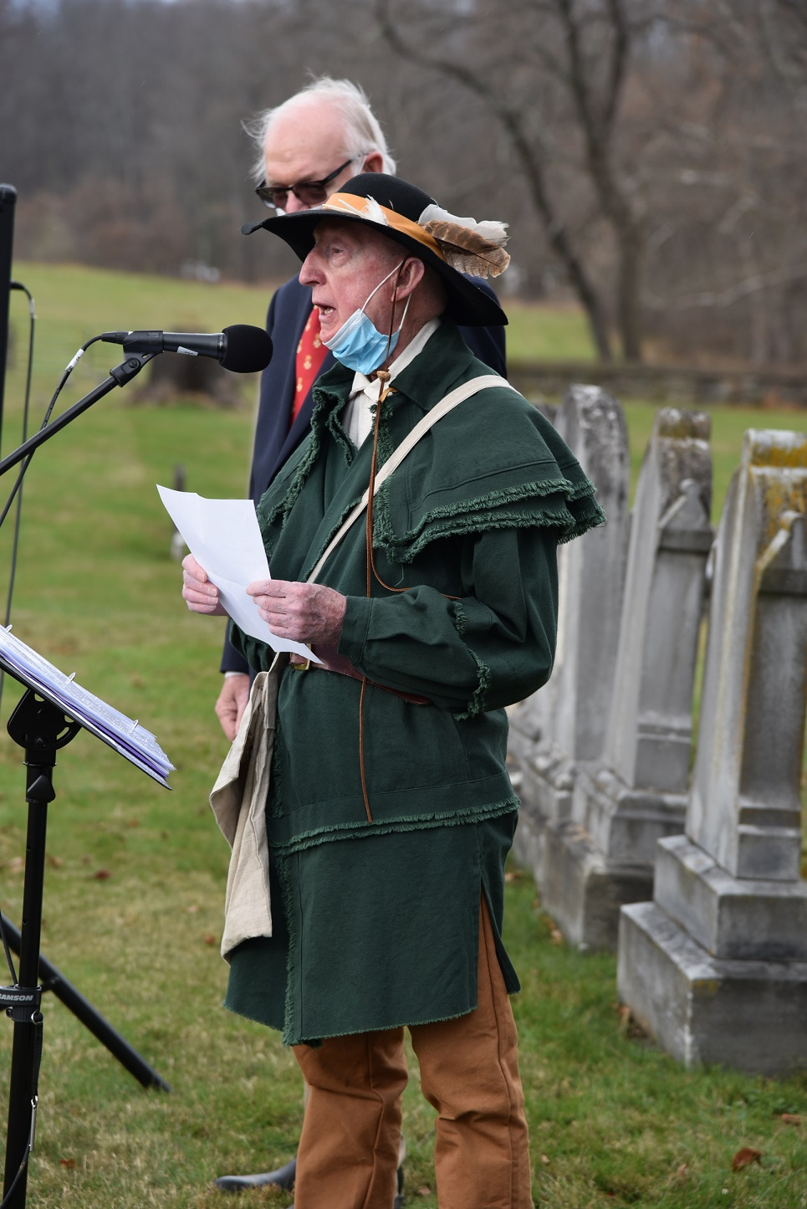

Winter 2020-2021 Virginia War Cry page 10

Ketochin Monument Unveilings (continued)

During the ceremony each War of 1812 veteran’s name is read. On the left William Collier, Councilor of the Society

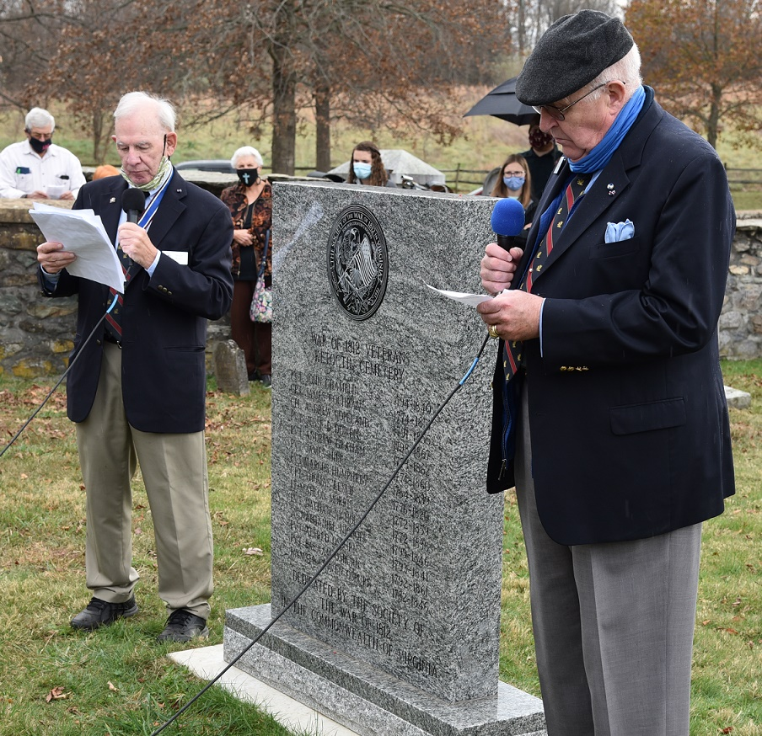

Winter 2020-2021 Virginia War Cry page 11

Ketochin Monument Unveilings (continued)

After the unveiling, the War of 1812 participants gathered. L/R member Dale Cory, past president Stuart Butler, councilor Michael Weyler, and past president, Thaddeus Hartman

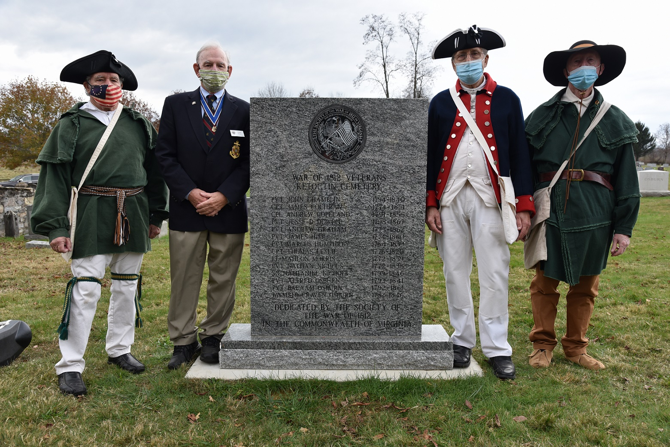

Winter 2020-2021 Virginia War Cry page 12

Ketochin Monument Unveilings (continued)

Stuart Butler presents the society wreath

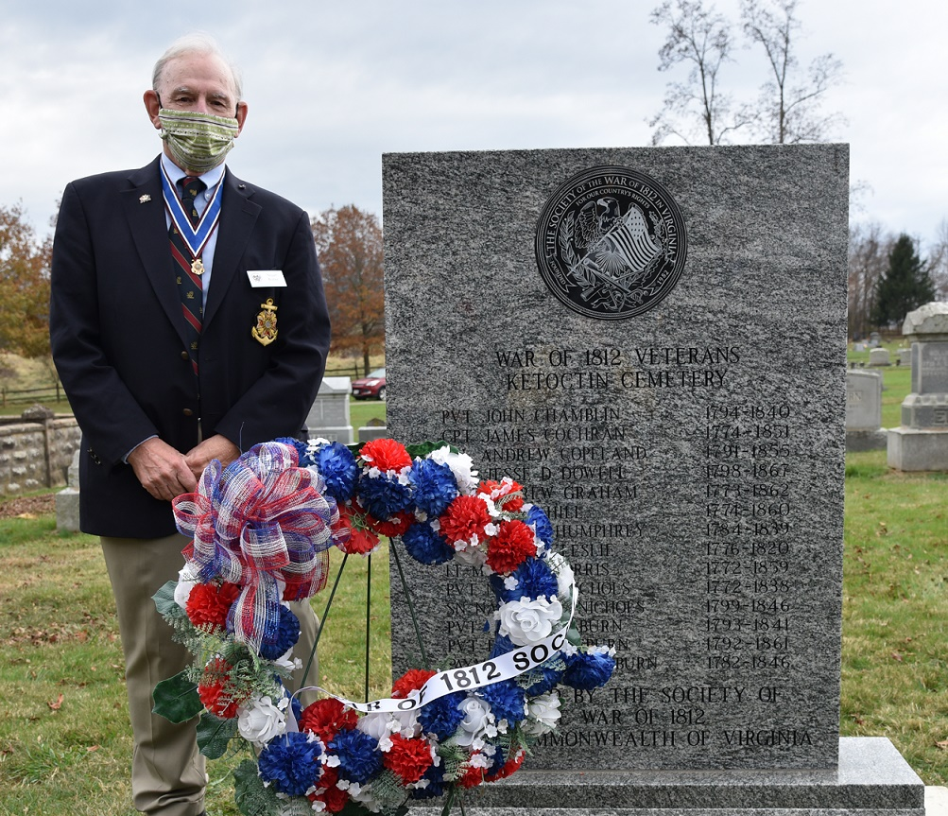

Winter 2020-2021 Virginia War Cry page 13

Ketochin Monument Unveilings (continued)

The VASSAR color guard provides the musket salute

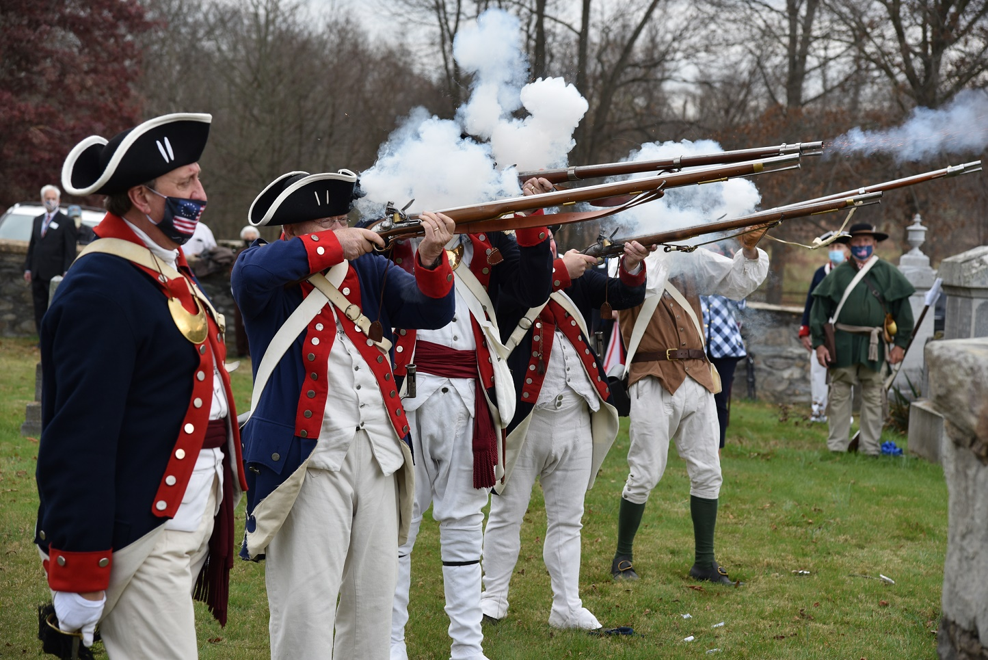

Winter 2020-2021 Virginia War Cry page 14

President Paul Walden gave greetings and presented the Society of the War of 1812 wreath during the Zoom Commemoration of the 1775 Battle of Great Bridge.

Winter 2020-2021 Virginia War Cry page 15
SOCIETY OF THE WAR OF 1812 IN THE COMMONWEALTH OF VIRGINIA

Minutes
Board of Direction Meeting 10:00 am, July 25, 2020
ZOOM meeting

- Due to the current COVID 19 pandemic, the meeting was held virtually via ZOOM. Meeting was called to order by President Stuart Butler at 10:00 am with 13 BOD members in attendance: Stuart Butler, Paul Walden, Charles Belfield, Hugh Markham, Mike Weyler, James Green, Tom Whetstone, William Collier, Thad Hartman, Kenneth Hawkins, Bob Vogler, Mike Lyman, and Dennis Fritts.
- Invocation was given by Chaplain Paul Walden
- Pledge of Allegiance to the Flag led by Mike Weyler
- Stuart Butler moved, Seconded by Paul Walden, to waive the reading of the minutes from the February BOD meeting. Motion passed.
- Officer Reports
  - President Stuart Butler
    - Report submitted and made a part of these minutes
  - pt Vice President, Quartermaster, and Treasurer Shane Newcombe
    - Absent; however report submitted and incorporated in these minutes
  - 2nd Vice President James Green
    - Report submitted and made a part of these minutes
    - Responded to an inquiry via our Facebook page regarding a War of 1812 question
  - Registrar Hugh Markham
    - Report submitted and incorporated in these minutes
  - Chaplain's Report, Paul Walden
    - Two member deaths: John Burch (June) and Edward Trexler (May 12)
    - Condolence cards were sent to their families
  - Secretary Paul Walden
    - Report submitted and incorporated in these minutes
  - Essay Contest, Paul Walden
    - One entry was received from Jesse Robinson from Light of the World Academy, Dunnsville, VA. Essay judges John Walenta, Dennis Fritts, and Charles Belfield agreed to give this student the first place prize
    - Charles Belfield, since he lives in the area, agreed to present the check and certificate to the student at an assembly when school reconvenes
Historian Peter Broadbent,
    - Report submitted and incorporated in these minutes

Winter 2020-2021 Virginia War Cry page 16

Minutes July 25, 2020 BOD Meeting (continued)

  - Color Guard Chairman, Charles Belfield
    - No Color Guard activities due to the COVID pandemic
    - Uniform for new Color Guard Jim Russell is complete
    - There was a discussion about the polyester uniforms worn by Color Guard may present a bum hazard during musket firings. Would wool uniforms be safer?
  - Publications Chair and Grave Marking Chair: Mike Lyman
    - Report submitted and incorporated in these minutes
    - Mike has completed the compilation of War of 1812 in graves in VA in one list which will be sent to BOD
    - Thad Hartman reported Ebenezer plaque is installed. Ketoctin stone monument is scheduled for delivery sometime in late October. He is in the process of confirming the delivery date as COVID 19 caused the processing plant in India to close. The grave markings are scheduled for Nov 21. Thad also gave a copy of the graves addendum to the Prince William County Relic Library
  - Newsletter Chair, Tom Whetstone
    - Tom was thanked for taking on this task
    - He is requesting articles and photos for inclusion in the newsletter
    - Tom is speaking to a Daughters of the War of 1812 meeting in the Norfolk area.

- Old Business
  - ROTC program, Stuart Butler
    - All programs are on hold due to the colleges being closed due to COVID
- New Business
  - Audit Committee
    - Ken Williamson and Bill Nash completed their audit in March. No errors were found and the result was a clean audit. Only suggestion made was that deposits be made to coincide with the recordation date.
  - Election and Installation of Officers
    - The following slate was approved at the February 2020 meeting
    - A motion was made by Thad Hartman, Seconded by Dennis Fritts, to elect the following officers. Motion passed. The 2020-22 Officers were then duly installed by President Butler:
      - President, Paul Walden
      - 1st VP, James Green,
      - 2nd VP, Kenneth Hawkins
      - Secretary, Jim Russell
      - Treasurer: Shane Newcombe
      - Historian: Peter Broadbent
      - Legal Council: Carter Furr
      - Registrar: Hugh Markham
Winter 2020-2021 Virginia War Cry page 17

Minutes July 25, 2020 BOD Meeting (continued)

      - Vice President General (National Society): Stuart Butler

- Fall meeting tentatively scheduled to coincide with the SAR Fall meeting on Sep 27 at South Boston, VA. Given the pandemic situation, we may wish to have our own meeting separately.
- Paul Walden gave the benediction
- Motion to adjourn made by Mike Weyler, Seconded by Dennis Fritts: Motion passed. Meeting was adjourned at 11:10 am

Respectfully submitted,
/J .
,,.A 1,lf/
Paul Walden Secretary

Winter 2020-2021 Virginia War Cry page 18

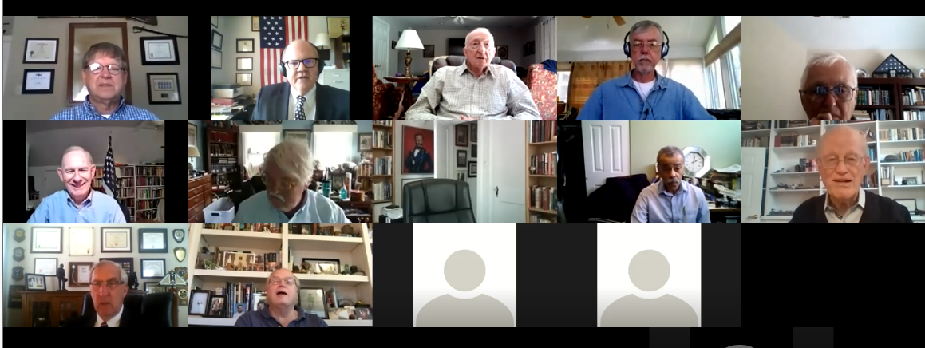

Minutes of the Board of Directors Meeting/Fall Muster

September 19, 2020

Meeting Held Using Zoom

The Society President Paul Walden called the Meeting to order at 2:00 PM using “ZOOM” as the platform for the Society’s electronic meeting.
President Walden proceeded with a roll call of participants and found a quorum present. The establishment of a quorum allows for the Board of Directors of the Society to conduct business in accord with our By-Laws.
President Walden asked our Chaplain, Thad Hartman, to give the invocation.
Our Past President Stuart Butler was called on to lead us in The Pledge of Allegiance.
President Walden opened the business meeting by asking for the Reports from all officers.
Each officer submitted their reports to the Secretary prior to the meeting and the written reports will be include as a part of the minutes of this meeting. The following officers did not give a report: Secretary, Chaplain, and Historian.

President Walden asked for Standing Committee Chairs to provide reports.
Mike Lyman , although not present, provided a report on Publications and Grave Marking.
After the report there ensued a brief discussion about current plans for grave marking with particular attention being called to the War of 1812 Veterans interred at the Alexandria Pubic Library sit (the former Quaker Cemetery), and Shockoe Cemetery. Jeffry Burden mentioned the number of veteran buried in the Shockoe Cemetery is possibly the largest of anywhere in the country.
President Walden wondered if anyone had knowledge of the National Society providing financial aide for grave marking and Thad Hartman confirmed that they had provided funds in the past for grave markings.
Winter 2020-2021 Virginia War Cry page 19
Minutes of September 19. 2020 Meeting (continued)

The Board unanimously approved the motion made by Stuart Butler and seconded by Paul Walden to continue the Society of the War of 1812 sponsorship of a essay contest with a first prize award of $500.00 and a second prize award of $250.00.
The Board unanimously approved the motion made by Stuart Butler and seconded by Paul Walden to continue the sponsorship of the ROTC Award where there are active ROTC programs. Stuart Butler volunteered to chair the ROTC Award program.
The President called for any other matter(s) under Old Business to come before the Board. Hearing none we moved on to New Business.

Under new business the first item was the approval of the 2020-2022 slate of Officers and Members of the Council.
President Walden read the slate as follows:
- President – Paul Walden
- 1st VP, - James Green
- 2nd VP, - Kenneth Hawkins
- Secretary, - Jim Russell
- Treasurer, - Shane Newcombe
- Historian, - Peter Broadbent
- Legal Council, - Carter Furr
- Registrar, - Hugh Markam
Councilors: Mike Weyler, John Epperly, Bill Collier, John Whetstone, and Charles Belfield
President Walden then asked for a motion to approve the slate as presented. The motion was made by Carter Furr, and seconded by Charles Belfield. The membership voted unanimously to approve the slate as presented.

Our Chaplain gave the Benediction
President Walden asked for a motion to adjourn
Carter Furr so moved and a second was provided by Kenneth Hawkins
The Meeting was adjourned at 2:55 PM.

Winter 2020-2021 Virginia War Cry page 20

Essay Contest Winner

Jessie Robinson is a senior and honor roll student of Light of the World Academy, Dunnsville, Virginia. He plans to pursue a degree in Agribusiness at Rappahannock Community College.
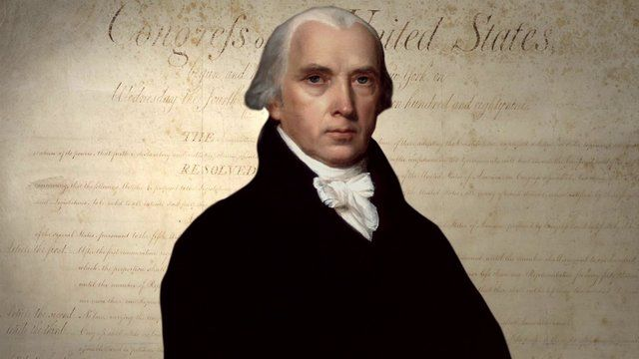

Great Little Man
By Jessie Robinson

For generations there have been many who were born for a purpose, but few would have been able to fill the shoes of a man named James Madison. Being one of the most well known and brilliant men of his time, James Madison was not only a signer of the Declaration of Independence, but also a voice to make it heard throughout the world; America was built on freedom. Though he was small in stature and weak at times from illnesses, his legacy is our great United States of America. Without Madison our country may never have flourished. If Madison, when president, had not stepped in but had let the country go in the direction it was going, towards division, we may never have become the most powerful nation on Earth.
James Madison, a quiet, soft-spoken, and somewhat feeble man proved that, though small, he could lead a growing nation through struggle and adversity and turn it into a great and confident nation.
Winter 2020-2021 Virginia War Cry page 21
Winning Essay (continued)
He was born, March 16, 1751, in Port Conway, Virginia. He grew up in Orange County, Virginia on a plantation called Montpelier. Being the oldest of twelve children and being the son of a wealthy plantation owner, (also named James) and a smart and involved mother named Eleanor (Nelly) Rose Conway, a lot was expected of James. Madison tended to be a rather sickly child therefore, his parents gave him a private education until he attended Princeton University in New Jersey as a young adult. On his return to Virginia, Madison would prove an influential and prominent figure, much like his father. He worked on the safety of the citizens of Orange County and later he became a colonel in the Virginia militia in 1775. In 1776 James Madison, having been chosen as a representative of Orange County, joined the Virginia Convention and along with his new found friend, Thomas Jefferson, put his penmanship to work. Madison would also handle most of France's involvement in the Revolutionary War; giving aid to George Washington and the American cause, which without France, the colonists may have surely lost. After victory in the Revolution Madison would go on to serve as a Virginia delegate to the Continental Congress in 1780. During the following years Madison fought for religious freedoms, freedom of speech, and a strong central government. He created the three branches of government (executive, legislative, and judicial) that we know today in order to have a set of checks and balances to keep any one governing body from having too much power. Many of these issues were addressed in the Constitution written by James Madison. Madison later was known as the Father of the Constitution. He also was a driving force for the Bill of Rights and his influence had a great impact. However; James, became tired of political issues after serving in politics for over 20 years so he returned to Montpelier in 1797 with his wife Dolley whom he had met and married in 1794. He would later inherit Montpelier in 1801 after the death of his father, though he returned to politics as the Secretary of State under Thomas Jefferson, elected as third president that year. (Biography.com editors)
Great Britain who had been a great affliction to America since the Revolution, came roaring back into the picture during James Madison's tenure as Secretary of State. Britain was at war with France and was seizing American trade ships and making the sailors fight for them, meaning the French would not receive supplies or men from the states. Sadly, Madison was getting ready to fight his greatest battle at age 63. Little did he know that he would be the one in command. (Joy Hakim, 77)
After beating Federalist candidate Charles Pinckney, President James Madison, in his inaugural address, admitted he had received a situation "full of difficulties". After Thomas Jefferson promoted the Embargo Act with Madison' s help in 1807 American ships stoppedleaving for foreign ports. In 1809, at the end of Thomas Jefferson' s second term, the Non Intercourse Act was passed by Congress allowing trade to commence except to Britain and France. This measure however, stiU proved unsuccessful and James Madison had to deal with the backlash from

Winter 2020-2021 Virginia War Cry page 22
Winning Essay (continued)
all sides. With Madison making the poor decision of not creating a stronger Navy after being elected President in 1809, Americans began questioning his leadership as the fourth President of the United States.Ignoring the President's threat to declare war on them, Great Britain continued in their seizing of American ships. This led to Madison's declaration of war on June 1, 1812 against Great Britain. On June 5, 1812, the House of Representatives voted for war, 79 to 49 and the Senate, in turn, voted in favor of the war 19 to 13, as well, bringing about the Second Great War for Independence. With war on the horizon the British simply wished to avoid conflict and so they stopped interfering with American ships for a while, even though it was too late. The U.S. was already preparing to take on the British Army. In need of allies to fight the American colonies, the British convinced certain Native American tribes' leaders, like Tecumseh and his half-brother , Tenskwatawa to fight on their side against the Americans. The result however, for Tecumseh and his half-brother was a terrible defeat at the Battle of Tippecanoe, where William Henry Harrison and his 1,000 troops defeated their army.
The war would proceed on three fronts; the Northern front being between Michigan and Canada, the Southern Front reaching from Florida to Louisiana, and the Central front being in the Chesapeake Bay directly across :from the District of Columbia. At one point in the war, James Madison, after seeing the U.S. Army' s losses to British troops, began to doubt his own army and nearly saw it as " an embarrassing situation" in which the British, who were trying to hold off Napoleon from beating them back at home, were also holding the American army at bay. (David Emory Shi 244-257)
With Americans in doubt of his leadership, Madison would successfully lead the U.S. through a tumultuous time. With criticism from every direction, Madison proved he could rise to the occasion. He rode out to meet the ramshackle army waiting for him with two pistols tied around his waist and a large horse that made him look tiny upon its back. Madison tried to rally his men against the might of the British army barreling down on the capitol. His efforts, though seen as being in vain at the time, proved to America that he was a leader. In an effort to destroy American's new found pride, Britain had laid waste to the capitol. However; a giant storm, possibly a hurricane, tore its' way through the British bombarded shores of D.C. and through divine providence liberated the city from complete and utter destruction (Evan Andrews, History.com)
Madison was forced to flee D.C. with his wife, Dolley, who caught up with him later. With Dolley was a portrait of George Washington and the sacred Declaration of Independence. (Miller Center.org)
On September, 13-14, 1814, Francis Scott Key, a lawyer and young writer, composed the "Star Spangled Banner" while in sight of Fort McHenry, Baltimore. On that day a flag stood in the harbor with resilience leaving the British puzzled as to why they could not destroy it. The flag proved that

Winter 2020-2021 Virginia War Cry page 23
Winning Essay (continued)
America would stand its' ground as would freedom.
The British were ready to end the war before Andrew Jackson even got the chance to defend New Orleans, where 2,000 British soldiers were killed and only a dozen Americans died. On December 24, 1814, news arrived of the signing of the Treaty of Ghent. The U.S. had sent five commissioners; including John Quincy Adams, Henry Clay, James A. Bayard, Jonathan Russell, and Albert Gallatin to meet with British ambassadors to discuss peace negotiations in Ghent, Belgium, in order to end the second war for independence. (Jean Fritz 116-141)
Now heralded as a hero, James Madison may have been surprised that after such defeat in the capitol city, the Americans had won the war. With the help of Commodore Oliver Perry, in the Great Lakes to the North and Andrew Jackson, dismantling the British in the South the victory was sealed. The Union had been saved and so had America. With all of the dividing factions at work, James Madison was able to withstand all of the pressure against him and the war that raged around him. The war may have been prevented if it were not for Madison, but his decision to declare war would shape America's self-identity and pride in itself and in its' people for generations.
On returning to regular life, after James Monroe's election, Madison would go on to have many great achievements, but his greatest achievement was leading America with a sense of purpose and a new self-confidence that freedom will ring as long as there are people who are willing to defend it, like a small but mighty, James Madison.

Bibliography

Fritz, Jean, The Great Little Madison, Copyright 1989, Publisher the Penguin Group

Hakim, Joy, A History of Us; The New Nation, Copyright 1993 Third Edition, Publisher Oxford University Press

https://millercenter.org/president/james-madison/key-events

https://www.biography.com/us-president/james-madison

https://www.history.com/news/10-things-you-may-not-know-aboutj-ames -madison

Shi, David Emory, America, The Essential Learning Edition, Copyright 2018, Publisher W.W. Norton and Company Inc.
Winter 2020-2021 Virginia War Cry page 24

THE END

