Society Conducts Ceremony at President Tyler’s Gravesite Mar 29, 2021
Wreath Presentation
John Tyler
March 29, 2021
Hollywood Cemetery, 412 South Cherry St, Richmond, VA GPS 37.5337430,-77.4563462
President Paul Walden, President of the War of 1812 Society in the Commonwealth of Virginia presented introductory remarks.
Then he asked the color guard to post the colors? (The colors were presented by Color Guard Commander, Charles Belfield, Registrar, Hugh Markham, and past President, Mike Lyman). He then asked Past Society President Stuart Butler to lead us in the Pledge of Allegiance to the Flag of the United States. (See photo below) He then asked Dr Cheryl Davis, an officer in the James Monroe Chapter, US Daughters of 1812 to sing the National Anthem. (See photos below) He then asked Past President Mike Lyman to discuss the design of the three flags carried by the color guard, the Star Spangled Banner Flag, the Virginia Society War of 1812 Flag and the James City County Regimental Flag (Note the flag carried is a replica of the only Virginia War of 1812 regimental flag that has been found. The original was captured by the British in 1813 when they made incursions up the James River into James City County and into Williamsburg. A photo of the front side was procured from England. From a description obtained from England, the reverse side was prepared by the Virginia society)

Good morning, I am Paul Walden, President of the Society of the War of 1812 in the Commonwealth of Virginia, and we are gathered this morning to honor the memory of John Tyler, our 10th US President and officer in the War of 1812.
John Tyler was born on this date in 1790 in Charles City County, Virginia, the son of John Tyler Sr, a college roommate of Thomas Jefferson. The Tylers were one of the early Virginia families, going back to 17th century Williamsburg.
John Tyler was tutored on the family’s Greenway Plantation and later attended the College of William and Mary. He was admitted to the bar at the premature age of 19 because the judge neglected to ask his age.
At the age of 21 he was elected to represent Charles City County in the House of Delegates. After the British capture of Hampton in 1813, Tyler organized the Charles City Rifles to defend Richmond, which he commanded as captain.

In 1816 he was elected to the US Congress, and later to the Senate in 1827. He became the 10th President of the United States in 1841 when his predecessor Harrison died from a cold he caught during his inauguration a month earlier. Tyler became the first vice president to become president due to the death of his predecessor. His distractors called him the “Accidental President” as a result. Tyler was a strong advocate of state’s rights: he vetoed a bill to establish a National Bank, he also vetoed a tariff bill resulting in the first impeachment resolution introduced by Congress. He was also known for his “log cabin” bill which enabled settlers to claim 160 acres of land before it was offered publicly for sale. When the first state seceded in 1861, Tyler led a compromise movement which failed; he later became a member of the Confederate House of Representatives and died in office in 1862.”

The society of the War of 1812 was chartered in 1842 by actual veterans of the War of 1812. It was reorganized in 1894 to allow descendants of veterans to join the society, after the last veteran serving as society president, died in 1890.”

President Walden: This wreath is dedicated to the memory of President John Tyler, veteran of the War of 1812. (See photo below)
Below is the benediction Walden gave at the end of the ceremony.
“Almighty God, grant us your mercies as we part. In the coming days, help us to reaffirm our roles as citizens of the United States. Keep before us the privations and sacrifices of our ancestors, who freely gave themselves in the cause of liberty and democracy. Endow us with their resolve. Strengthen us as we pledge ourselves to the preservation of the freedoms bestowed by your hand. Amen.”
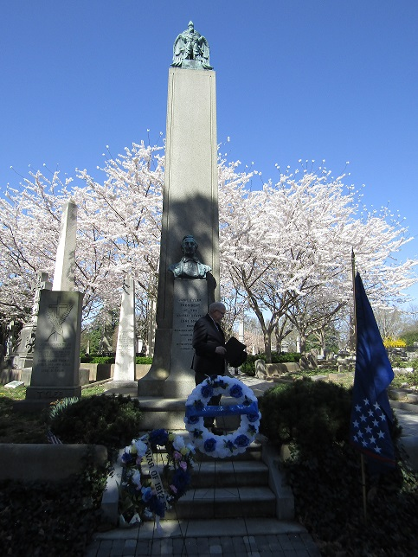
President Tyler’s Monument, Hollywood Cemetery, Richmond
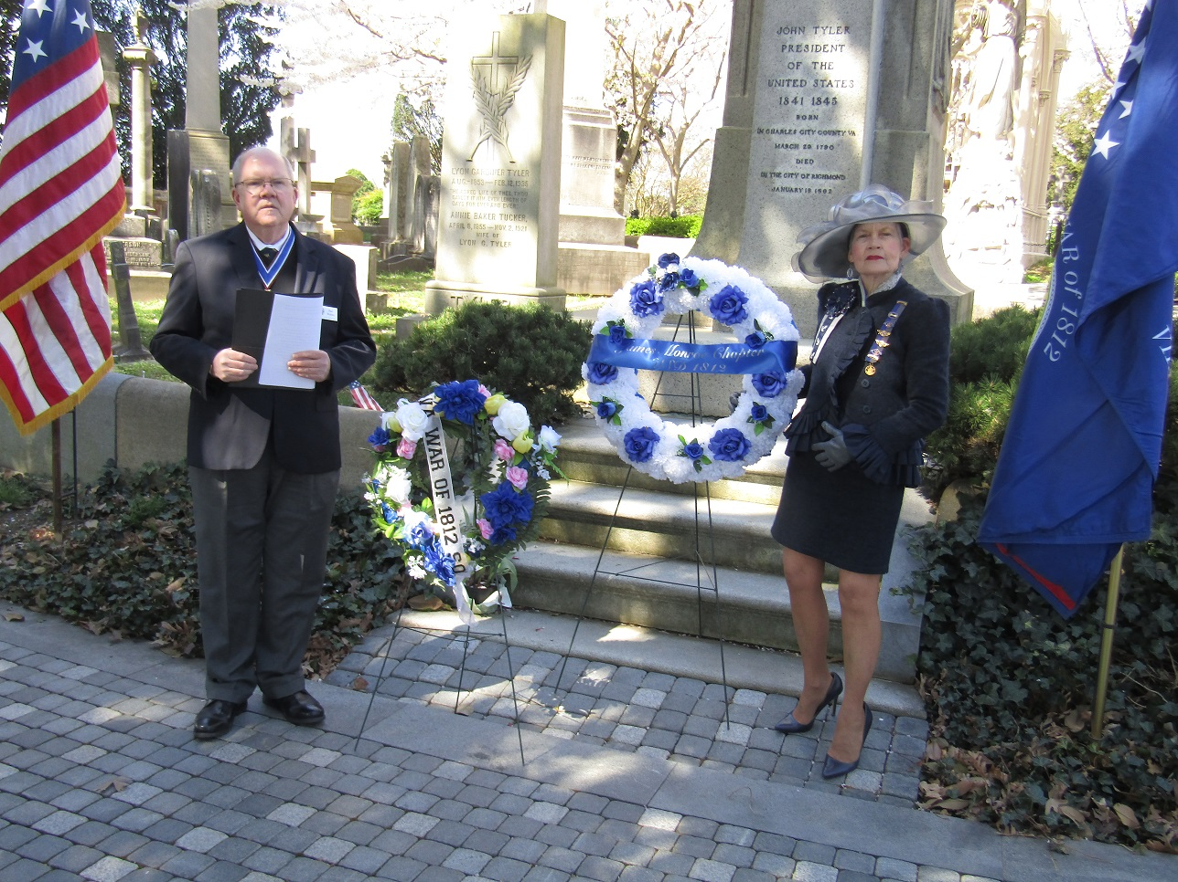
President Paul Walden and Dr Cheryl Davis present wreaths
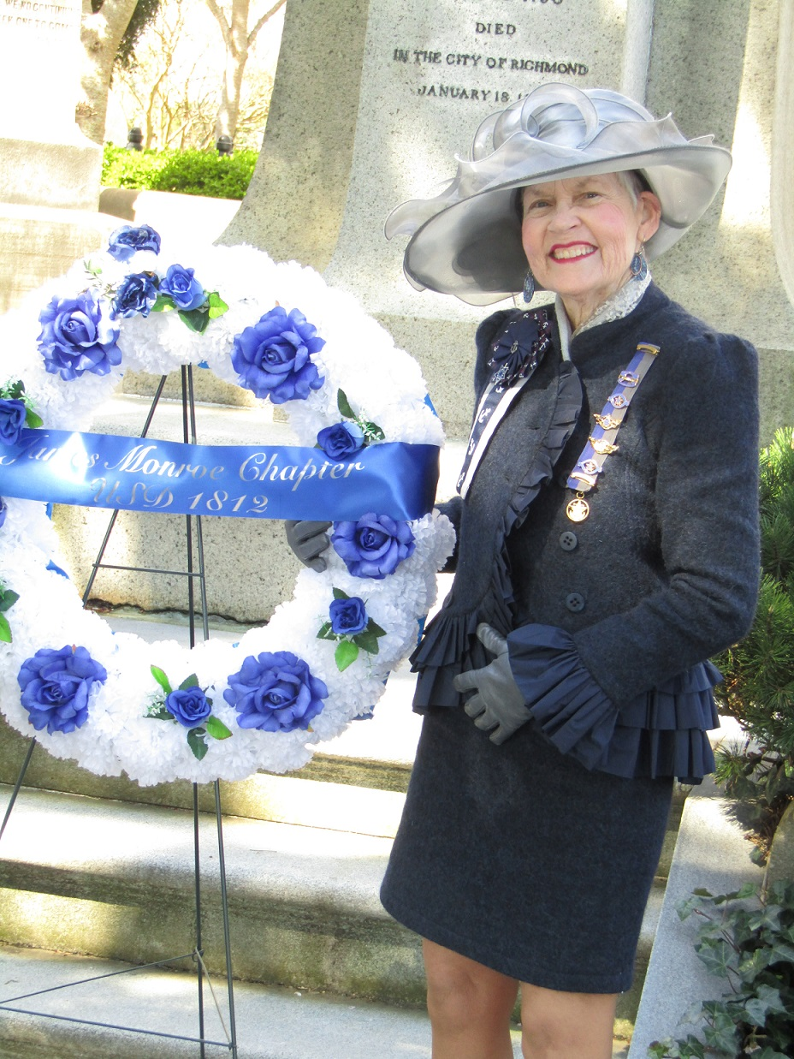
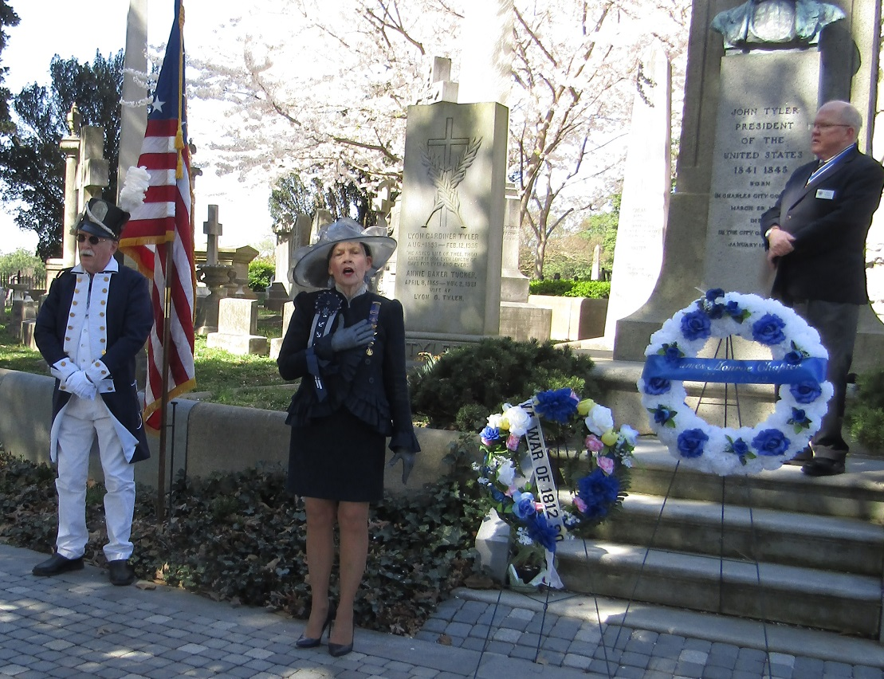
Dr Davis sings National Anthem
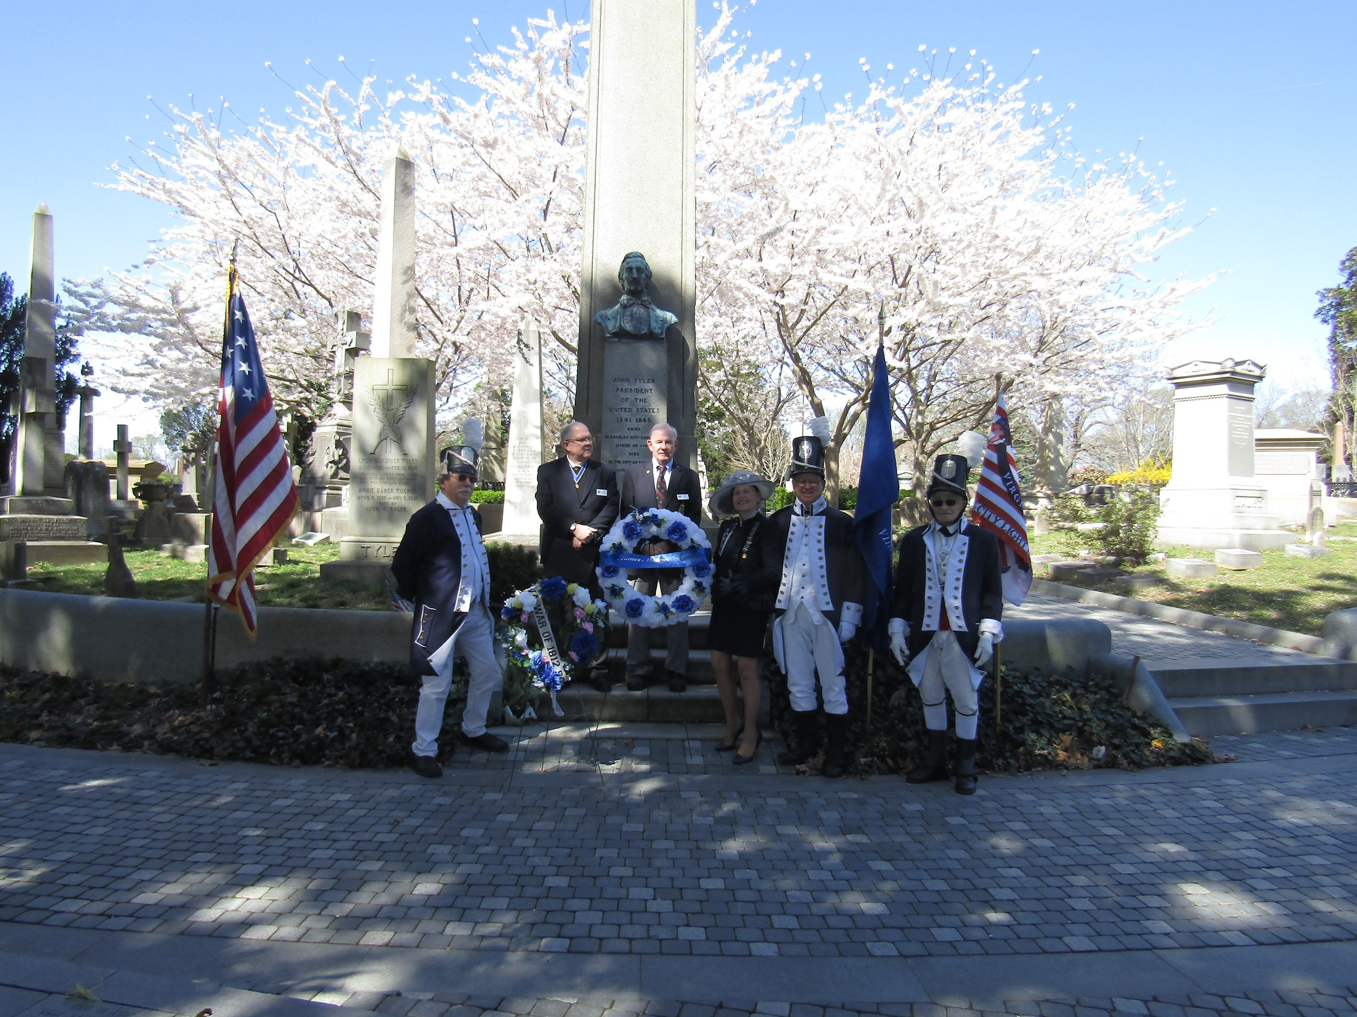
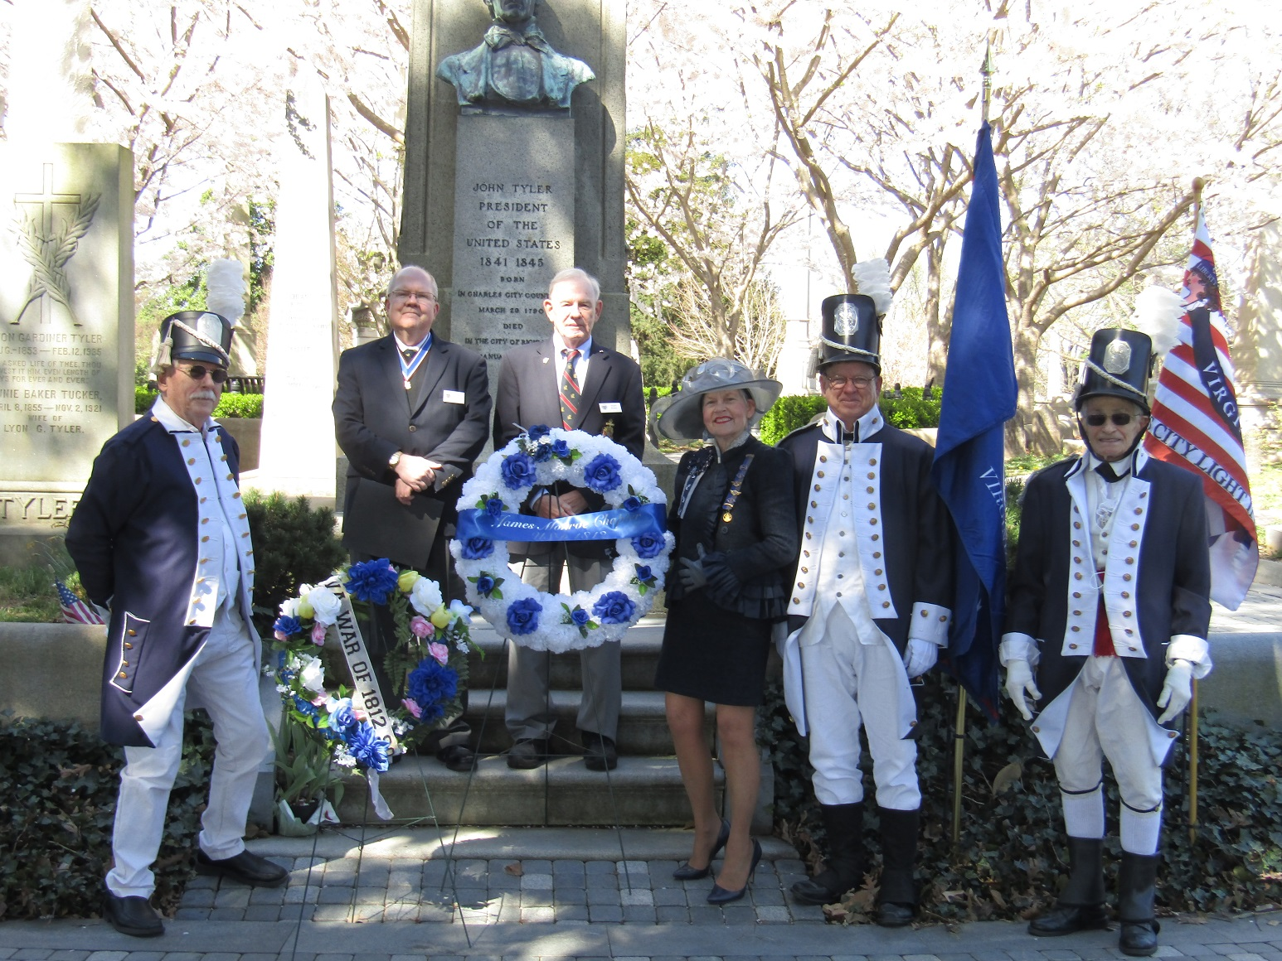
Group photo from left -Hugh Markham, Society Registrar; Paul Walden, President; Stuart Butler, Past President; Dr Cheryl Davis, officer in James Monroe Chapter, US Daughters of 1812; Charles Belfield, Color Guard Commander; and Mike Lyman, Past President
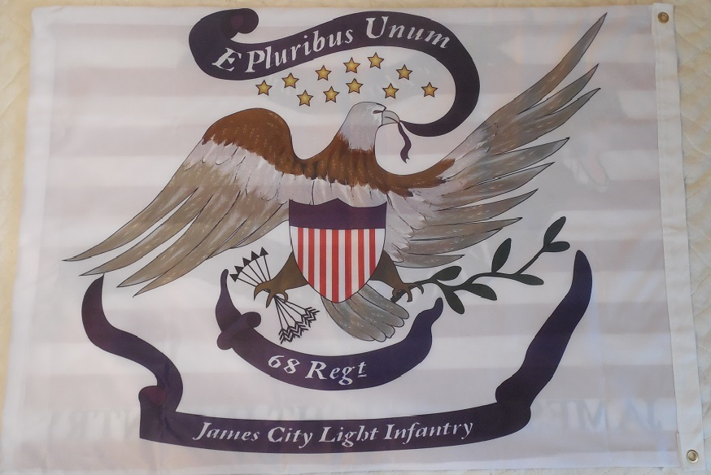
Front side James City County 68th Light Infantry Regimental Flag
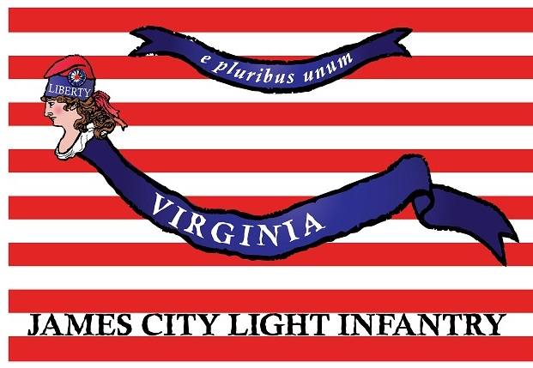
Reverse side of flag

