Society Participates in Event Honoring James Monroe Apr 28 2021
Members of the War of 1812 Society in the Commonwealth of Virginia participated in a ceremony conducted by The Northern Neck of VA Historical Society at James Monroe’s birthplace by presenting a wreath, representing James Monroe and participating in the color guard. The replica birthplace house is located at 4460 James Monroe Highway (Rt 205), Westmoreland County 22443
Below is a photograph taken 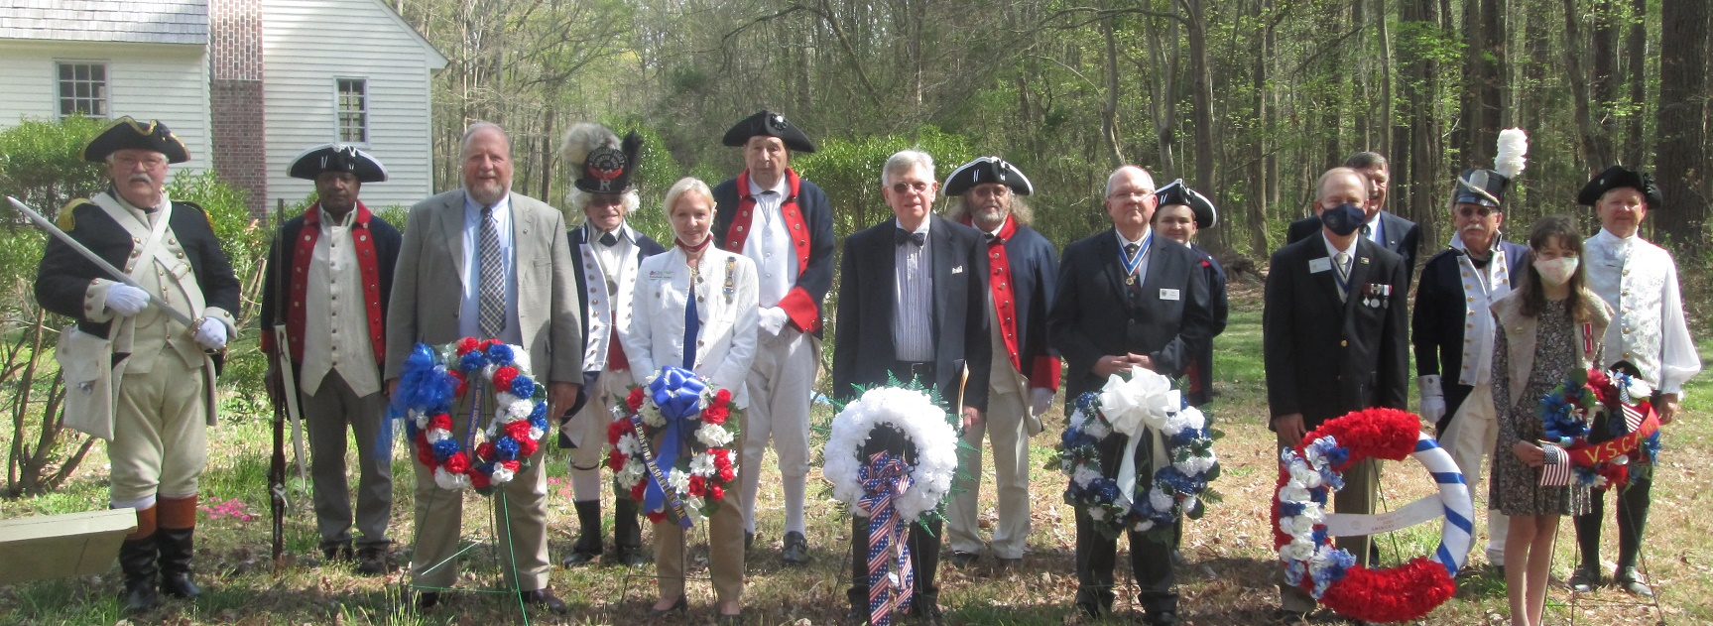
From the left is Jim Russell, Secretary; 4th from the left is Mike Lyman, past president; 9th from the left is Paul Walden, President behind the wreath he presented; 3rd from the right is Hugh Markham, Registrar; and on the right is the main participant, Charles Belfield , Color Guard Chairman who represented Monroe. Behind is a portion of the birthplace replica house.
Some other photos taken of the house and markers at the site are shown
The event was posted on Youtube and may be seen at https://youtu.be/HJyll4Ytrc8
