Society Unveils Cemetery Plaque Listing War of 1812 Veterans May 15 2021
In a joint ceremony with the VA Society Sons of the American Revolution on May 15th 2021 in the Ebenezer Church Cemetery in Bluemont, Loudoun County, the War of 1812 Society in the Commonwealth of Virginia unveiled a plaque listing 24 War of 18122 veterans interred there.
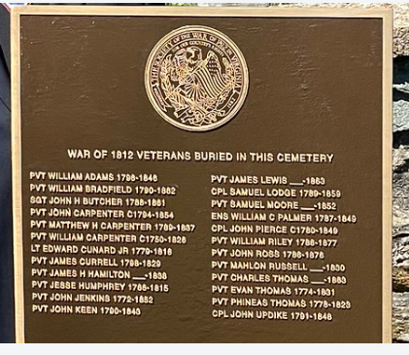
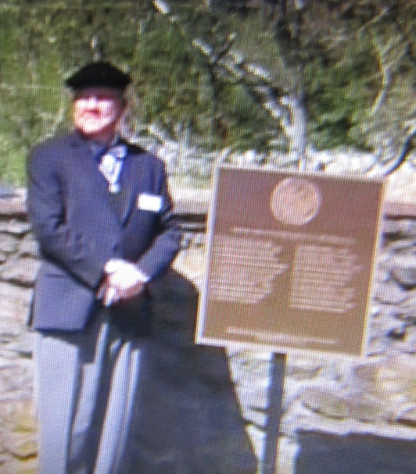
Above President Paul Walden stands by the unveiled plaque
Below he is shown with President Jeff Thomas, VA Society SAR beside the Revolutionary War plaque listing 12 Revolutionary War patriots interred in the cemetery.
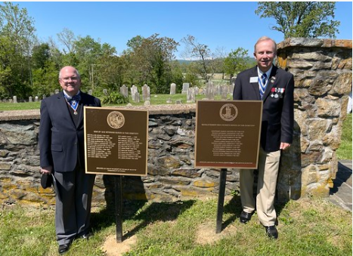
Past president and founding member of the War of 1812 Society in the Commonwealth of Virginia, Thadeus Hartman is shown acting as Master of Ceremony

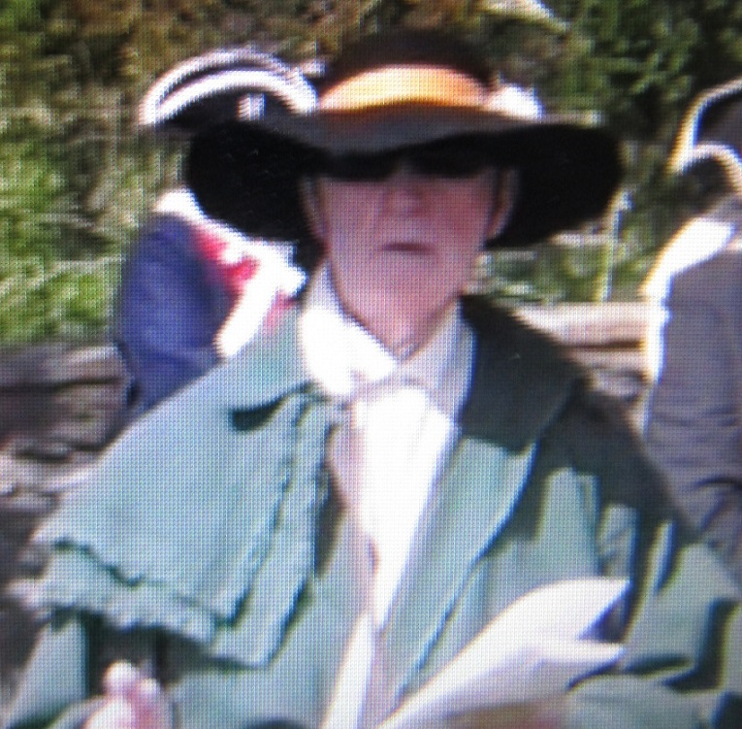
Below President Walden gives greetings and presents the ritual with VASSAR representative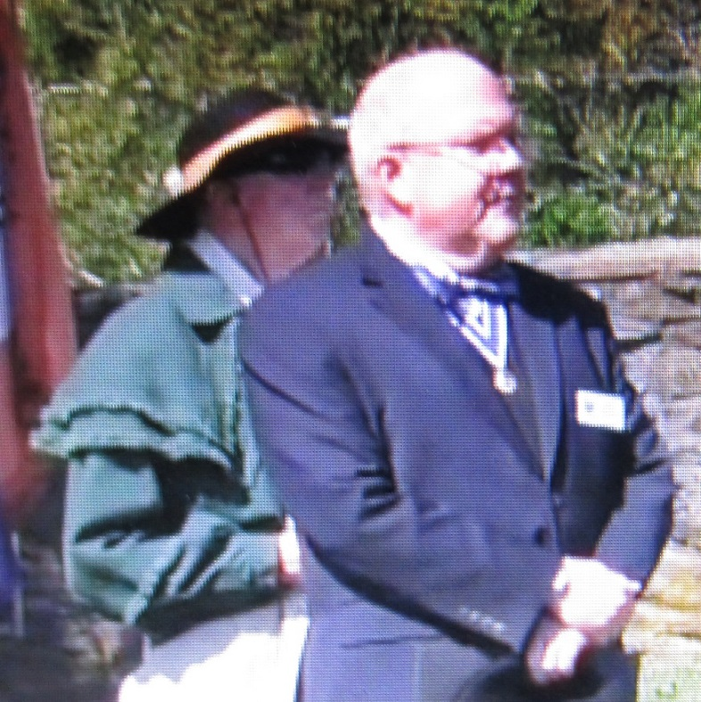
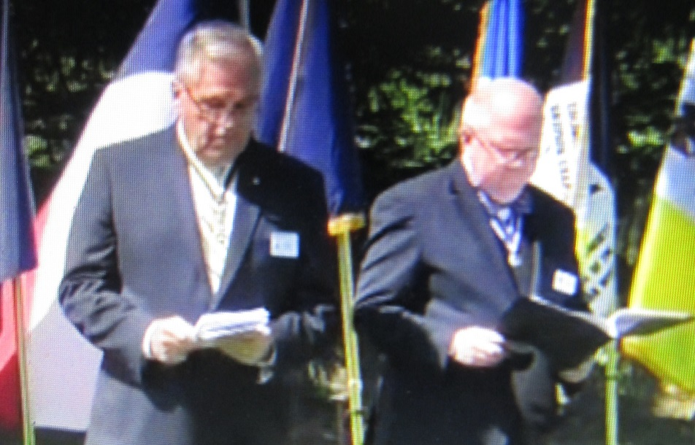
Below the VASSAR Color Guard arrives
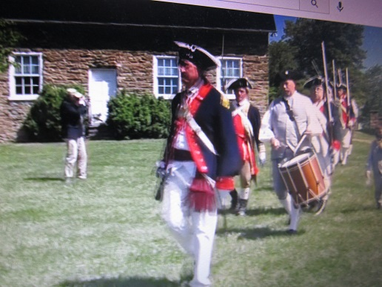
The wreaths that were presented are shown
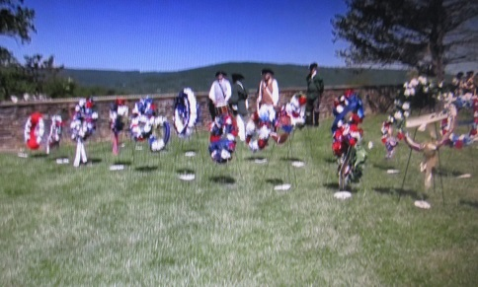
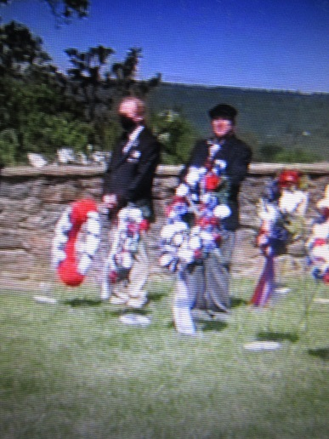
Above President Walden presents the War of 1812 society wreath
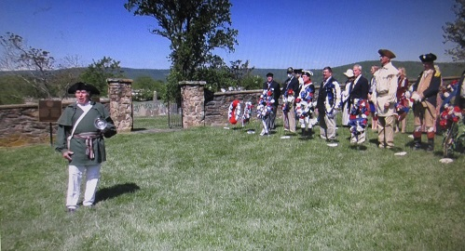
Above: member of the War of 1812 society, Dale Corey sings the National Anthem
Below the Musket Salute is performed by The VASSAR Color Guard
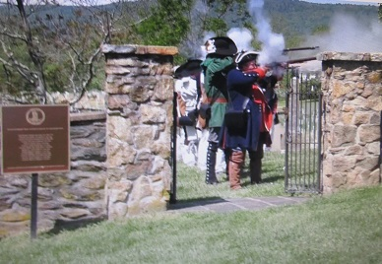
and TAPS is played
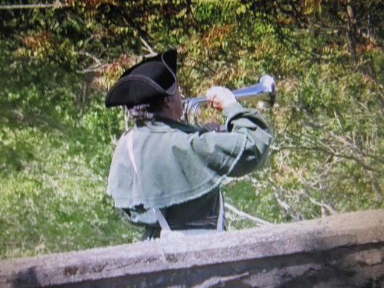
Below is listing of the 1812 veterans
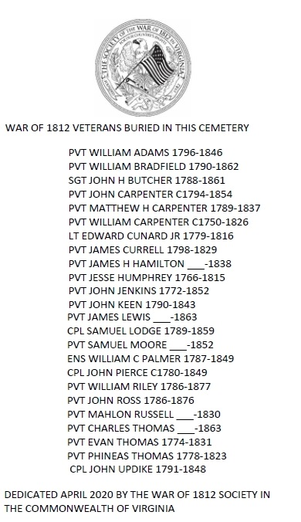
(Note: In April 2020 the ceremony was postponed because of the virus)
The event is shown for viewing on VASSAR youtube https://youtu.be/DM0nLFoQLJ8

