SOCIETY VICE-PRESIDENT GENERAL AND PAST PRESIDENT DELIVERS VIRGINIA WAR OF 1812 LECTURES AT THE COLLEGE OF WILLIAM AND MARY, WILLIAMSBURG, VIRGINIA
Virginia Society of War of 1812 Vice-President General and past president Stuart L. Butler, delivered a series of three lectures about the events in Virginia during the War of 1812. The talk, entitled, “The War of 1812 in Virginia, did anything happen here?” was delivered as part of the Osher Lifelong Learning Institute affiliated with the College of William and Mary. The major topics covered included the role of the Virginia militia, Virginia’s governmental response to the British threat in the Chesapeake Bay, the objectives of the British naval forces in the Chesapeake, and the flight of the former African-American enslaved to British ships. The talks were given on October 26, October 31, and November 9, 2021, at the Kaplan Arena on the campus of William and Mary. The talk was well-attended with nearly sixty individuals signing up for the course. During the talk, Butler displayed a replica of the James City County regimental flag for the 68th Virginia Militia, the original of which was captured by British forces at Hampton in June 1813. The lectures were based on Butler’s two books on Virginia and the War of 1812: Defending the Old Dominion: Virginia and its Militia in the War of 1812 (2013); A Guide to Virginia Militia Units in the War of 1812 (2011), and numerous articles on the subject.
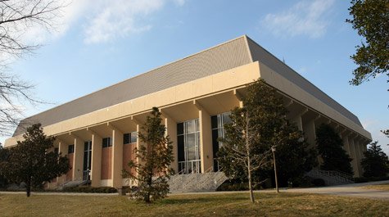
Kaplan Arena, College of William and Mary, Williamsburg, Virginia

