War of 1812 Solder’s Remains Are Moved to Tavern He Owned
Captain Griffin Henry Foushee’s remains were removed from a cornfield in a ceremony, Oct 15 2022 to Rice’s Hotel Hughlett’s Tavern in Heathsville, Northumberland County. The event was captured by the local newspaper on their front page as shown below, which provides many details. The event was organized by Col (Ret) George Beckett, assisted by James Russell of the War of 1812 Society and others. A horse drawn wagon was used to move the stone and was guided by the society color guard.
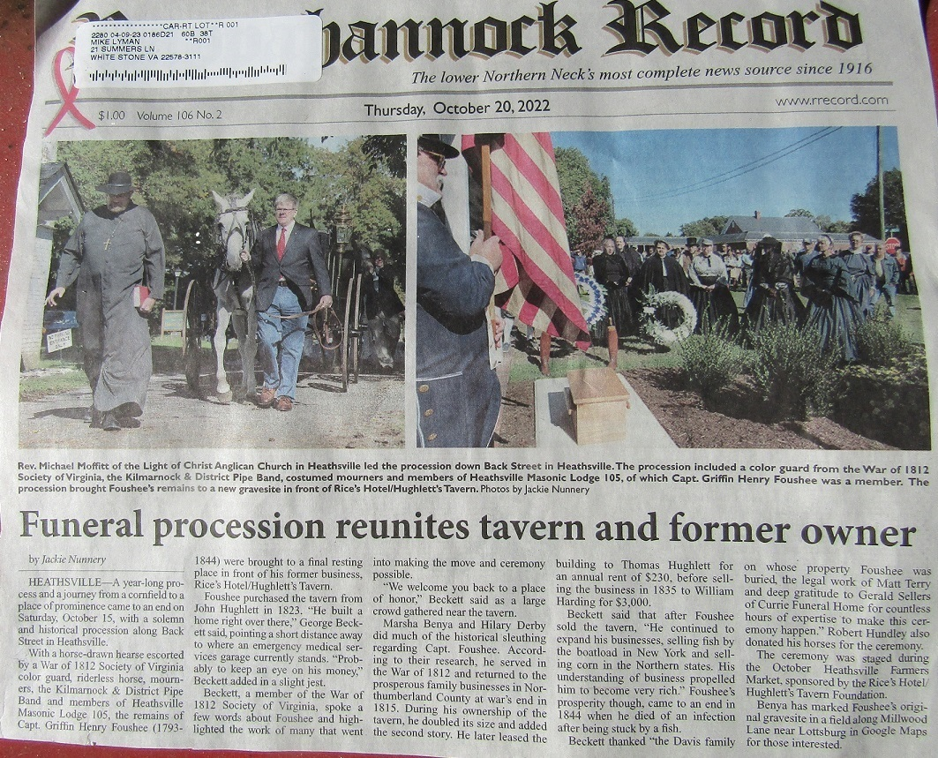
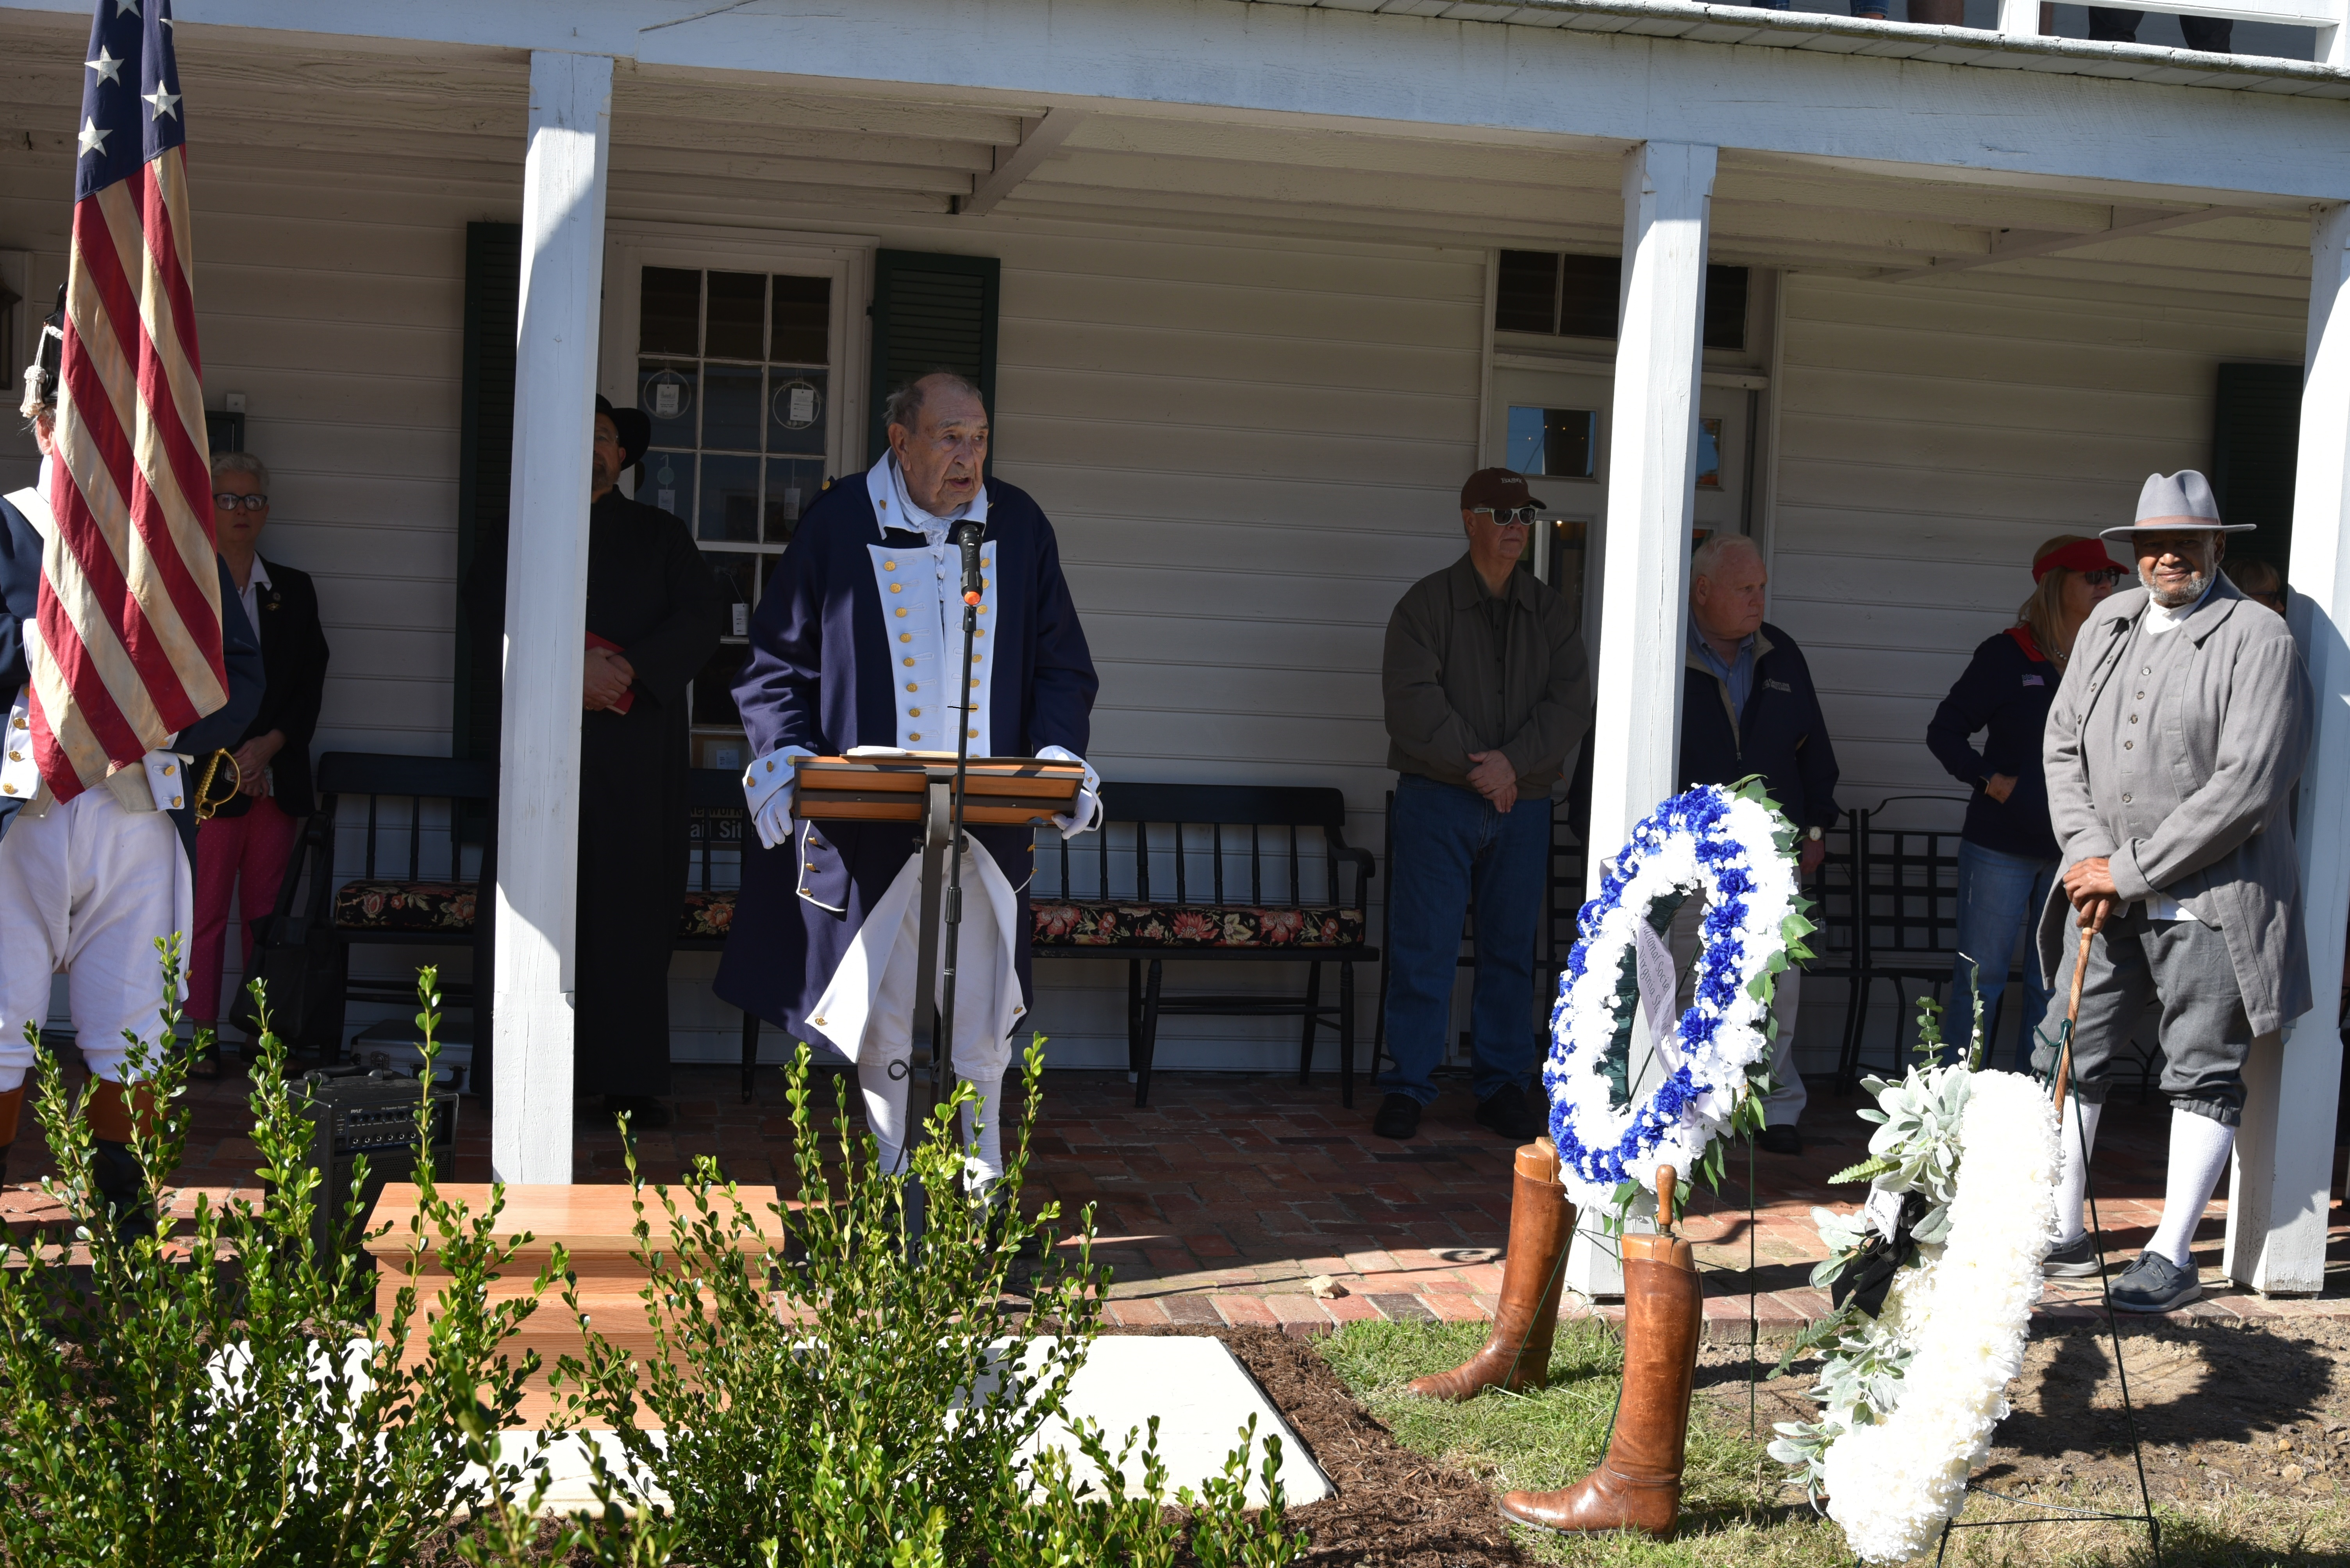
At the tavern Beckett presides by the gravestone. Wreaths have been presented. Below the gravestone with remains are carried to the new site by the tavern to be set.
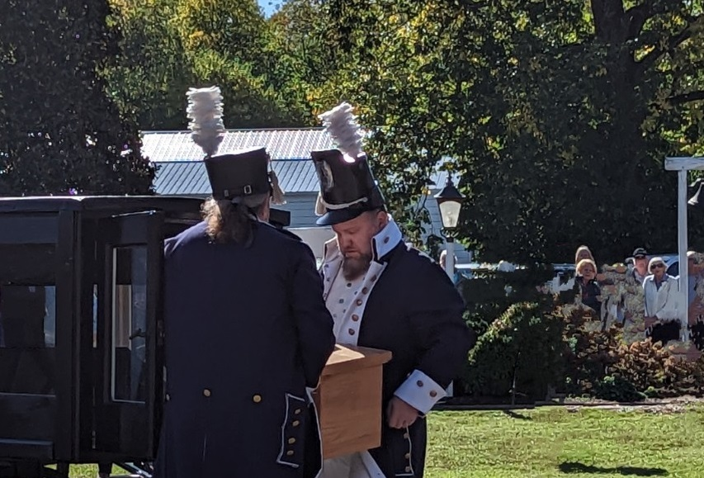
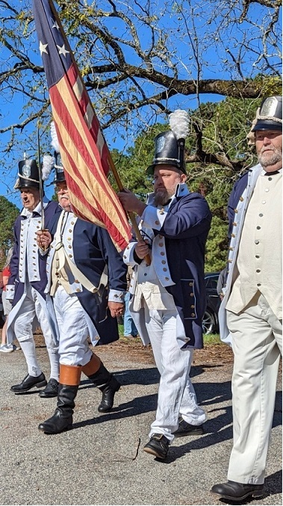
Above the Color Guard Advances
Below is the horse & carriage that was used
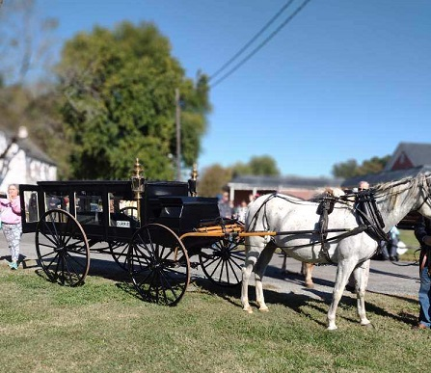
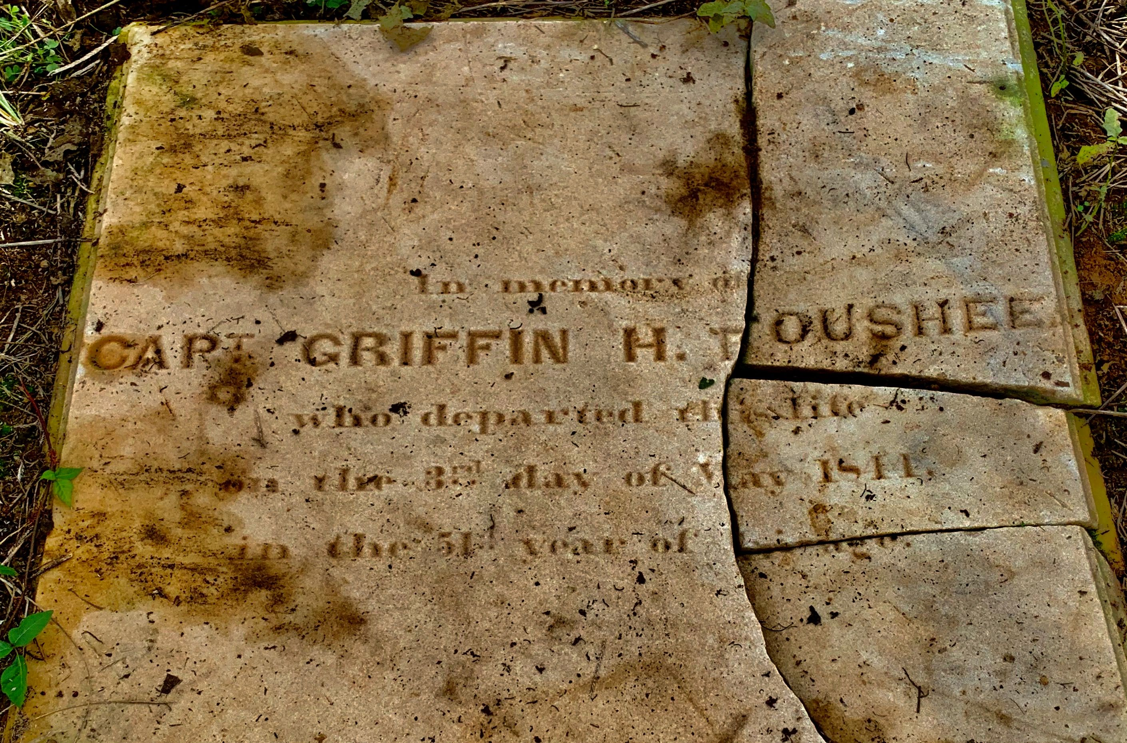
The gravestone before movement

