War of 1812 Society Holds Meeting February 3 2023 in Richmond
AGENDA
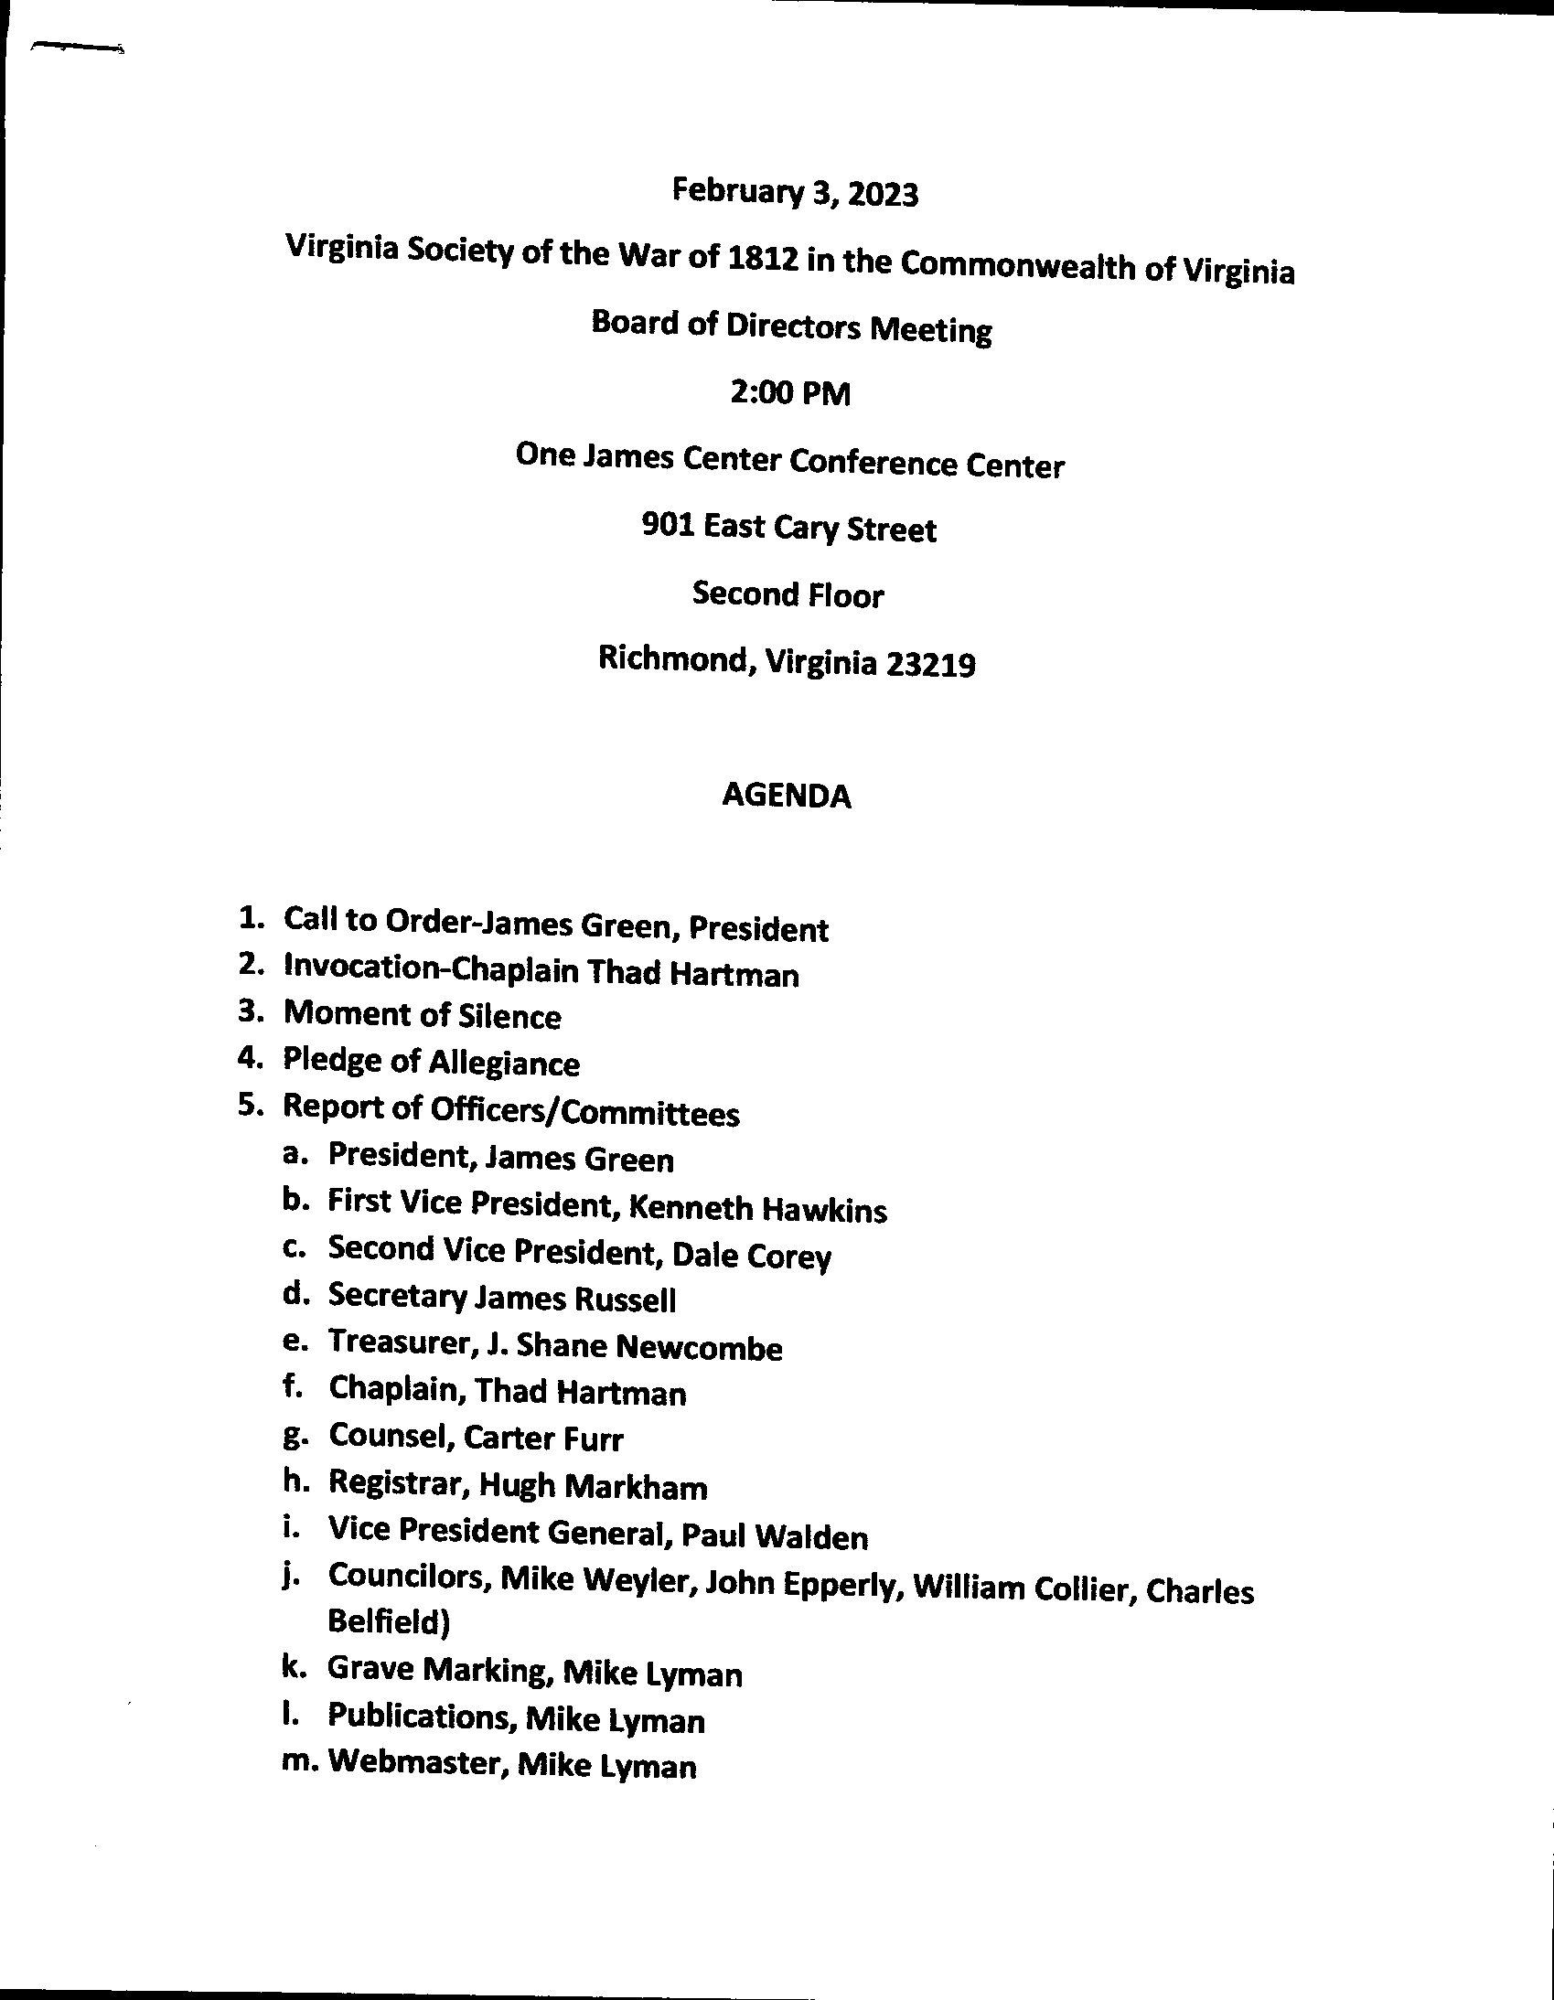
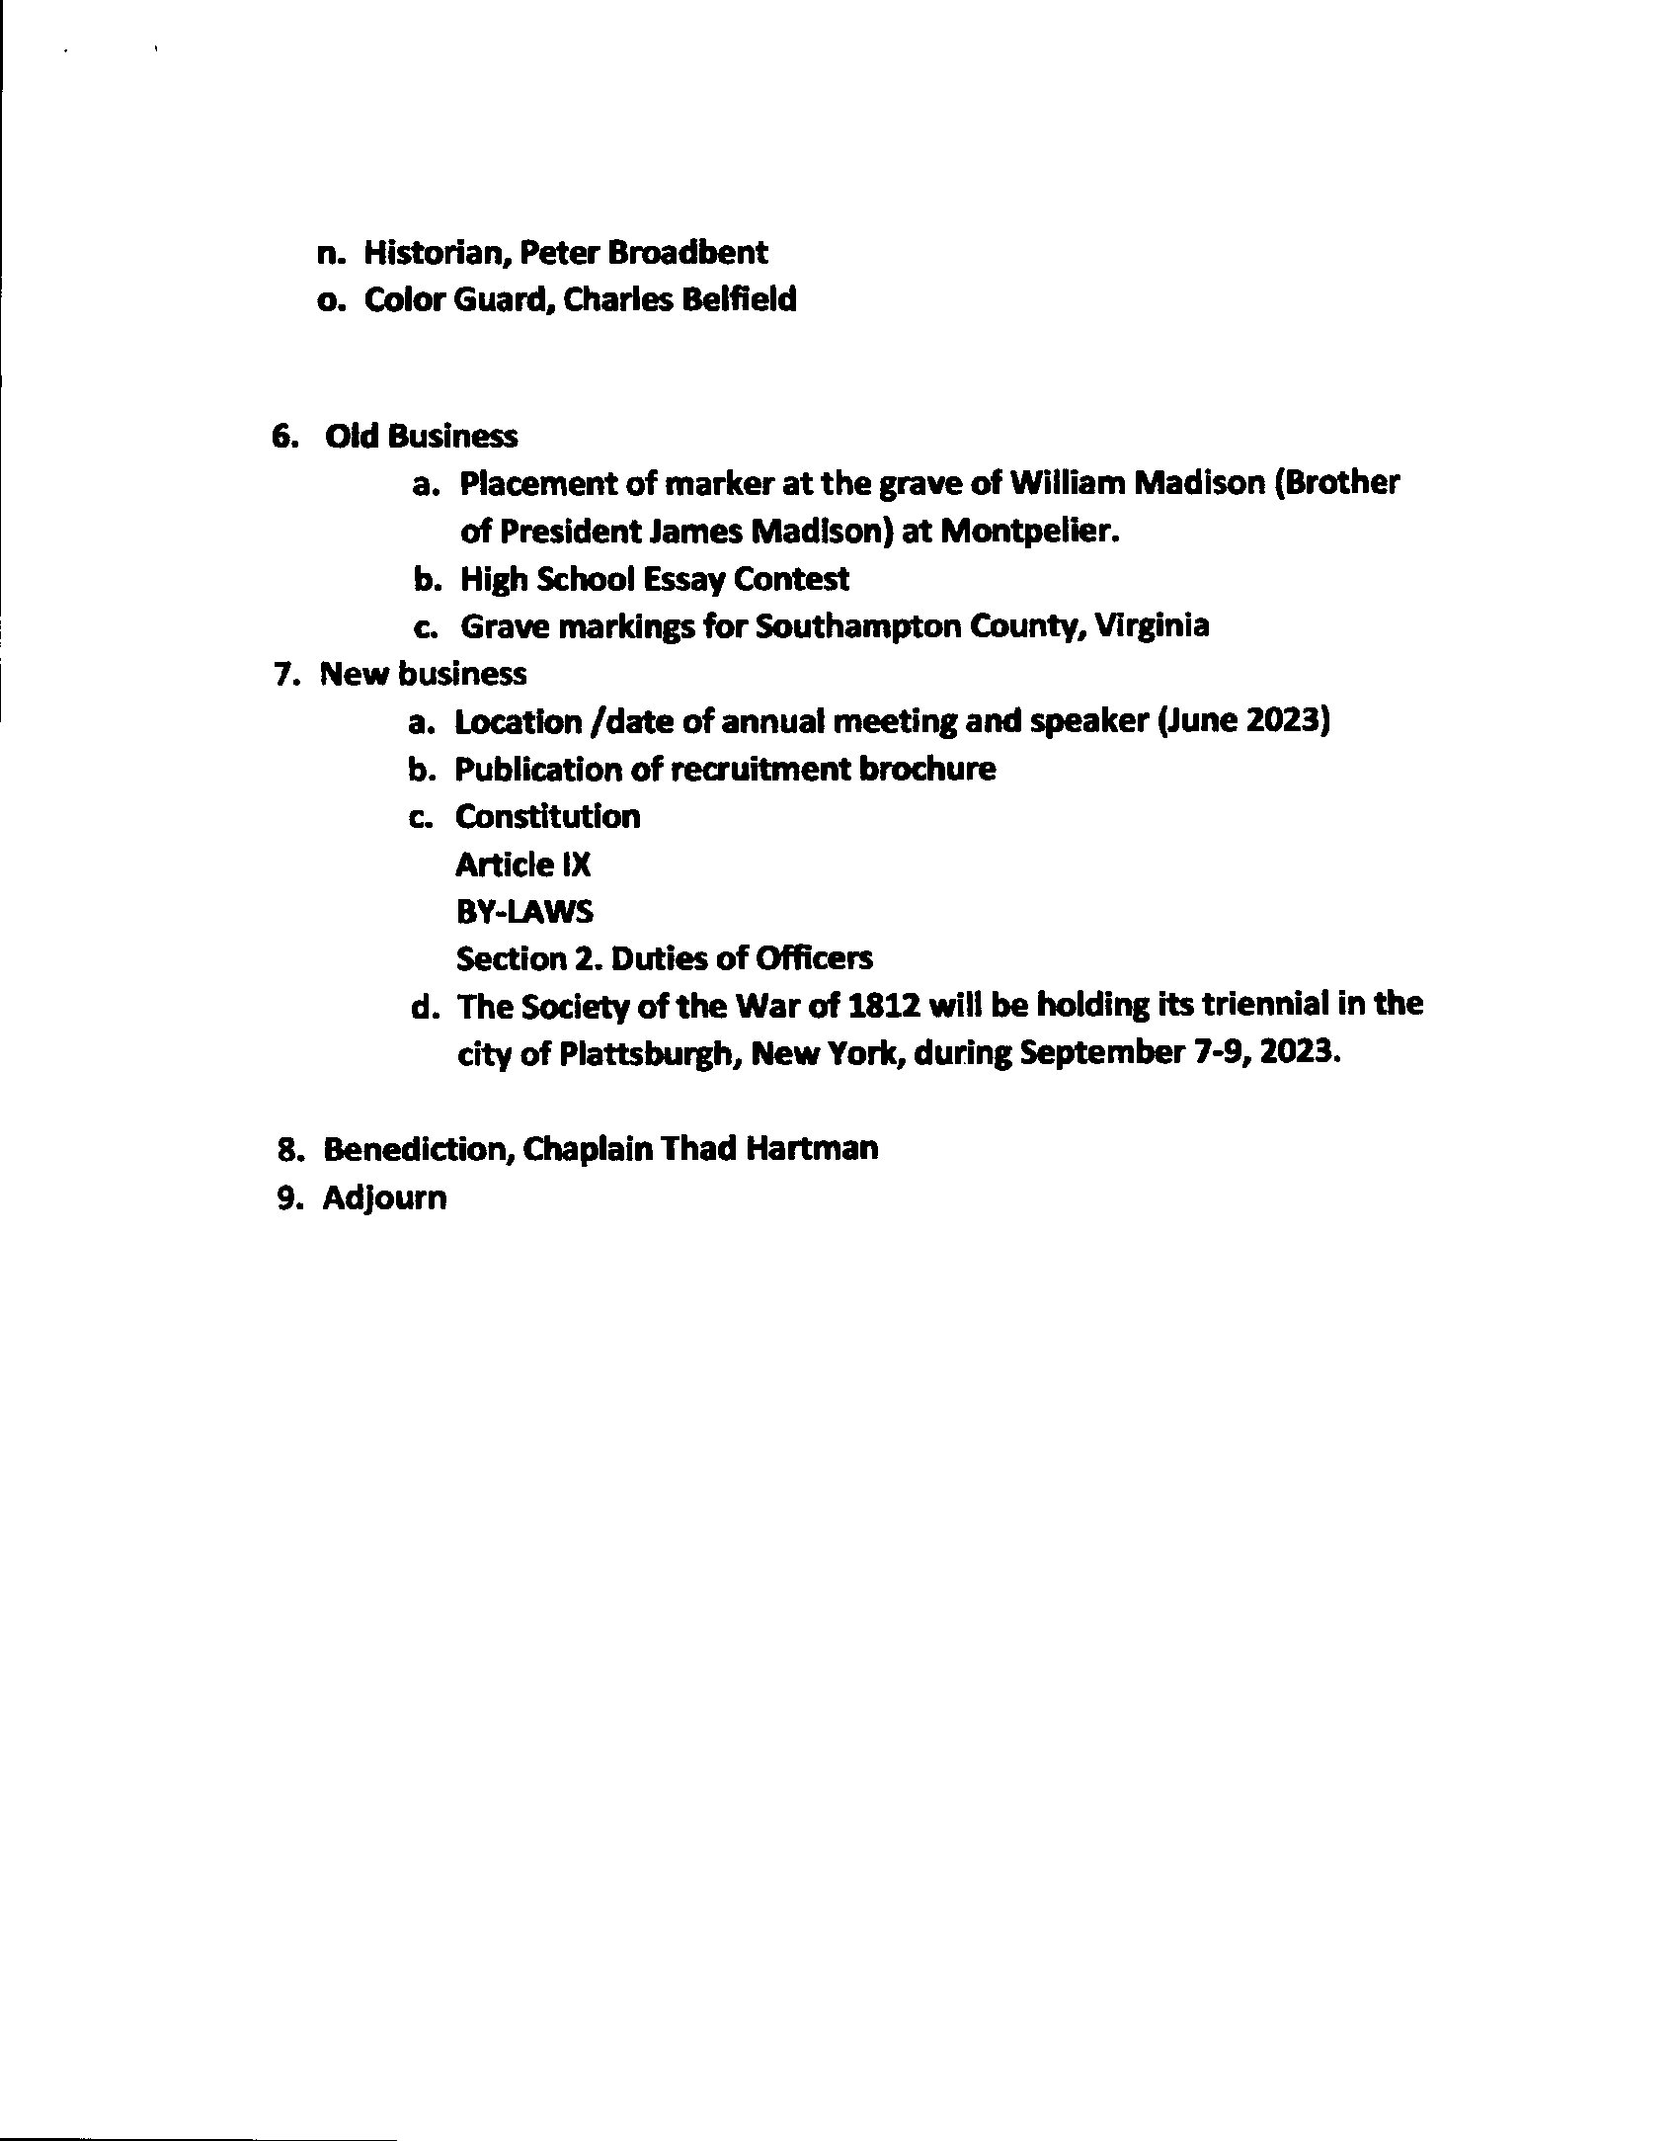
The Minutes
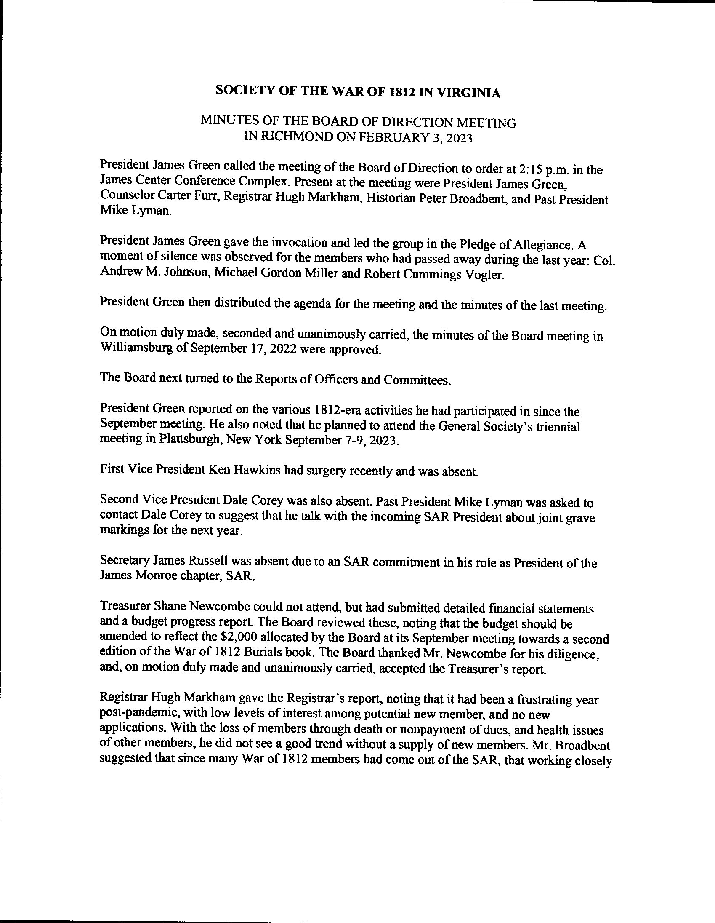
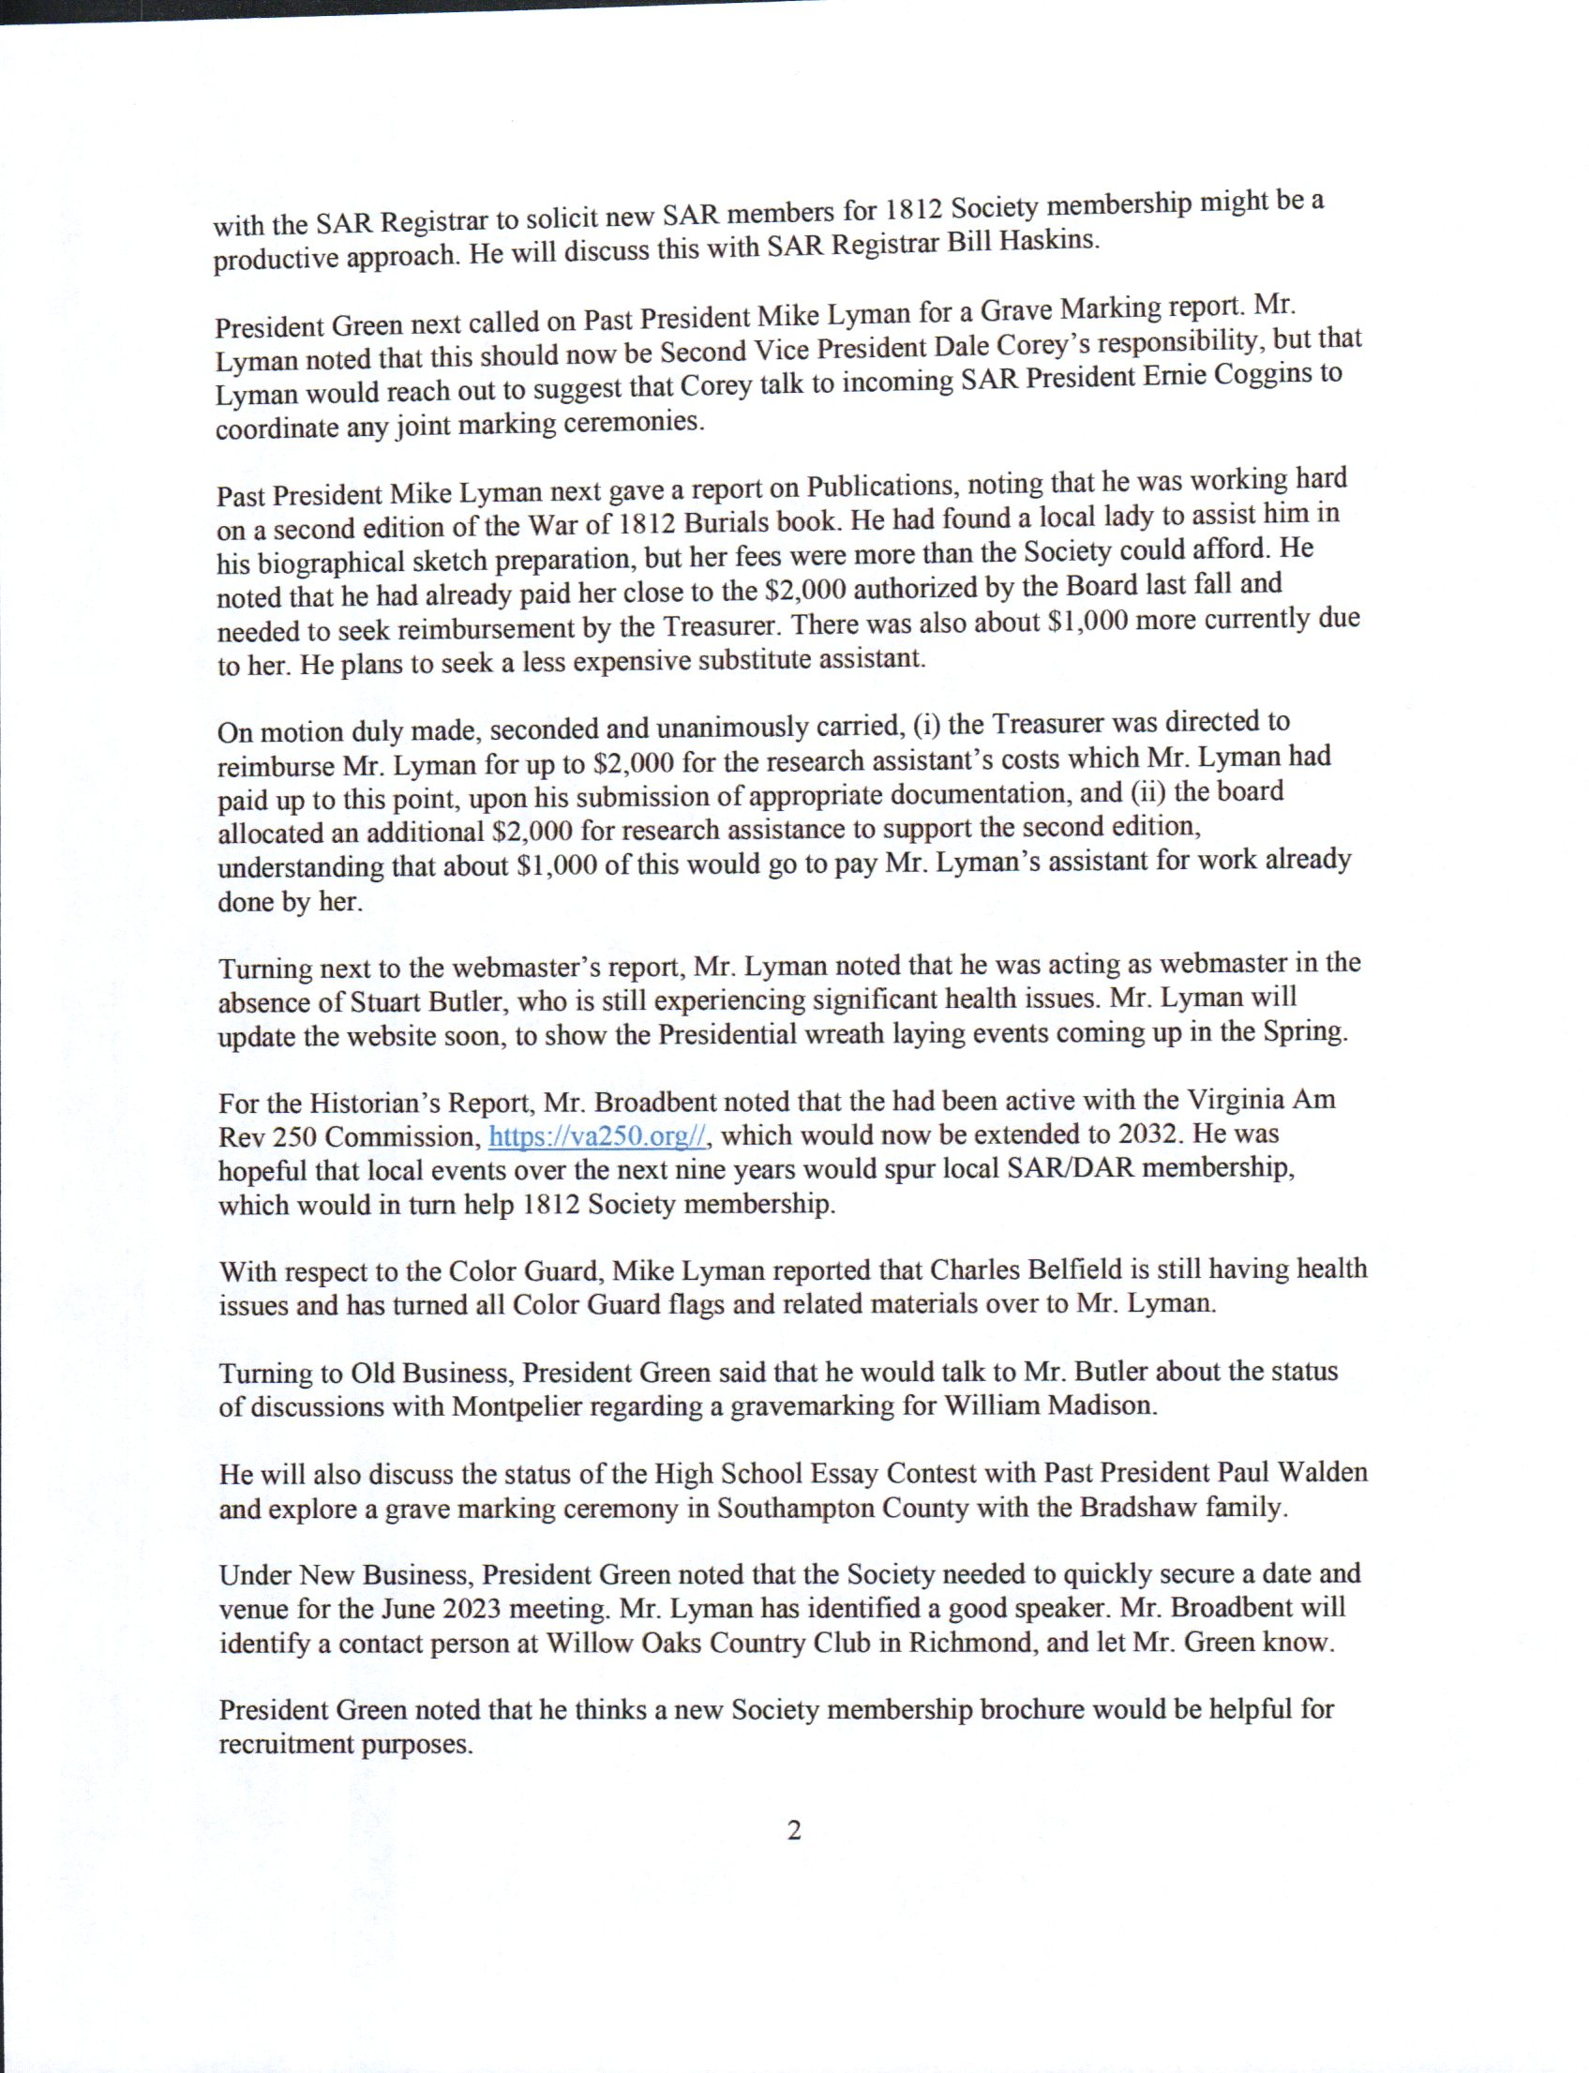
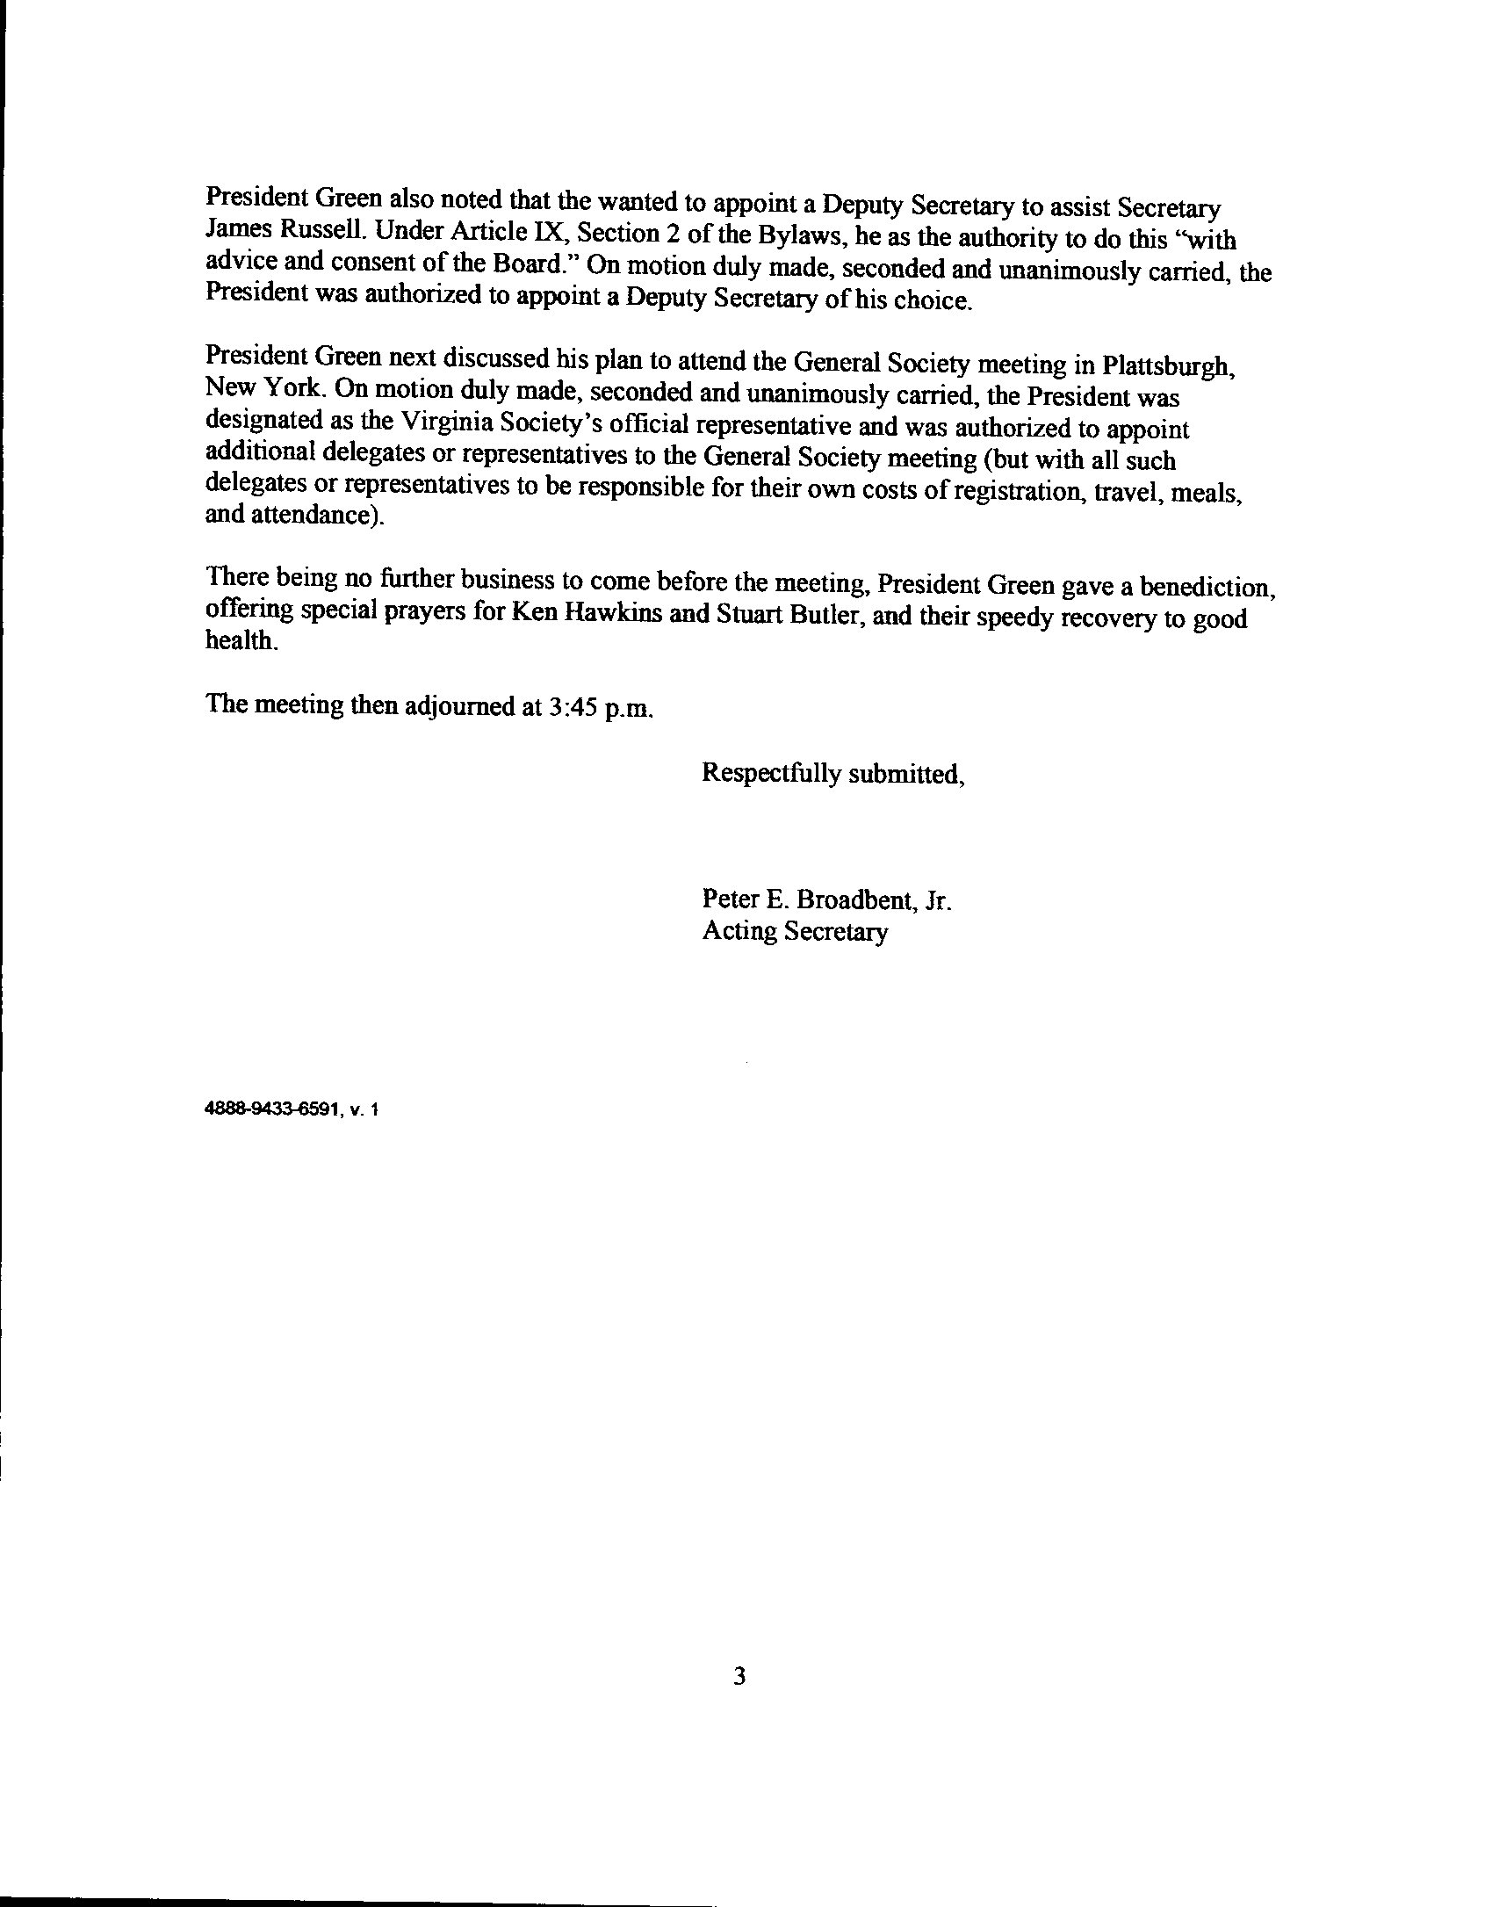
The Attendees
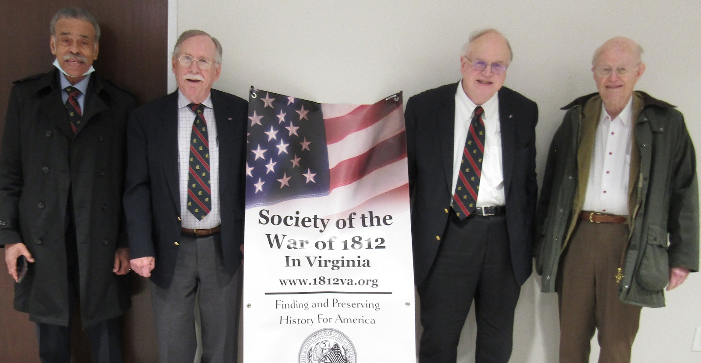
L/R President, James Green; Registrar Hugh Markham; Historian, Peter Broadbent
Counselor, Carter Furr
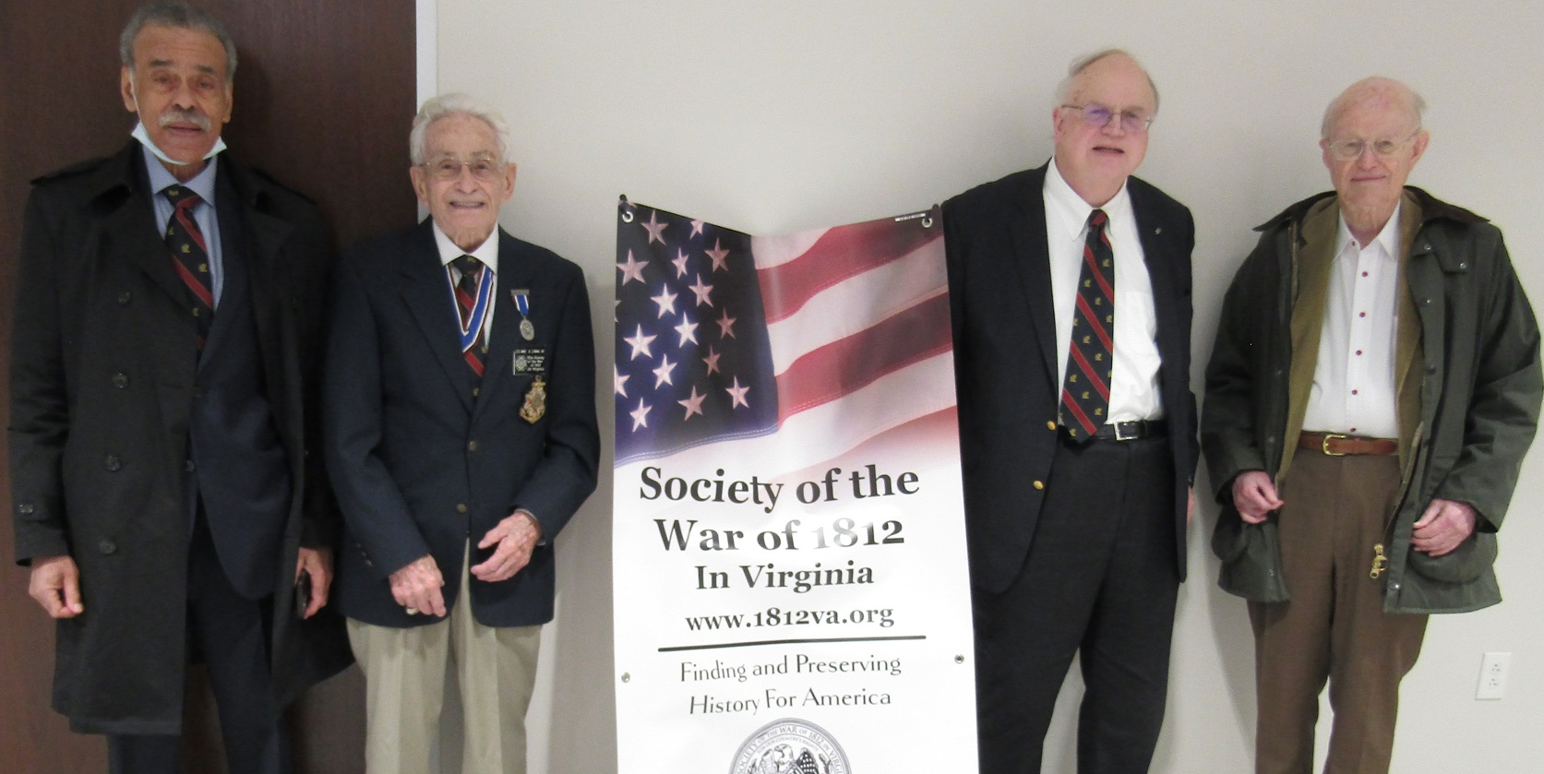
Above 2d from left is Past President, Mike Lyman

